I put to the master

This is a test…

Hello world

The first line is test.

How to find a string within one, return the position.

Original table

|  |
| --- |
| Name |
| This is a test. |

Desired table

|  |
| --- |
| Start position of test |
| 11 |

Using position

# Find one string within one another. The value 0 indicates not found. 11 indicates find the test is start at

How to find a key word in string or not. Return 0 or 1

Original table

|  |
| --- |
| Name |
| This is a test. |

Desired table

|  |
| --- |
| If contain test in the string (1 stands for yes) (0 stands for no) |
| 1 |

Using decode and position, the number of position return is two categories, 0 ->not found, (1~1+) found.

decode is return the exactly match value.

decode (position(‘test’ in name),0,0,1) as flag_test.

select case when position(‘test’ in name) = 0 then ‘0’

else ‘1’

end

Case when using decode too

decode, the very first beginning of the element is .. the element inside could be odd number or even number.

How to change null to 0, others still others -> iferror

If the column is not null, then some value, otherwise return 0

Original table

|  |
| --- |
| Click count |
| Null |
| 1 |
| Null |

Desired table

|  |
| --- |
| Click count |
| 0 |
| 1 |
| 0 |

nvl2(click_count, 1, 0)

nvl(click_count,0)

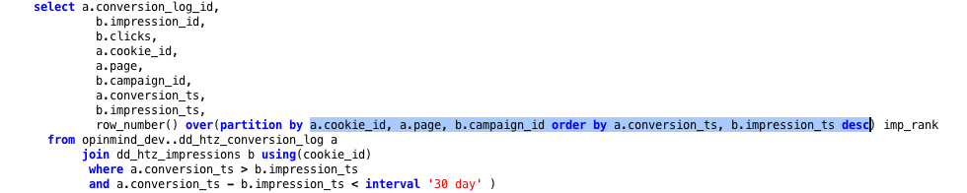

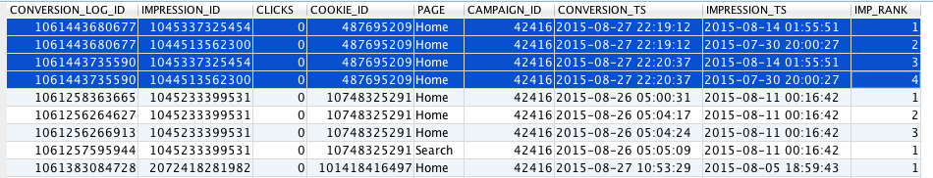

Countif in excel

Original table

|  |
| --- |
| Activity |
| Home |
| Home |
| Search |
| Book |
|  |
|  |

|  |  |  |
| --- | --- | --- |
| Home | Search | Book |
| 1 | 0 | 0 |
| 1 | 0 | 0 |
| 0 | 1 | 0 |
| 0 | 0 | 1 |

original

|  |  |
| --- | --- |
| Activity | num |
| Home | 2 |
| Search | 1 |
| Book | 1 |

desired table

|  |  |  |
| --- | --- | --- |
| Home | Search | Book |
| 2 | 1 | 1 |

Sum(Decode(Activity,’home’,num,0)as Home)as

Decode(Activity,’Search’,num,0)as Home

Decode(Activity,’book,num,0)as Home

sum( decode(Activity, ‘Home’,1,0) as Home,

sum( decode(Activity, ‘Search’,1,0) as Search,

sum( decode(Activity, ‘Book’,1,0) as Book,

the operation order of Aggregate function in MySQL is after where and group, like row_number and sum, count

Join two table without key words, and return all the combination

Original table 1

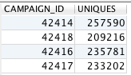

Original table 2



select ‘30-Day’ as attribution_window

union all

select ‘1-Day’ as attribution_window

Decided table

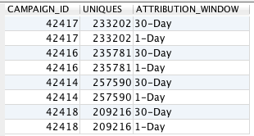

Code

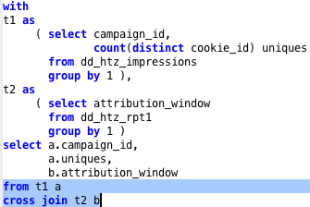

Original table 1

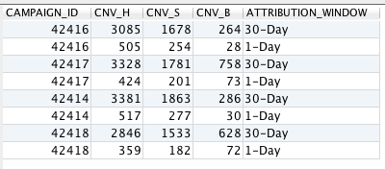

Original table 2

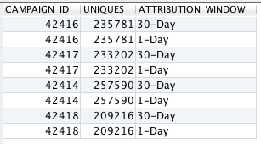

Designed table

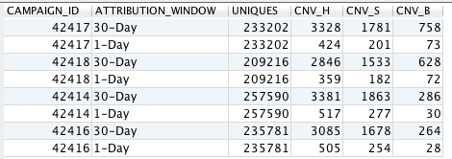

code

using/on

SELECT * FROM t1 **JOIN** t2 **USING** (id, date)

JOIN t2 ON (t2.id = t1.id AND t2.date = t1.date)

Look the brand, if shrik might be where clause, or join,

If different the column, might be use case when

How to use nvl, how to use nvl2

How to avoid the join or left join, within the result of null value

How to use extract

* Extract could extract time between two timestamp but use the epoch from syntax

extract ( epoch from book_ts – imp_ts) as slot_time

NOTE!!! Don’t add () in **(book_ts – imp_ts )**

* Extract could condition get the time different using lag

Extract (epoch from imp_ts – lag (imp_ts,1) over (partition by cookie_id order by imp_ts asc) )as pacing

Note epoch from no () after the calculation, and over partition by , partition by must have () to. so over must followed by ().

Get the list of those customers shopping every consecutive three month

Select distinct (a.customer)

From order a

join order b

on (a. customer = b.customer)

and month (a.order_ts + 1 Month) = Month(b.order_ts)

and Year (a.order_ts + 1 Month) = Year(b.order_ts)

join order c

on (b. customer = c.customer)

and month (b.order_ts + 1 Month) = Month(c.order_ts)

and Year (b.order_ts + 1 Month) = Year(c.order_ts)

Use the decode or case when

Nvl2( type, a,b) if type column is not null in that row, return “ a” , else return ‘ b

Nvl( type, b) if type column is not null, then return type column ,else return b

Case when type =”new” then inventory

when type = “used” then inventory

else “0”

end

as new_cloumn name

decode ( type, ‘new’, inventory,”use”, inventory ,0) as new column name

* there is no end in the decode

1. Given the following table, how do I pivot using SQL to get the result pivoted by brand, new inventory, and used inventory?

select brand,

sum(decode(type,’new’,inventory,0) )as new,

sum(decode(type,’old’, inventory, 0) )as old

from inventory

group by 1

order by 1

inventory

|  |  |  |  |
| --- | --- | --- | --- |
| **brand** | **locationid** | **type** | **inventory** |
| Toyota | 1113 | new | 100 |
| Chevrolet | 2505 | new | 125 |
| BMW | 9856 | new | 63 |
| Toyota | 3136 | used | 45 |
| Toyota | 48753 | new | 120 |
| BMW | 79285 | used | 31 |
| Honda | 4663 | new | 133 |
| Jeep | 7931 | used | 22 |

Desired Result:

|  |  |  |
| --- | --- | --- |
| **Brand** | **new_inventory** | **used_inventory** |
| BMW | 63 | 31 |
| Chevrolet | 125 | 0 |
| Honda | 133 | 0 |
| Jeep | 0 | 22 |
| Toyota | 220 | 45 |

Answer

Select brand,

sum(decode (type = “new” ,inventory,0 ) as new_inventory

sum(decode (type = “used” ,inventory,0) as old_inventory

from T1

group by 1

order by 1

call opinmind_dev..utl_drop_table_if_exists('wy_inventory1');

create table opinmind_dev..wy_inventory1 as

select 'Toyota' as brand, '1113' as locationid, 'new' as type, 100 as inventory

union all

select 'Chevrolet' as brand, '2505' as locationid, 'new' as type, 125 as inventory

union all

select 'BMW' as brand, '9856' as locationid, 'new' as type, 63 as inventory

union all

select 'Toyota' as brand, '3136' as locationid, 'used' as type, 45 as inventory

union all

select 'Toyota' as brand, '48753' as locationid, 'new' as type, 120 as inventory

union all

select 'BMW' as brand, '79285' as locationid, 'used' as type, 31 as inventory

union all

select 'Honda' as brand, '4663' as locationid, 'new' as type, 133 as inventory

union all

select 'Jeep' as brand, '7931' as locationid, 'used' as type, 22 as inventory

---------

watch the original table first, we could find using join. But you find Toyota has two record as new inventory always remember if you want to de the join ,must keep sure you have the unique join key_id, otherwise would be wrong!!!, even yourself don’t know where is wrong.

For the first new inventory part, you would find the Toyota has tow rows of the same new inventory. So the first step is the merge or sum by the same brand ,then using Full join.

--------

select *

from wy_inventory1

with T1 as

(

select brand, sum(inventory) as new_inventory

from wy_inventory1

where type = 'new'

group by 1

),

T2 as

(

select brand, inventory as used_inventory

from wy_inventory1

where type = 'used'

)

select brand,nvl(new_inventory,0) as new_inventory ,nvl(used_inventory,0) as new_inventory

from T1

full join T2

using (brand)

order by 1

Select brand,

Sum(case when type = ‘new’ then inventory

else 0

end) as new_inventory,

as used_inventory

sum(case when type = ‘old’ then inventory

else 0

end) as old_inventory

from inventory

group by 1

select brand,

decode(type,’new’, inventory,0) as

Select brand,

Case when type = ‘new’ then inventory

Else 0

End as new_inventory,

Case when type = ‘used’ then inventory

Else 0

End as usd_used_inventory

From inventory

|  |  |  |
| --- | --- | --- |
| **brand** | **inventory** | **used_inventory** |
| Toyota | 100 | 0 |
| Chevrolet | 125 | 0 |
| BMW | 63 | 0 |
| Toyota | 0 | 45 |
| Toyota | 120 | 0 |
| BMW | 0 | 31 |
| Honda | 133 | 0 |
| Jeep | 0 | 22 |

Select brand, sum(**inventory),sum(used_inventory)**

**From inventory**

**Group by 1**

**Order by 1**

Select brand,

Sum( Case

when type = ‘new’ then inventory

else 0

End ) as new_inventory,

Sum(Case when type = ‘used’ then inventory

Else 0

End )as usd_used_inventory

From inventory

Group by 1

Order by 1

Also we can do join

Select brand, sum(inventory) as inventory

From inventory

Where type = ‘new’

Group by 1

Select brand, type as used inventory

From inventory

Where type = ‘used’

|  |  |
| --- | --- |
| **brand** | **inventory** |
| Toyota | 220 |
| Chevrolet | 125 |
| BMW | 63 |
| Honda | 133 |

|  |  |
| --- | --- |
| **brand** | **used_inventory** |
| Toyota | 45 |
| BMW | 31 |
| Jeep | 22 |

With T1 as

(

Select brand, sum(inventory) as inventory

From inventory

Where type = ‘new’

Group by 1

)

T2 as

(

Select brand, type as used inventory

From inventory

Where type = ‘used’

)

select T1. Brand, nvl(T1.inventory,0), nvl(T2.used_inventory,0)

from T1

full join T2

on( T1.brand = T2.brand)

as used_inverntory

SQL:

with T1 as

(

select brand, **inventory as** new_inventory

from A

where type = ‘new’

)

select b.brand, T1.new_inverntory,b.inventory as used_inventory,

from A as b

full join T1

on T1.brand = b.brand

where type = ‘used’

Clickstream

|  |  |  |  |  |  |
| --- | --- | --- | --- | --- | --- |
| Date_time | Event_id | Visitor | Session | Page | Exit Flag |
| Jan 1st 2pm | 123rtfyd | V1 | S1 | Page A | 0 |
| Jan 1st 2:10 pm | 3434jdjsd | V1 | S1 | Page B | 1 |
| Jan 1st 3:00pm | 234343rd | V2 | S2 | Page A | 0 |
| Jan 1st 3:10pm | rereg6677 | V2 | S2 | Page B | 0 |
| Jan 1st 3:20pm | 34fgg | V2 | S2 | Page C | 1 |
| Jan 1st 3:00pm | 234343rd | V3 | S3 | Page A | 1 |

select date_time::date ,Page, count(distinct Visitor)

Smaple answer:

with T1 as

(

select

date_time::date,

Visitor,

Page,

row_number() over ( partition by visitor,page order by date_time desc) as exit_flag

from wy_click1

)

select date_time::date,

page,

sum(decode(exit_flag,1,1,0)) as exit_number

from T1

group by 1,2

** exit_flag,1,1,0 -> can’t add ‘’ quote, because add quote means varchar, we need do sum so, should leave the ‘’

Select Date_time::date as date, page, count(distinct Visitor) as num_visitor

From Clickstream

Group by 1,2

Order by 1,2

Distribute on(date);

|  |  |  |
| --- | --- | --- |
| Date | Page | Num_visitor |
| Jan 1st | Page A | 3 |
| Jan 1st | Page B | 2 |
| Jan 1st | Page C | 1 |

Select Date_time::date as date, visitor, page,

Row_number() over ( partition by visitor, date_time::date, order by date desc)

|  |  |  |  |  |
| --- | --- | --- | --- | --- |
| Date_time | Visitor | Page |  | Exit Flag |
| ] | V1 | Page A |  | 0 |
| Jan 1st 2:10 pm | V1 | Page B |  | 1 |
| Jan 1st 3:00pm | V2 | Page A |  | 0 |
| Jan 1st 3:10pm | V2 | Page B |  | 0 |
| Jan 1st 3:20pm | V2 | Page C |  | 1 |
| Jan 1st 3:00pm | V3 | Page A |  | 1 |

Total unique Visitors for each page by day:

select Date_time ::date

,Page,count ( distinct Visitors)

from Clickstream

group by 1,2

create temp table A as (

select visitor, page,

row_number() over( partition by Visitor asc, order by date_time desc) as exit Flag

from Clickstream

where row_number = 1 )

Exit Rate = # of people who exits the site on a page / Total # of people who visited the page

Page B: 1 / 2 = 0.5

Page A: 1 / 3 = 0.3333

select page, count( page), count(visitor)

from Clickstream

group by 1

page count(page) count(vistor)

A 3 3

B 2 2

C 1 1

(count (vistor - count(page) / count(vistor) → exit rate

create the table

call opinmind_dev..utl_drop_table_if_exists('wy_click1');

create table opinmind_dev..wy_click1 as

select '2015-10-13 14:00:00' as date_time, 'V1' as Visitor, 'Page A' as page

union all

select '2015-10-13 14:00:00' as date_time, 'V4' as Visitor, 'Page A' as page

union all

select '2015-10-13 14:10:00' as date_time, 'V1' as Visitor, 'Page B' as page

union all

select '2015-10-13 15:00:00' as date_time, 'V2' as Visitor, 'Page A' as page

union all

select '2015-10-13 15:10:00' as date_time, 'V2' as Visitor, 'Page B' as page

union all

select '2015-10-13 15:20:00' as date_time, 'V2' as Visitor, 'Page C' as page

union all

select '2015-10-13 15:00:00' as date_time, 'V3' as Visitor, 'Page A' as page

union all

select '2015-10-15 14:00:00' as date_time, 'V1' as Visitor, 'Page A' as page

union all

select '2015-10-15 14:10:00' as date_time, 'V1' as Visitor, 'Page B' as page

union all

select '2015-10-15 15:00:00' as date_time, 'V2' as Visitor, 'Page A' as page

union all

select '2015-10-15 15:10:00' as date_time, 'V2' as Visitor, 'Page B' as page

union all

select '2015-10-15 15:20:00' as date_time, 'V2' as Visitor, 'Page C' as page

union all

select '2015-10-15 15:00:00' as date_time, 'V3' as Visitor, 'Page A' as page

order by 1,2

output :

|  |  |  |
| --- | --- | --- |
| DATE_TIME | VISITOR | PAGE |
| 2015-10-13 14:00:00 | V1 | Page A |
| 2015-10-13 14:00:00 | V4 | Page A |
| 2015-10-13 14:10:00 | V1 | Page B |
| 2015-10-13 15:00:00 | V2 | Page A |
| 2015-10-13 15:00:00 | V3 | Page A |
| 2015-10-13 15:10:00 | V2 | Page B |
| 2015-10-13 15:20:00 | V2 | Page C |
| 2015-10-15 14:00:00 | V1 | Page A |
| 2015-10-15 14:10:00 | V1 | Page B |
| 2015-10-15 15:00:00 | V2 | Page A |
| 2015-10-15 15:00:00 | V3 | Page A |
| 2015-10-15 15:10:00 | V2 | Page B |
| 2015-10-15 15:20:00 | V2 | Page C |

Solution:

Thinking: generate tow tables, first table is how many distinct people to visit each page by date.

The other table is find the last page for each visitor they visit by date.

Sine the row number can be choose where = 1, then using the third table to bridge it.

When generate the third table, sum of the exit_flag is 1 table, the got the total number of exit number.

Last step is choose the first table join the exit table, calculate the exit_rate

But must to care about the last page for each visitor visit by day,

First think about how to the row number, last time visit which page, so last time order by desc time. Then partition by is every date and every visior, so it could be every date , we much convert date_time to date -> partition by date_time::date, visitor order by date_time desc) be careful the ::date or convert date it would matter the result.

----------------------------------------------------------------

--- how many distinct unique visitor touch each page everyday

--- Among this page when page is their last activities everyday

----------------------------------------------------------------

with T1 as

( select date_time::date as date, page, count(distinct visitor) as num_visitor

from wy_click1

group by 1,2 ),

T2 as

( select date_time::date as date, visitor, page,

row_number() over ( partition by date_time::date,visitor order by date_time desc) as exit_page

from wy_click1

),

T3 as

(

select date,page, sum(exit_page) as num_exit

from T2

where exit_page = 1

group by 1,2

)

select T1.date, T1.page,T1.num_visitor,T3.num_exit, T3.num_exit/T1.num_visitor as exit_rate

from T1

join T3

on (T1.date = T3.date) and (T1.page = T3.page)

Exit rate;

Logic, we must to get the distinct cookie in different page within a day.

Why distinct is some people would reload the page many times. So count as distinct.

If that people go the page B every hour, we still count as one didn’t make sense. We don’t allow the visit within 5 mins

How to write the query?

**Get the epoch with the same cookie_id**

select cookie_id, time_ts,

extract **(**epoch from time_ts - lag(time_ts,1)

over (partition by cookie_id order by time_ts asc)**) as time_lag_seconds**

from opinmind_dev..wy_dedupe1

where time_lag_seconds >60

|  |  |  |  |
| --- | --- | --- | --- |
| COOKIE_ID | TIME_TS | *** *** extract content* | TIME_LAG_SECONDS |
| 123 | 2015-10-13 14:01:00 |  | (null) |
| 123 | 2015-10-13 14:02:00 | 2015-10-13 14:01:00 | 60 |
| 123 | 2015-10-13 14:03:00 | 2015-10-13 14:02:00 | 60 |
| 123 | 2015-10-13 14:04:00 | 2015-10-13 14:03:00 | 60 |
| 123 | 2015-10-13 14:05:00 | 2015-10-13 14:04:00 | 60 |
| 123 | 2015-10-13 14:06:00 | 2015-10-13 14:05:00 | 60 |
| 123 | 2015-10-13 14:08:00 | 2015-10-13 14:06:00 | 120 |
| 456 | 2015-10-13 14:01:00 |  | (null) |
| 456 | 2015-10-13 14:07:00 | 2015-10-13 14:01:00 | 360 |
| 456 | 2015-10-13 14:17:00 | 2015-10-13 14:07:00 | 600 |

*extract follow by () , inside with the calculation time - time, for the seconde time, we write lag(time_ts,1) , that means move the time *ts down one position as anyother column( fake column) time A column minus time B column. How to move is if the original row cookie*id is the same with next row cookie id then move other wise list null.

*Move the time_ts to down 1 postion, if the donw position is same as the original, otherwise is null

**Get the epoch just by time**

select cookie_id, time_ts,

extract (epoch from time_ts - lag(time_ts,1) over (partition by null order by time_ts asc)) as time_lag_seconds

from opinmind_dev..wy_dedupe1

|  |  |  |  |
| --- | --- | --- | --- |
| COOKIE_ID | TIME_TS | *** extract content* | TIME_LAG_SECONDS |
| 456 | 2015-10-13 14:01:00 |  | (null) |
| 123 | 2015-10-13 14:01:00 | 2015-10-13 14:01:00 | 0 |
| 123 | 2015-10-13 14:02:00 | 2015-10-13 14:01:00 | 60 |
| 123 | 2015-10-13 14:03:00 | 2015-10-13 14:02:00 | 60 |
| 123 | 2015-10-13 14:04:00 | 2015-10-13 14:03:00 | 60 |
| 123 | 2015-10-13 14:05:00 | 2015-10-13 14:04:00 | 60 |
| 123 | 2015-10-13 14:06:00 | 2015-10-13 14:05:00 | 60 |
| 456 | 2015-10-13 14:07:00 | 2015-10-13 14:06:00 | 60 |
| 123 | 2015-10-13 14:08:00 | 2015-10-13 14:07:00 | 60 |
| 456 | 2015-10-13 14:17:00 | 2015-10-13 14:08:00 | 540 |

Other 5 mins 1,2,3,4,5,6 get 1 and 6 not each conversion 5 mins

select a.cookie_id, a.time_ts, b.time_ts---,row_number() over(partition by a.cookie_id order by b.time_ts desc) as flg

from opinmind_dev..wy_dedupe1 a

join opinmind_dev..wy_dedupe1 b

using (cookie_id)

where b.time_ts > a.time_ts

and extract(epoch from b.time_ts - a.time_ts) >= 300

work dedupe impression

----- base on the impression

----- find the first conversion

impression left join conversion

where c.conversion_ts > i.impression_ts

and extract(epoch from conversion_ts - impression_ts) <= 86400

row_number() over(partition by T1.impression_id order by **T1.conversion_ts asc**) imp_rank

----- base on the impression

----- find the cloesest impresssion

a.row_number() over(partition by a.conversion_log_id order by **a.impression_ts desc**) imp_rank

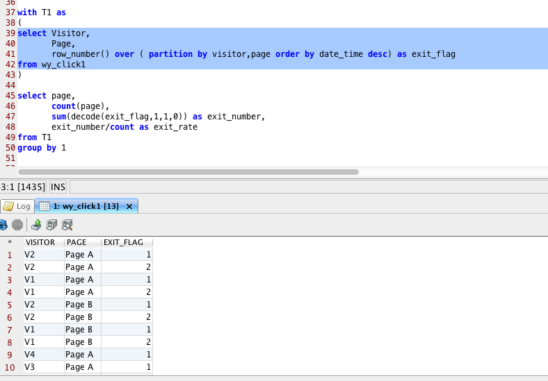

* notice the parentheses

extract ( epoch from time_ts – lag(time_ts,1)

over (partition by cookie_id order by date asc) ) as time_slot

row_number()

over( partition by Visitor asc, order by date_time desc) as exit Flag

how to check the column type

SELECT *

FROM INFORMATION_SCHEMA.COLUMNS

WHERE

TABLE_NAME = 'WY_DEDUPE1' ;

Note: use the upper case the name WY_DEDUPE1

How to extract to calculate

Row_number

Lag

Impression Table



find the time of impression pacing

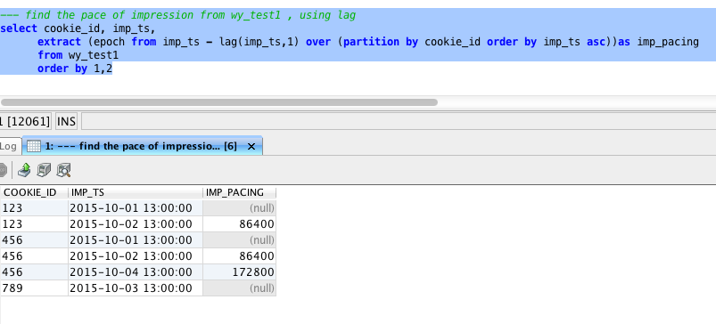

Conversion Table

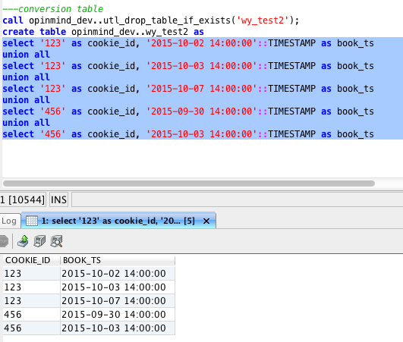

Join table

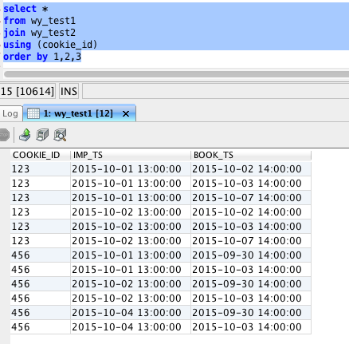

left join

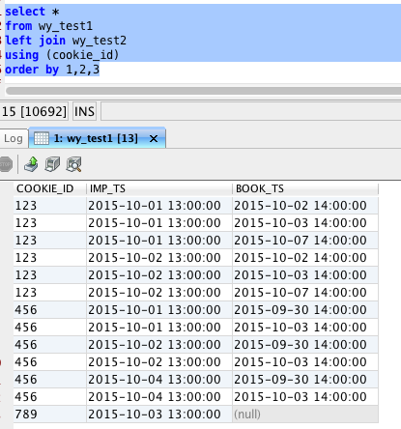

Left join with condition where

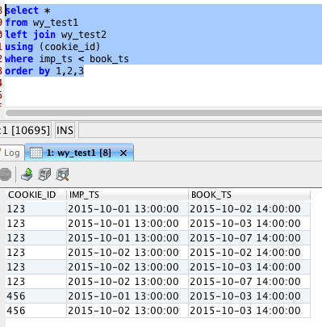

left join with TWO condition

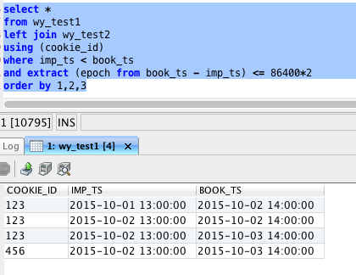

find the first conversion to each impression

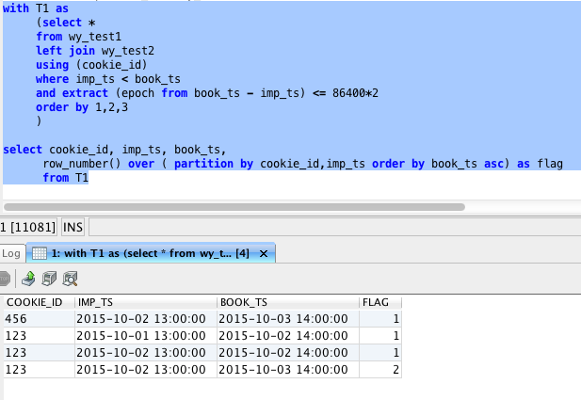

got the flag = 1

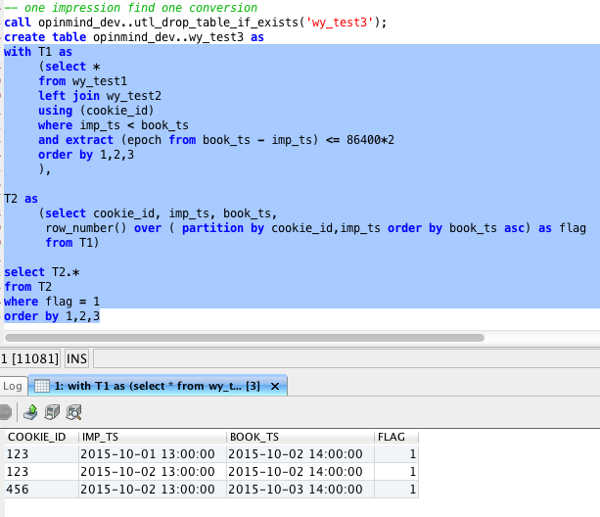

find the closest the impression corresponded to the first conversion

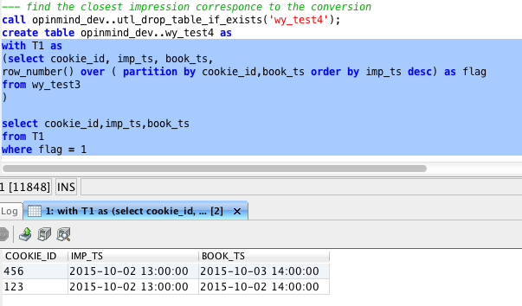

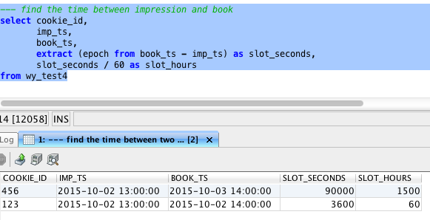

how to count times

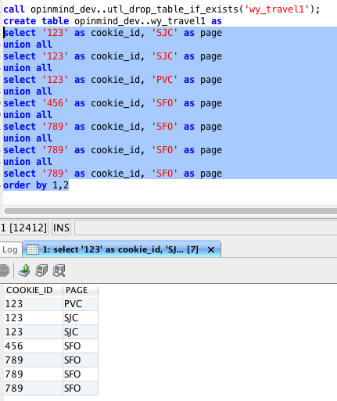

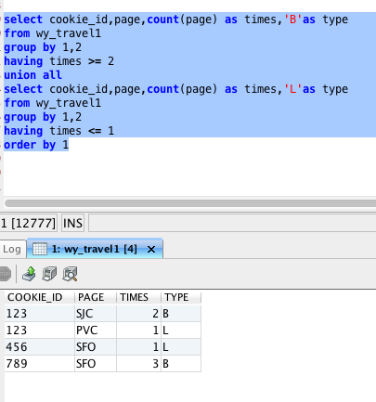

call opinmind_dev..utl_drop_table_if_exists('wy_inventory1');

create table opinmind_dev..wy_inventory1 as

select 'Toyota' as brand, '1113' as locationid, 'new' as type, 100 as inventory

union all

select 'Chevrolet' as brand, '2505' as locationid, 'new' as type, 125 as inventory

union all

select 'BMW' as brand, '9856' as locationid, 'new' as type, 63 as inventory

union all

select 'Toyota' as brand, '3136' as locationid, 'used' as type, 45 as inventory

union all

select 'Toyota' as brand, '48753' as locationid, 'new' as type, 120 as inventory

union all

select 'BMW' as brand, '79285' as locationid, 'used' as type, 31 as inventory

union all

select 'Honda' as brand, '4663' as locationid, 'new' as type, 133 as inventory

union all

select 'Jeep' as brand, '7931' as locationid, 'used' as type, 22 as inventory

select *

from wy_inventory1

------------------------------------------------------------------------

---using decode

---select colume as new name

---if no new value in the cell, it would return 'null' value

---sum to merget the same brand

------------------------------------------------------------------------

select brand, sum(decode(type,'new',inventory,0)) as new_inventory,sum(decode(type,'used',inventory,0)) as used_inventory

from wy_inventory1

group by 1

order by 1

--------------------------------------------------------------------

--using case when

--syntax of case when end by the new name

---if you want to do other calculate no need end follow by others

--------------------------------------------------------------------

--case when type = ' ' then...

-- when type = ' ' then...

-- else 0

-- end as inventory

------

select brand,

sum(case when type = 'new' then inventory

else 0

end)as new_inventory,

sum(case when type = 'used' then inventory

else 0

end) as used_inventory

from wy_inventory1

group by 1

-----------------------------------------------------------------------------

--using join

--when join , make sure key_id is unique

--full join, left join,join

--is table has '0' using nvl or decode or case when to tackle the null value

-----------------------------------------------------------------------------

with T1 as

(

select brand, sum(inventory) as new_inventory

from wy_inventory1

where type = 'new'

group by 1

),

T2 as

(

select brand, inventory as used_inventory

from wy_inventory1

where type = 'used'

)

select brand,nvl(new_inventory,0) as new_inventory ,nvl(used_inventory,0) as new_inventory

from T1

full join T2

using (brand)

order by 1

Given the following table about user activities:

content_id   user_id   time   activity   container_id  content

123                xxx      xxx   post       NULL         xxxxx

234                xxx      xxx     share   NULL         xxxxxx

256               xxx      xxx     picture   NULL         xxxxxx

354               xxx      xxx     comment   123     xxxxxx

574               xxx      xxx     comment   234     xxxxxx

join ? left join? On?

Where

Null!!!

Answer 1

select t1.content_id, t1.activity, nvl(count(t2.container_id),0) as num_comment

from activities T1

left join activities T2

on t1.content_id = t2.container_id

where t1.container_id is NULL ## where t1.activity != ‘comment’

group by 1,2

There are four possible types of activities. Three of those are actually creating a new entry: post (writing a post), share (share an article), and picture (post a picture).

The fourth one is comment, which can be for each of the first three activities (comment for a post, a share, or a picture).

a. How do you return the number of comments for each piece of content?

b. Based on a, how do you calculate the distribution of number of comments for each activity type:

e.g. the result should look like

#comments           num_activity     type

     1                          32245         post

     1                          24522         share

     1                         28763         picture

    2                         2134            post

    2                         1231            share

    2                          341             picture

Answer2:

select #comment, type, count(content_id)

from t3

group by 1,2

red book

with T1 as

(

select cookie_id, impression_ts, conversion_ts

from imp

left join con

using (cookie_id)

where con_ts > imp_ts

and extract (epoch con_ts – imp_ts) >= 86400*2

),

T2 as

(

select cookie_id, impression_ts, conversion_ts,

row_number() over (partition by cookie_id, conversion_ts order by impression_ts desc ) as flag

from T1

)

T3 as

(

select T2.*

from T2

where flag = 1

) ,

T4 as

(

select cookie_id, impression_ts, conversion_ts,

row_number() over (partition by cookie_id, impression_ts order by conversion_ts asc) as flag

from T3

),

T5 as

(

select T4.*

from T4

where flag = 1

)

Self join using rank

|  |  |
| --- | --- |
| Name | Score |
| Wenyi | 30 |
| Zhang | 40 |
| Li | 40 |
| Xing | 50 |

Desired table

|  |  |
| --- | --- |
| Name | Rank |
| Xing | 1 |
| Zhang | 2 |
| Li | 2 |
| Wenyi | 4 |

FROM T1 JOIN T2

|  |  |  |  |
| --- | --- | --- | --- |
| T1.Name | T1.Score | T2.Name | T2.Score |
| Wenyi | 30 | Wenyi | 30 |
| Wenyi | 30 | Zhang | 40 |
| Wenyi | 30 | Li | 40 |
| Wenyi | 30 | Xi | 50 |
| Zhang | 40 | Wenyi | 30 |
| Zhang | 40 | Zhang | 40 |
| Zhang | 40 | Li | 40 |
| Zhang | 40 | Xi | 50 |
| Li | 40 | Wenyi | 30 |
| Li | 40 | Zhang | 40 |
| Li | 40 | Li | 40 |
| Li | 40 | Xi | 50 |
| Xi | 50 | Wenyi | 30 |
| Xi | 50 | Zhang | 40 |
| Xi | 50 | Li | 40 |
| Xi | 50 | Xi | 50 |

On

(T2.Socre > T1.Socre)

or (t1.Name = t2.name and t1.score = t2.score)

|  |  |  |  |
| --- | --- | --- | --- |
| T1.Name | T1.Score | T2.Name | T2.Score |
| Wenyi | 30 | Wenyi | 30 |
| Wenyi | 30 | Zhang | 40 |
| Wenyi | 30 | Li | 40 |
| Wenyi | 30 | Xi | 50 |
| Zhang | 40 | Wenyi | 30 |
| Zhang | 40 | Zhang | 40 |
| Zhang | 40 | Li | 40 |
| Zhang | 40 | Xi | 50 |
| Li | 40 | Wenyi | 30 |
| Li | 40 | Zhang | 40 |
| Li | 40 | Li | 40 |
| Li | 40 | Xi | 50 |
| Xi | 50 | Wenyi | 30 |
| Xi | 50 | Zhang | 40 |
| Xi | 50 | Li | 40 |
| Xi | 50 | Xi | 50 |

Select T1.name, T1.score, count(*) as rank

From T1

Join T2

On

(T2.Socre > T1.Socre)

or (t1.Name = t2.name and t1.score = t2.score)

group by 1,2

order by rand desc