Report for COMP307 Assignment2 Part1

Wenyu Wang

300438451

Q1



The output and predicted class of the first instance in the dataset using the provided weights are Chinstrap and 1 respectively.

Q2

The updated weight after single BP

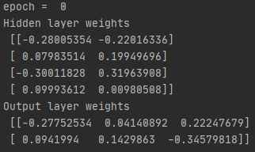

Q3 & Q4

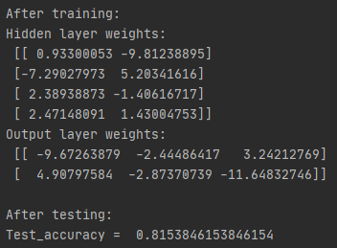

After 100 epochs training with accuracy at 82%, the test accuracy is about 81% and the final weights are showed above. In addition, I trained the algorithm 1000 epochs and the results was

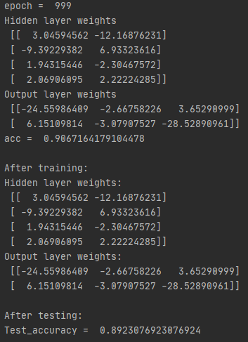

Training accuracy was 90% and test accuracy is 89%. That means more epochs can have better accuracy.

Then I added bias to the network, here is the result after trained 100 epochs with bias:

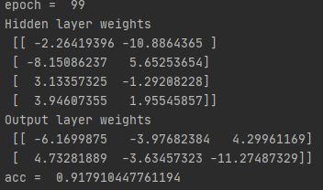

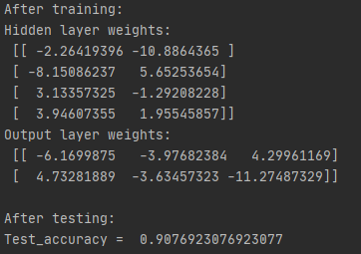

The training accuracy is 91% and the test accuracy is 90%. Also I did a 1000 epochs training.

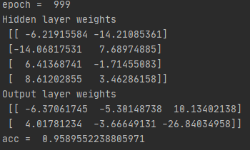

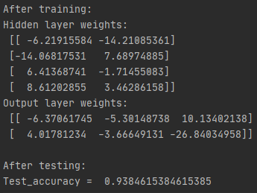

In this case the training accuracy is 95% and test is 93%. It may overfitted, because it performed well in training than test. Over all I am satisfied with the network performance. More epochs can leads to higher accuracy but can also cause overfitted.