Exercise:

This application contains an employee entry form and an employee viewer.

The employee entry form contains following entries:

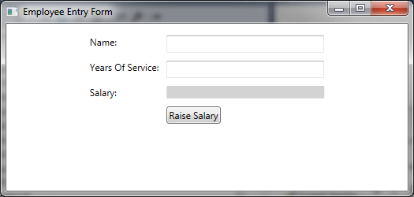

There is an Employee class defined.

Modify code to:

1. Display Employee’s Name, Years of Service and Salary.
2. Indicate that it is an error if user enter the Employee’s Years Of Service <= 0.
3. Give a visual indication if user enter the Employee’s Years Of Service >= 25. For example, change background color or something.
4. Raise Salary button will raise the Employee’s salary by 3%.

The Employee Viewer replicates the information in Employee Entry form.

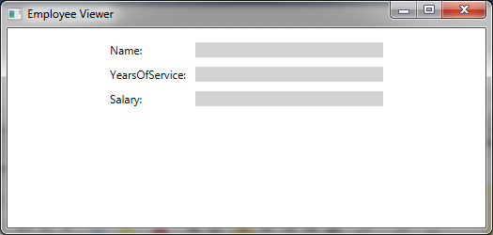

Modify the code such that the Employee Viewer is always in sync with Employee Entry Form.