no indenting: code is hard to read

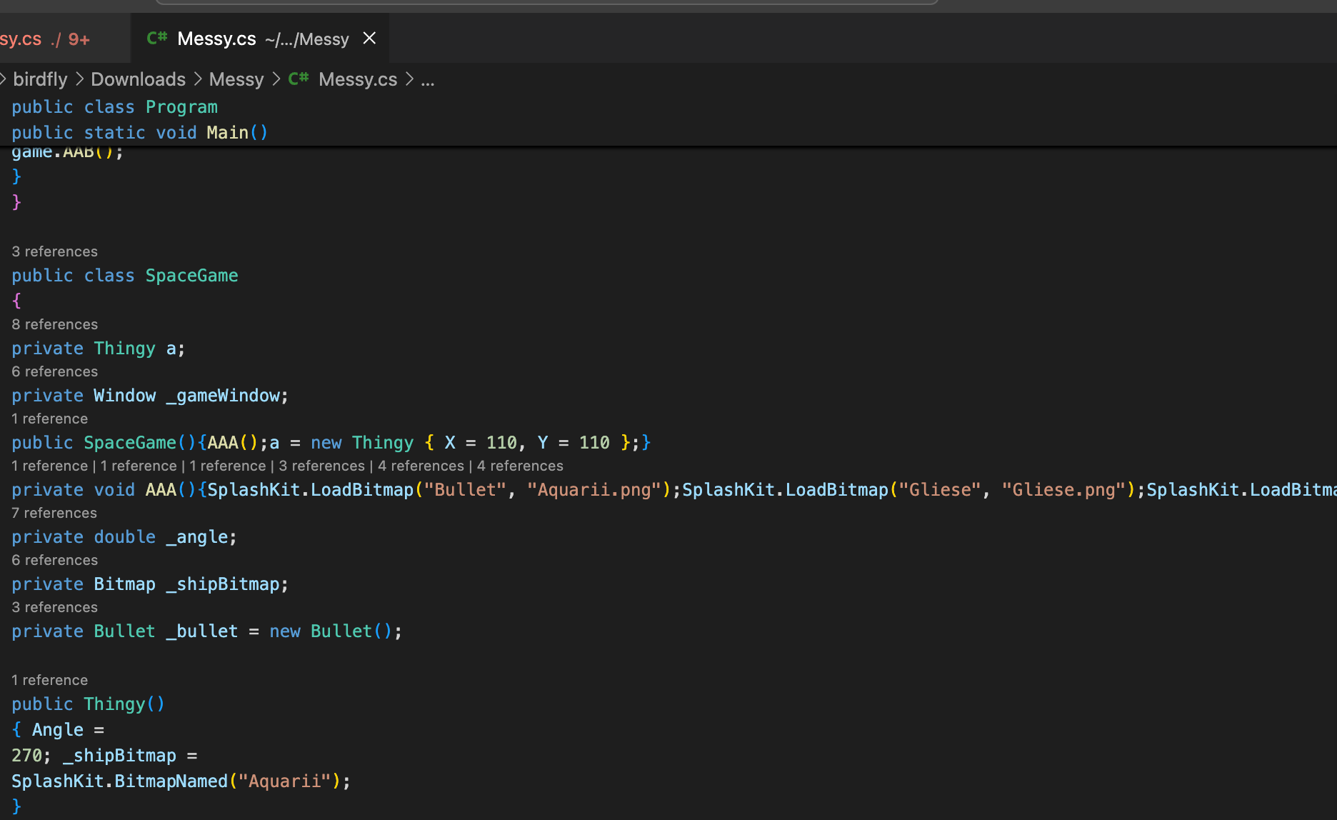

resource loading error

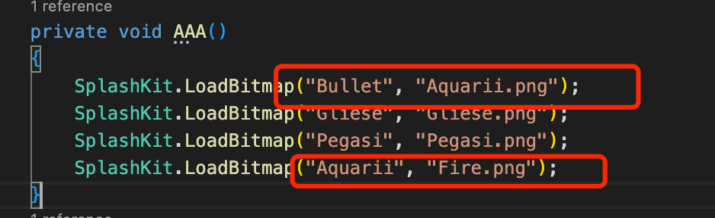

naming error

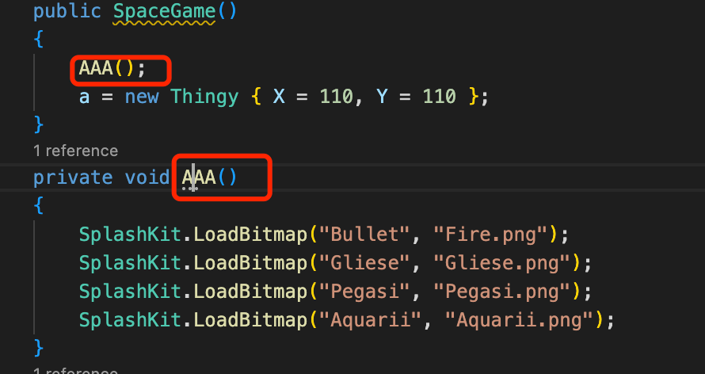

**Should the ultimate goal of a software project be code that works, or is there more to it than that?**

A good software project not only requires its code to run but also to be easy to maintain and extend. This means the code needs to be written in a way that is easy for humans to understand, and its design should follow a series of principles such as OCP, LSP, and others.

**What made the code hard to read?**

1. No formatting, no indenting;
2. Confusing naming convention;
3. Code redundancy;
4. Logic confusion;

**If this were a team project, how important to do think coding standards would be?**

It is very important to do think coding standards before start the project, Only when all members reach a consensus can the project proceed. In this way, there will not be multiple coding styles in the project, and members can reach a consensus on boundaries.

**What does this mean for software development in general?**

This means that projects will be built on the same development style, reducing maintenance and extension work

**Do a quick search on the idea of code refactoring, how does this relate to what you have been doing?**

When developers use different styles to build a project, the project will be difficult for newcomers to understand and adapt to. When the project needs to be refactored, it will be a difficult task and require more refactoring work.