# ER diagram

Actually, I confuse about the field in DEPENDENT, DEP_NUM? Is it DEP_CODE.

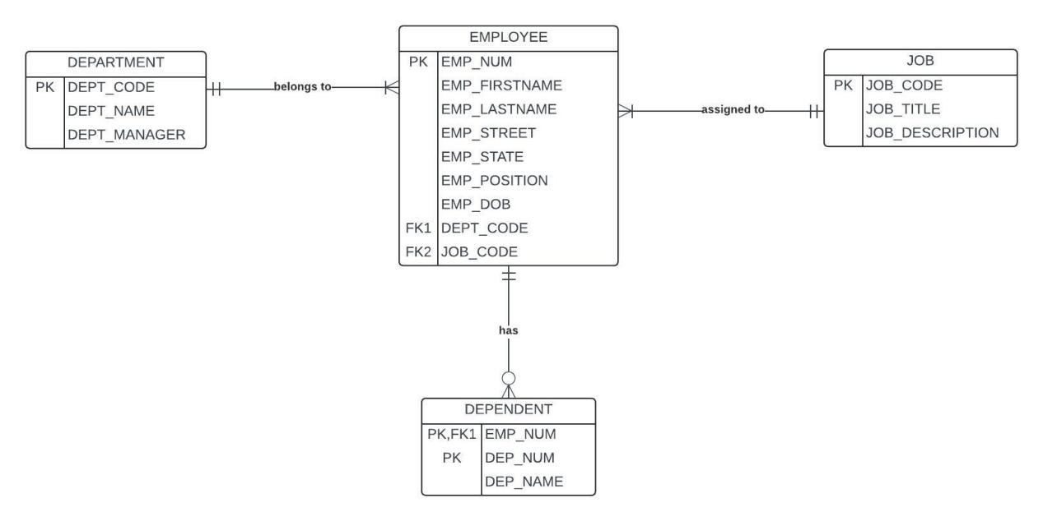

# ANSWER

## a.How many Entities are there and what are they?

3 entites;

DEPARTMENT; EMPLOYEE; JOB

## b. For the EMPLOYEE Entity:

## (i) List all attributes;

EMP_NUM

EMP_FIRSTNAME

EMP_LASTNAME

EMP_STREET

EMP_STATE

EMP_POSITION

EMP_DOB

DEPT_CODE

JOB_CODE

## (ii) What is the Primary Key and how do you know that? and

PK: EMP_NUM

It is a unique object in global

## (iii) Are there any Foreign Key(s)? If yes, what are they and what are they referring to?

YES;

FK1: DEPT_CODE , refer to DEPARTMENT entity’s primary key;

FK2: JOB_CODE, refer to JOB entity’s primary key;

## c. Explain the relationship between EMPLOYEE and DEPENDENT. Your explanation should include how is EMPLOYEE related to DEPENDENT and vice-versa in terms of whether the relationship is Optional/Mandatory and their cardinalities. Also, discuss how is the relationship maintained in the ERD [Hint: Primary and Foreign Keys].

In this ER diagram, the relationship between EMPLOYEE and DEPENDENT is one to many; EMPLOYEE entity use primary key EMP_NUM as DEPENDENT entity’s foreign key. However, DEPENDENT entity use EMP_NUM combine with DEP_NUM AS primary key, this represent that one employee can belongs to multiple department, but in one department does not allow two employees have the same EMP_NUM.

The relationship between these two is optional.

The relationship maintained in the ERD is linked by EMPLOYEE’s primary key(EMP_NUM).

## d. What is the Primary Key of DEPENDENT? What type of key is it?

Primary key: EMP_NUM, DEP_CODE

It is a composite primary key.

# Context Diagram

