

# Provide Justifications

## Patients and Prescriptions

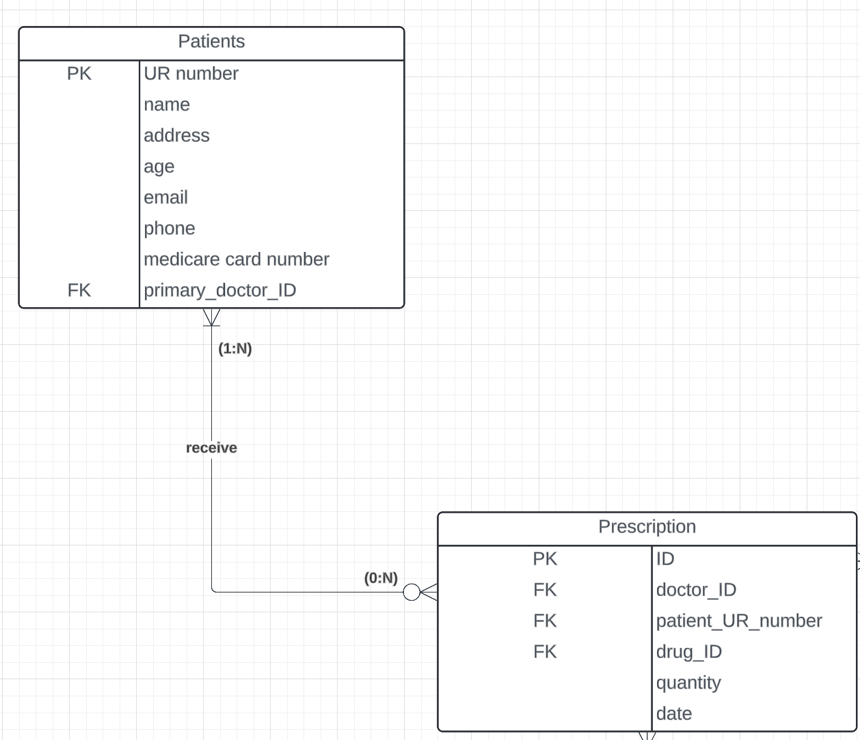

As it described “A doctor could prescribe one or more drugs for several patients, and a patient could obtain prescriptions from several doctors”, one prescription can be received by one or more patients, and one patient can receive zero to many prescription (I assume that no prescription is required for patients starting or completing treatment)

# Doctors and prescriptions

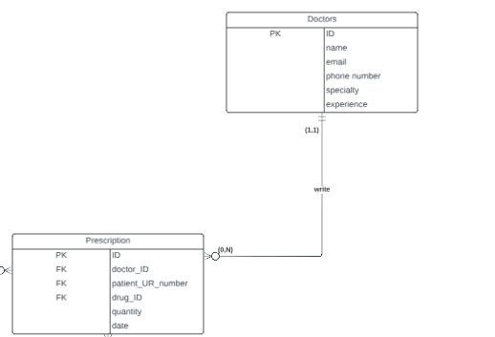

When a prescription is confirmed, a doctor must be assigned responsibility for it. The task specifies that "A doctor could prescribe one or more drugs for several patients," indicating a one-to-many relationship between doctors and prescriptions. However, it is assumed that some newly appointed doctors may not have prescribed any drugs yet, so I think their relationship is zero to many.

# Prescriptions and Drugs

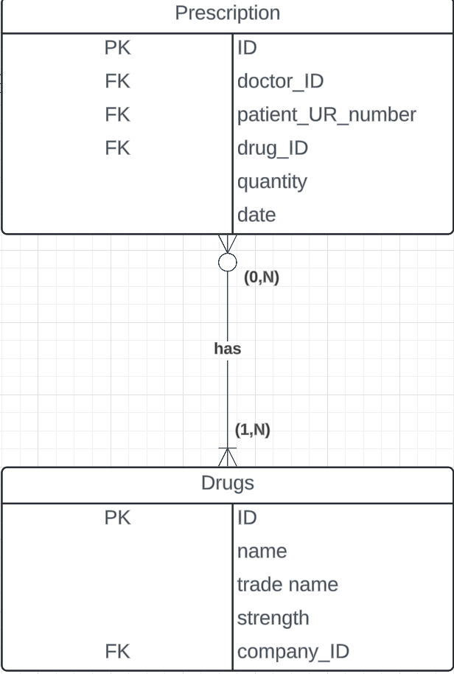

A prescription can contain multiple drugs but must include at least one drug. From the perspective of drugs, some drugs may be not prescribed by doctors.

# Drugs and Companies

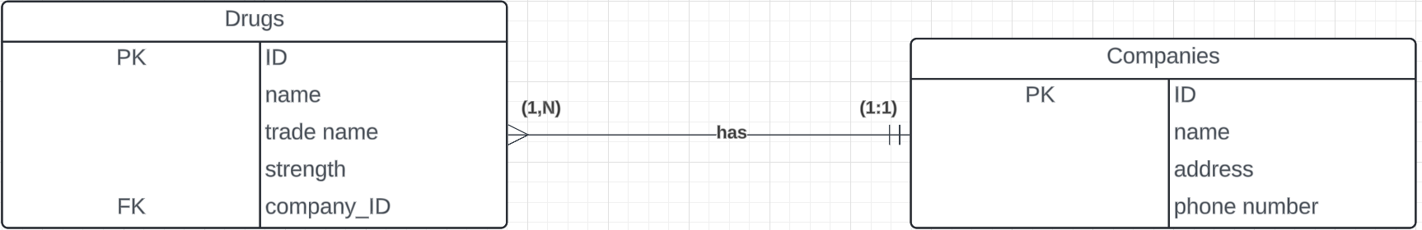

A company can produce many drugs, but a drug only belongs to one company.