**NoSQL Databases**

**FULL NAME: YUPENG WEN**

**STUDENT ID: s224212855**

**TEACHERS: Iynkaran Natgunanathan**

**DATE OF COMPLETION: 08/09/2024**

**WORD COUNT: 2475**

# Abstract

Relational databases have long been the dominant technology for managing structured data due to their reliability, consistency, and efficiency in transactional operations. Based on Edgar F. Codd's 1970 relational model, they organize data into tables with predefined schemas, ensuring data accuracy and consistency. This made them essential in industries like banking and finance. However, the rise of big data and cloud computing exposed their limitations, particularly with unstructured data and scalability. Chen et al. (2018) found processing times on blockchain networks slower than MySQL, and relational databases struggle with unstructured data. NoSQL databases emerged to address these challenges, offering flexible models and horizontal scalability. This essay will explore relational database limitations, introduce NoSQL, and discuss how NoSQL resolves these issues.

# Introduction

NoSQL databases are non-relational databases designed to handle large volumes of structured, semi-structured, or unstructured data. They offer flexibility in data storage and retrieval, making them well-suited for scenarios where traditional relational databases (like MySQL or PostgreSQL) might struggle. NoSQL databases are particularly useful for big data, real-time web applications, and distributed systems.  
There are four primary types of NoSQL databases, each suited to different types of data and use cases. Document stores, such as MongoDB and CouchDB, store data in the form of documents, typically in formats like JSON or BSON. This allows for flexible, nested data structures that are easy to modify and scale. Key-value stores, such as Redis and Amazon DynamoDB, use a simple key-value pair model, excelling in performance and scalability for applications that require fast read and write operations. Column-family stores, like Apache Cassandra and HBase, organize data into columns rather than rows, optimizing performance for large-scale distributed systems and real-time analytics. Lastly, graph databases, such as Neo4j, store data in a graph structure, making them ideal for applications that involve complex relationships between data points, such as social networks or recommendation engines.

# NoSQL databases’ types

## Document stores

Document stores, like MongoDB and CouchDB, are NoSQL databases that store data as individual documents in formats such as JSON or BSON, offering a flexible, schema-less structure. Unlike relational databases, they allow for complex, nested data and varying document structures, making them ideal for unstructured or evolving data. This flexibility suits applications like content management systems and user profiles. Document stores also provide easy scalability and high performance, especially for read and write heavy workloads. MongoDB, for example, efficiently handles large data volumes across distributed servers, ensuring scalability and availability.

## Key-Value Stores

Key-value stores, a type of NoSQL database, use a simple key-value pair model, associating each piece of data with a unique key for fast lookups and retrieval. This simplicity ensures high performance and scalability, making key-value stores ideal for applications requiring rapid read and write operations, such as caching, session management, and real-time analytics. Popular databases like Redis and Amazon DynamoDB handle large data volumes and transactions at high speed, distributing data across multiple nodes for scalability. Their horizontal scaling design allows easy expansion by adding servers, prioritizing fast data access with simple structures.

## Column-Family Stores

Column-family stores, a type of NoSQL database, organize data by columns instead of rows, optimizing performance for large-scale distributed systems and real-time analytics. This structure allows efficient querying, especially when retrieving specific columns (Counte & Cuza, 2018). Ideal for large datasets, such as log analysis and recommendation engines, column-family stores like Cassandra and HBase outperform relational databases for large-scale workloads (Sheth, 2023). These databases distribute data across multiple servers for high availability and fault tolerance, and their columnar format supports data compression, enhancing performance and storage efficiency.

## Graph Databases

Graph databases, a type of NoSQL database, store data as nodes (entities) and edges (relationships), making them ideal for managing complex, interconnected data. Unlike relational databases, which rely on tables and predefined relationships, graph databases use dynamic graph structures for efficient relationship-based queries (Pokorný, 2015). Nodes represent entities like people or products, while edges represent relationships between them, both holding properties for detailed information. This model excels in applications like social networks, recommendation engines, and fraud detection, where relationships are key. Popular graph databases like Neo4j and Amazon Neptune efficiently handle queries about mutual connections or product associations, making them vital for industries that rely on complex data networks. Additionally, their flexible data modelling allows for easy evolution without schema changes, providing powerful tools for systems that grow over time.

# Limitation of Relational Databases

Although relational databases are well known for their strong data consistency, integrity, complex querying capabilities, and transaction support, they still have several limitations. They struggle with unstructured data, offer poor scalability, and often exhibit lower performance.

## Struggle with unstructured data

The data model of relational databases is based on a structured table format, introduced by Edgar F. Codd. While this model excels at handling data with a clearly defined structure, it is not well-suited for managing unstructured data such as text, images, and videos. Moreover, as noted by Nishtha et al. (2012), relational databases use SQL, which is designed for structured data but can become highly complex when handling unstructured data. This rigidity poses a significant drawback when dealing with unstructured or semi-structured data, such as images, videos, or social media interactions.

## Poor scalability

Based on Wondwessen Haile Addal's research, relational databases traditionally scale vertically by adding resources like CPU and memory to a single machine, but this approach is limited and costly as data demands increase. Additionally, scalability often requires redundant data copies, leading to consistency and management challenges (Kolonko, 2018). Horizontal scaling, which involves adding more nodes, complicates transaction processing and data consistency across distributed systems. These limitations hinder traditional relational databases from adapting to modern, large-scale, and dynamic data environments.

## Poor Performance

Relational databases often struggle with performance when compared to NoSQL databases, particularly in handling large-scale, unstructured, or highly dynamic data. The rigid schema and high level of abstraction in relational databases can slow down query processing, especially for complex queries or operations requiring frequent schema changes. According to the study of Kotiranta et.al in 2022, the performance of MySQL 5.1.41 was too poor for complex queries. Additionally, relational databases face challenges when distributed across multiple nodes, often leading to operational inefficiencies and performance bottlenecks in cloud environments (Litchfield et.al 2017).

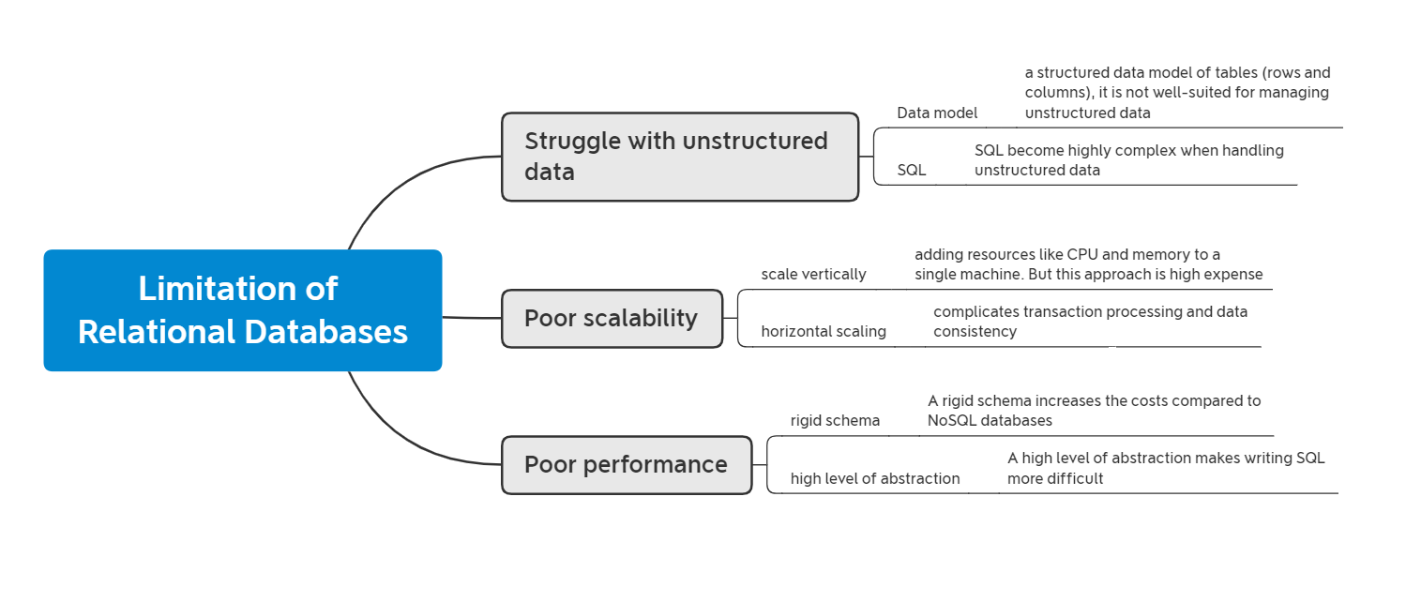

# NoSQL Databases overcome the challenges of Relational Databases

NoSQL databases effectively address the limitations of traditional relational databases, which struggle with unstructured data, scalability, and performance issues.

## Flexible Schema and Unstructured Data Support

Unlike relational databases that rely on rigid schemas, NoSQL databases handle unstructured and semi-structured data without predefined structures, making them ideal for managing diverse data types like images, videos, and social media content. According to Benymol Jose's 2017 study, MongoDB stores data as BSON and does not require a predefined schema, allowing for flexible and easily evolving data models.

|  |  |
| --- | --- |
| Databases | Store Data |
| Relational Databases | 1. Define the schema (build table structure)  2. Store data |
| NoSQL Databases | Store data |

* BSON, short for "Binary JSON," is a binary data format developed by MongoDB in 2009, designed to represent complex data structures like associative arrays, integer-indexed arrays, and scalar types.

## Horizontal Scaling

NoSQL databases support horizontal scaling, enabling data distribution across multiple nodes, which enhances scalability and reduces costs compared to the vertical scaling of relational systems. According to Rick Cattell's 2011 study, this capability allows NoSQL databases to effectively manage increasing data demands while maintaining cost-efficiency.

## Performance Improvement

By avoiding rigid schemas, NoSQL databases enhance query processing and performance, especially for large and dynamic datasets. According to Oussous et al. (2017), 'NoSQL databases for big data' benefit from flexible storage schemas, which facilitate faster query processing.

### Comparison of read and write Performance between MySQL and Redis

MySQL is a widely used relational database, while Redis is a popular NoSQL database known for its speed and efficiency. In this section, comparing the read and write performance of MySQL and Redis to highlight the differences in data storage and retrieval.

#### Write performance

To simulate real-world scenarios of handling large datasets, we used a Java-based application with Gradle, integrating Spring Boot, MySQL Connector, and Redis Starter. The goal was to insert ten million records into both databases and compare the time consumed for each operation.

##### MySQL

**Environment**

Windows + single MySQL server (8.4.0)

The MySQL table was defined as follows:

|  |
| --- |
| **CREATE** **TABLE** `students` (  `id` **bigint** **NOT** **NULL** **AUTO_INCREMENT**,  `first_name` **varchar**(30) **COLLATE** utf8mb4_general_ci **NOT** **NULL**,  `surname` **varchar**(30) **COLLATE** utf8mb4_general_ci **NOT** **NULL**,  **PRIMARY** **KEY** (`id`)  ) ENGINE=InnoDB **DEFAULT** CHARSET=utf8mb4 **COLLATE**=utf8mb4_general_ci; |

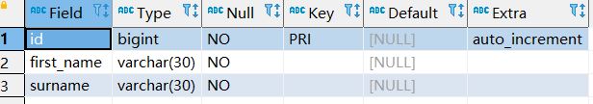

The following code simulates a batch insertion of ten million records into MySQL.

|  |
| --- |
| System.*out*.println("current time: " + new Date()); List<Student> students = new LinkedList<>(); String sql = "insert into students(first_name,surname) values(?,?)"; for (int i = 0; i < 10000000; i++) {  Student student = new Student(i);  students.add(student);  if (students.size() >= 10000) {  extracted(sql, students);  students.clear();  } }  if (!students.isEmpty()) {  extracted(sql, students);  students.clear(); } |

**Time consumed**

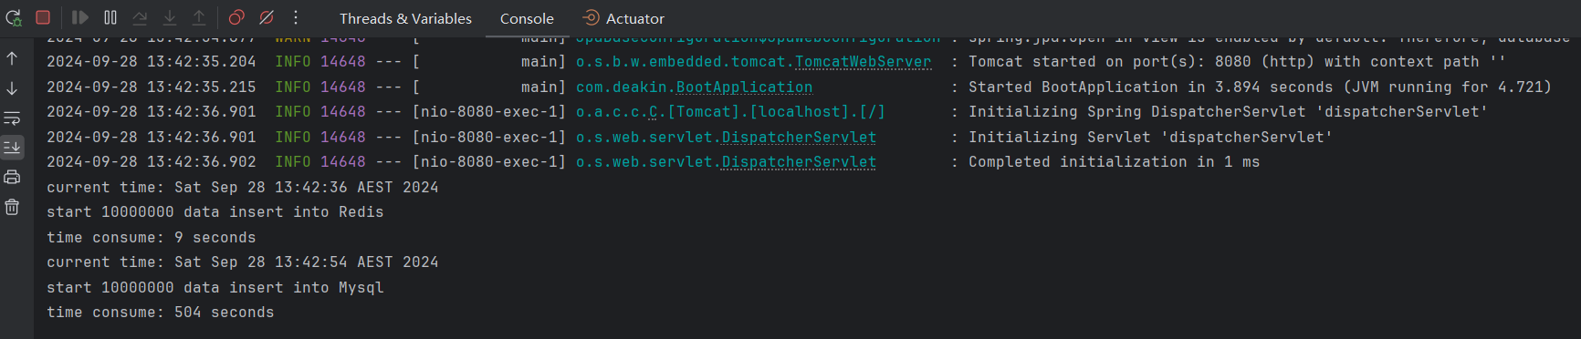

current time: Sat Sep 28 13:42:54 AEST 2024

start 10000000 data insert into Mysql

time consume: 504 seconds

##### Redis

**Environment**

Windows + single Redis Server (2.6.12)

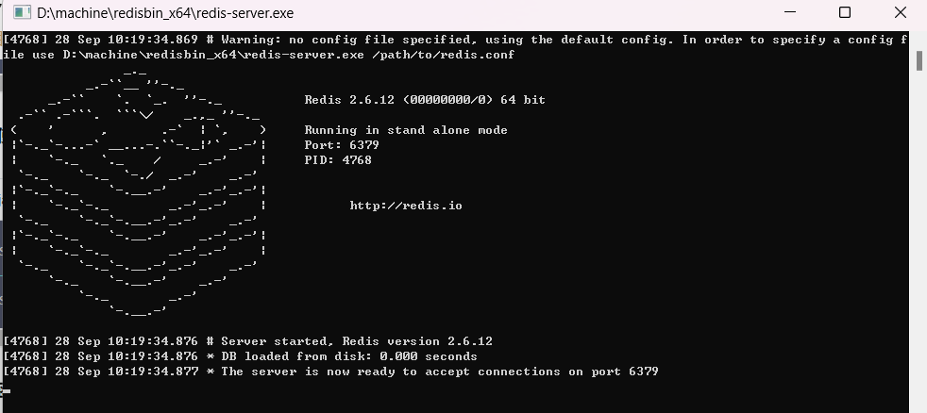

The following code simulates a batch insertion of ten million records into Redis

|  |
| --- |
| System.*out*.println("current time: " + new Date()); List<Student> students = new LinkedList<>(); for (int i = 0; i < 10000000; i++) {  Student student = new Student(i);  students.add(student);  if (students.size() >= 10000) {  redisTemplate.opsForList().leftPushAll("students", students);  students.clear();  } }  if (!students.isEmpty()) {  redisTemplate.opsForList().leftPushAll("students", students);  students.clear(); } |

**Time consumed**

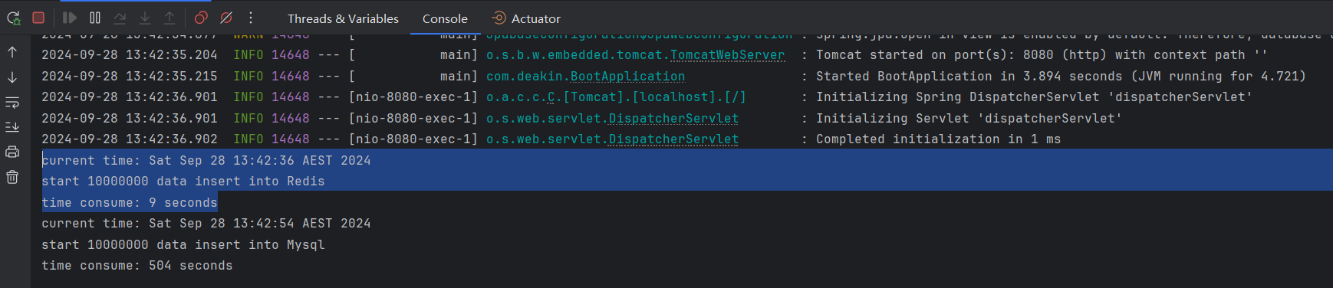

current time: Sat Sep 28 13:42:36 AEST 2024

start 10000000 data insert into Redis

time consume: 9 seconds

#### Read performance

##### MySQL

The following code simulates query a random object from MySQL

|  |
| --- |
| Student student = studentRepository.findByFirstName("test first name-"+index); System.*out*.println("data from MySQL, student = " + student); |

**Time Consumed**

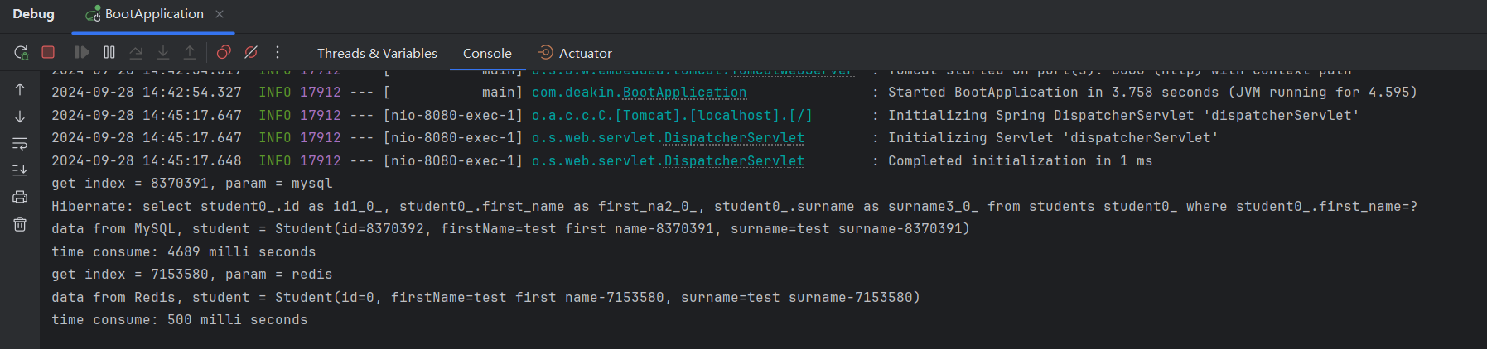

|  |
| --- |
| get index = 8370391, param = mysql  Hibernate: select student0_.id as id1_0_, student0_.first_name as first_na2_0_, student0_.surname as surname3_0_ from students student0_ where student0_.first_name=?  data from MySQL, student = Student(id=8370392, firstName=test first name-8370391, surname=test surname-8370391)  time consume: 4689 milli seconds |

##### Redis

The following code simulates query a random object from Redis

|  |
| --- |
| int page = index / 10000; int position = index % 10000; List<Student> students = (List<Student>) redisTemplate.opsForList().index("students", 1000 - (long) page - 1); System.*out*.println("data from Redis, student = " + students.get(position)); |

**Time Consumed**

|  |
| --- |
| get index = 7153580, param = redis  data from Redis, student = Student(id=0, firstName=test first name-7153580, surname=test surname-7153580)  time consume: 500 milli seconds |

# Disadvantages of NoSQL Databases

NoSQL databases have drawbacks, including limited support for full ACID transactions, as they often prioritize availability and partition tolerance over consistency. They also offer fewer standardized query capabilities compared to SQL, requiring custom solutions for complex queries. Data duplication is another issue, as NoSQL favours performance over strict normalization, leading to increased storage needs and potential consistency problems during updates. Additionally, NoSQL databases are relatively new, lacking the maturity, tooling, and community support of relational databases, which can be a challenge for complex analytical tasks. Understanding these limitations is key to selecting the appropriate database for specific use cases.

## No transaction support

Many non-relational databases implement BASE (Basically Available, Soft state, eventually consistent) properties, prioritizing performance over the traditional ACID guarantees. As a result, this often leads to a compromise on data consistency, allowing eventual consistency rather than immediate consistency across the database.

By not strictly adhering to ACID properties, non-relational databases offer a lower level of reliability compared to relational databases. To ensure ACID constraints, developers must implement custom programming solutions, which are inherently available in relational databases. (Nishtha et.al 2012).

In 2015, Ramesh Dharavath and Chiranjeev Kumar propose a scalable three-tier architecture and a distributed middleware protocol to support atomic transactions across heterogeneous NoSQL databases. The proposed framework is entirely distributed, making it highly scalable, available, flexible, and cost-effective. It addresses the lack of standard and interoperability issues in the current NoSQL database landscape, enabling complex applications to benefit from the use of NoSQL systems. The framework preserves atomicity and isolation of transactions in a heterogeneous distributed column-oriented database environment.

## Data Duplication

According to the study of Nicoleta C. Brad in 2012, NoSQL databases typically use a simple data model with flexible control over data layout, often resulting in highly de-normalized structures and excessive duplicate data. This duplication extends to backups, significantly increasing storage requirements. The flexibility of the key-value model, where values can be schema-less and complex, further contributes to the generation of duplicate data.

In this research, Nicoleta also proposes a data de-duplication approach for NoSQL databases, called DDNSDB, that operates at the database level rather than the file or sub-file level. DDNSDB leverages the structural information (metadata) of NoSQL data models to identify and remove duplicate data, leading to significant storage savings. The main goals are to maximize the reduction of duplicates in key-value NoSQL databases, improve the performance of the de-duplication process, and design the solution to be scalable in a cloud environment.

## Imperfect Technology Ecosystem

The technology ecosystem surrounding NoSQL databases is still evolving and lacks the maturity and robustness of traditional relational databases. Unlike SQL, which benefits from decades of standardization, well-established tools, and a large community of support, NoSQL databases often have fragmented ecosystems with fewer standardized frameworks. This can lead to challenges in finding comprehensive tools for database management, monitoring, and querying. Moreover, the relative novelty of many NoSQL systems means that they may not offer the same level of documentation, community resources, or integration capabilities as relational databases. This incomplete ecosystem can be a limiting factor for developers, particularly for complex applications requiring advanced analytics or enterprise-grade stability and support.

However, the future of the NoSQL technology ecosystem is promising, as the demand for scalable, flexible, and high-performance databases continues to grow. With increasing adoption in various industries, NoSQL databases are likely to see further advancements in tooling, standardization, and community support. As more companies and developers contribute to open-source NoSQL projects, improvements in database management, querying capabilities, and performance optimization will emerge. Additionally, the integration of NoSQL with cloud platforms and modern development frameworks is expected to enhance ease of use and scalability, making it more accessible for a wider range of applications. Over time, this evolving ecosystem will close the gap with relational databases, providing developers with a richer set of tools and resources for building and maintaining robust, large-scale systems.

# conclusion

In conclusion, while relational databases have long dominated the field of structured data management due to their reliability and well-defined schemas, they face increasing challenges in today’s data landscape. The emergence of NoSQL databases offers a flexible, scalable, and high-performance alternative for handling unstructured and semi-structured data, particularly in applications requiring real-time processing and distributed systems. With various types, including document stores, key-value stores, column-family stores, and graph databases, NoSQL provides tailored solutions for different data needs. However, despite their advantages in scalability and adaptability, NoSQL systems come with trade-offs, such as limited ACID transaction support and potential data redundancy. Therefore, the choice between relational and NoSQL databases should be based on specific application requirements, balancing the need for flexibility, performance, and consistency.

# Reference List

ADDAL, W.H., 2019. A COMPARATIVE ANALYSIS OF RELATIONAL AND NON-RELATIONAL DATABASES FOR WEB APPLICATION (Doctoral dissertation, NEAR EAST UNIVERSITY).

Azad, P., Navimipour, N.J., Rahmani, A.M. and Sharifi, A., 2020. The role of structured and unstructured data managing mechanisms in the Internet of things. Cluster computing, 23, pp.1185-1198.

Batra, S. and Tyagi, C., 2012. Comparative analysis of relational and graph databases. International Journal of Soft Computing and Engineering (IJSCE), 2(2), pp.509-512.

Cattell, R., 2011. Scalable SQL and NoSQL data stores. *Acm Sigmod Record*, *39*(4), pp.12-27.

Codd, E.F. (1970). A relational model of data for large shared data banks. Communications of the ACM, 13(6), pp.377–387. doi:https://doi.org/10.1145/362384.362685.

Conte, E. and Cuza, C.M., 2018. Column-based Databases and HBase.  
Sheth, V., 2023. Comparative Performance Analysis of Column Family Databases:

Cassandra and HBase (Doctoral dissertation, Dhirubhai Ambani Institute of Information and Communication Technology).

Chen, S., Zhang, J., Shi, R., Yan, J. and Ke, Q. (2018). A Comparative Testing on Performance of Blockchain and Relational Database: Foundation for Applying Smart Technology into Current Business Systems. Distributed, Ambient and Pervasive Interactions: Understanding Humans, pp.21–34. doi:https://doi.org/10.1007/978-3-319-91125-0_2.

Dharavath, R. and Kumar, C., 2015. A scalable generic transaction model scenario for distributed NoSQL databases. *Journal of Systems and Software*, *101*, pp.43-58.

Imam, A.A., Basri, S., Ahmad, R., Watada, J. and González-Aparicio, M.T. (2018). Automatic schema suggestion model for NoSQL document-stores databases. Journal of Big Data, 5(1). doi:https://doi.org/10.1186/s40537-018-0156-1.

Jatana, N., Puri, S., Ahuja, M., Kathuria, I. and Gosain, D., 2012. A survey and comparison of relational and non-relational database. International Journal of Engineering Research & Technology, 1(6), pp.1-5.

Jose, B. and Abraham, S., 2017, July. Exploring the merits of nosql: A study based on mongodb. In *2017 International Conference on Networks & Advances in Computational Technologies (NetACT)* (pp. 266-271). IEEE.

Kotiranta, P., Junkkari, M. and Nummenmaa, J., 2022. Performance of graph and relational databases in complex queries. *Applied sciences*, *12*(13), p.6490.

Kolonko, K., 2018. Performance comparison of the most popular relational and non-relational database management systems.

Lim, H., Fan, B., Andersen, D.G. and Kaminsky, M., 2011, October. SILT: A memory-efficient, high-performance key-value store. In Proceedings of the Twenty-Third ACM Symposium on Operating Systems Principles (pp. 1-13).

Litchfield, A., Althwab, A. and Sharma, C., 2017. Distributed relational database performance in cloud computing: An investigative study. AIS.

Mishra, S. and Misra, A., 2017, September. Structured and unstructured big data analytics. In 2017 International Conference on Current Trends in Computer, Electrical, Electronics and Communication (CTCEEC) (pp. 740-746). IEEE.

Brad, N., 2012. Data De-Duplication in NoSQL Databases (Doctoral dissertation, University of Saskatchewan).

Oussous, A., Benjelloun, F.Z., Lahcen, A.A. and Belfkih, S., 2017. NoSQL databases for big data. *International Journal of Big Data Intelligence*, *4*(3), pp.171-185.

Pokorný, J., 2015. Graph databases: their power and limitations. In *Computer Information Systems and Industrial Management: 14th IFIP TC 8 International Conference, CISIM 2015, Warsaw, Poland, September 24-26, 2015, Proceedings 14* (pp. 58-69). Springer International Publishing.

Seeger, M. (2009). Key-Value stores: a practical overview. [online] Available at: <https://blog.marc-seeger.de/assets/papers/Ultra_Large_Sites_SS09-Seeger_Key_Value_Stores.pdf>.

Wikipedia (n.d.) JSON, Wikipedia, accessed 08 September 2024. <https://en.wikipedia.org/wiki/JSON>.   
Wikipedia (n.d.) BSON, Wikipedia, accessed 08 September 2024. <https://en.wikipedia.org/wiki/BSON>.

# NoSQL Databases to Burwood Library

NoSQL databases can significantly improve the efficiency and service delivery of Burwood Library, especially in the face of evolving technology needs and user demands. Libraries like Burwood handle vast amounts of data that span across different formats, ranging from books and multimedia collections to user records, borrowing history, and event management. As modern libraries seek to offer personalized, scalable, and flexible services, NoSQL databases provide an ideal solution for accommodating the growing data variety and volume that traditional relational databases may struggle with.

**1. Scalability for Large Data Sets**

Burwood Library deals with a continuously expanding collection of digital and physical assets, as well as growing patron data. Traditional relational databases are typically vertically scaled, meaning they need increasingly powerful hardware to handle more data. However, NoSQL databases offer horizontal scalability, allowing the library to efficiently distribute data across multiple servers. This can improve performance when managing large datasets, such as digital book archives, multimedia content, and user-generated data, which can span terabytes or even petabytes. By using NoSQL, Burwood Library can scale its database system without costly hardware upgrades, ensuring smooth and fast access to resources as the collection grows.

**2. Flexible Data Management**

NoSQL databases excel at handling unstructured, semi-structured, and structured data, offering much-needed flexibility for modern libraries. Burwood Library likely manages diverse data types beyond traditional text, such as video files, e-books, scanned documents, and metadata. NoSQL databases such as MongoDB or Couchbase allow for the storage of various formats without requiring a rigid, predefined schema, which relational databases would demand. This flexibility is crucial for adapting to evolving data storage needs, as libraries continuously add new types of digital content and services, such as streaming platforms or interactive media.

**3. Personalized User Experience**

Burwood Library can greatly enhance its user experience by leveraging the capabilities of NoSQL databases. Modern users expect personalized recommendations and easy access to relevant resources. For example, a library could use a NoSQL database to power a recommendation system that suggests books, articles, or multimedia based on a user’s borrowing history, search behaviour, or interests. By using graph databases, like Neo4j, the library can build complex relationships between users, books, authors, and genres, allowing for personalized recommendations similar to what is seen on platforms like Netflix or Amazon. This would improve engagement by making it easier for patrons to discover new materials tailored to their preferences.

**4. Enhanced Real-Time Services**

Libraries increasingly offer real-time services such as live catalogue searches, instant book reservations, and real-time updates on event registrations. NoSQL databases, which are optimized for fast read and write operations, can enhance the responsiveness of such systems. Document-based NoSQL databases like MongoDB allow for rapid retrieval of catalogue information, enabling real-time search results for users, even during peak usage times. Additionally, NoSQL databases can handle large numbers of concurrent users efficiently, making them suitable for online library portals that serve multiple patrons simultaneously.

**5. Event Management and Community Engagement**

Libraries, including Burwood Library, often host events, workshops, and community programs. Managing event registrations, user participation, and feedback can generate a wealth of data that NoSQL databases can efficiently handle. NoSQL's ability to manage varied data types allows the library to track event attendees, capture feedback, and analyse trends over time, helping them to better understand community engagement and optimize future event planning. For example, a key-value store NoSQL system like Redis can help manage event ticketing and registration processes in real-time, while a document-based database can store detailed feedback and participant information for future analysis.

**6. Cost Efficiency and Resource Optimization**

By adopting NoSQL databases, Burwood Library can also benefit from cost efficiency. Many NoSQL solutions are designed to run on commodity hardware, avoiding the need for expensive servers that relational databases often require. This means the library can operate its digital infrastructure at a lower cost while still benefiting from high-performance data management. Moreover, with NoSQL databases' support for distributed systems, the library can ensure uptime and redundancy by distributing data across multiple locations, minimizing the risk of data loss or service interruptions due to server failures.

**7. Future-Proofing with Cloud Integration**

As cloud computing becomes increasingly important, NoSQL databases are particularly well-suited for integration with cloud services. Libraries, including Burwood Library, are embracing cloud platforms for digital services, and NoSQL databases offer the scalability and flexibility needed to thrive in such environments. Cloud-native NoSQL solutions, such as Amazon DynamoDB or Google Bigtable, allow libraries to expand their services seamlessly and access a global infrastructure, ensuring that digital resources are available to patrons from anywhere at any time. This opens up opportunities for Burwood Library to expand its reach and serve a broader, potentially international audience with digital content.

**Conclusion**

By implementing NoSQL databases, Burwood Library can significantly improve its scalability, flexibility, and ability to provide personalized services. NoSQL's capability to handle diverse data types and support real-time operations can enhance user engagement, improve operational efficiency, and reduce costs. Whether managing large multimedia collections, delivering personalized recommendations, or streamlining event management, NoSQL provides the tools necessary for Burwood Library to adapt to the demands of modern digital library services, ultimately ensuring a better experience for patrons and a more efficient system for staff.