# The data-driven business organization : Public Library(Burwood Library)

## Website Information

### Name

Burwood Library (Burwood Council and Library)

### Website

<https://www.burwood.nsw.gov.au/For-Residents/Burwood-Library>

### Main business

|  |  |  |
| --- | --- | --- |
| **Business** | **Type** | **URL** |
| Location, Contacts and Hours | static | https://www.burwood.nsw.gov.au/For-Residents/Burwood-Library/Location-and-Hours |
| Burwood Library Frequently Asked Questions (FAQ) | static | https://www.burwood.nsw.gov.au/For-Residents/Burwood-Library/Burwood-Library-FAQ |
| Catalogue & Resources | **dynamic** | https://www.burwood.nsw.gov.au/For-Residents/Burwood-Library/Catalogue-resources |
| Library Events | static | https://www.burwood.nsw.gov.au/For-Residents/Burwood-Library/Library-Events |
| Local Heritage | static | https://www.burwood.nsw.gov.au/For-Residents/Burwood-Library/Local-Heritage |
| Regular Library Programs | static | https://www.burwood.nsw.gov.au/For-Residents/Burwood-Library/Regular-Library-Programs |
| Kids’ Zone | static | https://www.burwood.nsw.gov.au/For-Residents/Burwood-Library/Kids-Zone |
| Young Adult Resources | static | https://www.burwood.nsw.gov.au/For-Residents/Burwood-Library/Young-Adult-Resources |
| Home Library Service | static | https://www.burwood.nsw.gov.au/For-Residents/Burwood-Library/Home-Library-Service |
| Computers and Printing | static | https://www.burwood.nsw.gov.au/For-Residents/Burwood-Library/Computers-and-Printing |
| Multicultural Resources | static | https://www.burwood.nsw.gov.au/For-Residents/Burwood-Library/Multicultural-Resources |
| Community Information | static | https://www.burwood.nsw.gov.au/For-Residents/Burwood-Library /Community-Information |
| Burwood Library Hub | static | https://www.burwood.nsw.gov.au/For-Residents/Burwood-Library /Hub |
| Library Policies | static | https://www.burwood.nsw.gov.au/For-Residents/Burwood-Library /Library-Policies |
| Information for better living | static | https://www.burwood.nsw.gov.au/For-Residents/Burwood-Library /Information-for-better-living |
| Newsletter | static | https://www.burwood.nsw.gov.au/For-Residents/Burwood-Library /Newsletter |

### Business process

As we can see from the sheet on the main business, all business data are static except for Catalogue & Resources. The static data will be embedded within the webpage, so we only need to analyse the Catalogue & Resources. This business is about finding out how to join the library, search the catalogue, and access the library resources.

The business process is described as follows:

1. User visit the Burwood library website and go to Catalogue & Resources;
2. User search books by keyword;
3. User find the book from books list;
4. User borrow the book;
   1. User have an account, and user has logged in, next step;
   2. User have an account, but user has not logged in, then user needs to login;
   3. User does not have an account, then user needs to register;
5. User has reserved books for several days;
   1. The system notifies users to return overdue books on time;
   2. User applies for delayed return of books;
6. Books return to library.

### Function

Register

Login

Search books

Borrowing books

Books track

### Activities

Kids’ Digital Resources: Burwood Library offers wonderful online resources for children. These include games, homework resources, stories, eBooks, and eAudio.

Burwood Babies: Burwood Babies is held weekly on Tuesdays at 10am during term time. Enjoy 30 minutes of stories, rhymes and songs, for babies aged 6-18 months.

### Scenarios

#### Scenario 1:

Sarah is a university student living in Burwood. She visits the Burwood Library to borrow some textbooks for her upcoming exams.

**Steps:**

1. **Arrival at the Library:** Sarah arrives at Burwood Library, heading straight to the textbook section.
2. **Book Search:** She uses the library catalogue on a computer to locate the specific textbooks she needs for her studies.
3. **Finding the Books:** Sarah navigates the aisles, finds the books, and checks their condition to ensure they’re in good shape.
4. **Borrowing Process:** She takes the books to the self-checkout station, scans her library card, and then scans each book.
5. **Due Date Notice:** The system displays the due date, and Sarah opts to receive a reminder via email.
6. **Leaving the Library:** With her borrowed books in hand, Sarah leaves the library, feeling prepared for her exams.

#### Scenario 2:

James is an avid reader and has placed a hold on a popular new release at Burwood Library. He receives a notification that the book is now available for pickup.

**Steps:**

1. **Notification:** James receives an email and SMS from Burwood Library informing him that the book he reserved is ready for pickup.
2. **Visiting the Library:** He visits the library on his way home from work.
3. **Collection Process:** At the library, James goes to the reserved books shelf near the entrance. He finds the book with his name on it.
4. **Borrowing Process:** James scans his library card and the book at the self-checkout station, completing the borrowing process.
5. **Enjoying the Book:** With the book in hand, James heads home, eager to start reading.

#### Scenario 3:

Lily, a high school student, needs to borrow several books on Australian history for a school project.

**Steps:**

1. **Consulting a Librarian:** Lily visits Burwood Library and asks a librarian for help finding books on Australian history.
2. **Assistance:** The librarian shows her how to use the online catalog and helps her locate several relevant books.
3. **Book Selection:** Lily chooses a few books that look promising for her project.
4. **Borrowing Process:** She takes the books to the checkout desk, where the librarian checks them out for her.
5. **Project Work:** Lily leaves the library and begins working on her project using the borrowed books.

### Use cases

#### Use case 1:

**Actor:** Library User (Sarah)

**Description:** A user borrows books from the library using the self-checkout system.

**Preconditions:**

* The user has a valid library membership.
* The books the user wants to borrow are available on the shelves.

**Main Flow:**

1. The user arrives at the library and locates the books she wants to borrow.
2. The user takes the books to the self-checkout station.
3. The user scans her library card.
4. The system verifies the user’s membership status.
5. The user scans the books she wants to borrow.
6. The system records the transaction, assigns a due date, and displays it to the user.
7. The user confirms the transaction.
8. The system sends a reminder notification to the user (optional).
9. The user leaves the library with the borrowed books.

**Postconditions:**

* The books are marked as borrowed in the library’s system under the user's account.
* The due date for the borrowed books is recorded in the system.

#### Use case 2:

**Actor:** Library User (James)

**Description:** A user picks up a book that was reserved and is now available at the library.

**Preconditions:**

* The user has a valid library membership.
* The user has previously placed a hold on a book.
* The reserved book is available for pickup.

**Main Flow:**

1. The user receives a notification from the library that the reserved book is ready for pickup.
2. The user visits the library.
3. The user goes to the reserved books shelf and locates the book with their name on it.
4. The user takes the book to the self-checkout station.
5. The user scans their library card.
6. The system verifies the user’s membership status.
7. The user scans the reserved book.
8. The system confirms the borrowing transaction and assigns a due date.
9. The user receives a confirmation of the transaction.
10. The user leaves the library with the reserved book.

**Postconditions:**

* The book is marked as borrowed in the library’s system under the user's account.
* The hold on the book is removed from the system.

#### Use case 3:

**Actor:** Library User (Lily)

**Description:** A student borrows books from the library to use for a school project.

**Preconditions:**

* The user has a valid library membership.
* The user knows the topic of the project and needs books on that subject.

**Main Flow:**

1. The user visits the library and consults a librarian for help finding relevant books.
2. The librarian assists the user by searching the online catalogue and locating the books in the library.
3. The user selects the books needed for the project.
4. The user takes the selected books to the checkout desk.
5. The librarian scans the user’s library card and the selected books.
6. The system records the transaction, assigns due dates, and confirms the borrowing.
7. The user receives a confirmation of the borrowed books.
8. The user leaves the library with the books needed for the project.

**Postconditions:**

* The books are marked as borrowed in the library’s system under the user's account.
* The due date for the borrowed books is recorded in the system.

## ERD

### Entities

USERS [USER_ID(PK), FIRST_NAME, SURNAME, PASSWORD, PHONE, EMAIL, BIRTHDAY, GENDER, LANGUAGE, ADDR, SUBURB, STATE, POSTCODE, COUNTRY, RESIDENTIAL_AREA]

BOOKS[BOOK_ID(PK), BOOK_NAME, MAIN_TITLE, AUTHOR, WORK, IMPRINT, COLLATION, AUDIENCE, ISBN, DEWEY_CLASS, LANGUAGE, SUBJECT, BRN, BOOKMARK_LINK, CREATOR (FK), UPDATER(FK)]

STAFF[STAFF_ID(PK), NAME, PHONE, BIRTHDAY, EMAIL, LANGUAGE, ADDR, SUBURB, STATE, POSTCODE, COUNTRY, RESIDENTIAL_AREA]

BOOK_INSTANCE [INSTANCE_ID (PK), BOOK_ID, IS_PHYSICAL_BOOK, LOCATION, LINK]

BORROW_RECORDS [BORROW_ID (PK), INSTANCE_ID (FK), USER_ID(FK), START_DATE, DUE_DATE, IS_FINISH]

### Normalization

1NF: No repeat column and have artificial unique key (USER_ID)

2NF: No partial dependency

3NF: No transitive dependency

|  |  |  |
| --- | --- | --- |
| USERS | 3NF | Primary key: USER_ID  No repeat column  No partial dependency  No transitive dependency |
| BOOKS | 3NF | Primary key: BOOK_ID  No repeat column  No partial dependency  No transitive dependency |
| STAFF | 3NF | Primary key: STAFF_ID  No repeat column  No partial dependency  No transitive dependency |
| BOOK_INSTANCE | 3NF | Primary key: INSTANCE_ID  No repeat column  No partial dependency  No transitive dependency |
| BORROW_RECORDS | 3NF | Primary key: BORROW_ID  No repeat column  No partial dependency  No transitive dependency |

### Diagram

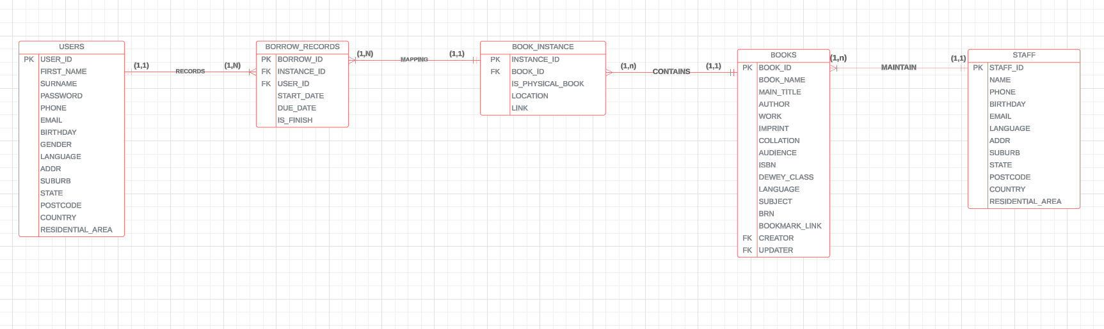

Staff & Books

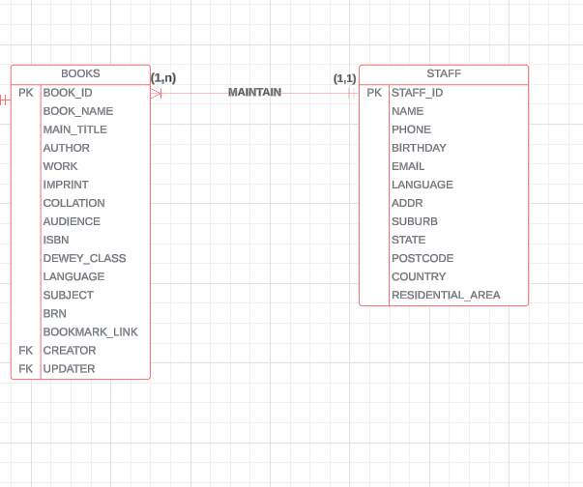

Books & Book instances

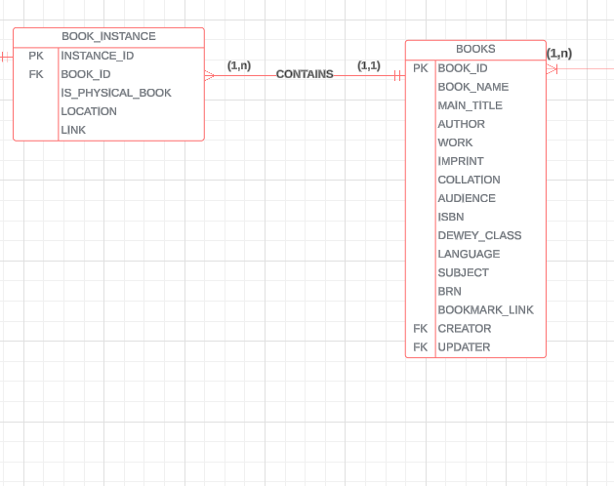

Book instances & Borrow records

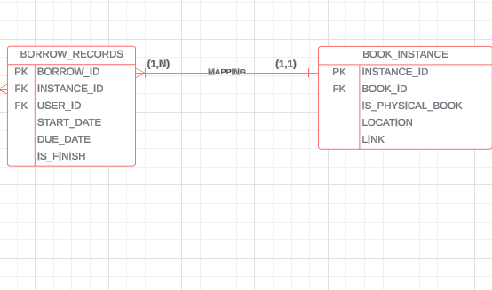

Users & Borrow records

