# Task to do

## Write a SQL query to retrieve names (displayed as “Employee Name”) and salary of employees. [Relevant table: Works]

select employeeName as 'Employee Name', salary from SIT772.works;

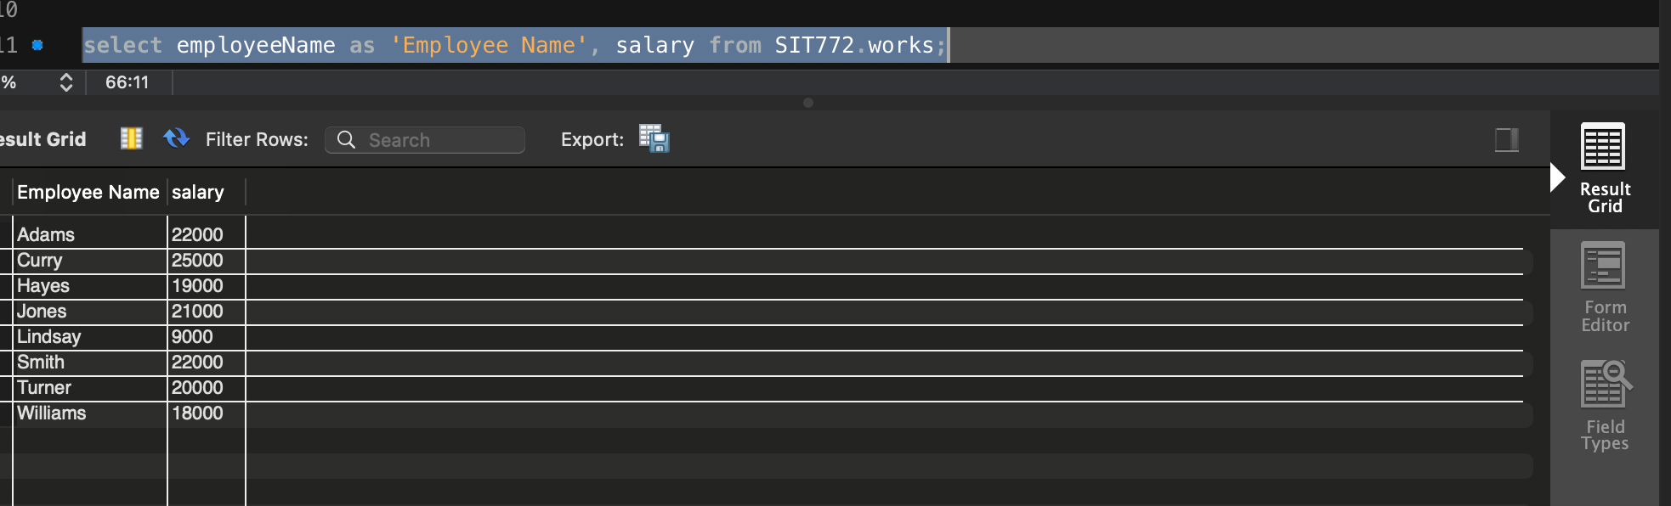

## Write a SQL query to list name, street, and city of employees in descending order by their names. [Relevant table: Employee]

select * from SIT772.employee order by employeeName desc;

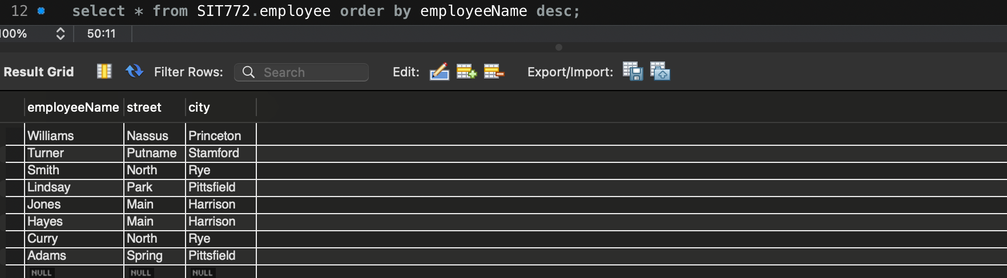

## Write a SQL query to get a list of unique streets from the Employee table. [Relevant table: Employee]

Write a SQL query to list all records in the works table in descending order of company names and within a company in ascending order by employee name. [Relevant table: Works]

Write a SQL query to list name and salary of all employees who work in Meyer and sort the records in ascending order by their incomes. [Relevant table: Works]

Assuming that the salary in the Works table is annual salary, write a SQL query to retrieve names (displayed as “Employee Name”) and monthly salary as “Monthly Salary” of employees. [Relevant table: Works]

Write a SQL query to list names and salaries of all employees who work in Meyer and earn more than 20000. [Relevant table: Works]

Write a SQL query to list names and companies of the employees who earn in the range of 20000 to 25000 (inclusive). [Relevant table: Works]

Write a SQL query to list names of employees whose managers have “ll” (double ls) in their names. [Relevant table: Manages]

Write a SQL query to list company names and the average salary of their employees. [Relevant table: Works]

Write a SQL query to list the name of the companies with average salary of employees more than or equal to 20000. [Relevant table: Works]

Write a SQL query to select details of the employees who works in companies located in Rye. [Relevant tables: Works and Company; Hint: use a subquery]

Write a SQL query find the number of rows in the Manages table. [Relevant tables: Manages; Hint: use COUNT()]

Write a SQL query to find the name and company of the employee earning the highest salary. [Relevant tables: Works; Hint: use a subquery using max() to find the highest salary. Please do not use ‘WHERE salary=25000’ as it is the highest salary in this case. Hope you can understand that it is not possible to know the highest value easily if there are millions of records. We want you to learn how to find it with a query.]