# TASK

## 1. Write a SQL statement to list invoices with their INV_NUMBER, INV_DATE along with the CUS_FNAME and CUS_LNAME of the customers they belong to.

**select**

**i.INV_NUMBER, i.INV_DATE ,c.CUS_FNAME ,c.CUS_LNAME**

**from**

**sit103.invoice i**

**natural join sit103.customer c ;**

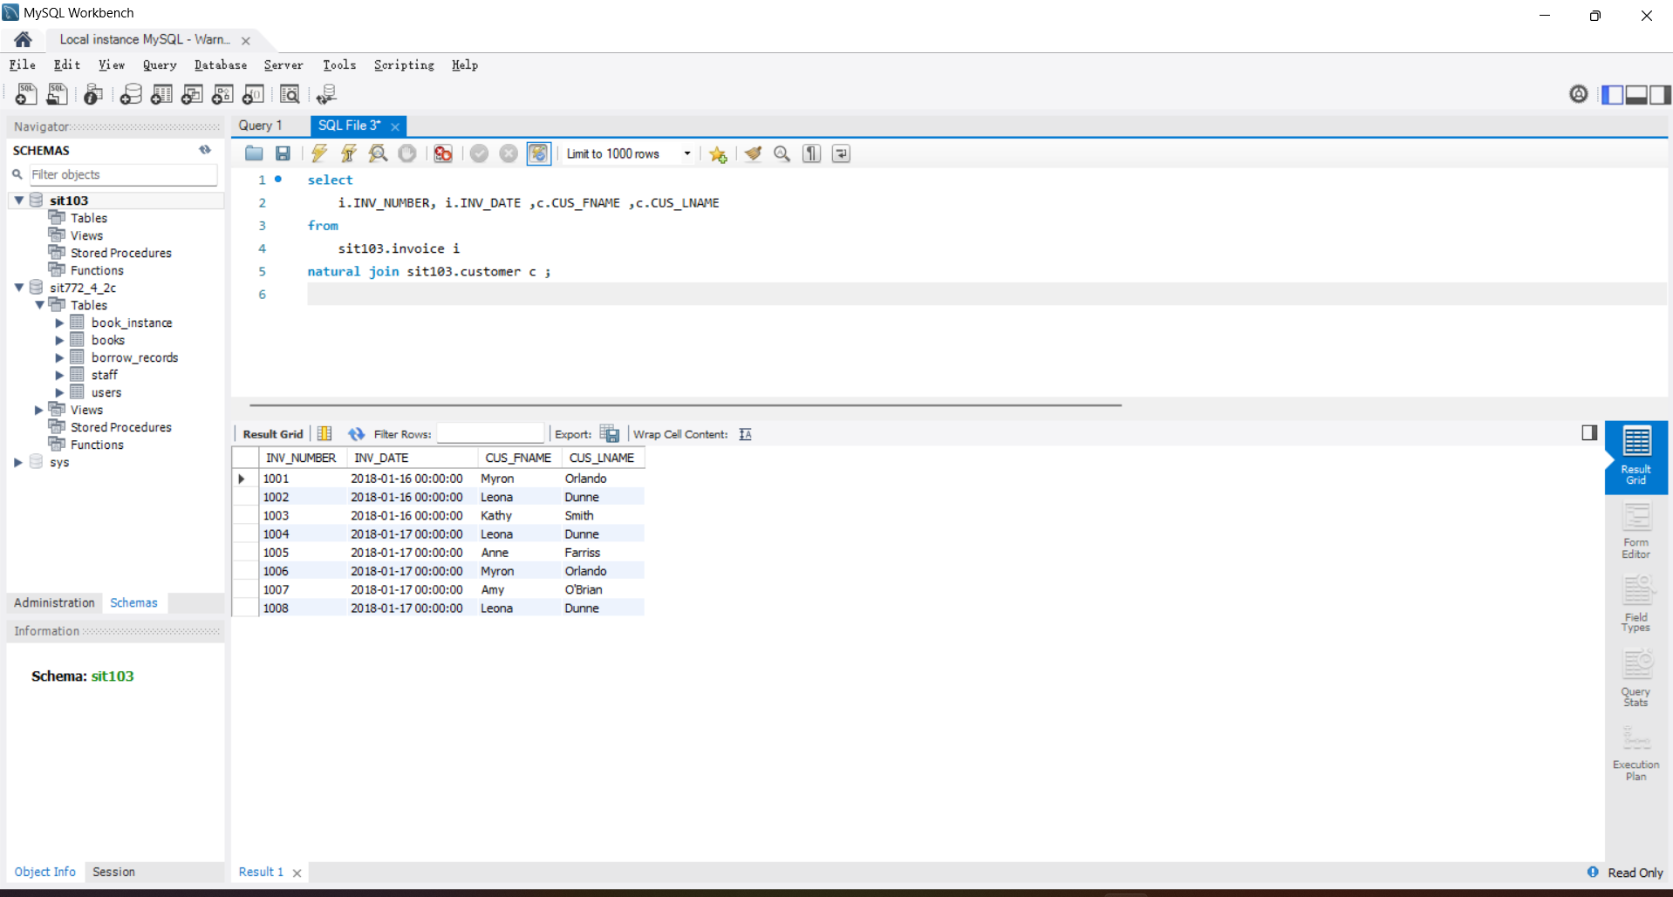

## 2. Write a SQL statement to list V_CODE and V_NAME along with the number of products they supply (column name as ‘NUM_PRODS’) and the average price of product they supply (column name as ‘AVG_PROD_PRICE’).

select v.V_CODE ,V_NAME, NUM_PRODS, AVG_PROD_PRICE from sit103.vendor v

join (

select V_CODE,count(1) NUM_PRODS,cast(avg(p.P_PRICE) as decimal(18,6)) AVG_PROD_PRICE from sit103.product p group by p.V_CODE) tmp using (V_CODE);

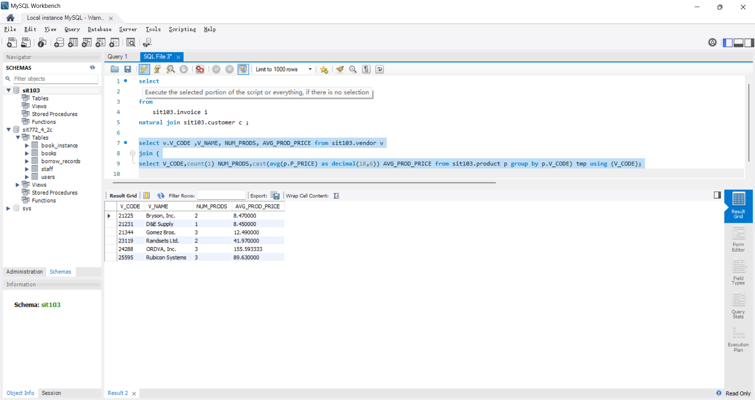

## 3. Write a SQL statement to list P_CODE and P_DESCRIPT of all products along with their vendors’ V_CODE and V_NAME if available. Note that your results must include all products regardless of whether vendor information is available or not. For products where vendor information is not available, V_CODE and V_NAME columns will be empty or NULL in the result (Hint: use outer join).

select p.P_CODE ,p.P_DESCRIPT ,v.V_CODE ,v.V_NAME from sit103.product p

left join sit103.vendor v on p.V_CODE =v.V_CODE;

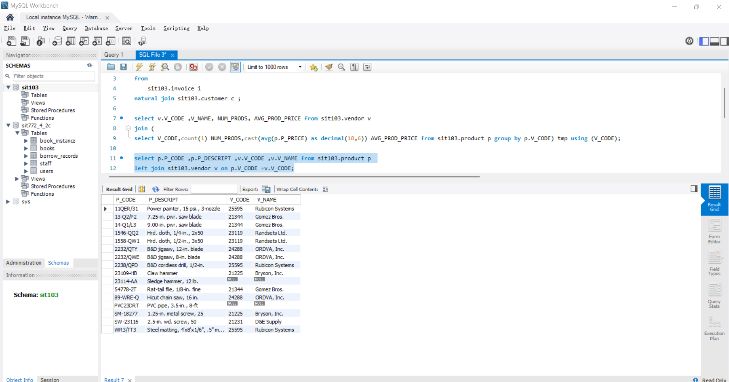

## 4. Write a SQL statement to retrieve INV_DATE and the list of products with P_CODE and P_DESCRIPT of the invoice with INV_NUMBER = 1008 (Hint: you may have to join three tables).

select i.INV_DATE ,p.P_CODE ,p.P_DESCRIPT from sit103.invoice i ,sit103.line l ,sit103.product p

where i.INV_NUMBER ='1008' and i.INV_NUMBER =l.INV_NUMBER and l.P_CODE =p.P_CODE ;

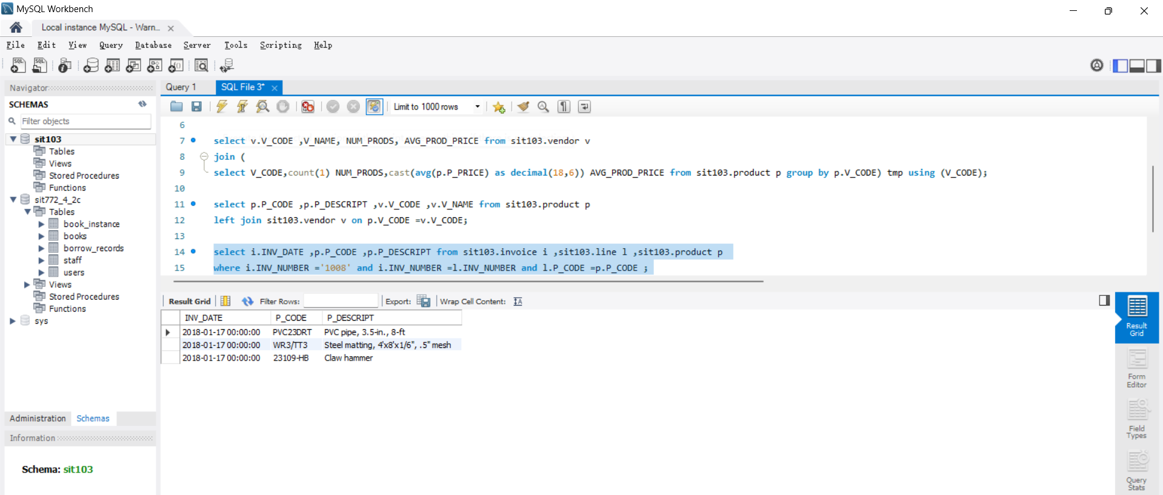

## 5. EMP table has records as follows:

select concat(e.EMP_FNAME,' ',e.EMP_LNAME) as Employee, concat(m.EMP_FNAME,' ',m.EMP_LNAME) as Manager from sit103.emp e ,sit103.emp m

where e.EMP_MGR =m.EMP_NUM ;

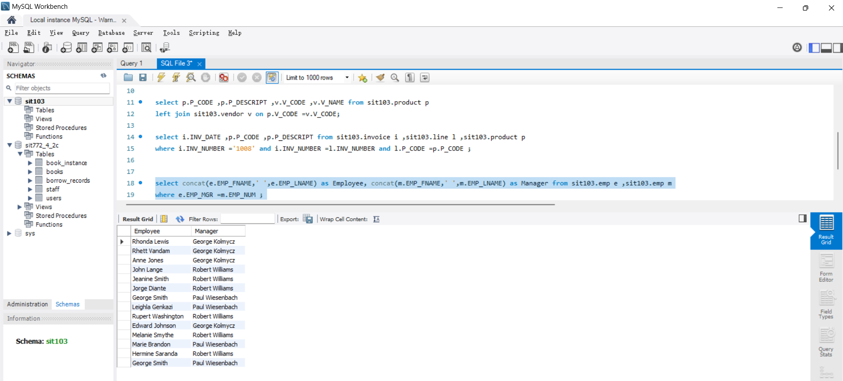

## 6. Write a SQL statement to list P_CODE and P_DESCRIPT of products that came in store (INDATE) in the month of February of 2018

select P_CODE , P_DESCRIPT from sit103.product p where year(P_INDATE) = '2018' and month(P_INDATE)=2;

