# Task

## 1. Write an SQL statement create the EMPLOYEE table with the following attributes and constraints

(i) your SQL statement to create the EMPLOYEE table, and

|  |
| --- |
| DROP TABLE  IF  EXISTS EMPLOYEE;  CREATE TABLE EMPLOYEE (  EMP_NUM DECIMAL ( 20, 0 ) PRIMARY KEY,  EMP_TITLE VARCHAR ( 5 ),  EMP_LNAME VARCHAR ( 25 ) NOT NULL,  EMP_FNAME VARCHAR ( 25 ) NOT NULL,  EMP_INITIAL CHAR ( 1 ) NOT NULL,  EMP_DOB date,  EMP_HIRE_DATE date,  EMP_AREACODE CHAR ( 3 ) DEFAULT '001',  EMP_PHONE CHAR ( 8 ),  EMP_MGR DECIMAL ( 20, 0 ) NULL DEFAULT NULL  ); |

(ii) a screenshot of the result of the following SQL statement

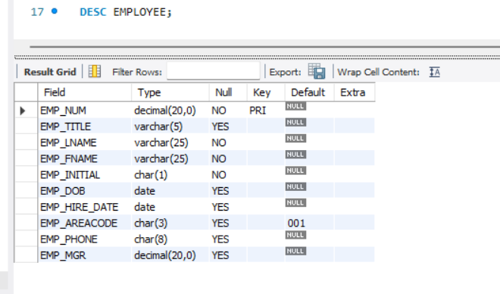

## 2. Write an SQL statement to change the column name ‘EMP_MGR’ to ‘EMP_MGR_NUM’. [Hint: ALTER TABLE to rename column, discussed in the class].

(i) your SQL statement to alter the EMPLOYEE table, and

ALTER TABLE EMPLOYEE RENAME COLUMN EMP_MGR TO EMP_MGR_NUM;

(ii) a screenshot of the result of the following SQL statement:

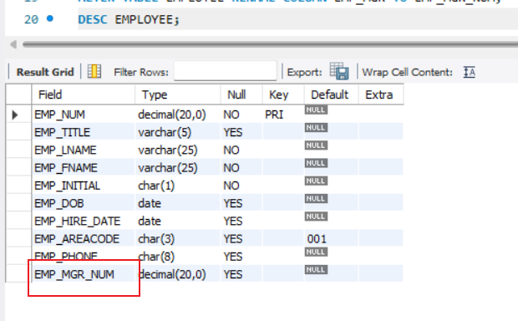

## 3. Write an SQL statement to ADD FOREIGN KEY CONSTRAINT to EMP_MGR_NUM to reference to EMP_NUM (self-reference). This column indicates who is the manager (EMP_NUM of the manager) of an employee. [Hint: ALTER TABLE to add constraint, discussed in the class]

(i) your SQL statement to add the FOREIGN CONSTRAINT, and

ALTER TABLE EMPLOYEE ADD FOREIGN KEY(EMP_MGR_NUM) REFERENCES EMPLOYEE(EMP_NUM);

(ii) a screenshot of the result of the following SQL statement:

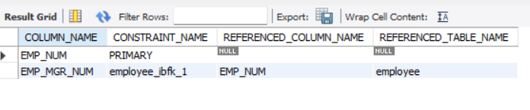

## 4. Write SQL statements to insert the following records in the EMPLOYEE TABLE.

(i) your SQL statements to insert the above records in the EMPLOYEE table, and

INSERT INTO EMPLOYEE VALUES(100,'Mr.' ,'Kolmycz' ,'George' ,'D' ,'1942-06-15','1985-03-15','615','324-5456',NULL);

INSERT INTO EMPLOYEE VALUES(101,'Ms.' ,'Lewis' ,'Rhonda' ,'G' ,'1965-03-19','1986-04-25','615','324-4472',100);

INSERT INTO EMPLOYEE VALUES(102,'Mr.' ,'Vandam' ,'Rhett' ,'N','1958-11-14','1990-12-20','901','675-8993',100);

INSERT INTO EMPLOYEE VALUES(103,'Ms.' ,'Jones' ,'Anne' ,'M' ,'1974-10-16','1994-08-28','615','898-3456',100);

INSERT INTO EMPLOYEE VALUES(104,'Mr.' ,'Lange' ,'John' ,'P' ,'1971-11-08','1994-10-20','901','504-4430',105);

INSERT INTO EMPLOYEE VALUES(105,'Mr.' ,'Williams' ,'Robert' ,'D' ,'1975-03-14','1998-11-08','615','890-3220',NULL);

INSERT INTO EMPLOYEE VALUES(106,'Mrs.','Smith' ,'Jeanine','K' ,'1968-02-12','1989-01-05','615','324-7883',105);

INSERT INTO EMPLOYEE VALUES(107,'Mr.' ,'Diante' ,'Jorge' ,'D' ,'1974-08-21','1994-07-02','615','890-4567',105);

INSERT INTO EMPLOYEE VALUES(108,'Mr.' ,'Wiesenbach','Paul' ,'R' ,'1966-02-14','1992-11-18','615','897-4358',NULL);

INSERT INTO EMPLOYEE VALUES(109,'Mr.' ,'Smith' ,'George' ,'K' ,'1961-06-18','1989-04-14','901','504-3339',108);

INSERT INTO EMPLOYEE VALUES(110,'Mrs.','Genkazi' ,'Leighla','W' ,'1970-05-19','1990-12-01','901','569-0093',108);

INSERT INTO EMPLOYEE VALUES(111,'Mr.' ,'Washington','Rupert' ,'E' ,'1966-01-03','1993-06-21','615','890-4925',105);

INSERT INTO EMPLOYEE VALUES(112,'Mr.' ,'Johnson' ,'Edward' ,'E' ,'1961-05-14','1983-12-01','615','898-4387',100);

INSERT INTO EMPLOYEE VALUES(113,'Ms.' ,'Smythe' ,'Melanie','P' ,'1970-09-15','1999-05-11','615','324-9006',105);

INSERT INTO EMPLOYEE VALUES(114,'Ms.' ,'Brandon' ,'Marie' ,'G' ,'1956-11-02','1979-11-15','901','882-0845',108);

INSERT INTO EMPLOYEE VALUES(115,'Mrs.','Saranda' ,'Hermine','R' ,'1972-07-25','1993-04-23','615','324-5505',105);

INSERT INTO EMPLOYEE VALUES(116,'Mr.' ,'Smith' ,'George' ,'A' ,'1965-11-08','1988-12-10','615','890-2984',108);

(ii) a screenshot of the result of the following SQL statement:

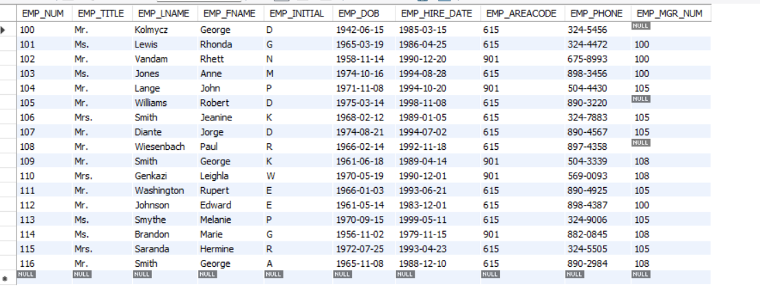

## 5. Write an SQL statement to set the manager of Paul Wiesenbach (EMP_NUM = 108) as George Kolmycz (EMP_NUM = 100).

(i) your SQL statement to update the manager num, and

UPDATE EMPLOYEE SET EMP_MGR_NUM = 100 WHERE EMP_NUM =108;

(ii) a screenshot of the result of the following SQL statement:



## 6. Write an SQL statement to delete records of all employees managed by Paul Wiesenbach (EMP_NUM = 108).

(i) your SQL statement to delete records, and

(ii) a screenshot of the result of the following SQL statement:

