1. write a procedure named PRC_ADD_CUSTOMER to add a new customer to CUSTOMER table.

|  |
| --- |
| CREATE OR REPLACE PROCEDURE *PRC_ADD_CUSTOMER*(CUST_NUM IN NUMBER,CUST_LNAME IN VARCHAR,CUST_FNAME IN VARCHAR,  CUST_BALANCE IN NUMBER) AS BEGIN  INSERT INTO CUSTOMER VALUES (CUST_NUM, CUST_LNAME, CUST_FNAME, CUST_BALANCE); END; |

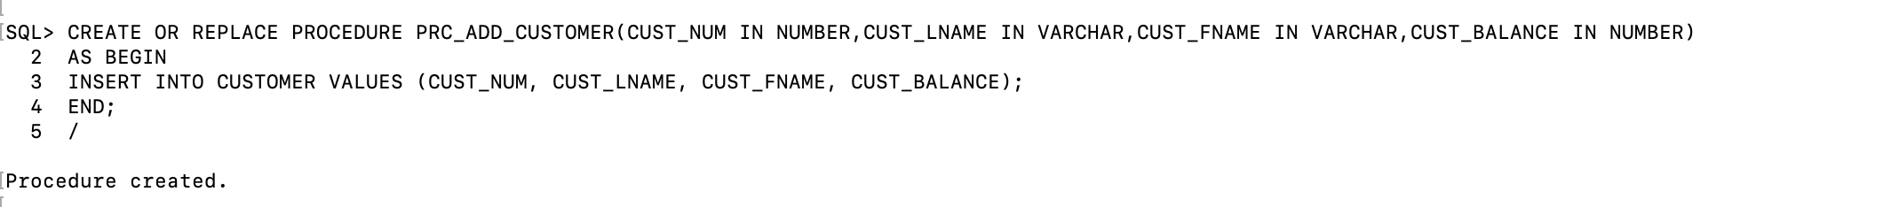

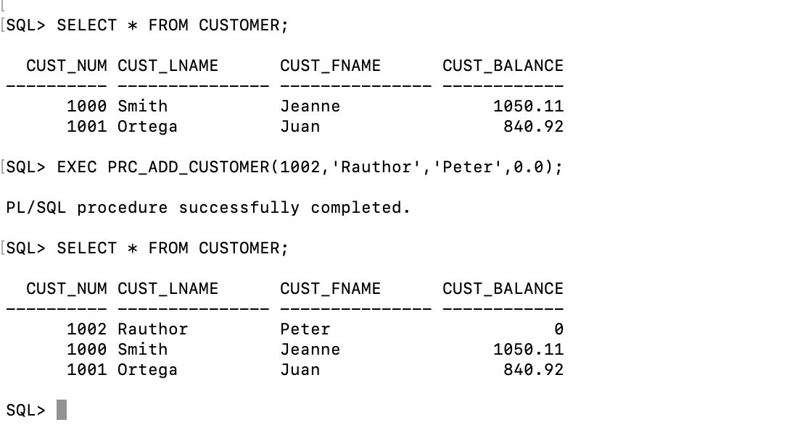

1. write a function name get_invoice_count to retrieve the number of invoices for a given customer.

|  |
| --- |
| CREATE OR REPLACE FUNCTION *get_invoice_count*(NUM IN NUMBER) RETURN NUMBER IS  invoicesCount NUMBER := 0; BEGIN  SELECT *COUNT*(1) INTO invoicesCount FROM INVOICE WHERE INVOICE.CUST_NUM =NUM; RETURN invoicesCount; END; |

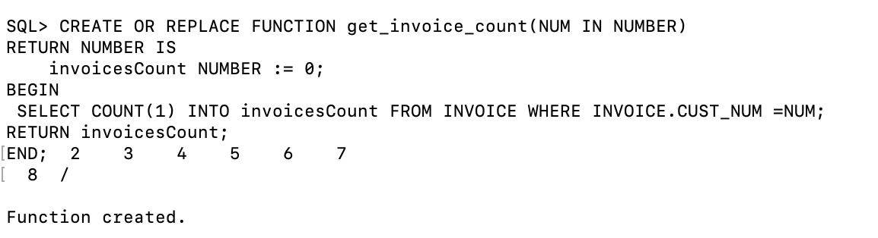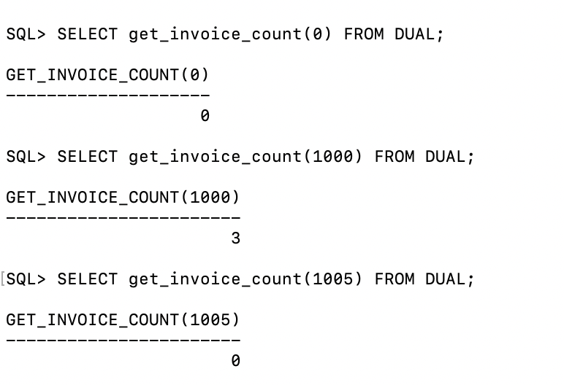

1. write a trigger name TRG_UPDATE_CUST_BALANCE to update the CUST_BALANCE in the CUSTOMER table when a new invoice is added in the INVOICE table;

|  |
| --- |
| CREATE OR REPLACE TRIGGER TRG_UPDATE_CUST_BALANCE  AFTER INSERT OR UPDATE OR DELETE ON INVOICE  FOR EACH ROW DECLARE  TOTAL_BALANCE NUMBER := 0; BEGIN  IF INSERTING THEN  SELECT *NVL*(CUST_BALANCE, 0) INTO TOTAL_BALANCE FROM CUSTOMER WHERE CUSTOMER.CUST_NUM = :NEW.CUST_NUM;  TOTAL_BALANCE := TOTAL_BALANCE + :NEW.INV_AMOUNT;  UPDATE CUSTOMER SET CUST_BALANCE = TOTAL_BALANCE WHERE CUSTOMER.CUST_NUM = :NEW.CUST_NUM;  ELSIF UPDATING THEN  SELECT CUST_BALANCE INTO TOTAL_BALANCE FROM CUSTOMER WHERE CUSTOMER.CUST_NUM = :OLD.CUST_NUM;  TOTAL_BALANCE := TOTAL_BALANCE - :OLD.INV_AMOUNT + :NEW.INV_AMOUNT;  UPDATE CUSTOMER SET CUST_BALANCE = TOTAL_BALANCE WHERE CUSTOMER.CUST_NUM = :OLD.CUST_NUM;  ELSIF DELETING THEN  SELECT CUST_BALANCE INTO TOTAL_BALANCE FROM CUSTOMER WHERE  CUSTOMER.CUST_NUM = :OLD.CUST_NUM;  TOTAL_BALANCE := TOTAL_BALANCE - :OLD.INV_AMOUNT;  UPDATE CUSTOMER SET CUST_BALANCE = TOTAL_BALANCE WHERE CUSTOMER.CUST_NUM = :OLD.CUST_NUM;  END IF; END; |

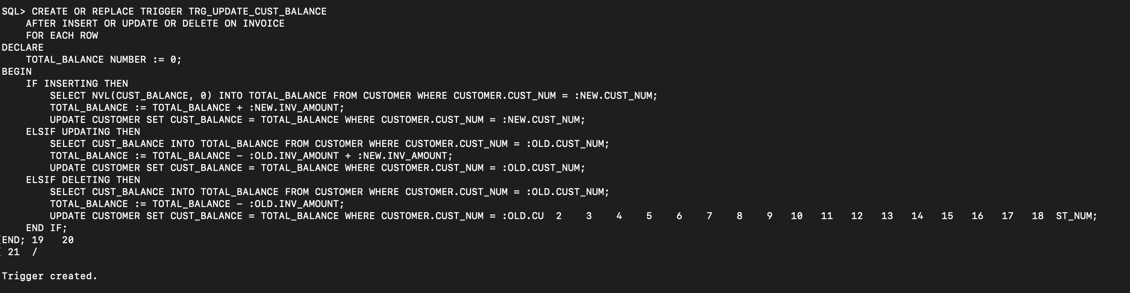

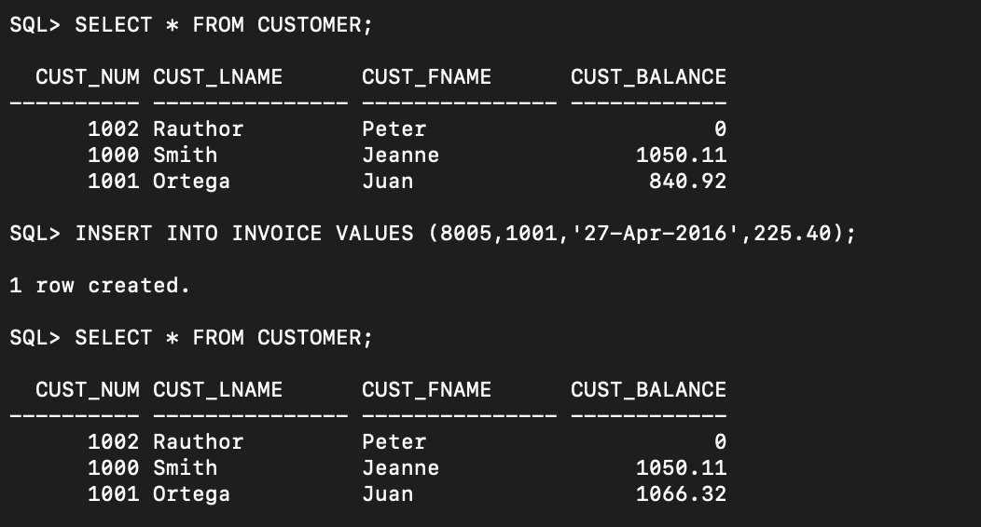

1. write aprocedure named PRC_ADD_INVOICE to add a new invoice record to the INVOICE table.

|  |
| --- |
| CREATE OR REPLACE PROCEDURE *PRC_ADD_INVOICE*(INV_NUM IN NUMBER,CUST_NUM IN NUMBER,INV_DATE IN DATE,INV_AMOUNT IN   NUMBER)  AS  BEGIN  INSERT INTO INVOICE VALUES (INV_NUM, CUST_NUM, INV_DATE, INV_AMOUNT); END; |

