# What web server package and technologies/tools (e.g., database system, scripting language, etc.) you used to design your form

In this task, I use EJS, HTML, and Bootstrap to build the page, Node.js and Express to build the server, Sequelize as the ORM framework, and MySQL as the database.

|  |  |
| --- | --- |
| Page | Html+ejs+bootstrap |
| Server | Nodejs+express |
| Orm | Sequelize |
| Database | Mysql |

# Show the state of the database table before you attempt to insert a record

Total is 8 records.

|  |
| --- |
| 1 John Doe Password123 0412345678 john.doe@example.com 1985-07-15 1 1 123 Main St Melbourne VIC 3000 Australia Urban READING  2 Jane Smith SecurePass456 0412345679 jane.smith@example.com 1990-02-28 2 2 456 Oak St Sydney NSW 2000 Australia Urban READING  3 Alice Johnson MyPassword789 0412345680 alice.johnson@example.com 1978-11-12 2 1 789 Pine St Brisbane QLD 4000 Australia Suburban READING  4 Bob Brown BobPass123 0412345681 bob.brown@example.com 1982-05-24 1 3 321 Birch St Adelaide SA 5000 Australia Urban READING  5 Charlie Davis PassWord456 0412345682 charlie.davis@example.com 1995-08-30 1 2 654 Maple St Perth WA 6000 Australia Suburban BASKETBALL  6 Luck Hobbs 123 0424068344 charlie.davis@example.com 2024-09-21 0 1 654 Maple St Perth WA 3136 Australia Suburban READING  7 Jack Hobbs 123 0424068344 charlie.davis@example.com 2024-09-21 0 1 654 Maple St Perth WA 3136 Australia Suburban READING  8 Tom Hobbs 123 0424068344 charlie.davis@example.com 2024-09-21 0 1 654 Maple St Perth WA 3136 Australia Suburban READING |

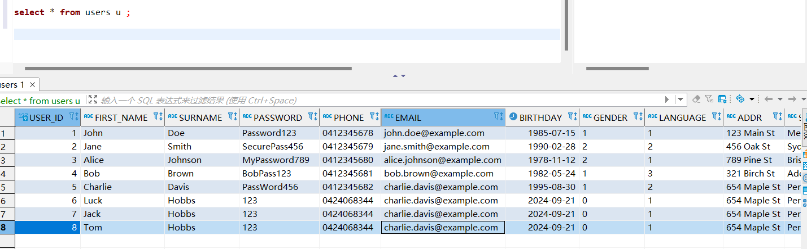

# An attempt to insert a record with incompatible or missing data [unsuccessful insertion attempt]

I will insert this record

|  |
| --- |
| 5 Charlie Davis PassWord456 0412345682 charlie.davis@example.com 1995-08-30 1 2 654 Maple St Perth WA 6000 Australia Suburban BASKETBALL |

If miss data, the page will alert this message, then user cannot submit the form.

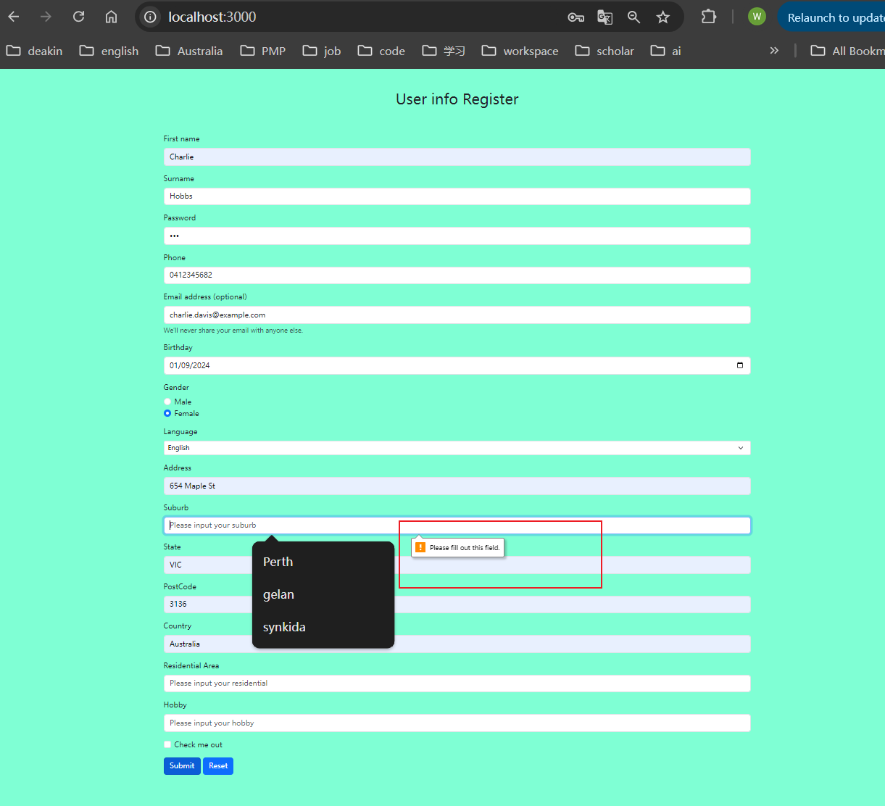

# Show what message is displayed to the user and what happens to the database table

If the user info have existed in database, the page will receive the message ‘user existed’

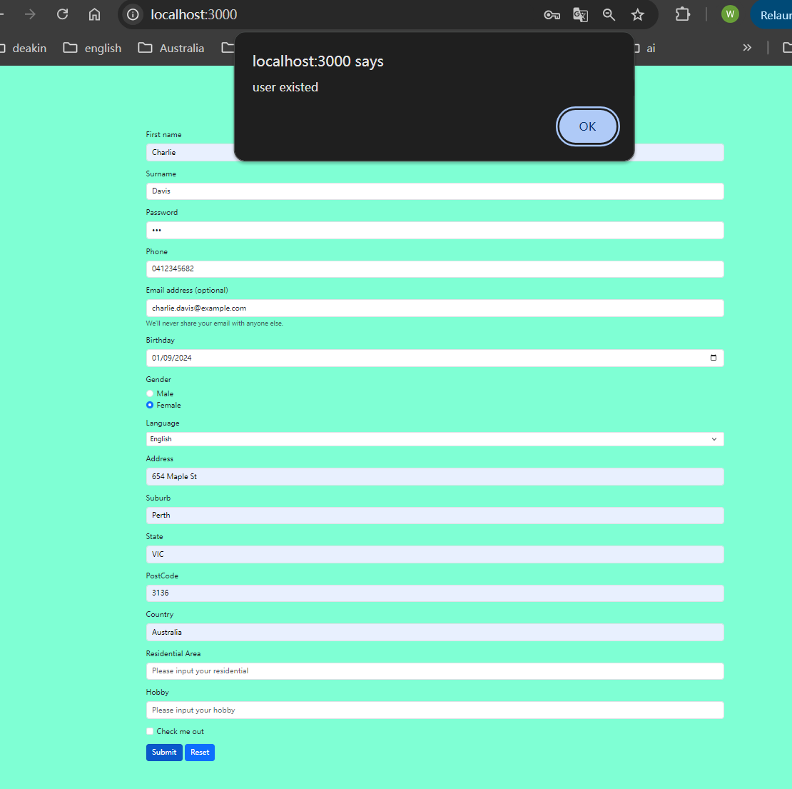

# An attempt to insert a record with all required data in right forms/formats [successful insertion attempt]

I will insert this record

|  |
| --- |
| Charlie Hobbs 123 0412345682 charlie.davis@example.com 2024-09-01 0 1 654 Maple St Perth VIC 3136 Australia READING |

# Show what message is displayed to the user and what happens to the database table

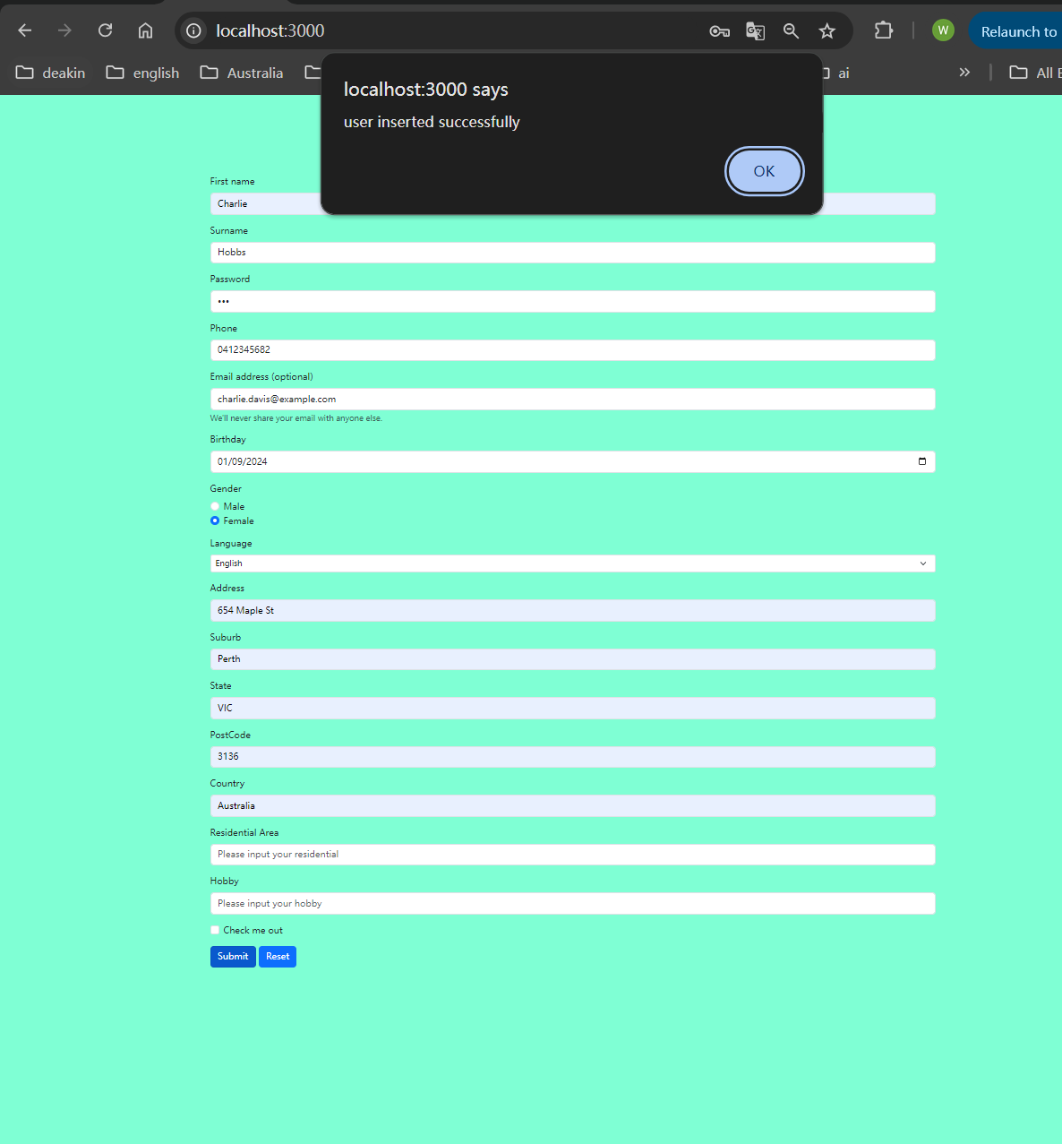

# Video link

https://deakin.au.panopto.com/Panopto/Pages/Viewer.aspx?id=6bab3ec0-e954-4b9d-a899-b1f20002f6d5