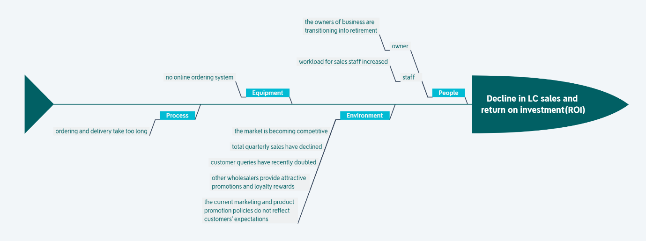

# Report

## Background

Leckie’s Choice(LC), a famous diversified service provider, with over 20 years of operating history, provides residential and industrial electrical equipment, supplies, and services, including energy management, solar systems, home automation, surveillance systems, and data and communication equipment. Known for its knowledgeable staff and strong customer relationships, LC primarily handles customer orders via phone and email, as their website lacks online ordering capabilities.

## Current Issues

As the competitive landscape evolves, LC faces significant challenges. With the owners transitioning into retirement, their children, John and Ruby, now oversee the business. They found out that a decrease in quarterly sales, the severely decline in sales and return on investment threatens the business's financial stability. And they also identified several pressing concerns:

|  |  |  |
| --- | --- | --- |
| **Field** | **Sub-Field** | **Concerns** |
| **People** | owner | the owners of business are transitioning into retirement |
|  | staff | workload for sales staff increased |
| **Environment** |  | The market is becoming competitive |
|  |  | total quarterly sales have declined |
|  |  | customer queries have recently doubled |
|  |  | other wholesalers provide attractive promotions and loyalty rewards |
|  |  | the current marketing and product promotion policies do not reflect customers' expectations |
| **Equipment** |  | no online ordering system |
| **Process** |  | ordering and delivery take too long |

## Observations and Concerns

John and Ruby are aware that leveraging technology is essential for LC to stay competitive but are uncertain about how to proceed. The newly appointed marketing manager is working to develop better promotion policies and loyalty programs based on customer feedback, but the outcomes are still uncertain.