SIT773

Software Requirements and Analysis

YUPENG WEN

s224212855

Learning Summary Report

# Self-Assessment Details

The following checklists provide an overview of my self-assessment for this unit.

|  |  |  |  |  |
| --- | --- | --- | --- | --- |
|  | Pass (D) | Credit (C) | Distinction (B) | High Distinction (A) |
| Self-Assessment |  |  |  | √ |

Self-Assessment Statement

|  |  |
| --- | --- |
|  | Included |
| Learning Summary Report | √ |
| Pass tasks complete | √ |

Minimum Pass Checklist

|  |  |
| --- | --- |
|  | Included |
| All Credit Tasks are Complete on Doubtfire | √ |

Minimum Credit Checklist (in addition to Pass Checklist)

|  |  |
| --- | --- |
|  | Included |
| Distinction tasks (other than Custom Program) are Complete | √ |
| Custom program meets Distinction criteria | √ |

Minimum Distinction Checklist (in addition to Credit Checklist)

|  |  |
| --- | --- |
|  | Included |
| Something Awesome included | √ |
| Custom project meets HD requirements | √ |

Minimum High Distinction Checklist (in addition to Distinction Checklist)

# Declaration

I declare that this portfolio is my individual work. I have not copied from any other student’s work or from any other source except where due acknowledgment is made explicitly in the text, nor has any part of this submission been written for me by another person.

Signature: **YUPENG WEN**

# Portfolio Overview

This portfolio includes work that demonstrates that I have achieve all Unit Learning Outcomes for SIT773 Unit Title to a **High Distinction** level.

I am writing to provide a justification for why I should be awarded a High Distinction for the software requirement and analysis unit. Throughout this unit, I have consistently demonstrated my ability to extend beyond the material presented, applying theoretical concepts to complex, real-world scenarios. My work reflects an advanced understanding of the subject, and I have gone beyond simply meeting the requirements of each task.

I have completed several challenging tasks, including LC case study, conduct my own case. where I thoroughly analyzed the problem, identified key requirements, and employed advanced techniques for requirement modeling and specification. In addition, I critically examined various challenges related to requirement elicitation and proposed tailored solutions that were both innovative and practical.

Additionally, during the task 6.4HD, I incorporated relevant external research into my work, synthesizing findings from academic papers and industry best practices. This allowed me to build upon the foundational material of the unit and explore cutting-edge approaches to requirements analysis and modeling.

In summary, the quality and depth of my submissions, combined with my ability to critically extend beyond the unit material, illustrate that I have not only mastered the subject matter but have also applied it creatively and effectively. I respectfully request that my performance be considered for a High Distinction.

# Reflection

## The most important things I learnt:

The most important lessons I learned were how to transform requirements, analyze them from a global perspective, assess risks, and write user stories and epics, among other key skills.

## The things that helped me most were:

The things that helped me most were understanding the requirement life cycle, the structured approach of gathering, analyzing, and documenting requirements through various models provided a strong foundation for my analysis.

## I found the following topics particularly challenging:

The topics I found particularly challenging were requirement elicitation in complex scenarios. Navigating through conflicting stakeholder priorities and ensuring all viewpoints were accurately captured required careful balancing.

## I found the following topics particularly interesting:

The topics I found particularly interesting were User stories and epics. Learning how to break down complex requirements into manageable user stories and epics gave me insight into how to structure tasks for better development outcomes.

## I feel I learnt these topics, concepts, and/or tools really well:

1. Use case modeling. I became proficient in creating detailed use cases that accurately represent user interactions with the system. This helped clarify functional requirements and ensure they were aligned with user expectations.
2. Writing user stories and epics. I gained a solid understanding of how to write clear and concise user stories and break them down into epics, ensuring they are both actionable and valuable for developers.

## I still need to work on the following areas:

1. Non-functional requirements: While I understand the importance of performance, security, and scalability, I still need to improve my ability to define, quantify, and measure these requirements effectively.
2. Advanced risk management: Although I can identify and mitigate risks, I need more practice in handling complex risk scenarios, especially those with long-term or strategic impacts.
3. Handling requirement changes: Managing and documenting changes in requirements throughout the project lifecycle, while maintaining alignment with business objectives, is something I aim to refine.

## My progress in this unit was …:

I have finished all tasks.

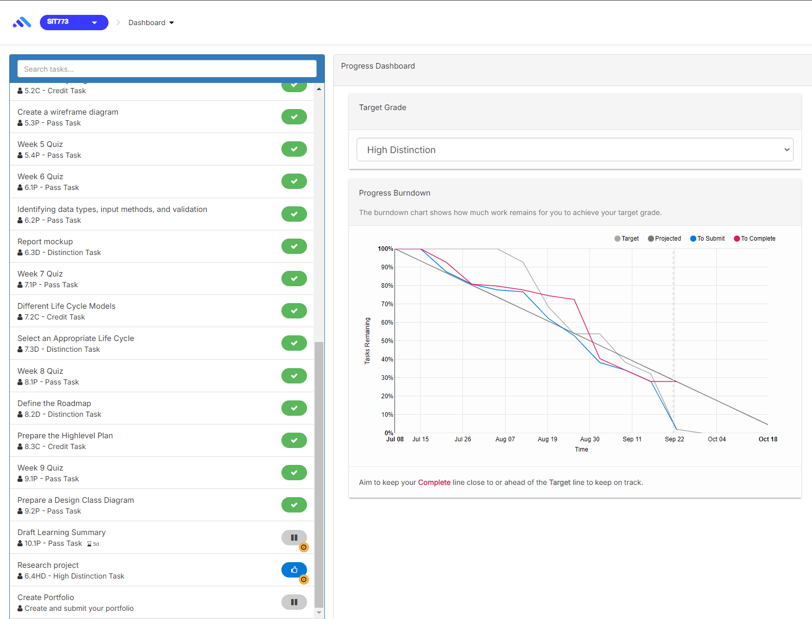

## This unit will help me in the future:

Software requirement analysis will help me ensure project success by accurately identifying and documenting stakeholder needs, reducing misunderstandings and rework. It enhances communication with teams, breaks down complex tasks, and mitigates risks early in the project. These skills will allow me to manage evolving technologies and adapt to changing business requirements. Additionally, strong requirement analysis is highly valued across industries, positioning me for career advancement in roles that bridge technical and business teams, ensuring smooth project execution and alignment with business goals

## If I did this unit again I would do the following things differently:

The most important aspect of requirement analysis is clearly understanding and documenting stakeholder needs to ensure the final product aligns with business objectives and user expectations. Mastering this involves learning how to effectively elicit requirements through techniques like interviews, surveys, and workshops, and then translating these into detailed, actionable specifications. If I did this unit again, I would focus on practicing real-world scenarios, engaging in collaborative sessions with stakeholders, and using models like use cases, user stories, and prototypes to capture and communicate requirements accurately. Frequent feedback and iteration also refine the process over time.

## Other…:

To learn requirement analysis better, actively engage in hands-on practice by working on real or simulated projects, and seek feedback from mentors. Participate in workshops and training to gain new insights, and study relevant textbooks and articles to understand best practices. Familiarize myself with requirement management tools, and practice eliciting requirements through stakeholder interactions. Regular reflection on my approaches and iterating based on feedback will also help refine skills and improve proficiency in requirement analysis.