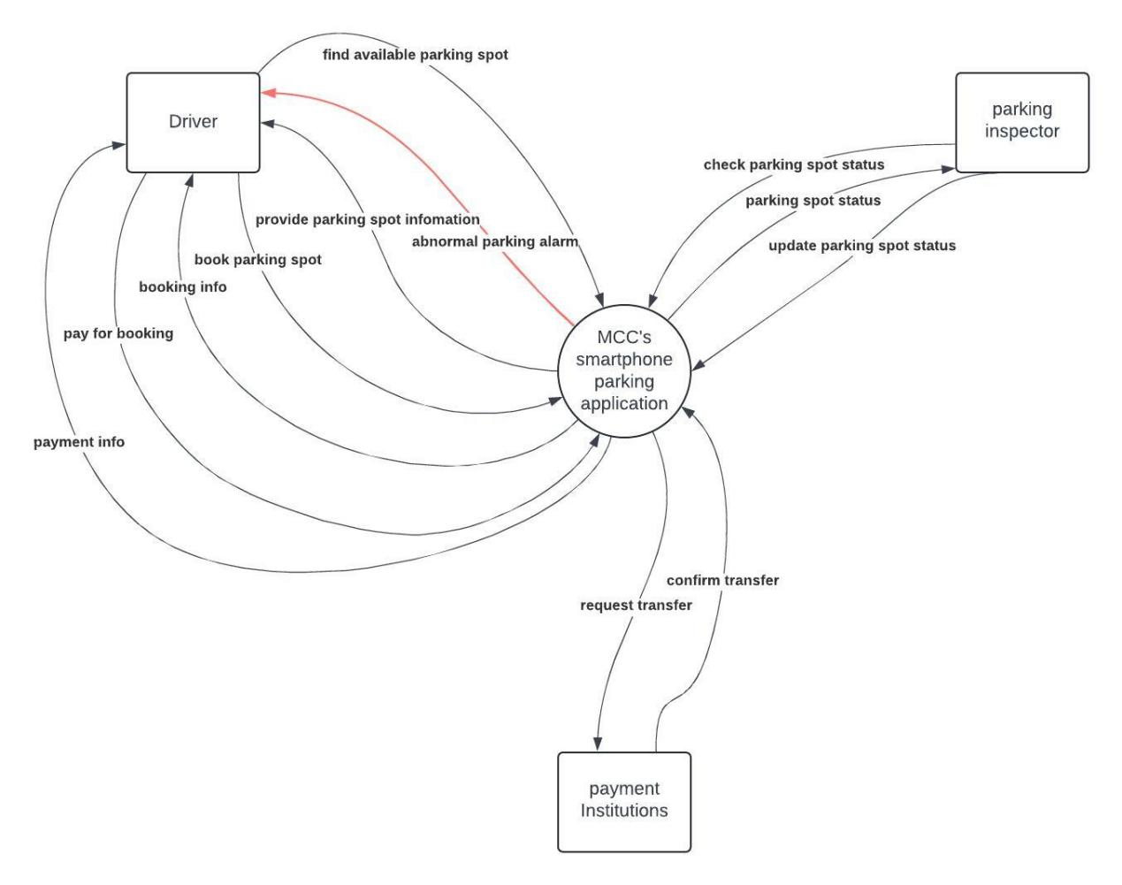

# Data flows

## Drivers

1. Drivers need to find avaliable parking spot via MCC’s smartphone parking application;
2. Drivers book parking spot;
3. Drivers pay for booking;

## Parking inspector

1. check the status of parking spot whether it is abnormal;
2. update the status of parking spot if the spot is expired.

## MCC’s Smartphone Parking Application

1. when drivers use this application, it needs to provide parking spot information;
2. when drivers request booking, application must provide booking info, and maintain booking status;
3. after drivers finish payment, application should provide payment info to drivers;
4. when parking inspectors identify abnormal parking, application needs to alarm vehicle owner;
5. when drivers request to pay booking, application have to send request to payment institutions to transfer money.

## Payment Institutions

1. when application request for payment, payment institutions should return payment info.