# Case Study

Tina has been very busy lately because of some problems at home. A few weeks ago, a strong wind caused a sudden power outage at home, and the whole family was at a loss. Tina immediately contacted the staff of the power bureau. After careful inspection, they found that Tina's power lines were aging and the electrical box was a little loose. Fortunately, the staff helped her restore the power supply urgently and made simple repairs to the electrical box. However, they required Tina to complete the repair of the electrical box and the circuit upgrade within 20 working days, otherwise the power supply bureau would cut off the power to her home.

For this reason, Tina began to contact power engineers for help. However, power engineers in Victoria are very busy. She made several calls, but the replies were that the engineers' schedules were full and they could not provide help in the near future. Finally, Tina contacted an engineer and made an appointment for a door-to-door time. Because the engineer lived far away, it took some time to reach Tina's home.

After the engineer arrived, he assessed the degree of damage to the electrical box and the aging of the wires. It turned out that the repair of the electrical box also required the cooperation of carpenters because the switch of the electrical box was fixed on the aged wood. The repair cost was quite high, and Tina felt that the quote was unreasonable, so she contacted another engineer with great effort, and went through the process of telephone appointment, on-site assessment and cost estimation again. Just like that, a few days passed, and Tina's problem was still not solved.

Recently, Tina found an electrical repair company. This company not only provides electrical repair services, but also carpentry services, and it seems to have some discounts. Through this company, Tina may be able to save a sum of money. She is now contacting the company to make an appointment for on-site service.

# Relevant Pain Points

1. **Aging Infrastructure and Urgency:** Tina’s home electrical system is aging, leading to unexpected issues like a sudden power outage. The urgency imposed by the power bureau to repair the electrical box and upgrade the circuit within 20 working days adds significant pressure.
2. **Difficulty in Finding Available Workers**: Tina faces challenges in finding available power engineers, as they are in high demand and have packed schedules. This delay in securing help prolongs the resolution of her electrical issues.
3. **Geographical Constraints**: The engineer Tina contacts lives far away, leading to delays in service. This geographic distance exacerbates the problem, as it takes additional time for the engineer to reach her home.
4. **High Repair Costs**: The repair of the electrical box not only involves electrical work but also requires the cooperation of carpenters due to the aged wood structure. The combined repair costs are high, and Tina feels the quotes are unreasonable, leading to further delays as she searches for alternative solutions.
5. **Inefficient Booking Process**: Tina has to go through a repetitive and time-consuming process of contacting different engineers, making appointments, and undergoing multiple on-site assessments and cost estimations. This inefficiency results in several days passing without the issue being resolved.
6. **Cost Assessment Delays**: Electricians and carpenters need to assess repair costs, and if the homeowner rejects the quote, it prolongs the process of finding another worker.
7. **Lack of Integrated Services:** Tina’s experience highlights the need for a service that can offer both electrical and carpentry repairs in one package. The lack of integrated services forces her to coordinate between different trades, adding to the complexity and delays.

# Problem Statement

Tina, a homeowner in Victoria, is facing significant challenges in resolving urgent electrical issues caused by aging infrastructure in her home. Following a sudden power outage, the power bureau mandated that Tina repair her electrical box and upgrade the circuit within 20 working days to avoid a power cut-off. However, Tina's attempts to secure help from power engineers have been met with delays due to high demand and limited availability in her area. The repair process has been further complicated by the need for carpentry work, which requires coordination between electricians and carpenters. Despite her efforts, Tina has encountered high repair costs, repeated assessments, and ongoing uncertainty, leaving her problem unresolved as the deadline approaches. This situation highlights the difficulties homeowners face in finding timely, coordinated, and affordable repair services when dealing with complex and urgent home maintenance issues.

# Domain Analysis

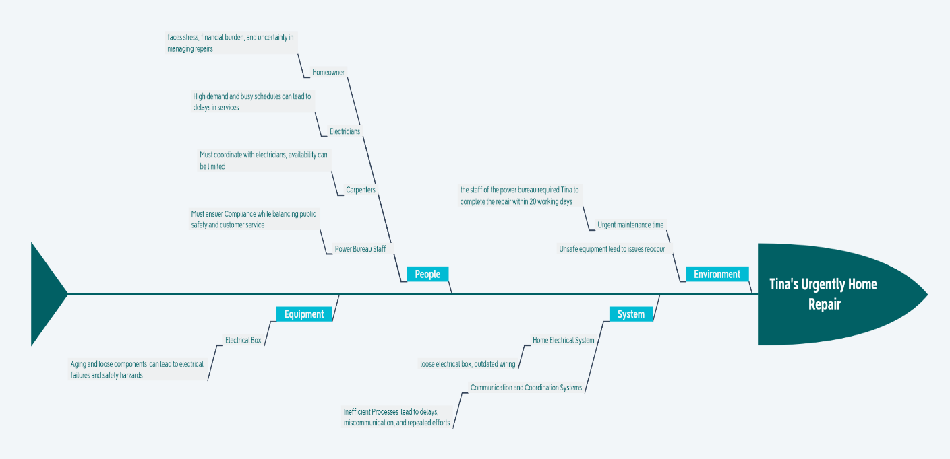

The relevant issues:

|  |  |  |
| --- | --- | --- |
| Environment | Urgent maintenance time | the staff of the power bureau required Tina to complete the repair within 20 working days |
|  | Unsafe equipment leads to issues reoccur |  |
| System | Home Electrical System | loose electrical box, outdated wiring |
|  | Communication and Coordination Systems | Inefficient Processes lead to delays, miscommunication, and repeated efforts |
| People | Homeowner | faces stress, financial burden, and uncertainty in managing repairs |
|  | Electricians | High demand and busy schedules can lead to delays in services |
|  | Carpenters | Must coordinate with electricians, availability can be limited |
|  | Power Bureau Staff | Must ensure Compliance while balancing public safety and customer service |
| Equipment | Electrical Box | Aging and loose components can lead to electrical failures and safety hazard |

# Stake holders

1. **House Owner**: Tina, the homeowner needs to contact the electrician and carpenter to find out if any repairs are needed to the home and provide them with some details about the problem.
2. **Power Bureau**: The regulatory body enforcing deadlines for necessary electrical repairs.
3. **Power Engineers/Electricians**: Professionals responsible for diagnosing and repairing electrical issues.
4. **Carpenters**: The current method involves homeowners contacting service providers via phone, leading to delays and inefficiencies.