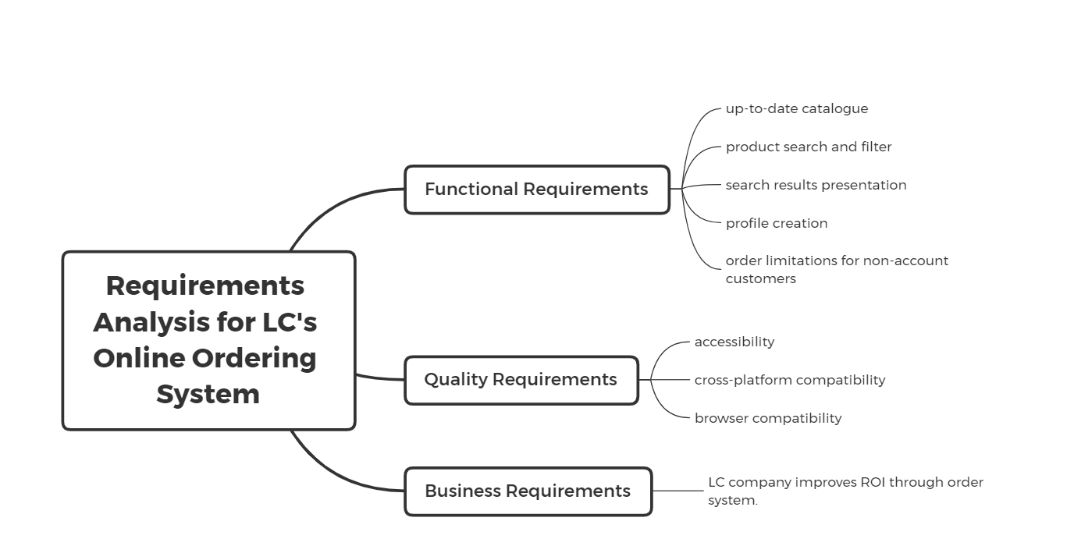

# Introduction

This report analyses the requirements for LC’s new online ordering system to ensure it meets the needs and preferences of its customers. The requirements are categorized into functional, non-functional, and business to provide a clear understanding of the system’s expected functionalities and constraints.

# Requirements

|  |  |  |
| --- | --- | --- |
| Requirement Category | Requirements | Description |
| Functional Requirements | Up-to-date catalogue | when shopping online, LC's customers would like to be provided with an up-to-date catalogue, which reflects all of the products LC sell, as well as any current promotions |
|  | Product search and filter | customers would prefer to be able search for products by varying identifiers, such as name and brand as well having various filter options like price and promotions. |
|  | Search results presentation | upon searching for a product, a customer should be presented with results that display a thumbnail of the relevant products as well as a brief description of each. |
|  | Profile creation | All customers are required to create a profile on the system before placing an order. |
|  | Order limitations for non-account customers | Customers who are not account customers cannot order a quantity of more than 5 for an item that is on promotion. |
| Quality Requirements | Accessibility | The internet ordering system should have accessibility features, such as the ability to increase font size and contrast for people with vision impairment |
|  | Cross-platform compatibility | The internet ordering system may be used on different operating systems, such a mobile platforms and conventional desktop environments. |
|  | Browser compatibility | the system should function on any web browser, such as Chrome, Safari and Firefox to name a few |
| Business Requirements |  | LC company improves ROI through order system. |

# Formal Description

1. Functional Requirements:
   1. When customers shop online, the system should provide an up-to-date catalogue that reflects all the products LC sells, as well as any current promotions.
   2. When customers search for products, the system shall offer various identifiers, such as name and brand, as well as filter options like price and promotions.
   3. After customers search for products, the system must present results that display a thumbnail of the relevant products as well as a brief description of each.
   4. Before placing an order, the customer must create personal information on the system.
   5. When a non-account customer orders promotional items, the system must restrict them from ordering more than 5 promotional items.
2. Quality Requirements
   1. The internet ordering system should have accessibility features, such as the ability to increase font size and contrast for people with vision impairment.
   2. The internet ordering system may be used on different operating systems, such a mobile platforms and conventional desktop environments.
   3. the system should function on any web browser, such as Chrome, Safari and Firefox to name a few.
3. Business Requirements
   1. LC company improves ROI through order system.

# Summary

To meet the needs of LC’s customers and stay competitive in the market, the online ordering system must provide a comprehensive and up-to-date product catalogue, robust search and filter capabilities, secure profile creation, and ensure accessibility and compatibility across various platforms and browsers. Adhering to these requirements will enhance customer satisfaction and improve overall efficiency.