# Use case diagram

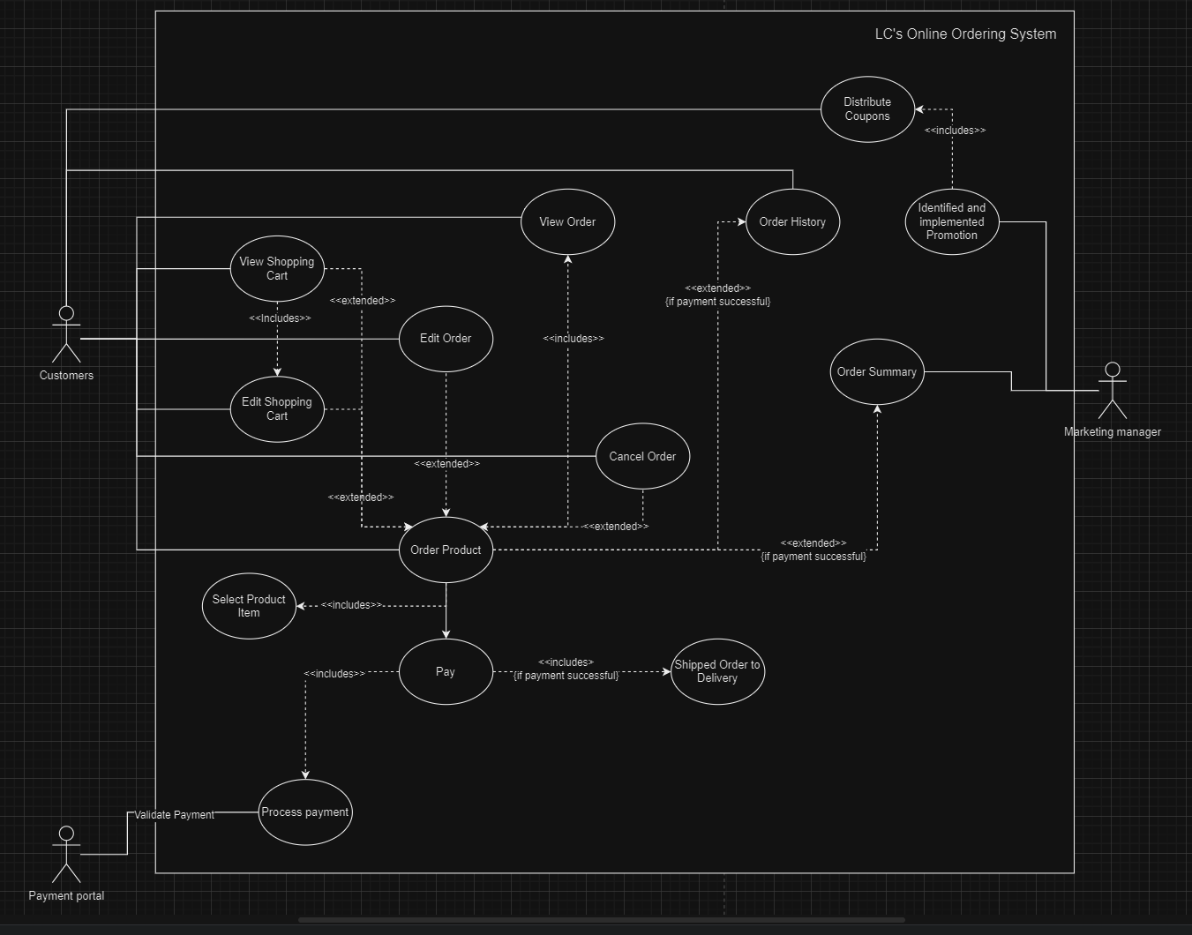

# Detailed use case description

|  |  |  |
| --- | --- | --- |
| Use case name | Order product | |
| Scenario | Online order scenario | |
| Triggering event | Customer visits online ordering system, view shopping cart, edit shopping cart and logs on or click the link for new account | |
| Brief description | Customer logs on to the online ordering system. Customer selects the purchase items add to shopping cart, and create order from shopping cart. Then customer uses the coupons they have, and selects the payment method. Finally, system verifies the payment and finalize the order | |
| Primary actor | Customer | |
| Related use cases | Includes: view order, select product item  Extended: view shopping cart, edit shopping cart, edit order, cancel order, order summary, order history | |
| Stakeholders | Marketing department: To provide promotion information, to collect customer purchase activities;  Inventory department: To provide stock availability; | |
| Precondition | Customer must be online with web access, catalogue and inventory item must exist for requested item | |
| Post condition | * Customer order must be created/placed * Inventory items must have the quantity updated as the order transaction is created. * Order must be associated with a customer. * Rollback any uncompleted transaction | |
| Flow of activities | Actor  1. Customer visits the online ordering system and clicks the log on link in the page. | System |
| 2.lf the customer is new to the online ordering system, customer clicks the register link, provide appropriate information to create customer account | 2.1Create an account record for a new customer |
| 2.a Customer logs on to the system | 2a1. Validate customer account  2a2. Displays the catalogue page |
| 3. Customer searches the catalogue to see a particular product's detail | 3.1 Displays product detail of search criteria and check availability in stock |
| 4. When customer finds the preferred product items, customer provide the quantity and customer clicks the add button to add the item to the shopping cart of the order page | 4.1 Add item to the shopping cart |
| 5. Customer continues shopping by repeating the activities from step 3 to step4 | 5.1 Displays summary of ordered items |
| 6. Customer clicks end of order |  |
| 7. Customer makes any change to shopping cart |  |
| 8. When customer wants to finish, customer checkout | 8.1 Displays total cost and payment screen |
| 9. Customer selects payment method, provides payment information and shipping address |  |
| 10. Customer clicks confirm order | 10.1 Processes payment, displays order confirmation information and sends an email to customer |
|  | 10.2 order will be transfer to delivery |
| Exception conditions | 2a.1 | lf existing customer cannot remember the password, then   1. System generates a password and sends the password by e-mail to customer to log on again using the password, or 2. Customer can create another account |
| 4.1.(1) | lf a product item is not in stock, then customer can   1. Select not to add that item in shopping cart. 2. request item is added as a back-order item |
| 4.1.(2) | lf Customer did not enter the quantity, then  2a. Customer is notified that an invalid quantity was entered. Customer enters quantity and clicks the add button again. |
| 10.1. | lf Customer's credit card information is invalid and payment cannot be processed, then   1. Customer re-enters credit card information and clicks the confirm button again, or 2. Customer can cancel the order, or 3. The order can be saved and customer can process the order later |