# Activity Diagram

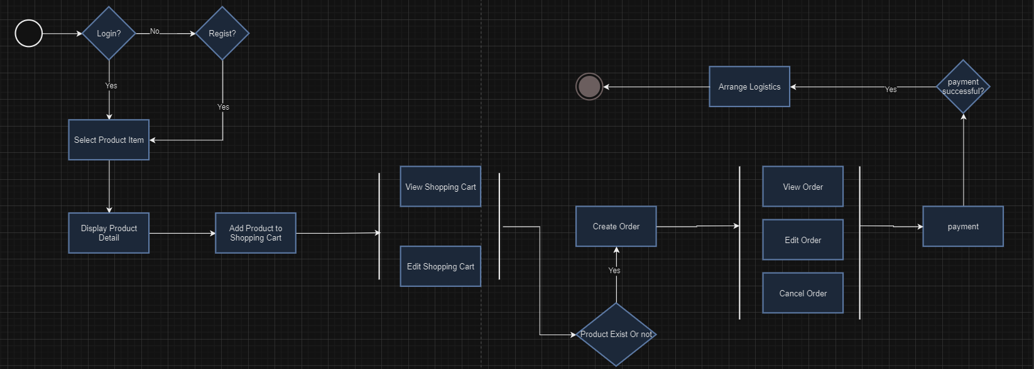

# Description

1. Customer visit online ordering system;
   1. Customer have logged in; (To 2)
   2. Customer does not login, but have an account; (customer needs to login)
   3. Customer does not login, and do not have an account; (customer needs to create an account, and login)
2. Customer select product item;
3. Customer view product details;
4. Customer add product to shopping cart;
   1. Customer view shopping cart;
   2. Customer edit shopping cart;
5. Customer create order;
   1. Product has sufficient stock, order create successfully;
   2. Product does not have enough stock, notice customer but not block order creation;
6. Customer create order successfully;
   1. View order;
   2. Edit order;
   3. Cancel order;
7. Customer processes payment;
   1. Payment success, order transfers to delivery;
   2. Payment failed, the order will be temporarily stored;