# Different Data Types

## Text Data

Example: Customer feedback left on the website, emails, and comments about order and delivery times. This data is usually unstructured and consists of sentences or paragraphs of text.

## Numerical Data

Example: Total quarterly sales figures, the number of customer queries, and discounts or promotions applied to products. This data is often used for calculations, reporting, and analytics.

## Date/Time Data

Example: Dates of customer orders, delivery dates, and dates when promotions are applied. This data is important for tracking timelines and scheduling.

## Categorical Data

Example: Types of electrical equipment (residential and industrial), categories of customer feedback (delivery time and product quality), and customer segments (wholesalers and individual customers).

## Boolean Data

Example: Whether a customer is eligible for a promotion, whether a product is in stock, and whether a service is available in a certain location. This data is used for decision-making processes.

## Currency Data

Example: Prices of electrical equipment and services, total purchase amounts, and discounts. This data is crucial for financial transactions and accounting.

# Data Validation Checks From the Shopping Cart

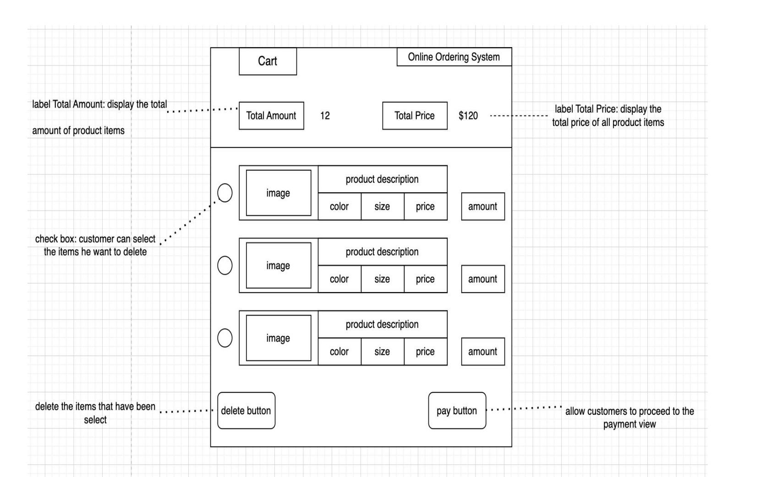

## Required Field Validation

Check: Ensure that the shopping cart contains at lease one product before the form can be submitted.

Example: The shopping cart form can not be submitted if there is not product item.

## Data Type Validation

Check: Ensure that the input matches the expected data type (text, number, date).

Example: The number of the purchase items should be digital number.

## Range Validation

Check: Ensure that numerical data falls within a specified range.

Example: The quantity of items purchased should be greater than zero and within the stock limit.

Example2: In the purchase process of LC’s system, customers who are not account customers cannot order a quantity of more than 5 for an item that is on promotion; quantities of more than 5 on promotional products are reserved for account holders only.

## Length Validation

Check: Ensure that the input data does not exceed or fall below a certain number of characters.

Example: The number of purchase items should less or equal than the available number.

# Other Data Validation Checks Before The Shopping Cart

## Format Validation

Check: Ensure that the data entered follows a specific format (email addresses, phone numbers).

Example: An email address should follow the format example@domain.com.

## Uniqueness Validation

Check: Ensure that certain fields contain unique values (order ID, email address).

Example: The order ID should be unique and not duplicated in the system.

## Consistency Validation

Check: Ensure that related fields contain consistent data.

Example: The billing address should match the address associated with the payment method.

## Logical Validation

Check: Ensure that the input data makes sense in context.

Example: The delivery date should not be set earlier than the current date or beyond a reasonable future period.

## Cross-field Validation

Check: Ensure that the values of two or more fields are logically compatible.

Example: If a customer selects "express shipping", the system should check that their location is eligible for this option.

These validation checks are crucial to ensure the integrity of the data collected during the online purchase process and to provide a seamless user experience.