# Roadmap of Leckie’s Choice (LC)

## Introduction

In this task, there are many important product features of Leckie’s Choice (LC), list as following:

* Catalogue search
* Shopping cart
* Online payment and order submission
* Customer login and authentication
* Customers’ personal space for profiling
* Maintain purchase history
* Reporting system for management
* Loyalty calculation and provide rewards
* Determination of product promotion policies
* Catalogue management
* Tracking of customer activities

In real life, after a customer completes a catalogue search, the system should use the customer's information to proceed with the next steps, such as online payment and loyalty rewards. Once the order is created, the customer can then maintain and review their purchase history. Overall, I will divide these features into three releases.

## Roadmap overview

Releases: 3 (Release 1.0, Release 2.0, Release 3.0)

Focus: Incremental delivery of key functionalities

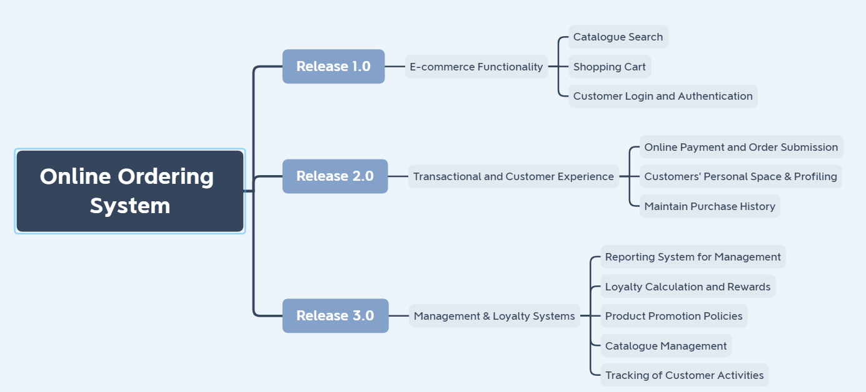

## Release 1.0

Goal: Deliver core e-commerce features allowing customers to search for products, add items to the cart, and log in.

### Features

1. Catalogue Search: Implement basic catalogue browsing and search capabilities.
2. Shopping Cart: Develop and integrate a shopping cart system for adding, removing, and updating items.
3. Customer Login and Authentication: Set up user registration, login, and authentication mechanisms.

### Critical Path

|  |  |  |
| --- | --- | --- |
| Catalogue Search | Shopping Cart | Critical path |
|  | Customer Login and Authentication |  |

## Release 2.0

Goals: Launch features that support full transaction flow and enhance customer experience through personalized profiles and order history management.

### Features

1. Online Payment and Order Submission: Implement secure payment gateway integration and order submission workflows.
2. Customers’ Personal Space & Profiling: Develop a personalized user space for managing profiles and viewing order history.
3. Maintain Purchase History: Enable the system to track and display customer purchase history.

### Critical Path

|  |  |  |
| --- | --- | --- |
| Online Payment and Order Submission | Customers’ Personal Space & Profiling | Critical path |
|  | Maintain Purchase History |  |

## Release 3.0

Goals: Final release with management reporting, loyalty rewards, product promotions, and activity tracking, completing the full e-commerce and management ecosystem.

### Features

1. Reporting System for Management: Create a reporting dashboard for management to track sales, customer activities, and more.
2. Loyalty Calculation and Rewards: Implement loyalty point calculation and integrate rewards into the customer profile.
3. Product Promotion Policies: Develop features for determining and managing product promotions and discounts.
4. Catalogue Management: Enable administrators to manage the product catalogue, including adding, editing, and removing products.
5. Tracking of Customer Activities: Track and analyse customer interactions on the platform to enhance personalized marketing and support.

### Critical Path

|  |  |  |  |
| --- | --- | --- | --- |
| Reporting System for Management | Loyalty Calculation and Rewards | Tracking of Customer Activities | Critical Path (make decisions based on data) |
|  | Product Promotion Policies |  |  |
|  | Catalogue Management |  |  |