Overlook

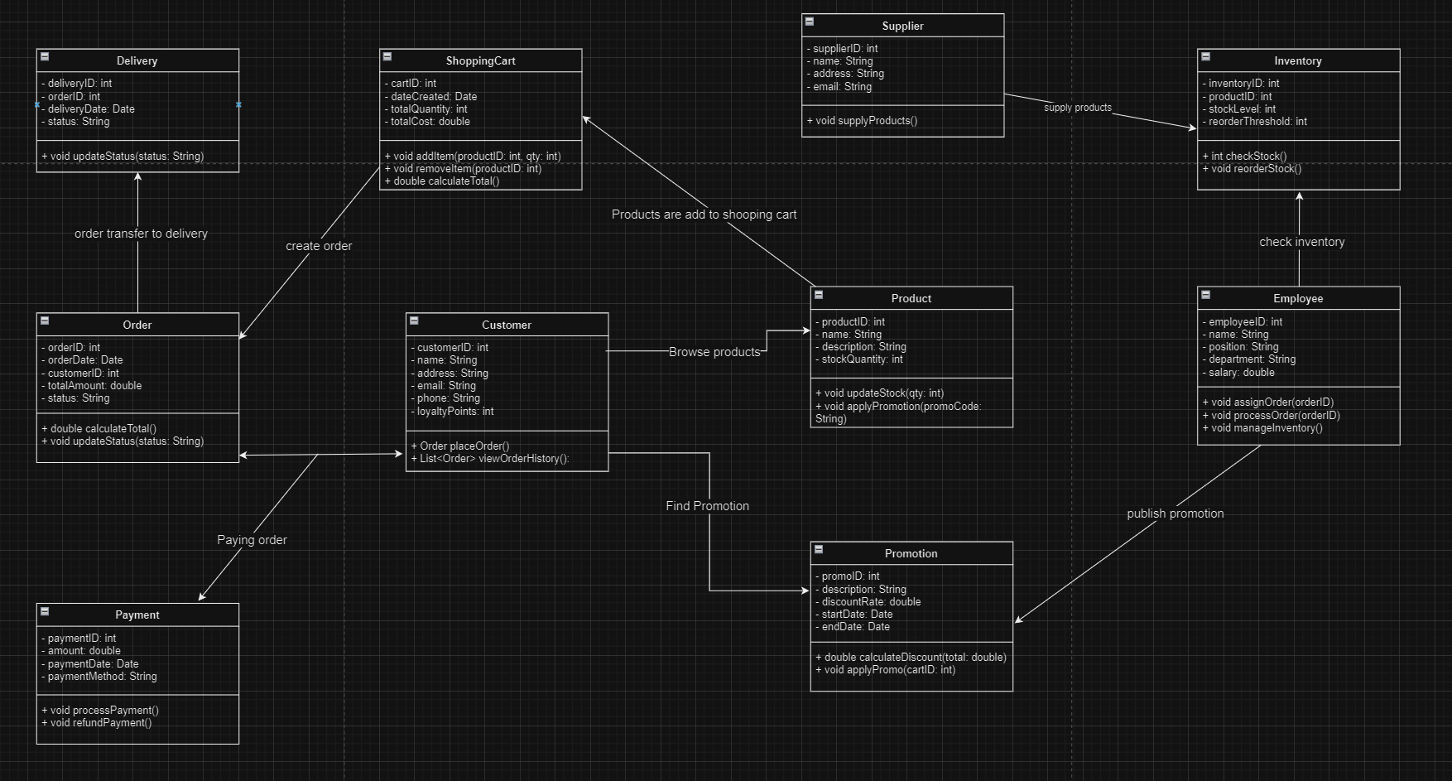

Customers’ actions

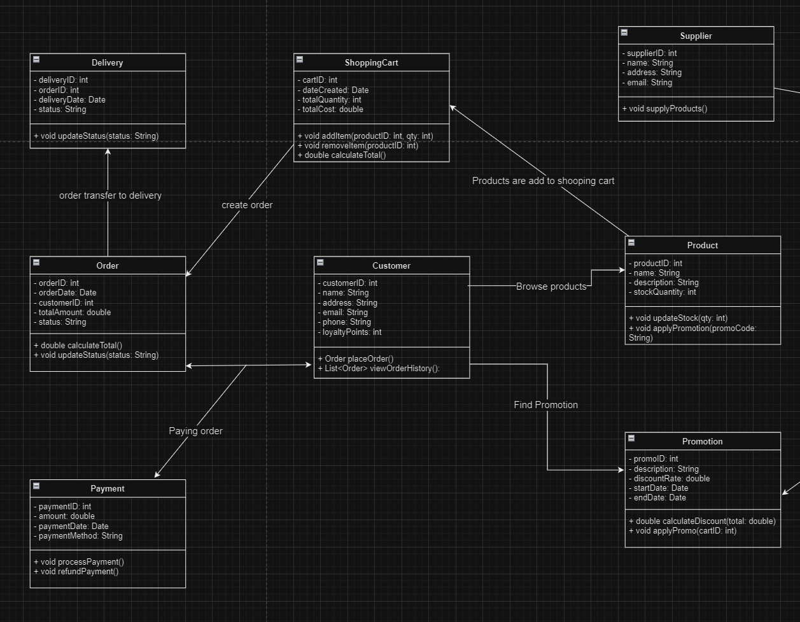

In this class diagram, I mainly describe the customers' ordering process. First, customers browse products. Then, they find relevant promotions and add the desired products to their shopping cart. Once the products are added, the system creates an order. After that, customers proceed to pay for their orders. Finally, the system shifts the orders to delivery for fulfillment.

Employees actions

