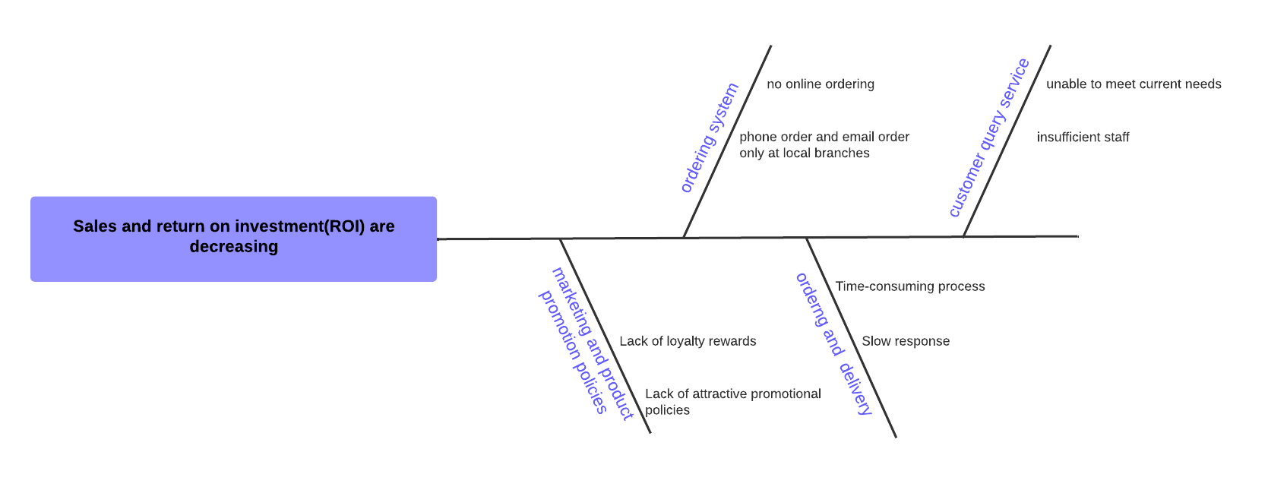

Report:

There are several reasons for the decreasing of the sales and return on investment(ROI) of LC. First of all, the marketing and product promotion policies in LC are outdated, which leads to customer loss. Secondly, the ordering system only supports orders by phone and email at the local branch, this is not suitable for the digital market. Thirdly, the ordering and delivery process is time-consuming which has a bad impact on customer experience. In addition, customer query service regular overloaded, because this system does not work efficiently and does not have enough sales staff.