# Functions

In this task, I have developed several functions.

## Registration

Upon the user entering their information, the details will be stored in the database, with passwords encrypted using bcryptjs. Additionally, I have implemented a check to determine whether the username already exists. If it does, the user will receive an alert notifying them of this issue. Furthermore, all inputs are subject to validation to ensure that no fields are left empty.

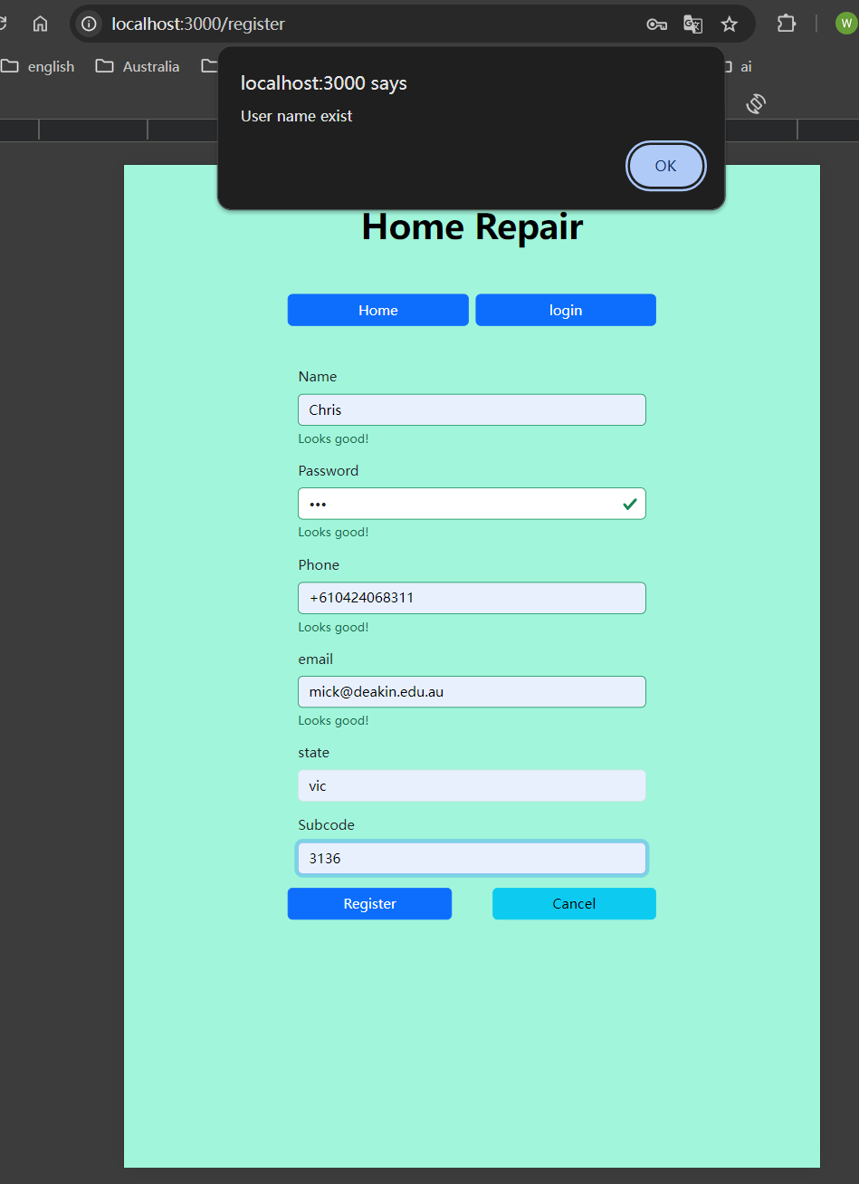

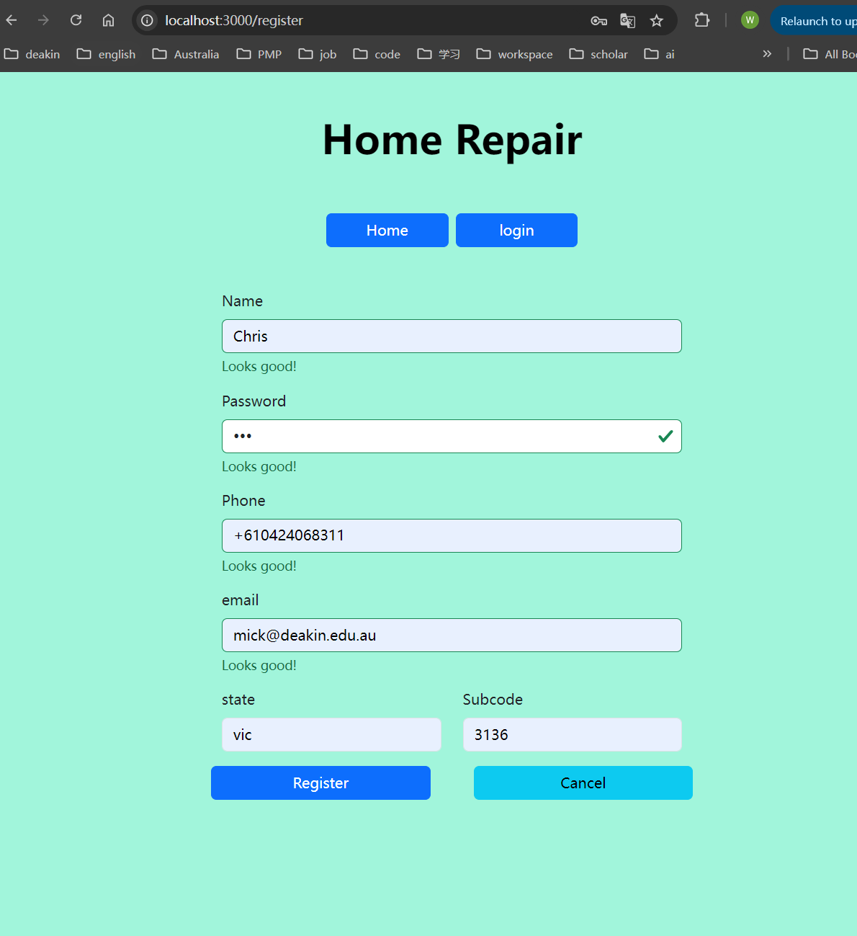

## Login

In this function, I utilized **express-session** to store user information in the request session. After the user logs in, the login and registration buttons will be hidden. Additionally, the logged-in user's information will be saved in **sessionStorage**.

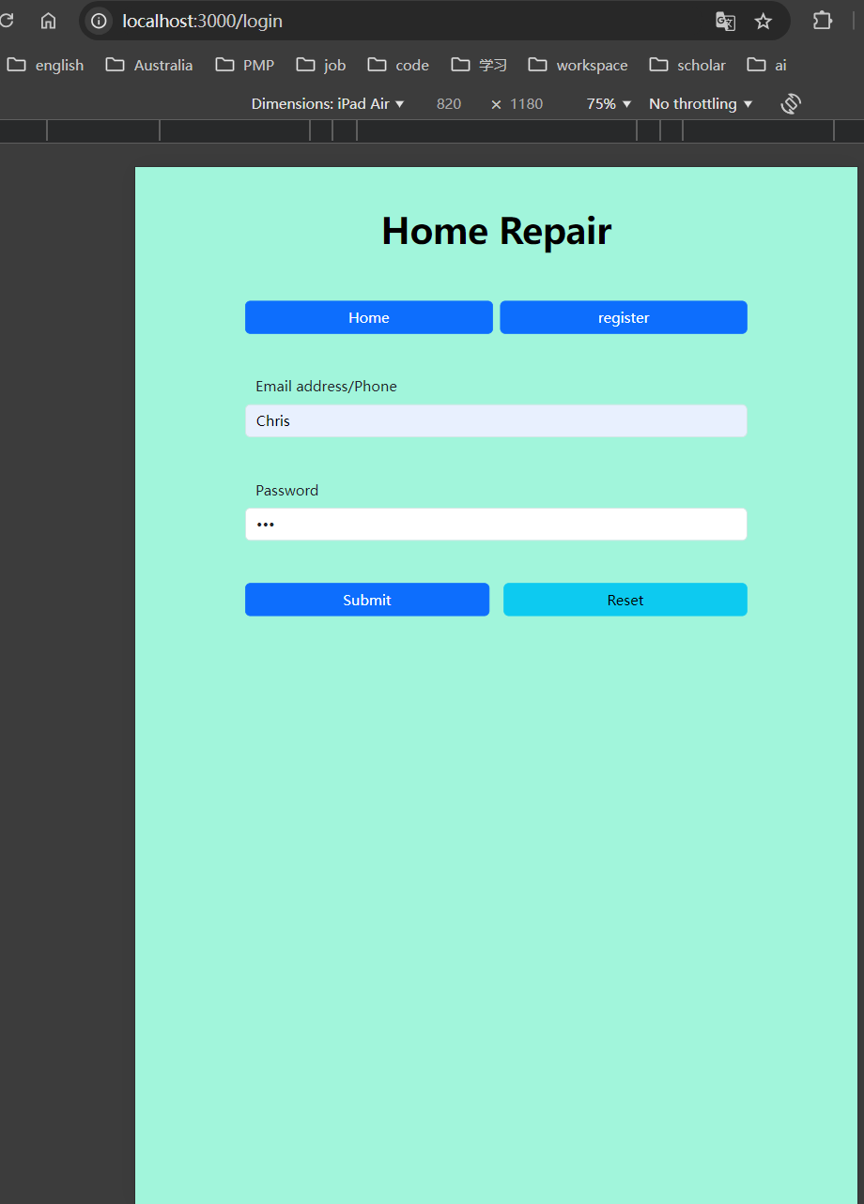



## News/Home Issues Pagination

In this function, I implemented pagination. When the number of news records exceeds three, the fourth record and subsequent entries will appear on the following page.



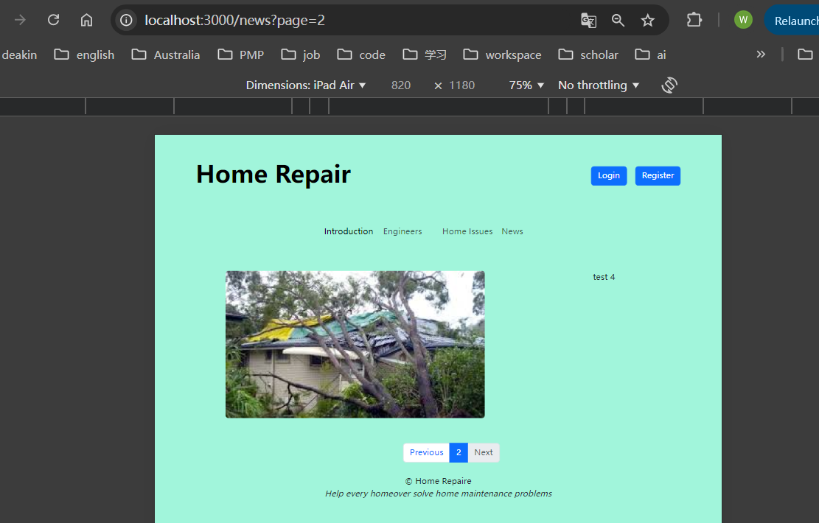

## Engineer Carousel

In this function, I opted to display the top three highest-priced engineers.

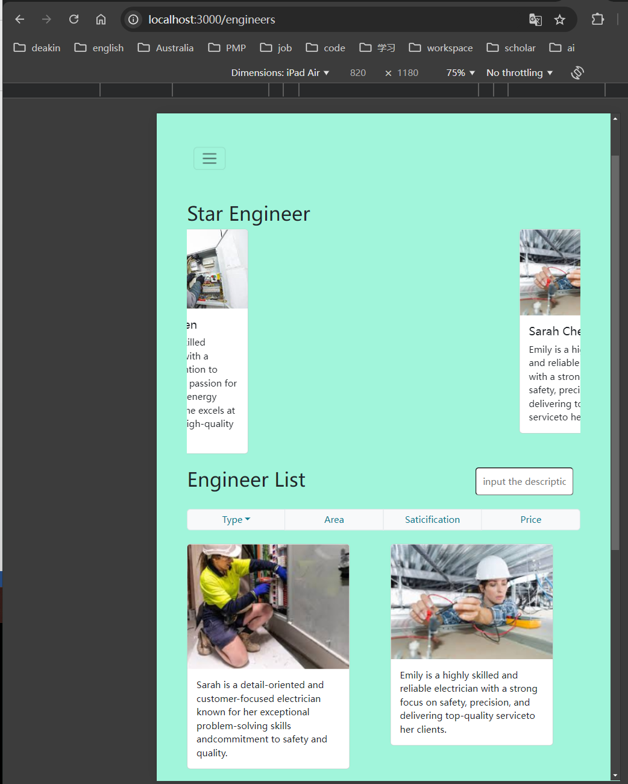

## Engineer search by specification

In this function, when the user selects a type, area, satisfaction rating, or price, the server will respond by displaying the corresponding engineers.

# Repository

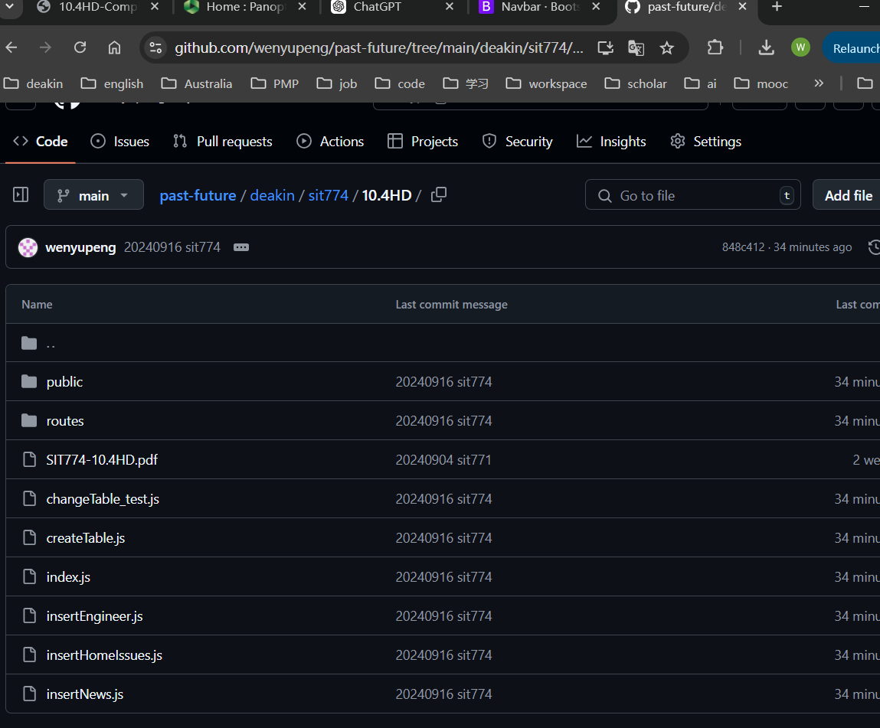

<https://github.com/wenyupeng/past-future/tree/main/deakin/sit774/10.4HD>

Video

<https://deakin.au.panopto.com/Panopto/Pages/Viewer.aspx?id=ffb73089-e10c-4305-8cd1-b1ed00de455f>