SIT774

Web Technologies and Development

YUPENG WEN

S224212855

Learning Summary Report

# Self-Assessment Details

The following checklists provide an overview of my self-assessment for this unit.

|  |  |  |  |  |
| --- | --- | --- | --- | --- |
|  | Pass (D) | Credit (C) | Distinction (B) | High Distinction (A) |
| Self-Assessment |  |  |  | ✓ |

Self-Assessment Statement

# Declaration

I declare that this portfolio is my individual work. I have not copied from any other student’s work or from any other source except where due acknowledgment is made explicitly in the text, nor has any part of this submission been written for me by another person.

Signature: **YUPENG WEN**

# Portfolio Overview

This portfolio includes work that demonstrates that I have achieve all Unit Learning Outcomes for SIT774 Unit Web Technologies and Development to a **High Distinction** level. Through this unit, I have developed a comprehensive understanding of advanced web design and development principles. I have applied my knowledge of HTML, CSS, and JavaScript to create responsive, user-friendly web applications that meet modern standards of usability and aesthetics. My projects showcase my ability to design and implement functional and visually appealing websites, reflecting a high level of proficiency in front-end development.

In addition to front-end skills, I have effectively utilized server-side technologies such as Node.js and Express to build dynamic web applications. By integrating these technologies with databases like sqlite3, I have demonstrated my capability to manage and manipulate data, develop robust back-end systems, and ensure seamless interaction between the server and the client. My work highlights my ability to address complex development tasks, from handling user authentication to optimizing database queries, ensuring both functionality and performance in my applications.

Moreover, my portfolio reflects not only technical expertise but also my problem-solving abilities and innovative approach to web development challenges. I have tackled intricate problems with creative solutions and adhered to best practices for web performance and security. Collaborative projects and peer reviews have further enhanced my communication skills and ability to work effectively within a team, which are crucial for success in professional web development roles. Overall, this portfolio showcases my dedication to excellence and readiness to contribute meaningfully to the field of web development.

# Reflections

## The most important things I learnt:

In this unit, the most important things I learned include advanced web design principles, server-side scripting, and database integration. Key learning points were mastering responsive web design with HTML, CSS, and JavaScript to create user-centric and visually appealing applications. I also gained significant experience in server-side technologies like Node.js and Express, which enabled me to develop dynamic, data-driven applications.

## I feel I learnt these topics, concepts, and/or tools really well:

I am particularly confident in creating responsive web designs using HTML, CSS, and JavaScript, ensuring that websites function seamlessly across various devices. I have a solid grasp of server-side scripting with Node.js and Express, enabling me to build and manage robust server-side applications. My experience in debugging and optimizing both front-end and back-end code has further enhanced my ability to develop efficient, high-performance web solutions.

## I found the following topics particularly challenging:

The most challenging part of the unit was mastering server-side scripting and database integration, particularly when dealing with complex interactions between the server and the database. Understanding how to effectively manage routes, middleware, and asynchronous operations in Node.js, along with designing efficient database schemas and writing optimized queries, required significant effort and practice.

I have since gained confidence in these areas, successfully applying these skills to build functional and scalable web applications. I learned that I am resilient and adaptable when faced with complex problems, often breaking them down into manageable parts and seeking out additional resources when needed. This approach not only helped me overcome the challenges but also strengthened my problem-solving skills and reinforced my ability to tackle intricate technical tasks.

## I found the following topics particularly interesting:

The most interesting and valuable thing I learned from this unit was the integration of server-side scripting with front-end development, particularly how seamlessly connecting these components can create dynamic and responsive web applications. I found it fascinating to see how server-side technologies like Node.js and Express interact with databases to manage and manipulate data effectively, enhancing the functionality of web applications.

On a personal level, I discovered my enthusiasm for tackling complex problems and my ability to persist through challenging tasks. This unit highlighted my capability to learn and adapt quickly, reinforcing my passion for web development and my commitment to continuous improvement in this field.

## I still need to work on the following areas:

I still need to work on advanced debugging and performance optimization techniques, particularly for complex web applications with large-scale data operations. Although I have made significant progress, refining these skills will be crucial for ensuring optimal performance and reliability in real-world projects.

The next step for me is to build upon what I’ve learned by actively seeking opportunities to work on more complex projects, such as contributing to open-source initiatives or undertaking freelance web development tasks. I will focus on applying advanced debugging tools and performance optimization strategies to enhance my proficiency.

## The things that helped me most were:

The most helpful resources is Video Tutorials. YouTube videos provided clear, step-by-step explanations and visual demonstrations of complex web development concepts, making it easier to understand and apply technologies like Node.js, Express and sqlite3.

## My progress in this unit was …:

I have finished all tasks.

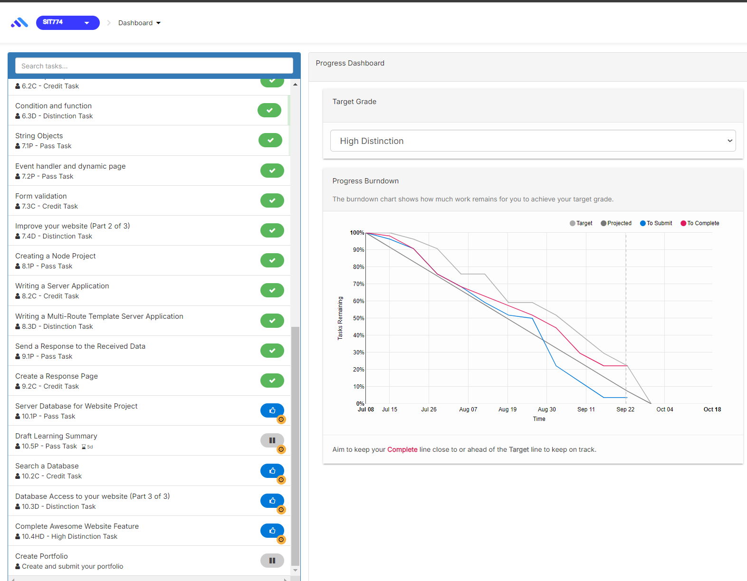

## If I did this unit again, I would do the following things differently:

If I did this unit again, I would start by setting clearer learning goals and milestones at the beginning, which would help me stay focused and track my progress more effectively. I would also engage more actively in collaborative projects and peer discussions to gain different perspectives and deepen my understanding of complex concepts. Additionally, I would allocate more time to hands-on practice, particularly with advanced topics like performance optimization and debugging, to build greater confidence and proficiency.

## Other…:

This unit has not only deepened my technical expertise but also significantly contributed to my development as an IT professional. The hands-on experience with web technologies and server-side scripting has strengthened my problem-solving skills and ability to handle complex technical challenges. Engaging with diverse resources and collaborative projects has enhanced my communication and teamwork abilities, essential for success in the industry.