# Major improvements

1. Style adjustment, web responsive, content adjust to the screen automatically

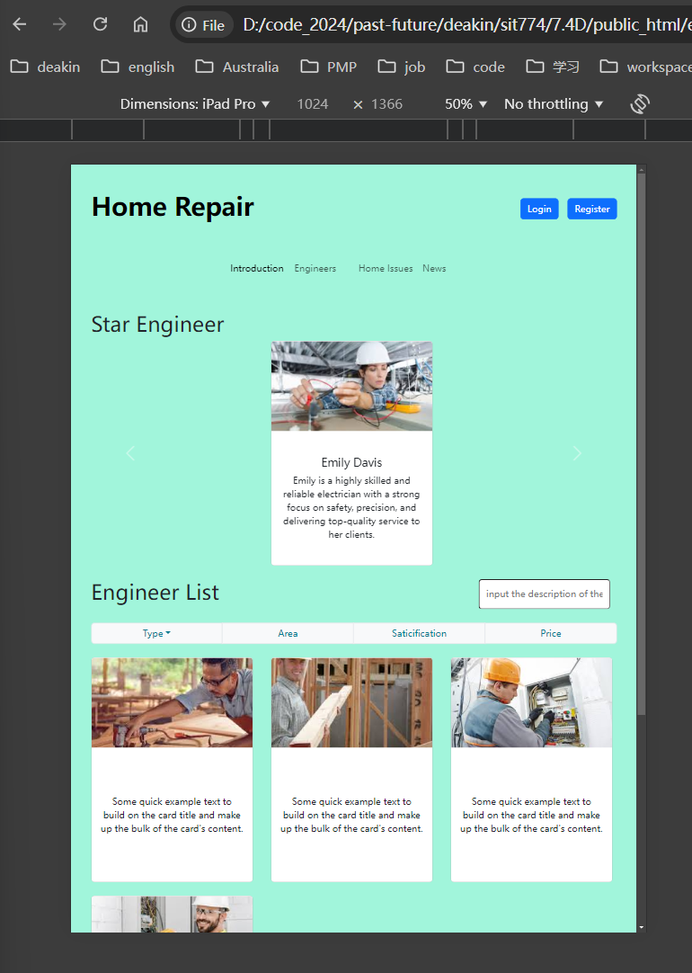

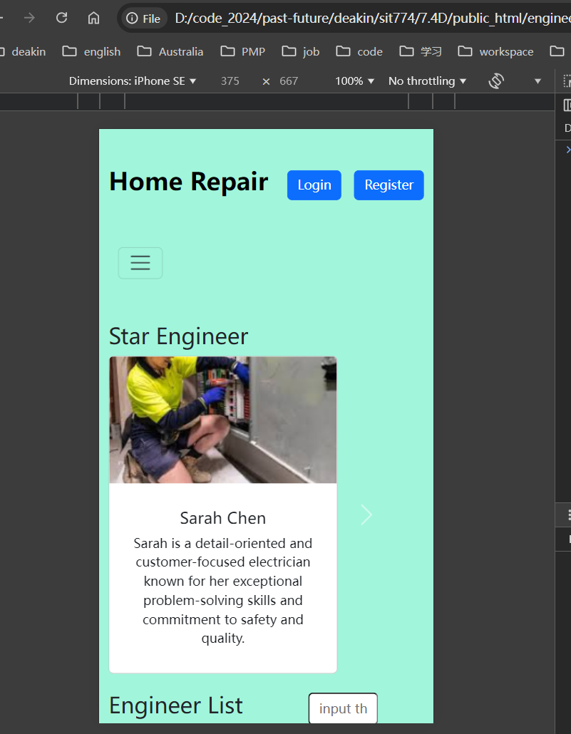

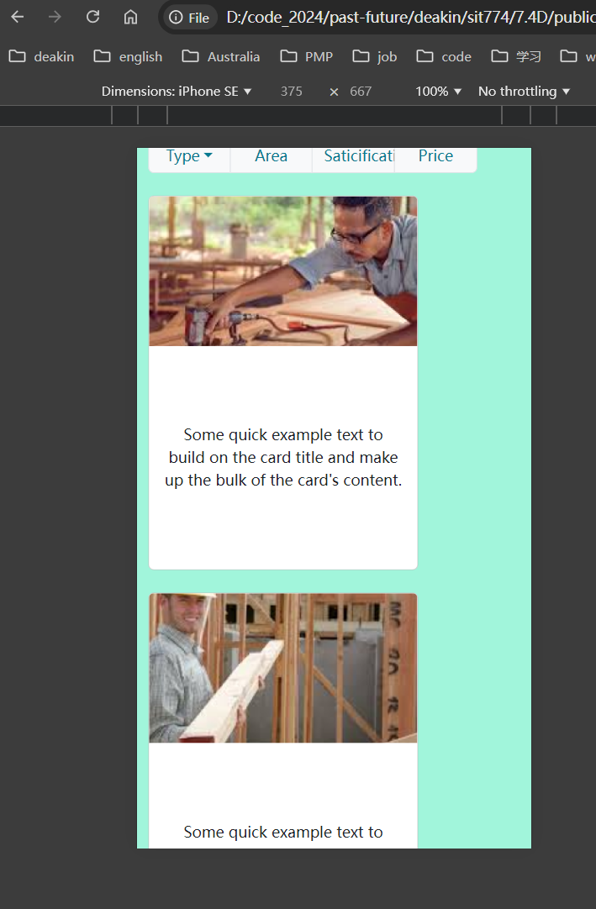

1. Navbar collapse;

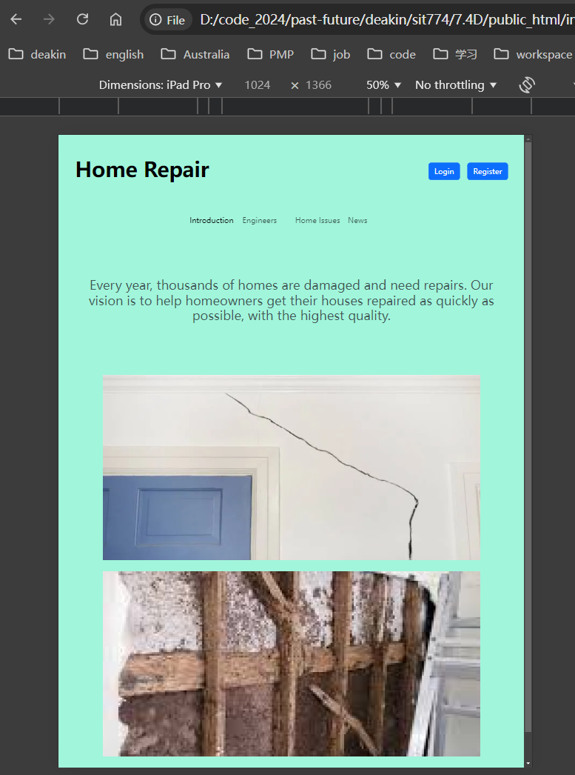

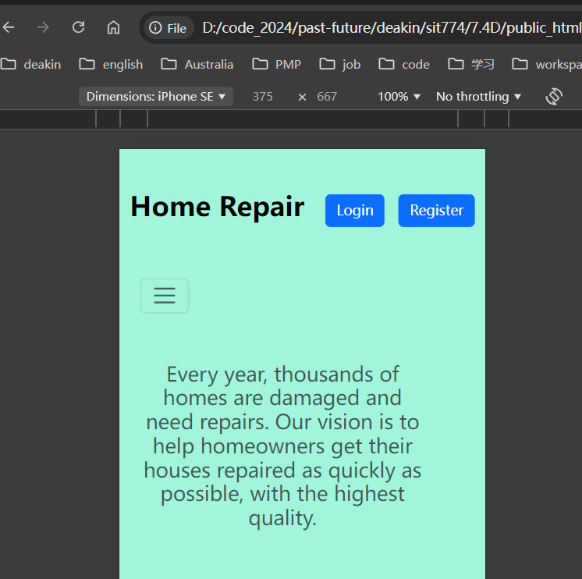

1. Carousel display;

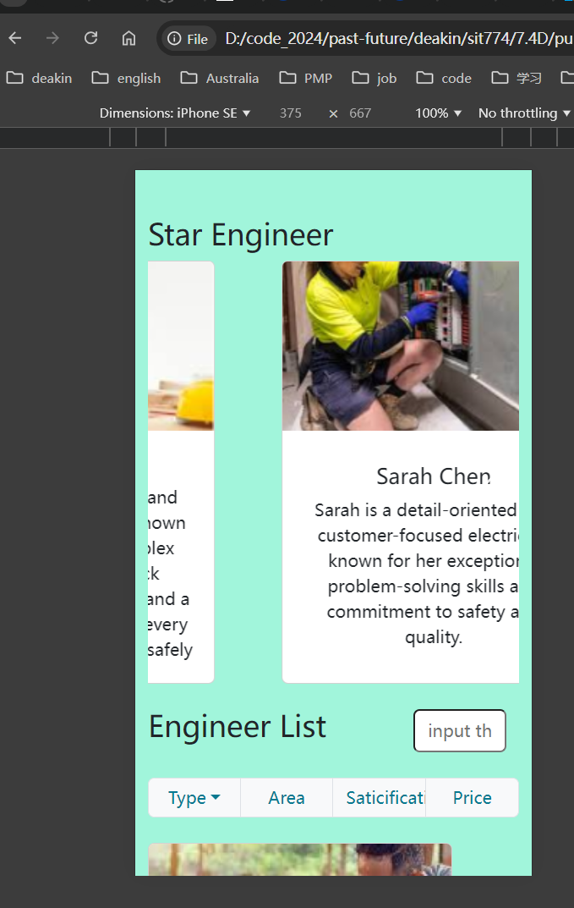

1. Pagination;

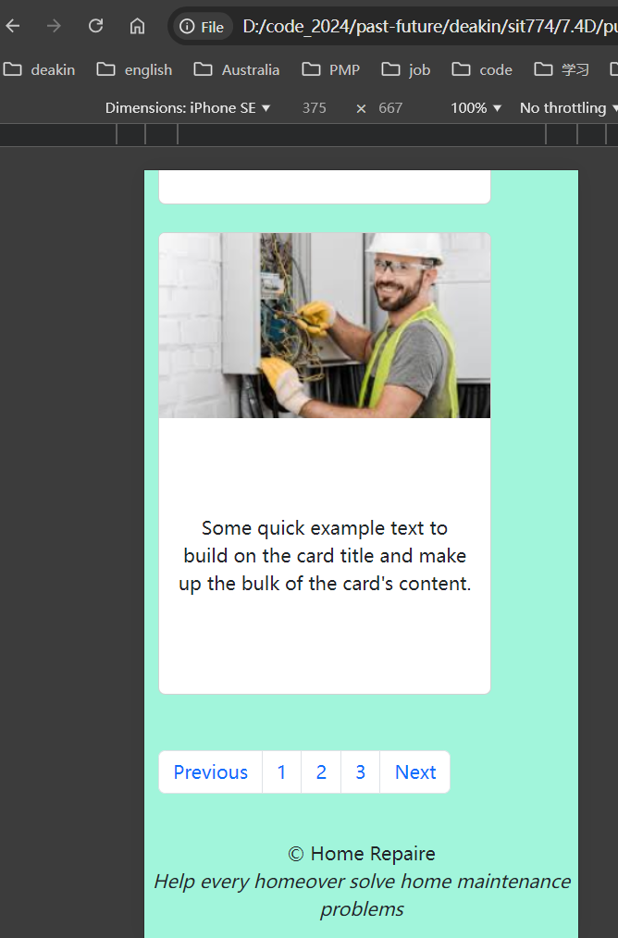

1. Form validation;

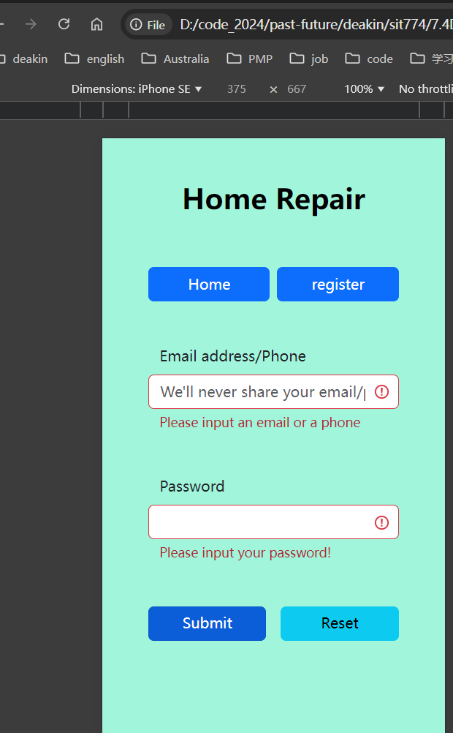

1. Event handlers bind function to do form check;

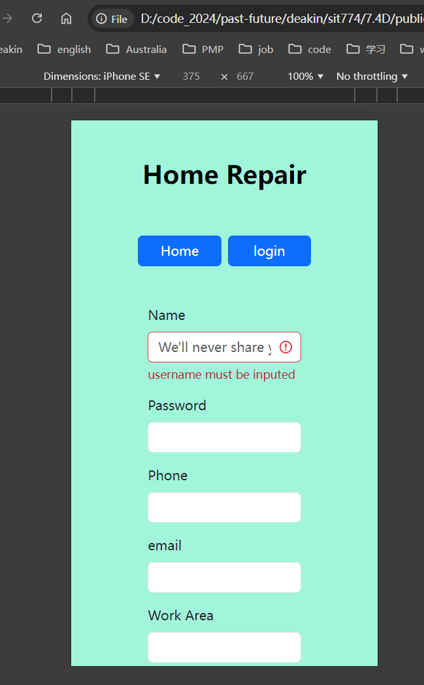

# Html code

## Introduction

|  |  |
| --- | --- |
| Introduction | <!DOCTYPE html>  <html lang="en">  <head>      <meta charset="UTF-8">      <meta name="viewport" content="width=device-width, initial-scale=1.0">      <title>Document</title>      <link rel="stylesheet" href="https://cdn.jsdelivr.net/npm/bootstrap@5.3.0-alpha1/dist/css/bootstrap.min.css" />      <link rel="stylesheet" href="./css/index.css">  </head>  <body>      <header class="container">          <div class="row justify-content-between align-items-center mt-5 mb-5 flex-nowrap">              <div class="col-auto">                  <h1 class="display-5 fw-bold text-body-emphasis" style="white-space: nowrap;">Home Repair</h1>              </div>              <div class="col-auto">                  <div class="d-flex gap-3">                      <a class="btn btn-primary" href="./login.html">Login</a>                      <a class="btn btn-primary" href="./register.html">Register</a>                  </div>              </div>          </div>            <nav class="navbar sticky-top navbar-expand-lg rounded" aria-label="Thirteenth navbar example">              <div class="container-fluid">                  <button class="navbar-toggler" type="button" data-bs-toggle="collapse"                      data-bs-target="#navbarsExample11" aria-controls="navbarsExample11" aria-expanded="false"                      aria-label="Toggle navigation">                      <span class="navbar-toggler-icon"></span>                  </button>                  <div class="collapse navbar-collapse d-lg-flex justify-content-center" id="navbarsExample11">                      <ul class="navbar-nav col-lg-6 justify-content-lg-center">                          <li class="nav-item col-lg-3">                              <a class="nav-link active" aria-current="page" href="./introduction.html">Introduction</a>                          </li>                          <li class="nav-item col-lg-3">                              <a class="nav-link" href="./engineers.html">Engineers</a>                          </li>                          <li class="nav-item col-lg-3">                              <a class="nav-link" href="./home_issues.html">Home Issues</a>                          </li>                          <li class="nav-item col-lg-3">                              <a class="nav-link" href="./news.html">News</a>                          </li>                      </ul>                  </div>              </div>          </nav>      </header>      <main class="container">          <section class="py-5 text-center container">              <div class="row py-lg-5">                  <h3 class="text-center fw-normal text-muted mb-3">Every year, thousands of homes are damaged and need                      repairs. Our vision is to                      help homeowners get their                      houses repaired as quickly as possible, with the highest quality.</h3>              </div>          </section>          <div class="row mb-4 mx-5">              <img class="w-100" style="max-height: 400px" src="./img/introduction-damaged house 1.png"                  alt="damaged house1">          </div>          <div class="row mb-4 mx-5">              <img class="w-100" style="max-height: 400px" src="./img//introduction-damaged house2.png"                  alt="damaged house2">          </div>      </main>      <footer class="container">          <div class="text-center">&copy; Home Repaire <p><em>Help every homeover solve home maintenance problems</em></p>          </div>      </footer>  </body>  <script src="https://cdn.jsdelivr.net/npm/bootstrap@5.3.0-alpha1/dist/js/bootstrap.bundle.min.js"      integrity="sha384-w76AqPfDkMBDXo30jS1Sgez6pr3x5MlQ1ZAGC+nuZB+EYdgRZgiwxhTBTkF7CXvN"      crossorigin="anonymous"></script>  </html> |

## Engineers

|  |
| --- |
| <!DOCTYPE html>  <html lang="en">  <head>      <meta charset="UTF-8">      <meta name="viewport" content="width=device-width, initial-scale=1.0">      <title>Document</title>      <link rel="stylesheet" href="https://cdn.jsdelivr.net/npm/bootstrap@5.3.0-alpha1/dist/css/bootstrap.min.css" />      <link rel="stylesheet" href="./css/engineers.css" />      <link rel="stylesheet" href="./css/index.css">  </head>  <body>      <header class="container">          <div class="row justify-content-between align-items-center mt-5 mb-5 flex-nowrap">              <div class="col-auto">                  <h1 class="display-5 fw-bold text-body-emphasis" style="white-space: nowrap;">Home Repair</h1>              </div>              <div class="col-auto">                  <div class="d-flex gap-3">                      <a class="btn btn-primary" href="./login.html">Login</a>                      <a class="btn btn-primary" href="./register.html">Register</a>                  </div>              </div>          </div>          <nav class="navbar sticky-top navbar-expand-lg rounded" aria-label="Thirteenth navbar example">              <div class="container-fluid">                  <button class="navbar-toggler" type="button" data-bs-toggle="collapse"                      data-bs-target="#navbarsExample11" aria-controls="navbarsExample11" aria-expanded="false"                      aria-label="Toggle navigation">                      <span class="navbar-toggler-icon"></span>                  </button>                  <div class="collapse navbar-collapse d-lg-flex justify-content-center" id="navbarsExample11">                      <ul class="navbar-nav col-lg-6 justify-content-lg-center">                          <li class="nav-item col-lg-3">                              <a class="nav-link active" aria-current="page" href="./introduction.html">Introduction</a>                          </li>                          <li class="nav-item col-lg-3">                              <a class="nav-link" href="./engineers.html">Engineers</a>                          </li>                          <li class="nav-item col-lg-3">                              <a class="nav-link" href="./home_issues.html">Home Issues</a>                          </li>                          <li class="nav-item col-lg-3">                              <a class="nav-link" href="./news.html">News</a>                          </li>                      </ul>                  </div>              </div>          </nav>      </header>      <main class="container">          <div class="mt-5 mb-4">              <div class="mb-4 gap-3">                  <h1>Star Engineer</h1>                  <div id="cardCarousel" class="carousel slide" data-bs-ride="carousel">                      <div class="carousel-inner">                          <div class="carousel-item active">                              <div class="row justify-content-center">                                  <div class="col-md-4">                                      <div class="card">                                          <img src="./img/star engineer1.png" class="card-img-top" alt="Card 1">                                          <div class="card-body">                                              <h5 class="card-title">Sarah Chen</h5>                                              <p class="card-text">Sarah is a detail-oriented and customer-focused                                                  electrician known for her exceptional problem-solving skills and                                                  commitment to safety and quality.</p>                                          </div>                                      </div>                                  </div>                              </div>                          </div>                          <div class="carousel-item">                              <div class="row justify-content-center">                                  <div class="col-md-4">                                      <div class="card">                                          <img src="./img/star engineer2.png" class="card-img-top" alt="Card 2">                                          <div class="card-body">                                              <h5 class="card-title">Emily Davis</h5>                                              <p class="card-text">Emily is a highly skilled and reliable electrician with                                                  a strong focus on safety, precision, and delivering top-quality service                                                  to her clients.</p>                                          </div>                                      </div>                                  </div>                              </div>                          </div>                          <div class="carousel-item">                              <div class="row justify-content-center">                                  <div class="col-md-4">                                      <div class="card">                                          <img src="./img/star engineer3.png" class="card-img-top" alt="Card 3">                                          <div class="card-body">                                              <h5 class="card-title">James Wilson</h5>                                              <p class="card-text">James is an experienced and dependable electrician,                                                  known for his expertise in complex electrical systems, quick                                                  problem-solving abilities, and a commitment to ensuring every job is                                                  done efficiently and safely</p>                                          </div>                                      </div>                                  </div>                              </div>                          </div>                      </div>                      <button class="carousel-control-prev" type="button" data-bs-target="#cardCarousel"                          data-bs-slide="prev">                          <span class="carousel-control-prev-icon" aria-hidden="true"></span>                          <span class="visually-hidden">Previous</span>                      </button>                      <button class="carousel-control-next" type="button" data-bs-target="#cardCarousel"                          data-bs-slide="next">                          <span class="carousel-control-next-icon" aria-hidden="true"></span>                          <span class="visually-hidden">Next</span>                      </button>                  </div>              </div>              <div class="row mb-4">                  <div class="mb-4 row">                      <h1 class="col-9">Engineer List</h1>                      <input type="text" class="col-3 rounded" placeholder="input the description of the engineer">                  </div>                  <div class="mb-4 btn-group" role="group" aria-label="Basic example">                      <div class="btn-group col-3" role="group">                          <button type="button" class="btn text-info-emphasis text-bg-light border dropdown-toggle"                              data-bs-toggle="dropdown" aria-expanded="false">Type</button>                          <ul class="dropdown-menu w-100 text-center">                              <li><a class="dropdown-item" href="#">Electrician</a></li>                              <li><a class="dropdown-item" href="#">Carpenter</a></li>                          </ul>                      </div>                      <button type="button" class="btn text-info-emphasis text-bg-light border col-3">Area</button>                      <button type="button"                          class="btn text-info-emphasis text-bg-light border col-3">Saticification</button>                      <button type="button" class="btn text-info-emphasis text-bg-light border col-3">Price</button>                  </div>                  <div class="mb-4 col-lg-4 col-md-6 col-sm-10">                      <div class="card col-lg-6" style="width: 18rem;">                          <img src="./img/engineer list1.png" class="card-img-top" alt="...">                          <div class="card-body">                              <p class="card-text">Some quick example text to build on the card title and make up the bulk                                  of                                  the card's content.</p>                          </div>                      </div>                  </div>                  <div class="mb-4 col-lg-4 col-md-6 col-sm-10">                      <div class="card" style="width: 18rem;">                          <img src="./img/engineer list2.png" class="card-img-top" alt="...">                          <div class="card-body">                              <p class="card-text">Some quick example text to build on the card title and make up the bulk                                  of                                  the card's content.</p>                          </div>                      </div>                  </div>                  <div class="mb-4 col-lg-4 col-md-6 col-sm-10">                      <div class="card col-lg-6" style="width: 18rem;">                          <img src="./img/engineer list3.png" class="card-img-top" alt="...">                          <div class="card-body">                              <p class="card-text">Some quick example text to build on the card title and make up the bulk                                  of                                  the card's content.</p>                          </div>                      </div>                  </div>                  <div class="mb-4 col-lg-4 col-md-6 col-sm-10">                      <div class="card col-lg-6" style="width: 18rem;">                          <img src="./img/engineer list4.png" class="card-img-top" alt="...">                          <div class="card-body">                              <p class="card-text">Some quick example text to build on the card title and make up the bulk                                  of                                  the card's content.</p>                          </div>                      </div>                  </div>              </div>              <div class="row">                  <div class="offset-lg-5 offset-md-4 offset-sm-4 col-lg-4 col-md-4 col-sm-4">                      <nav aria-label="Page navigation example">                          <ul class="pagination">                              <li class="page-item"><a class="page-link" href="#">Previous</a></li>                              <li class="page-item"><a class="page-link" href="#">1</a></li>                              <li class="page-item"><a class="page-link" href="#">2</a></li>                              <li class="page-item"><a class="page-link" href="#">3</a></li>                              <li class="page-item"><a class="page-link" href="#">Next</a></li>                          </ul>                      </nav>                  </div>              </div>          </div>      </main>      <footer>          <div class="text-center">&copy; Home Repaire <p><em>Help every homeover solve home maintenance problems</em></p></div>      </footer>  </body>  <script src="https://cdn.jsdelivr.net/npm/bootstrap@5.3.0-alpha1/dist/js/bootstrap.bundle.min.js"      integrity="sha384-w76AqPfDkMBDXo30jS1Sgez6pr3x5MlQ1ZAGC+nuZB+EYdgRZgiwxhTBTkF7CXvN"      crossorigin="anonymous"></script>  </html> |

## Home Issues

|  |
| --- |
| <!DOCTYPE html><html lang="en"><head>    <meta charset="UTF-8">    <meta name="viewport" content="width=device-width, initial-scale=1.0">    <title>Document</title>    <link rel="stylesheet" href="https://cdn.jsdelivr.net/npm/bootstrap@5.3.0-alpha1/dist/css/bootstrap.min.css" />    <link rel="stylesheet" href="./css/index.css">    <link rel="stylesheet" href="./css/home_issues.css"></head><body>    <header class="container">        <div class="row justify-content-between align-items-center mt-5 mb-5 flex-nowrap">            <div class="col-auto">                <h1 class="display-5 fw-bold text-body-emphasis" style="white-space: nowrap;">Home Repair</h1>            </div>            <div class="col-auto">                <div class="d-flex gap-3">                    <a class="btn btn-primary" href="./login.html">Login</a>                    <a class="btn btn-primary" href="./register.html">Register</a>                </div>            </div>        </div>        <nav class="navbar sticky-top navbar-expand-lg rounded" aria-label="Thirteenth navbar example">            <div class="container-fluid">                <button class="navbar-toggler" type="button" data-bs-toggle="collapse"                    data-bs-target="#navbarsExample11" aria-controls="navbarsExample11" aria-expanded="false"                    aria-label="Toggle navigation">                    <span class="navbar-toggler-icon"></span>                </button>                <div class="collapse navbar-collapse d-lg-flex justify-content-center" id="navbarsExample11">                    <ul class="navbar-nav col-lg-6 justify-content-lg-center">                        <li class="nav-item col-lg-3">                            <a class="nav-link active" aria-current="page" href="./introduction.html">Introduction</a>                        </li>                        <li class="nav-item col-lg-3">                            <a class="nav-link" href="./engineers.html">Engineers</a>                        </li>                        <li class="nav-item col-lg-3">                            <a class="nav-link" href="./home_issues.html">Home Issues</a>                        </li>                        <li class="nav-item col-lg-3">                            <a class="nav-link" href="./news.html">News</a>                        </li>                    </ul>                </div>            </div>        </nav>    </header>    <main>        <div class="container">            <h1 class="mb-4" >Emergency</h1>            <div class="row mb-4 text-center">                <div class="col-lg-6">                    <img class="rounded mx-auto d-block" style="max-width: 100%;" src="./img/emergency house 1.png" alt="house info 1">                </div>                <div class="col-lg-6">                    <p class="text-center">A large tree, its massive trunk splintered and roots partially uprooted, has fallen across a residential house. The branches have shattered windows and torn through the roof, causing significant structural damage. The weight of the tree has crushed one side of the house, leaving the walls cracked and the roof caved in. Debris is scattered across the yard, and the house is now partially buried under the tangled mass of leaves, branches, and broken wood. The scene is one of chaos, with the tree looming over the damaged home, emphasizing the sheer force of nature.</p>                </div>            </div>            <div class="row mb-4 text-center">                <div class="col-lg-6">                    <img class="rounded mx-auto d-block" style="max-width: 100%;" src="./img/emergency house 2.png" alt="house info 1">                </div>                <div class="col-lg-6">                    <p class="text-center">The wooden structure of the house shows clear signs of decay, with the once sturdy beams now soft and crumbling to the touch. The wood has darkened in color, with patches of mold and mildew spreading across the surface. In some areas, the wood is visibly warped and cracked, with sections flaking off and disintegrating into dust. The corners and edges of the wooden planks have begun to rot away, leaving gaps and exposing the inner layers. The smell of dampness and rot lingers in the air, and the house’s framework appears weakened, as if it could give way at any moment.</p>                </div>            </div>            <h1>Urgent List</h1>            <div class="row">                <div class="mb-4 col-lg-4 col-md-4 col-sm-10">                    <div class="card col-lg-4" style="width: 18rem;">                        <img src="./img/urgent list1.png" class="card-img-top" alt="...">                        <div class="card-body">                            <p class="card-text">Termites have infested the wooden structures of the house, leaving behind a trail of destruction. The wood appears hollowed out, with visible tunnels and galleries carved through beams, floorboards, and walls. The once sturdy framework is now brittle, crumbling at the slightest touch, and riddled with small holes. Piles of fine, sawdust-like material known as frass can be found around the baseboards, a telltale sign of their activity. In some areas, the damage is so severe that the wood has collapsed, compromising the integrity of the house. The infestation has weakened the structure, making it unsafe and requiring extensive repairs.</p>                        </div>                    </div>                </div>                <div class="mb-4 col-lg-4 col-md-4 col-sm-10">                    <div class="card col-lg-4" style="width: 18rem;">                        <img src="./img/urgent list2.png" class="card-img-top" alt="...">                        <div class="card-body">                            <p class="card-text">Termites have infested the wooden structures of the house, leaving behind a trail of destruction. The wood appears hollowed out, with visible tunnels and galleries carved through beams, floorboards, and walls. The once sturdy framework is now brittle, crumbling at the slightest touch, and riddled with small holes. Piles of fine, sawdust-like material known as frass can be found around the baseboards, a telltale sign of their activity. In some areas, the damage is so severe that the wood has collapsed, compromising the integrity of the house. The infestation has weakened the structure, making it unsafe and requiring extensive repairs.</p>                        </div>                    </div>                </div>            </div>            <div class="row">                <div class="offset-lg-5 offset-md-4 offset-sm-4 col-lg-4 col-md-4 col-sm-4">                    <nav aria-label="Page navigation example">                        <ul class="pagination">                            <li class="page-item"><a class="page-link" href="#">Previous</a></li>                            <li class="page-item"><a class="page-link" href="#">1</a></li>                            <li class="page-item"><a class="page-link" href="#">2</a></li>                            <li class="page-item"><a class="page-link" href="#">3</a></li>                            <li class="page-item"><a class="page-link" href="#">...</a></li>                            <li class="page-item"><a class="page-link" href="#">Next</a></li>                    </ul>                    </nav>                </div>            </div>        </div>    </main>    <footer>        <div class="text-center">&copy; Home Repaire <p><em>Help every homeover solve home maintenance problems</em></p></div>    </footer></body><script src="https://cdn.jsdelivr.net/npm/bootstrap@5.3.0-alpha1/dist/js/bootstrap.bundle.min.js"    integrity="sha384-w76AqPfDkMBDXo30jS1Sgez6pr3x5MlQ1ZAGC+nuZB+EYdgRZgiwxhTBTkF7CXvN"    crossorigin="anonymous"></script></html> |

## News

|  |
| --- |
| <!DOCTYPE html>  <html lang="en">  <head>      <meta charset="UTF-8">      <meta name="viewport" content="width=device-width, initial-scale=1.0">      <title>Document</title>      <link rel="stylesheet" href="https://cdn.jsdelivr.net/npm/bootstrap@5.3.0-alpha1/dist/css/bootstrap.min.css" />      <link rel="stylesheet" href="./css/index.css">  </head>  <body>      <header class="container">          <div class="row justify-content-between align-items-center mt-5 mb-5 flex-nowrap">              <div class="col-auto">                  <h1 class="display-5 fw-bold text-body-emphasis" style="white-space: nowrap;">Home Repair</h1>              </div>              <div class="col-auto">                  <div class="d-flex gap-3">                      <a class="btn btn-primary" href="./login.html">Login</a>                      <a class="btn btn-primary" href="./register.html">Register</a>                  </div>              </div>          </div>          <nav class="navbar sticky-top navbar-expand-lg rounded" aria-label="Thirteenth navbar example">              <div class="container-fluid">                  <button class="navbar-toggler" type="button" data-bs-toggle="collapse"                      data-bs-target="#navbarsExample11" aria-controls="navbarsExample11" aria-expanded="false"                      aria-label="Toggle navigation">                      <span class="navbar-toggler-icon"></span>                  </button>                  <div class="collapse navbar-collapse d-lg-flex justify-content-center" id="navbarsExample11">                      <ul class="navbar-nav col-lg-6 justify-content-lg-center">                          <li class="nav-item col-lg-3">                              <a class="nav-link active" aria-current="page" href="./introduction.html">Introduction</a>                          </li>                          <li class="nav-item col-lg-3">                              <a class="nav-link" href="./engineers.html">Engineers</a>                          </li>                          <li class="nav-item col-lg-3">                              <a class="nav-link" href="./home_issues.html">Home Issues</a>                          </li>                          <li class="nav-item col-lg-3">                              <a class="nav-link" href="./news.html">News</a>                          </li>                      </ul>                  </div>              </div>          </nav>      </header>      <main>          <div class="container mt-5">              <div class="row">                  <div class="row mb-4">                      <div class="col-lg-8">                          <img class="rounded mx-auto d-block" style="max-width: 100%;" src="./img/new1.png" alt="news 1">                      </div>                      <div class="col-lg-4">                          <p class="text-center">A large tree, its massive trunk splintered and roots partially uprooted, has fallen across a residential house. The branches have shattered windows and torn through the roof, causing significant structural damage. The weight of the tree has crushed one side of the house, leaving the walls cracked and the roof caved in. Debris is scattered across the yard, and the house is now partially buried under the tangled mass of leaves, branches, and broken wood. The scene is one of chaos, with the tree looming over the damaged home, emphasizing the sheer force of nature.</p>                      </div>                  </div>                  <div class="row mb-4">                      <div class="col-lg-8">                          <img class="rounded mx-auto d-block" style="max-width: 100%;" src="./img/new2.png" alt="news 2">                      </div>                      <div class="col-lg-4">                          <p class="text-center">The wooden structure of the house shows clear signs of decay, with the once sturdy beams now soft and crumbling to the touch. The wood has darkened in color, with patches of mold and mildew spreading across the surface. In some areas, the wood is visibly warped and cracked, with sections flaking off and disintegrating into dust. The corners and edges of the wooden planks have begun to rot away, leaving gaps and exposing the inner layers. The smell of dampness and rot lingers in the air, and the house’s framework appears weakened, as if it could give way at any moment.</p>                      </div>                  </div>                  <div class="row mb-4">                      <div class="col-lg-8">                          <img class="rounded mx-auto d-block" style="max-width: 100%;" src="./img/new3.png" alt="news 3">                      </div>                      <div class="col-lg-4">                          <p class="text-center">Termites have infested the wooden structures of the house, leaving behind a trail of destruction. The wood appears hollowed out, with visible tunnels and galleries carved through beams, floorboards, and walls. The once sturdy framework is now brittle, crumbling at the slightest touch, and riddled with small holes. Piles of fine, sawdust-like material known as frass can be found around the baseboards, a telltale sign of their activity. In some areas, the damage is so severe that the wood has collapsed, compromising the integrity of the house. The infestation has weakened the structure, making it unsafe and requiring extensive repairs.</p>                      </div>                  </div>              </div>          </div>          <div class="row">              <div class="offset-lg-5 offset-md-4 offset-sm-4 col-lg-4 col-md-4 col-sm-4">                  <nav aria-label="Page navigation example">                      <ul class="pagination">                          <li class="page-item"><a class="page-link" href="#">Previous</a></li>                          <li class="page-item"><a class="page-link" href="#">1</a></li>                          <li class="page-item"><a class="page-link" href="#">2</a></li>                          <li class="page-item"><a class="page-link" href="#">3</a></li>                          <li class="page-item"><a class="page-link" href="#">Next</a></li>                  </ul>                  </nav>              </div>          </div>      </main>      <footer>          <div class="text-center">&copy; Home Repaire <p><em>Help every homeover solve home maintenance problems</em></p></div>      </footer>  </body>  <script src="https://cdn.jsdelivr.net/npm/bootstrap@5.3.0-alpha1/dist/js/bootstrap.bundle.min.js"      integrity="sha384-w76AqPfDkMBDXo30jS1Sgez6pr3x5MlQ1ZAGC+nuZB+EYdgRZgiwxhTBTkF7CXvN"      crossorigin="anonymous"></script>  </html> |

## Login

|  |
| --- |
| <!DOCTYPE html>  <html lang="en">  <head>      <meta charset="UTF-8">      <meta name="viewport" content="width=device-width, initial-scale=1.0">      <title>Document</title>      <link rel="stylesheet" href="https://cdn.jsdelivr.net/npm/bootstrap@5.3.0-alpha1/dist/css/bootstrap.min.css" />      <link rel="stylesheet" href="./css/index.css">  </head>  <body>      <header class="container">          <div class="row text-center mt-5 mb-5">              <div class="offset-sm-2 col-sm-8 col-md-8 col-lg-8">                  <h1 class="display-5 fw-bold text-body-emphasis">Home Repair</h1>              </div>          </div>      </header>      <main>          <div class="offset-2 col-8">              <div class="col-lg-6 col-xxl-4 my-5 mx-auto">                  <div class="row gap-2">                      <a class="col btn btn-primary" href="./introduction.html">Home</a>                    <a class="col btn btn-primary" href="./register.html">register</a>                  </div>                </div>              <form id="loginForm" class="needs-validation" novalidate>                  <div class="row my-5">                      <label for="emailOrPhone" class="form-label">Email address/Phone</label>                      <input type="text" class="form-control" id="emailOrPhone" aria-describedby="userInputHelp"                          placeholder="We'll never share your email/phone with anyone else." onfocus="clearTips('login')"                          required>                      <div class="valid-feedback">                          Looks good!                      </div>                      <div class="invalid-feedback">                          Please input an email or a phone                      </div>                  </div>                  <div class="row my-5">                      <label for="password" class="form-label">Password</label>                      <input type="password" class="form-control" onfocus="clearTips('pwd')" id="password">                      <div class="valid-feedback">                          Looks good!                      </div>                      <div class="invalid-feedback">                          Please input your password!                      </div>                  </div>                  <div class="row gap-3">                      <button type="button" class="col btn btn-primary" onclick="login()">Submit</button>                      <button class="col btn btn-info" onclick="reset()">Reset</button>                  </div>              </form>          </div>      </main>  </body>  <script>      function login() {          let usernameTag = document.getElementById('emailOrPhone')          let pwdTag = document.getElementById('password')          usernameTag.classList.remove("is-valid", "is-invalid");          pwdTag.classList.remove("is-valid", "is-invalid");          if (usernameTag.value == undefined || usernameTag.value == '') {              usernameTag.classList.add("is-invalid")          } else {              usernameTag.classList.add('is-valid')          }          if (pwdTag.value == undefined || pwdTag.value == '') {              pwdTag.classList.add("is-invalid")          } else {              pwdTag.classList.add('is-valid')          }      }      function clearTips(methond) {          let usernameTag = document.getElementById('emailOrPhone')          let pwdTag = document.getElementById('password')          if ('login' == methond) {              usernameTag.classList.remove("is-valid", "is-invalid");          } else {              pwdTag.classList.remove("is-valid", "is-invalid");          }      }      function reset() {          let usernameTag = document.getElementById('emailOrPhone')          let pwdTag = document.getElementById('password')          usernameTag.classList.remove("is-valid", "is-invalid");          pwdTag.classList.remove("is-valid", "is-invalid");          usernameTag.value = ''          pwdTag.value = ''      }  </script>  <script src="https://cdn.jsdelivr.net/npm/bootstrap@5.3.0-alpha1/dist/js/bootstrap.bundle.min.js"      integrity="sha384-w76AqPfDkMBDXo30jS1Sgez6pr3x5MlQ1ZAGC+nuZB+EYdgRZgiwxhTBTkF7CXvN"      crossorigin="anonymous"></script>  </html> |

## Register

|  |
| --- |
| <!DOCTYPE html>  <html lang="en">  <head>      <meta charset="UTF-8">      <meta name="viewport" content="width=device-width, initial-scale=1.0">      <title>Document</title>      <link rel="stylesheet" href="https://cdn.jsdelivr.net/npm/bootstrap@5.3.0-alpha1/dist/css/bootstrap.min.css" />      <link rel="stylesheet" href="./css/index.css">  </head>  <body>      <header class="container">          <div class="row text-center mt-5 mb-5">              <div class="offset-sm-2 col-sm-8 col-md-8 col-lg-8">                  <h1 class="display-5 fw-bold text-body-emphasis">Home Repair</h1>              </div>          </div>      </header>      <main>          <div class="offset-3 col-6">              <div class="col-lg-6 col-xxl-4 my-5 mx-auto">                  <div class="row gap-2">                      <a class="col btn btn-primary" href="./introduction.html">Home</a>                      <a class="col btn btn-primary" href="./login.html">login</a>                  </div>              </div>              <form class="needs-validation" novalidate>                  <div class="mb-3">                      <label for="name" class="form-label">Name</label>                      <input type="text" class="form-control" id="name" aria-describedby="userInputHelp"                          placeholder="We'll never share your email/phone with anyone else." required                          onfocus="clearTips(this)" onblur="checkInput(this)">                      <div class="valid-feedback">                          Looks good!                      </div>                      <div class="invalid-feedback">                          username must be inputed                      </div>                  </div>                  <div class="mb-3">                      <label for="password" class="form-label">Password</label>                      <input type="password" class="form-control" id="password" onfocus="clearTips(this)" onblur="checkInput(this)">                      <div class="valid-feedback">                          Looks good!                      </div>                      <div class="invalid-feedback">                          password must be inputed                      </div>                  </div>                  <div class="mb-3">                      <label for="phone" class="form-label">Phone</label>                      <input type="phone" class="form-control" id="phone" onfocus="clearTips(this)" onblur="checkInput(this)">                      <div class="valid-feedback">                          Looks good!                      </div>                      <div class="invalid-feedback">                          Phone must be inputed                      </div>                  </div>                  <div class="mb-3">                      <label for="email" class="form-label">email</label>                      <input type="email" class="form-control" id="email" onfocus="clearTips(this)" onblur="checkInput(this)">                      <div class="valid-feedback">                          Looks good!                      </div>                      <div class="invalid-feedback">                          Email must be inputed                      </div>                  </div>                  <div class="mb-3">                      <label for="workArea" class="form-label">Work Area</label>                      <input type="text" class="form-control" id="workArea">                  </div>                  <div class="row">                      <div class="col-lg-6 col-sm-12 mb-3">                          <label for="state" class="form-label">state</label>                          <input type="text" class="form-control" id="state">                      </div>                      <div class="col-lg-6 col-sm-12 mb-3">                          <label for="subcode" class="form-label">Subcode</label>                          <input type="text" class="form-control" id="subcode">                      </div>                  </div>                  <div class="mb-3">                      <label for="experience" class="form-label">Experience</label>                      <textarea class="form-control" id="experience"></textarea>                  </div>                  <div class="row gap-5">                      <button type="submit" class="col btn btn-primary" onclick="formCheck">Register</button>                      <button type="button" class="col btn btn-info">Cancel</button>                  </div>              </form>          </div>      </main>  </body>  <script>  function formCheck(){    }  function clearTips(tag){      tag.classList.remove("is-valid", "is-invalid");  }  function checkInput(tag){      if(tag.value == null || tag.value == ''){          tag.classList.add("is-invalid")      }else{          tag.classList.add("is-valid")      }  }  </script>  <script src="https://cdn.jsdelivr.net/npm/bootstrap@5.3.0-alpha1/dist/js/bootstrap.bundle.min.js"      integrity="sha384-w76AqPfDkMBDXo30jS1Sgez6pr3x5MlQ1ZAGC+nuZB+EYdgRZgiwxhTBTkF7CXvN"      crossorigin="anonymous"></script>  </html> |