A spatially honest trust router for smallholder agricultural mapping under scarce verified labels
Wenzhe Dai (ORCID: 0009-0009-0210-9839) a; Wang Cao b; Xuehui Hou c,*
a Faculty of Built Environment and Surveying, Universiti Teknologi Malaysia (UTM), Johor Bahru 81310, Malaysia
b College of Resources and Environment, Wuhan Textile University, Wuhan 430200, China
c Institute of Information and Economics, Shandong Academy of Agricultural Sciences, Jinan 250100, China
* Corresponding author: Xuehui Hou (email: sxhouxh@126.com)

Highlights
- Trust router converts conformal uncertainty into agricultural work queues.
- Indicator variogram and zero-leakage audits define spatial honesty.
- AoA adds a deployment safety gate without overclaiming singleton effects.
- Weak global references are audited, not treated as local ground truth.
- Support-density audit separates scale, legend, and sampling limits.

Abstract
Smallholder land-cover mapping is often evaluated as classification, but agencies need a defensible rule for accepting, reviewing, or refusing map outputs when verified labels are scarce. We develop a spatially honest trust router combining Sentinel-1/2, AlphaEarth embeddings, an indicator variogram, zero-leakage spatial folds, class-conditional conformal sets, Area-of-Applicability, weak-reference audits, public-evidence checks, a blind second-reader visual audit, and explicit class-support gates. The variogram-derived block distance was approximately 151 km, and all 4 standard folds passed zero-leakage checks. In 4-fold outer spatial cross-validation, the B3 Random Forest forced-label diagnostic achieved mean OA 0.460 and macro-F1 0.331 (pooled OA 0.410; macro-F1 0.304). Only 174 of 524 B3 outer-test samples were router-evaluable; 350 were routed to field verification or refusal, including 86/86 oil-palm and 74/75 rubber samples. A completed blind second-reader audit produced readable-pair agreement of 0.606 and Cohen's kappa of 0.519 across 500 scorable pairs, while preserving 24 unreadable cases. Rubber remained unstable (5/70 agreement; 8/70 after a targeted rescreen sensitivity), supporting refusal of automatic rubber release rather than a crop-specific mapping claim. The B3 risk gate released 32 cases (6.1% of all samples) with accuracy 0.938 (Wilson 95% CI [0.799, 0.983]). The result is a conservative verification-routing workflow, not an in-situ-validated automated map product.

Keywords
smallholder agriculture; conformal prediction; Area of Applicability; AlphaEarth; Sentinel; spatial validation; weak labels; verification routing

1. Introduction
Land-cover maps are increasingly used to support crop inventory, land-use planning, agricultural monitoring, and field-survey design. In smallholder regions, however, the operational question is rarely limited to which classifier has the highest overall accuracy. A provincial mapping team, extension service, plantation-monitoring unit, or crop-statistics group needs to know which mapped locations can be released with confidence, which locations should be checked by a remote-sensing analyst, and which locations deserve scarce field visits. This is an agricultural computing problem as much as a remote-sensing problem: the output must help allocate labor, vehicle time, and expert attention, and it must do so with an auditable evidence trail rather than an unqualified accuracy number (Boryan et al., 2011; Shao et al., 2019; Stehman, 1997).
Smallholder landscapes are difficult because multiple agricultural and non-agricultural classes coexist at short distances. Oil palm, rubber, paddy, other agricultural land, forest, and built-up/other land differ in management relevance, but they may appear spectrally similar or be collapsed by coarse global products. A map that reports a confident but wrong rubber-to-forest or paddy-to-other-agriculture decision can misdirect crop inventory, reduce trust in digital mapping, and waste field verification effort. For this reason, a credible smart-agriculture workflow should not only maximize map accuracy; it should identify when the map should abstain or request verification.
Recent satellite foundation embeddings such as AlphaEarth create new opportunities for mapping from sparse labels, especially when paired with reproducible cloud-scale processing environments such as Google Earth Engine (Brown et al., 2025; Gorelick et al., 2017). Yet embeddings do not by themselves solve spatial leakage, weak-label contamination, or deployment accountability. Random validation splits can exaggerate performance when nearby samples are spatially dependent (Ploton et al., 2020; Roberts et al., 2017). Weak products such as WorldCover and Dynamic World may be helpful for screening candidate samples but are too coarse to serve as final local truth for smallholder crop classes. Uncertainty scores are often reported as maps, but they are less useful to agricultural teams unless they are converted into action queues.
We address these gaps by developing a spatially honest trust router. The workflow compares four feature stacks but treats the classifier as only one component of a larger agricultural decision system. The main developed component is a conformal-action and AoA layer: singleton prediction sets inside the applicability envelope are eligible for automatic mapping; two-class sets are routed to expert review; larger sets, or samples outside the applicability envelope, are prioritized for field verification or refused for automated mapping. Because no geotagged in-situ field campaign is available in the current repository, the manuscript uses field verification only as an operational action queue and keeps in-situ validation as an unresolved evidence gate.
The paper makes five contributions for Computers and Electronics in Agriculture. First, it reframes smallholder land-cover mapping as a verification-aware agricultural decision-support problem. Second, it implements a reproducible spatially honest validation workflow using an indicator empirical variogram and zero-leakage checks. Third, it evaluates audit-budget policies that prioritize model-visible uncertainty rather than random checks. Fourth, it adds AoA as a deployment safety gate and reports when the sample size is too small to prove singleton-error enrichment. Fifth, it reconciles evidence gates for historical blind audit, completed second-reader visual agreement, public ground-view availability, weak-reference contamination, and leave-region transfer without converting remote visual review into field-truth validation.
The work is positioned against seven bodies of prior evidence: foundation geospatial embeddings and cloud-scale Earth observation computing (Brown et al., 2025; Gorelick et al., 2017; Google Earth Engine, 2025), conformal prediction and set-valued classification (Angelopoulos and Bates, 2021; Sadinle et al., 2019; Singh et al., 2024; Vovk et al., 2005), spatially separated validation and area-of-applicability reasoning for structured environmental data (Meyer and Pebesma, 2021; Ploton et al., 2020; Roberts et al., 2017; Valavi et al., 2019; Wadoux et al., 2021), land-cover accuracy assessment and reference-response design (Congalton, 1991; Foody, 2002; Olofsson et al., 2014; Pontius and Millones, 2011; Stehman, 1997; Wilson, 1927), remote-sensing tree ensembles and operational land-cover production (Belgiu and Dragut, 2016; Breiman, 2001; Chen and Guestrin, 2016; Inglada et al., 2017; Pelletier et al., 2016), smallholder and tropical agricultural mapping workflows (Descals et al., 2021; Rao et al., 2021; Trivedi et al., 2023; Xu et al., 2024), and CEA-oriented decision support for agricultural survey and inventory users (Boryan et al., 2011; Computers and Electronics in Agriculture, 2026). Weak-reference screening is treated separately because global products such as ESA WorldCover and Dynamic World are valuable candidate sources but are not local ground truth for this study legend (ESA WorldCover Consortium, 2021; Brown et al., 2022).
This framing is important because many agricultural remote-sensing products are consumed by non-specialist users. A field officer or crop-statistics team may not inspect calibration curves, confusion matrices, or feature embeddings. They need a simple operational answer: can this label be used, should an analyst look at it, or should a field visit be scheduled? The proposed layer turns the statistical output into that answer while preserving the underlying evidence trail for technical review.
The manuscript also responds to a common failure mode in rapid agricultural mapping. When verified local labels are scarce, project teams may be tempted to treat global products as ground truth or to rely on random validation splits because they are easy to implement. Both shortcuts can produce maps that look numerically acceptable but fail under deployment. The workflow in this study is intentionally conservative: it allows the system to decline a claim when the evidence is insufficient. Fig. 1 shows the empirical variogram used to set the spatial block distance.
Figure 1. Indicator empirical variogram used to select the spatial block distance. The selected block distance (approximately 151 km) was used to construct the zero-leakage spatial folds and the spatially separated conformal calibration and test partitions.
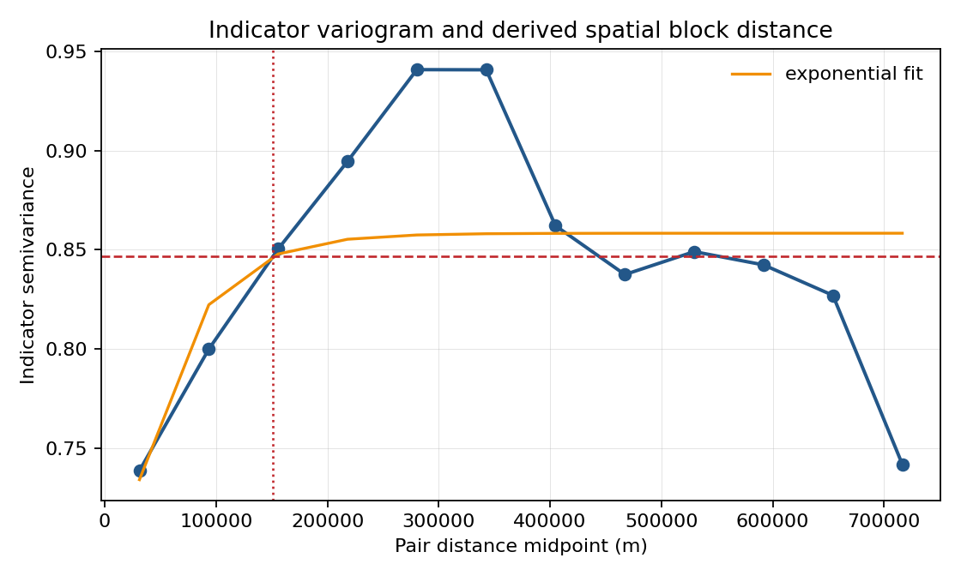

2. Materials and methods

2.1 Agricultural decision context
The intended users are agricultural mapping teams that must create or update crop and land-cover inventories with limited verified labels and limited field-survey capacity. The workflow is designed for tasks such as identifying where paddy fields require irrigation-related planning, where rubber and oil palm inventories need field confirmation, and where settlement or forest classes should be excluded from crop-area estimates. The decision layer is especially relevant when field teams cannot visit every uncertain point and need a transparent rule for prioritizing checks.
The operational unit in the current experiment is a verified sample location rather than a cadastral field polygon. This choice keeps the evidence chain strict: every reported metric is computed only from verified samples and written to disk with provenance. In a production deployment, the same decision rules would be applied to pixels, candidate parcels, or field objects after wall-to-wall inference. The manuscript therefore evaluates the decision logic and evidence sufficiency before claiming an operational map product.
A typical field campaign begins with more candidate locations than the team can visit. If verification teams have a fixed number of available visits, a random audit wastes part of the budget on easy or already reliable locations. A confidence-only strategy can also be incomplete because high probability does not necessarily mean calibrated trust under spatial dependence. The proposed workflow gives the field manager a ranked audit list derived from conformal prediction sets and probability margins, while retaining the ability to mark some map units as not ready for release.
The practical interpretation is deliberately simple. The auto-map queue is the portion of the map that can be used for preliminary inventory. The expert-review queue is a desk-based interpretation workload, often cheaper than field visits, where an analyst can inspect imagery or ancillary information for two plausible classes. The field-verify/refuse queue is reserved for ambiguous locations where remote evidence is insufficient. This separation is closer to how agricultural agencies manage scarce verification resources than a single probability threshold.

2.2 Verified samples, weak references, and study legend
The final reference set contains 524 verified samples. The locked legend contains six classes: oil palm, rubber, paddy, other agriculture, forest, and built-up/other. ESA WorldCover, Dynamic World, and FDP probability hints were not treated as ground truth. They were used only for candidate screening and for a contamination audit against the verified reference set.

2.2.1 Reference-label provenance and verification protocol
The term verified refers to rows whose `verified` field is true in the locked reference file. It does not imply that every row was newly collected during an in-situ field campaign. To match the evidence actually available in the repository, the reference-label protocol is described as an author-controlled and user-confirmed visual/reference review workflow. Candidate labels could be proposed from existing user-confirmed references, weak screening products, and multi-source comparison evidence, but a row entered the final reference set only after the recorded verification status accepted the label.
Four safeguards were used to keep weak labels from becoming hidden ground truth. First, weak products were retained in separate hint columns rather than overwriting the final class. Second, the final class was taken only from rows with `verified == True`. Third, provenance fields record the source reference, verification source, user confirmation status, and review notes. Fourth, weak products were audited after locking the labels, so their agreement or disagreement could not define the reported truth. Table 1 records the provenance fields that protect this distinction.
Table 1. Reference-label provenance recorded in the locked verified reference file.
Reference source | Verification evidence recorded in CSV | n
existing_user_confirmed_reference | Previously user-confirmed verified reference sample | 345
priority_candidates_CODEX_OPINION_80_USER_CONFIRMED_MATCH_20260603 | USER_VISUAL_REVIEW_CONFIRMED_CODEX80_OPINION | 80
codex_balanced_completion_provisional | User confirmed agreement with the Codex-filled comparison opinion in the Codex thread on 2026-06-02 | 67
targeted_codex_opinion_user_confirmed_20260603 | User confirmed that their targeted-candidate review matched the Codex comparison opinion in the Codex thread on 2026-06-03. | 32
The current artifact also retains 32 rows with non-empty warning metadata from the candidate-review workflow. These rows are not treated differently in the experiments because the locked file records `verified == True`; nevertheless, the warning count is disclosed here so reviewers can distinguish a transparent reference audit trail from a conventional field-survey dataset.
This limitation is important for CEA positioning. The experiments evaluate a sample-level decision layer and its evidence sufficiency under a strict reference file. They do not claim a full parcel-level map, a new field-survey campaign, or monetary field-cost savings. A future operational submission should add independently collected field or parcel labels under reported survey conditions; the present manuscript reports the decision-support method and the reproducible evidence gates that identify where such additional verification is needed. Table 2 and Table 3 summarize the class and region denominators used by the evidence gates.
Table 2. Verified sample counts by final study class.
Class | Verified samples
oil_palm | 86
rubber | 75
paddy | 92
other_agri | 62
forest | 126
builtup_other | 83
Table 3. Verified sample counts by region key.
Region key | Verified samples
johor_negeri_pahang_rubber_belt | 75
kedah_perlis_paddy_belt | 131
study_area | 318
The study legend was kept compact because overly detailed legends can create unstable calibration classes under sparse labels. The six classes retain the agricultural distinctions that matter for the decision-support objective: oil palm and rubber as perennial commodity crops, paddy as an irrigation-relevant seasonal crop, other agriculture as a broader managed-land category, forest as a non-agricultural natural cover, and built-up/other as an exclusion or settlement-related category. Classes with too few calibration samples are not silently reported, because unstable per-class conclusions would be misleading for deployment.

2.3 Feature stacks and classifier
Four feature stacks were evaluated under identical preprocessing and fixed classifier settings. B0 used Sentinel-2 spectral and index features; B1 combined Sentinel-1 and Sentinel-2; B2 used the 64-dimensional AlphaEarth annual embedding; and B3 combined AlphaEarth with Sentinel-1/Sentinel-2. Random Forest was the primary classifier because the study objective was not per-stack hyperparameter optimization but the evaluation of a downstream trust and verification layer. XGBoost was run as a limited model-family robustness check on the same locked sample table, but the current CEA decision-layer outputs are reported for Random Forest because that is the implemented conformal-action pipeline. Table 4 lists the feature stacks and their agricultural roles.
Table 4. Feature stacks and agricultural roles.
Stack | Feature content | Agricultural role in the comparison
B0 | Sentinel-2 spectral and index features | Optical baseline familiar to crop mapping workflows
B1 | Sentinel-1 plus Sentinel-2 | Radar-optical baseline for cloud-prone agricultural mosaics
B2 | AlphaEarth 64-dimensional embedding | Foundation-model representation under sparse verified labels
B3 | AlphaEarth plus Sentinel-1/Sentinel-2 | Combined representation for trust-action and budget tests
The feature-stack comparison is used to evaluate how different information sources affect trust actions, not to tune separate models for each stack. This distinction matters for reproducibility: a stack that receives more favorable hyperparameter tuning could appear better for reasons unrelated to the information content. Fixed classifier settings keep the comparison focused on the operational effect of the features and the downstream conformal decision layer (Belgiu and Dragut, 2016; Pelletier et al., 2016).

2.4 Spatial honesty and conformal calibration
The spatial-block distance was derived from an indicator empirical variogram rather than chosen manually. The regenerated range model used indicator semivariance, an exponential range model, and selected approximately 151 km as the block distance. The empirical fallback distance was approximately 218 km, but the recorded chosen method was exponential_model. This distance was used to construct zero-leakage spatial folds and spatially separated conformal calibration/test partitions. The workflow asserts zero leakage for spatial evaluation and logs split status to disk.
Conformal prediction was evaluated under both random and spatial calibration/test splits. For each test sample, the trained classifier produced class probabilities. Nonconformity scores from the calibration set determined the conformal threshold, and classes above the resulting probability threshold formed the prediction set. Classes below the configured minimum calibration count were dropped according to the config and logged rather than silently reported. This conservative handling follows the logic of set-valued classification: uncertainty is allowed to widen the returned set or trigger abstention rather than being hidden inside a single forced label (Sadinle et al., 2019; Vovk et al., 2005).
Conformal coverage in this manuscript is conditional on the locked verified-reference labels. The completed blind second-reader visual audit provides an inter-reader reliability check, but it is not a geotagged field survey and does not estimate the full label-noise process. Label-noise-adjusted conformal coverage therefore remains SKIPPED rather than reported from an unsupported assumption.
The spatial split is more conservative than the random split because nearby samples can share unobserved landscape structure, management history, sensor artifacts, and phenology. If calibration and test points are close together, the uncertainty layer may appear better calibrated than it will be when deployed to a genuinely separate area. The variogram-derived distance provides a data-driven way to set this separation distance rather than using an arbitrary buffer.
The workflow also separates two types of honesty. Spatial honesty asks whether the evaluation samples are separated enough to avoid leakage. Statistical honesty asks whether conformal coverage is reported under the split that matters for deployment, not only under a random split. The manuscript therefore reports both random and spatial conformal results and does not treat random coverage as sufficient evidence for operational release (Ploton et al., 2020; Wadoux et al., 2021).
The final support-aware pipeline adds an explicit class-support estimand gate to prevent unsupported class-folds from being interpreted as releasable map errors. A B3 test sample is router-evaluable only when its true class has enough zero-leakage outer-training support to supply the configured minimum calibration count and the minimum model-training count. With min_class_count = 30 and five retained model-training cases, this requires at least 35 outer-training samples for that class in the fold. Test rows below this support threshold are assigned to field verification or refusal, while raw forced-label classifier output is retained only as a diagnostic of spatial support failure.
To diagnose that failure without weakening the declared spatial rule, a support-density sensitivity reran the same zero-leakage fold construction at fractions of the variogram-derived range and under diagnostic coarse legends. These rows are not replacement headline estimates. They ask whether the support failure is relieved by block scale, by legend coarsening, or only by adding more spatially separated verified samples. Under the locked six-class legend, router-evaluable support was 217/524 at 0.25x, 77/524 at 0.55x, and 174/524 at 1.00x. The broad three-class agriculture/forest/built-up diagnostic reached 445/524 at 1.00x, but that changes the product from crop-specific inventory to a coarse land-cover triage.

2.5 Trust-action layer
The trust-action layer is the central CEA contribution. The final pipeline uses class-conditional conformal sets as an uncertainty diagnostic, AoA as an applicability gate, and a fold-specific calibration risk threshold as the release gate. A sample is eligible for automatic mapping only when its prediction set contains one class, it lies inside the AoA, and its top probability passes a threshold selected without test labels. Samples outside AoA, larger conformal sets, singleton cases below the calibration risk threshold, non-evaluable classes, or folds with no certifiable risk threshold are sent to field verification or refused for automated mapping. Table 5 summarizes this action mapping.
Table 5. Risk-controlled operational action mapping from conformal, AoA, and calibration evidence.
Evidence condition | Operational action | Agricultural interpretation
Set size = 1, inside AoA, and top probability passes the calibration risk gate | Risk-controlled auto-map | Release the label for preliminary inventory with a fold-specific calibration audit trail
Set size = 2 and inside AoA | Expert review for two-class ambiguity | Ask an analyst to resolve the specific two-class ambiguity
Outside AoA, set size >= 3, singleton below the risk gate, or no certifiable risk threshold | Field verification or refusal | Prioritize field verification or exclude from automated reporting

2.6 Field-verification budget policies
The field-audit experiment asks how a survey team should allocate a fixed number of visits after a map has been produced. Policies were compared at several budget shares. The random baseline is an exact expected value for simple random field checks. Deterministic policies prioritize model-visible uncertainty signals only: low confidence, low top-vs-second probability margin, large conformal prediction set size, trust-action priority, and a composite conformal-risk score. Verified labels are used only after selection to evaluate how many errors would have been intercepted. The experiment therefore connects accuracy-assessment practice with an agricultural decision-support task: where limited verification effort should go first (Boryan et al., 2011; Olofsson et al., 2014).
The audit-budget experiment does not treat point estimates as field-cost savings. The budget tables report checks per detected error, error capture, audit precision, and residual unchecked error from the held-out sample-level decision table. The policies use model-visible uncertainty signals only, and verified labels are used only after selection to evaluate the audit list.
This design avoids an important pitfall. It does not use true labels to choose which samples to inspect. Therefore, the field-audit curves simulate a decision-support tool that could be applied before field teams leave the office.
The budget experiment reports several operational quantities. Error capture rate measures the fraction of mapping errors intercepted by the audit list. Audit precision measures how often a selected field-check location is actually an error. Unchecked error rate estimates residual risk among locations not selected for verification. Field checks per detected error is the most direct labor-efficiency proxy, because it asks how much field effort is needed to find one incorrect map label. No monetary costs are reported because travel, labor, and opportunity costs were not measured.

2.7 Blind-audit alignment and second-annotator gate
A previous author-confirmed blind remote audit is retained as historical package evidence, but it is no longer evaluated against the abandoned single-split denominator. The historical audit contains 70 samples; all 70 now overlap the B3 outer spatial cross-fit, 47 overlap the router-evaluable subset, and 14 overlap the risk-controlled auto-map subset. Because this historical table is not a locked second-reader agreement table and is not geotagged field truth, it is used only as a membership audit; Cohen's kappa is not reported from this historical table.
The alignment result changes after moving to the outer spatial cross-fit: the old remote-audit rows are no longer absent from the evaluation universe, but they still do not close the validation gate. They cover only part of the router-evaluable and risk-auto subsets and cannot be promoted into field validation. A separate completed R2 blind second-reader table now supplies a readable-pair inter-reader agreement audit for all 524 sample rows.
The completed R2 blind second-reader table contains 524 rows, including 500 readable paired labels and 24 rows preserved as unreadable. On the 500 readable pairs, observed agreement was 0.606, expected agreement was 0.181, and Cohen's kappa was 0.519. A targeted rubber-rescreen sensitivity increased rubber agreement from 5/70 to 8/70 but reduced overall kappa from 0.519 to 0.511, so it is treated as sensitivity evidence rather than the primary audit.

2.8 Weak-reference contamination and leave-region readiness gates
The weak-reference audit maps weak-product labels to the study legend where possible and computes coverage, exact agreement, agricultural mismatch, and threshold screening performance. The leave-region audit is not framed as a performance result. It is a readiness gate: if a target region lacks enough zero-leakage source samples and calibration-supported target agricultural classes, the row is recorded as SKIPPED and no transfer accuracy is claimed.
This gate is useful even when it produces no positive transfer result. In operational mapping, a failed readiness gate tells the field team what additional data are needed before deployment: more verified labels, better spatial separation, or more balanced target-region class coverage. Treating the failure as a formal output is preferable to relaxing constraints until a numerical accuracy can be printed.

2.8.1 Open public-evidence audit
The open public-evidence audit was rerun on the B3 outer spatial cross-fit denominator. For each of 524 samples, the script generated public map and evidence links and queried available public sources under the configured API limits. The audit found 0 samples with any API-returned public ground-view candidate and 0 evidence records. These open evidence layers are used only as triage and transparency evidence. They are never treated as ground truth or as author-collected in-situ field validation.

2.9 Reproducible implementation
All experiments were executed from configuration files and repository scripts. Each output table contains timestamp, configuration hash, input file names, random seed, status, and reason fields. Figures were written as PNG artifacts. If a metric could not be computed, the pipeline wrote SKIPPED, MISSING, or ERROR rather than an empty or guessed value.
The reproducibility design is part of the scientific contribution because decision-support systems used in agriculture must be inspectable. If a field team changes the study area, class legend, calibration count threshold, or feature stack, the same scripts can expose whether results remain valid. The evidence index records the current version of every table, figure, script, and provenance file used in this draft.

3. Results

3.1 Trust actions change the interpretation of map performance
The final evaluation resolves the earlier split mismatch by evaluating classifier accuracy and router actions inside the same outer spatial folds. Under the standard zero-leakage folds, B3 achieved mean OA 0.460 and macro-F1 0.331 across all 524 outer-test samples when the classifier was forced to return a label for every sample. The support-aware analysis treats that all-sample classifier output as a stress diagnostic rather than a release denominator. The support-aware router could be evaluated on 174 retained-class test samples after applying the configured calibration support rule; the other 350 samples were sent directly to field verification or refusal. In this common spatial-CV denominator, singleton set size alone was not reliable, while the combined AoA and calibration risk gate produced a smaller but substantially safer auto-map queue. Table 6 and Fig. 2 summarize the stack-level performance and release decisions. Table 6 and Table 7 report the paired performance and support accounting.
Table 6. Random Forest spatial cross-fitted performance and risk-controlled routing.
Stack | Spatial CV mean OA | Spatial CV macro-F1 | Router evaluable n | Risk auto n (% eval; % all) | Auto-map acc. (95% CI) | Not auto-mapped n
B0 | 0.319 | 0.248 | 174 | 40 (23.0%; 7.6%) | 0.800 [0.652, 0.895] | 484
B1 | 0.397 | 0.288 | 174 | 42 (24.1%; 8.0%) | 0.762 [0.615, 0.865] | 482
B2 | 0.472 | 0.331 | 174 | 40 (23.0%; 7.6%) | 0.825 [0.681, 0.913] | 484
B3 | 0.460 | 0.331 | 174 | 32 (18.4%; 6.1%) | 0.938 [0.799, 0.983] | 492
Table 7. B3 class-support accounting under zero-leakage spatial folds.
Class | Outer-test n | Router-evaluable n | Field/refuse n | Support interpretation
oil_palm | 86 | 0 | 86 | Not estimable under spatial support rule
rubber | 75 | 1 | 74 | Partly router-evaluable; remaining samples require field/refuse
paddy | 92 | 40 | 52 | Partly router-evaluable; remaining samples require field/refuse
other_agri | 62 | 3 | 59 | Partly router-evaluable; remaining samples require field/refuse
forest | 126 | 126 | 0 | Fully router-evaluable
builtup_other | 83 | 4 | 79 | Partly router-evaluable; remaining samples require field/refuse
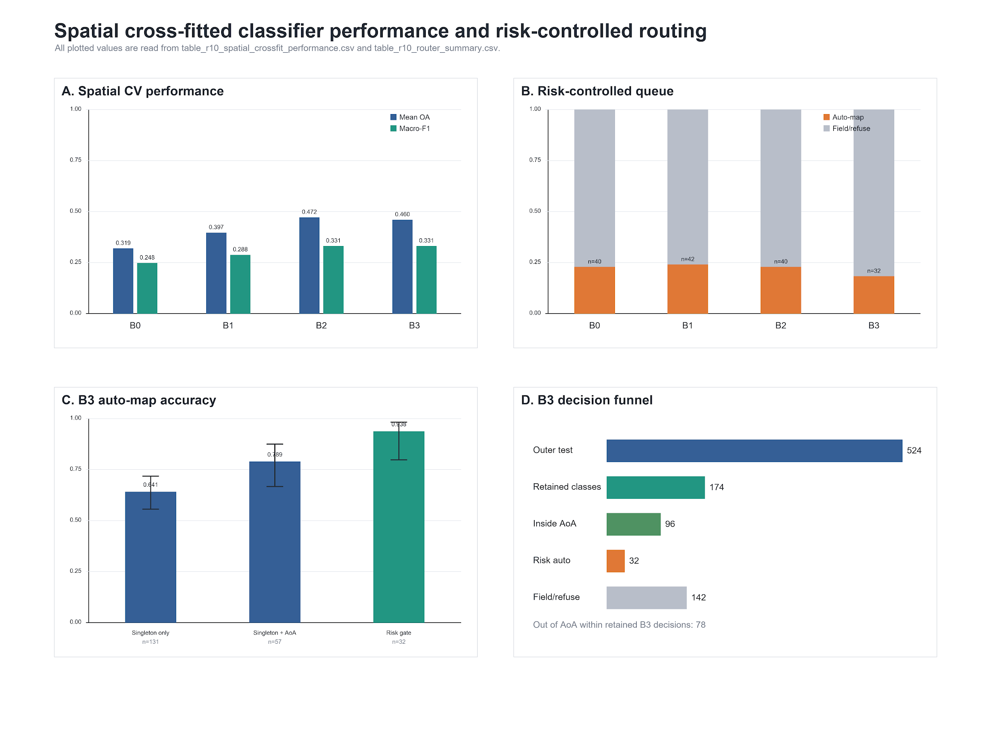
Figure 2. Spatial cross-fitted classifier performance and risk-controlled router decisions.
For an agricultural user, the important pattern is the trade-off between release rate and residual risk. B2 and B3 have the strongest spatial-CV macro-F1 among the four stacks, but automatic release becomes defensible only after the risk gate reduces the queue. For B3, this means 32 automatically released samples, or 6.1% of the full outer-test denominator, while 492 samples remain not auto-mapped. The resulting product is therefore a conservative triage layer for verification planning rather than a claim that the full map can be released without review.
The class-support audit explains the apparent oil-palm and rubber collapse in the raw forced-label confusion matrix. At the variogram-derived block distance, all 86 oil-palm outer-test samples and 74 of 75 rubber samples fell in fold-class combinations that lacked the required training support. The new support-density sensitivity shows that this is not solved by simply switching to the approximately 83.0 km diagnostic block: the locked six-class legend retained only 77 of 524 samples there, with 0/86 oil-palm and 0/75 rubber support. Even at 0.25x, only 11/86 oil-palm and 28/75 rubber samples became router-evaluable. Merging oil-palm and rubber into a perennial-plantation class at 151 km raised support only to 182/524, so that merge alone does not rescue the crop-specific product. A stratified random diagnostic using the same B3 stack reached pooled OA 0.737 and macro-F1 0.719, with oil-palm F1 0.854 and rubber F1 0.614; this remains a non-spatial diagnostic, but it confirms that the failure is spatial support density rather than complete feature non-identifiability.
The B3 result illustrates why the workflow should not be reduced to a promotional statement about a combined feature stack. The combined stack is useful because it gives the risk-controlled router a small high-confidence queue while preserving explicit refusal for most remaining cases. Class-conditional conformal calibration reduced the number of empty prediction sets from 79 to 32, but retained-subset coverage remained 0.713, below the nominal 0.900 target. The paper's main claim is therefore the conservative calibrated routing rule, not universal superiority of one feature stack or a conformal coverage guarantee under spatial shift.

3.2 Field-audit allocation reduces wasted verification effort
For the B3 outer spatial cross-fit at a 20% audit budget, the budget experiment is restricted to the 174 router-evaluable retained-class samples because the 350 non-evaluable samples have no conformal/probability action and are already routed to field verification or refusal. Within that evaluable denominator, a 20% audit inspects 35 samples. Class-conditional conformal set-size prioritization captured 16 of 63 verified-key errors, while a random audit was expected to capture 12.7. Low-confidence and low-margin prioritization captured 15 and 16 errors, respectively. These policies are reported as uncertainty-ranking diagnostics, not as field-proven cost savings. Table 8 and Fig. 3 summarize the audit-budget comparison. Table 8 reports the 20% audit-share comparison.
Table 8. B3 outer spatial cross-fit field-audit budget summary at 20% audit share.
Policy | Budget | Checks | Errors found/expected | Error capture | Checks per error
Random expected | 20% | 35 | 12.7 | 0.201 | 2.762
Class-conditional set size | 20% | 35 | 16 | 0.254 | 2.188
Low confidence | 20% | 35 | 15 | 0.238 | 2.333
Low margin | 20% | 35 | 16 | 0.254 | 2.188
Field/refuse first, then low confidence | 20% | 35 | 15 | 0.238 | 2.333
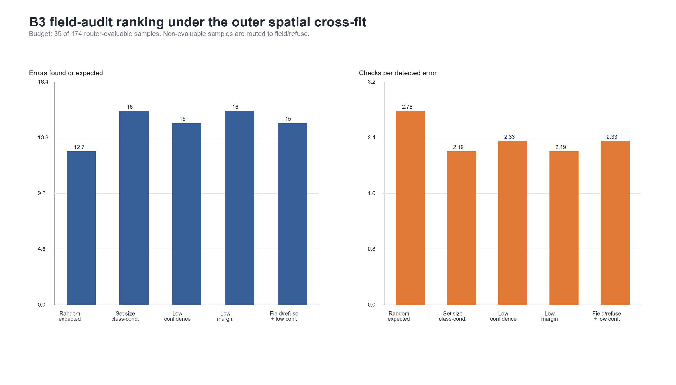
Figure 3. Field-verification budget curves under spatial evaluation.
The interpretation for field planning is deliberately narrow. If a team can inspect only 35 of the 174 router-evaluable B3 samples, selecting by class-conditional conformal set size or low margin finds more verified-key errors than random expected checking. This does not imply that the selected samples are the only locations needing attention. It means the uncertainty layer can triage the first wave of verification within the retained-class router subset, while the 350 non-evaluable samples remain in the field/refuse queue.
The experiment also avoids over-optimistic active learning language. The policy is not evaluated by retraining after new labels are added. It is evaluated as a post-map audit allocator: after a candidate map exists, which locations should be checked first? This is a narrower and more directly operational claim.

3.3 Blind-audit alignment replaces reuse of the old remote-audit denominator
The old author-confirmed blind remote audit covered 70 locations. Under the outer spatial cross-fit, those 70 locations all have B3 outer-test predictions, but only 47 fall in the retained-class router denominator and only 14 fall in the risk-controlled auto-map subset. The audit therefore supports denominator accounting, not an accuracy or kappa claim. The new R2 table is used for readable-pair inter-reader agreement instead.
The scientific consequence is to weaken, not decorate, the claim. The manuscript does not use the historical remote-audit queue rates as current validation evidence. Instead, it reports the membership overlap as a reproducibility gate and reports the completed R2 blind second-reader audit as remote visual inter-reader agreement, not as in-situ validation. Table 9 summarizes both the historical alignment and completed R2 visual-agreement audit.
Table 9. Blind remote-audit alignment and completed R2 second-reader visual agreement.
Metric | Count/status | Interpretation
Historical author-confirmed remote-audit records | 70 | Historical remote audit rows; not field truth and not the source of Cohen's kappa.
Overlap with B3 outer spatial cross-fit | 70 | Old audit samples that now have B3 outer spatial cross-fit predictions.
Overlap with router-evaluable subset | 47 | Old audit samples inside the retained-class router denominator.
Overlap with risk-controlled auto-map subset | 14 | Old audit samples inside the risk-controlled auto-map subset.
Completed R2 blind second-reader rows | 524 | Remote visual second-reader audit; not geotagged field truth.
Readable/scorable R2 pairs | 500 | Twenty-four rows were preserved as unreadable and excluded from readable-pair agreement.
Primary R2 readable-pair agreement | agreement 0.606; kappa 0.519 | Expected agreement 0.181; computed from the completed R2 table.
Rubber agreement and rescreen sensitivity | primary 5/70; V2 8/70 | Rubber remains unstable; V2 overall agreement 0.600 and kappa 0.511, so V2 is sensitivity evidence, not a rescue result.
The earlier remote-audit yield figure is not carried forward as validation evidence because the historical audit is remote and partial. The completed R2 audit replaces the previous MISSING kappa gate only for readable-pair visual agreement; it does not replace geotagged field validation.

3.3.1 Open public-evidence audit exposes the remaining field-data gap
The public ground-view search did not find automatically returned public ground-view candidates for any B3 outer spatial cross-fit sample (0 of 524). This negative result is important because it prevents the manuscript from replacing missing in-situ data with unsupported public-image claims. The result supports the decision-support interpretation: the workflow can create a reproducible queue of places where remote, public, and satellite evidence should be inspected first, but it still cannot claim ground truth from field observations. Table 10 and Table 11 summarize the zero-found result, and Figure S1 and Figure S2 visualize queue availability and query status.
Table 10. Open public-evidence audit metrics for the B3 outer spatial cross-fit.
Metric/action | n or value | Status | Interpretation
B3 outer spatial cross-fit samples | 524 | OK
Samples with API-returned public ground-view candidates | 0 | OK
Public evidence records returned | 0 | OK
In-situ validation claim status | SKIPPED | SKIPPED | Public ground-view evidence is a proxy evidence chain, not author-collected in-situ GPS field validation.
Risk-controlled auto-map | 0 of 32 | OK | Public ground-view proxy availability, not field truth
Field/refuse within router-evaluable subset | 0 of 142 | OK | Public ground-view proxy availability, not field truth
Field/refuse for non-evaluable samples | 0 of 350 | OK | Public ground-view proxy availability, not field truth

Table 11. Public ground-view API availability by trust-action queue.
Trust action | n | Any public ground-view API hits | Interpretation
Risk-controlled auto-map | 32 | 0 (0.0%) | Public ground-view proxy availability, not field truth
Field/refuse within router-evaluable subset | 142 | 0 (0.0%) | Public ground-view proxy availability, not field truth
Field/refuse for non-evaluable samples | 350 | 0 (0.0%) | Public ground-view proxy availability, not field truth

Figure S1. Open public ground-view availability by queue. The zero-found result is retained because it is the computed outcome of the open-evidence search.
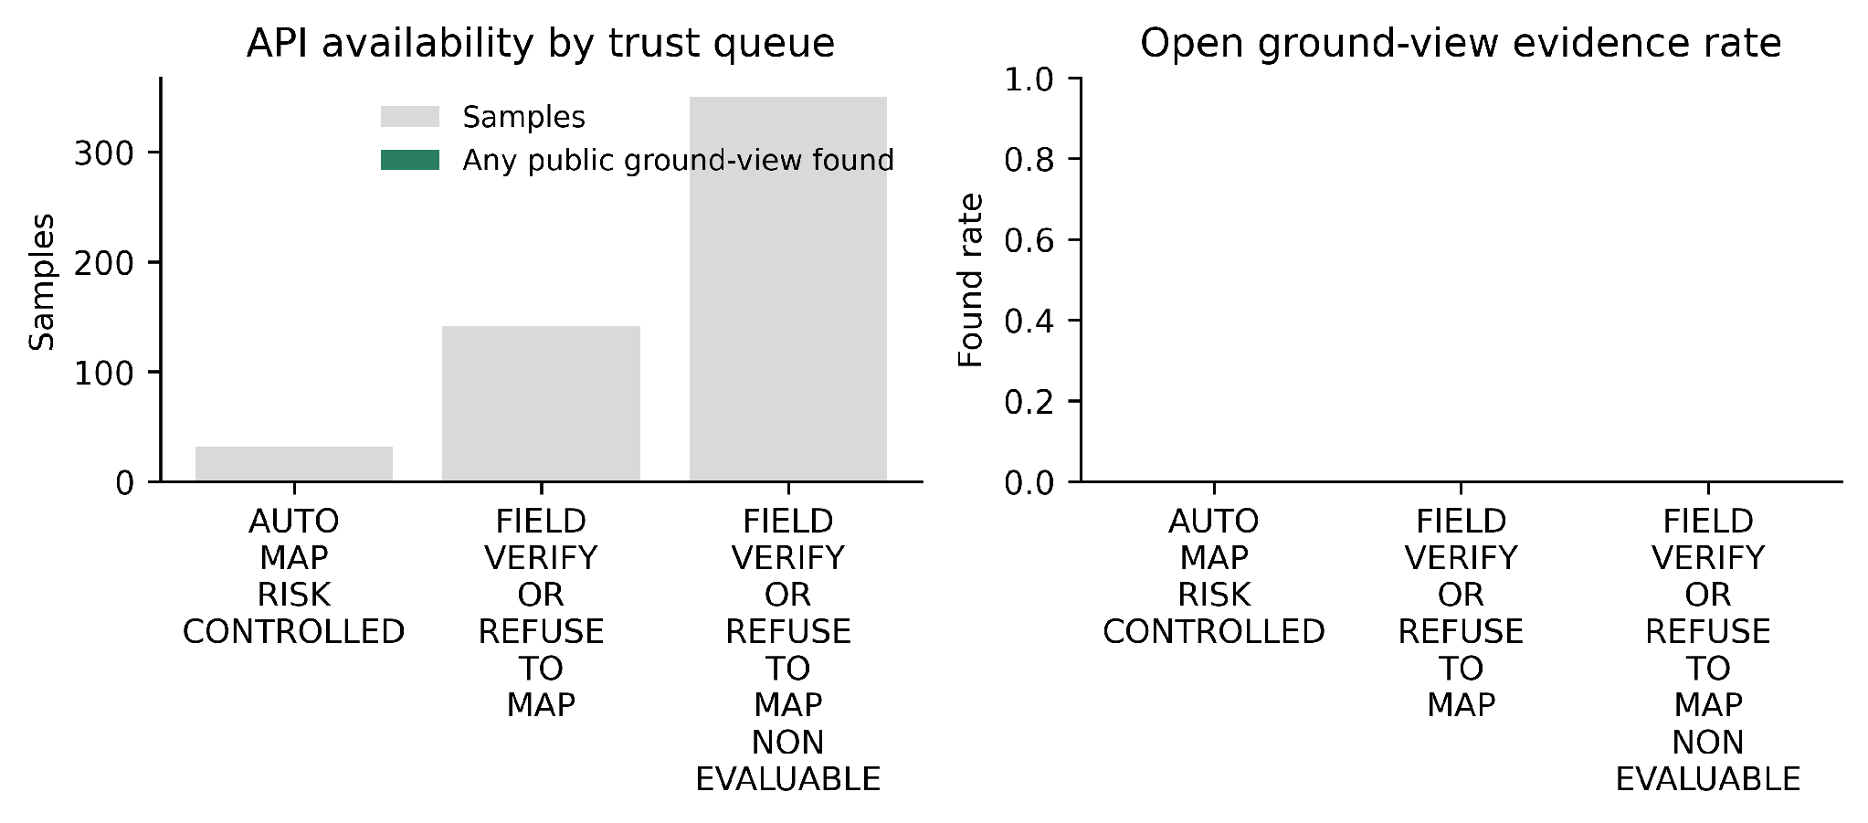
Figure S2. Public evidence query status. This figure documents search status rather than in-situ validation.
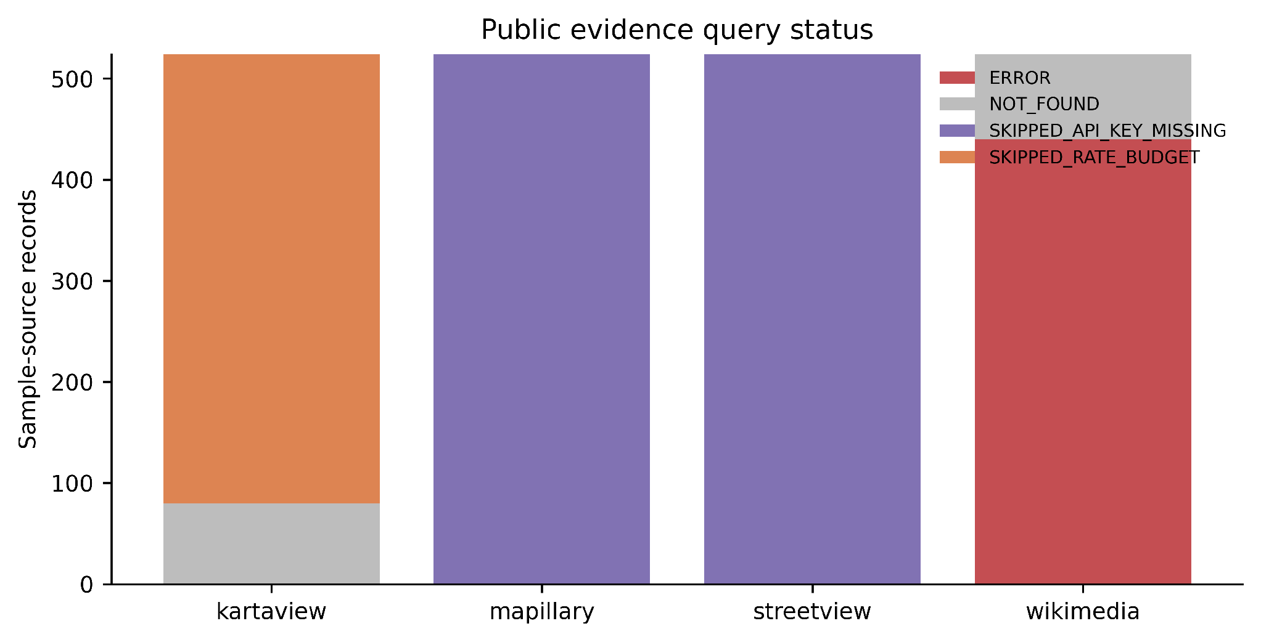

3.4 Weak references would contaminate smallholder agricultural truth
Weak-product labels were available for 32.1% of verified samples in both the WorldCover and Dynamic World audits. After mapping weak labels to the study legend, exact match rates were only 0.393 for WorldCover and 0.464 for Dynamic World. The problem was more severe for agricultural classes: mismatch rates were 0.898 and 0.927, respectively.
The class-level contamination is agriculturally meaningful. Rubber was collapsed to forest in 53 WorldCover-hint rows and 53 Dynamic World-hint rows. Paddy was collapsed to other agriculture in 25 WorldCover rows and 23 Dynamic World rows. These are not minor label differences; they affect crop inventory and field-survey routing. Table 12 and Figure S3 summarize this weak-reference contamination.
Table 12. Weak-reference contamination against verified smallholder labels.
Weak source | Weak-label coverage | Exact match | Agricultural mismatch | Key agricultural failure
worldcover_hint | 32.1% | 0.393 | 0.898 | rubber->forest: 53; paddy->other_agri: 25
dynamicworld_mode_hint | 32.1% | 0.464 | 0.927 | rubber->forest: 53; paddy->other_agri: 19
Figure S3. Weak-reference contamination against verified smallholder labels.
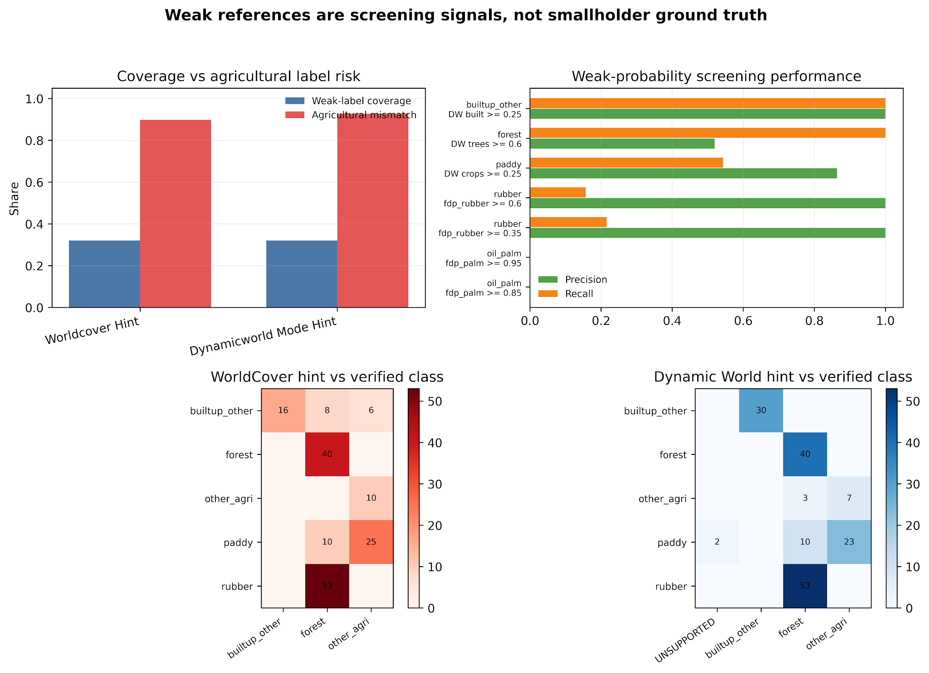
The weak-reference contamination figure is retained as a supplementary diagnostic because the main claim rests on regenerated spatial cross-fit, risk-routing, AoA, and evidence-gate outputs.
The threshold audit gives a more nuanced view. Some weak probabilities can be useful for screening a narrow candidate class. For example, high FDP rubber probability is precise but misses many verified rubber samples, whereas Dynamic World crop probability captures only part of paddy. This confirms the correct role of weak products: they can reduce search space for human review, but they cannot replace final verified labels.

3.5 Area of Applicability adds a deployment safety gate
AoA was added as a second, distance-based safety gate alongside conformal set size. In the earlier single spatial conformal diagnostic, B2 marked 17 of 110 samples outside the AoA, whereas B3 marked 5 of 110 outside. This difference follows from stack-specific feature geometry and calibration thresholds: the B2 DI threshold was 1.458, while the B3 threshold was 1.712. In the final B3 outer spatial cross-fit, 96 of 174 retained-class decisions were inside the AoA and 78 were outside. Because the current samples come from one broad connected study system, AoA is best interpreted as a deployment safety gate for future distribution shift rather than as proof of an enriched singleton-error detector in the present data. Table 13 summarizes AoA membership, Table 14 summarizes action-policy routing, and Fig. 4 shows the AoA and conformal routing diagnostics.
Table 13. AoA membership and interpretation under single-split and cross-fitted evaluations.
Evaluation | Stack | Test/evaluable n | In AoA | Out of AoA | DI threshold/source | Interpretation
Single spatial conformal diagnostic | B2 | 110 | 93 | 17 | 1.458 | AoA fires more often in the AlphaEarth-only feature space
Single spatial conformal diagnostic | B3 | 110 | 105 | 5 | 1.712 | Higher DI threshold and combined features produce fewer out-of-AoA flags
Outer spatial cross-fit | B3 | 174 | 96 | 78 | fold-specific calibration quantile | AoA is evaluated inside each zero-leakage fold
Figure 4. AoA and conformal routing diagnostics. AoA is a safety gate; it is not reported as a proven singleton-error enrichment effect in the current sample set.
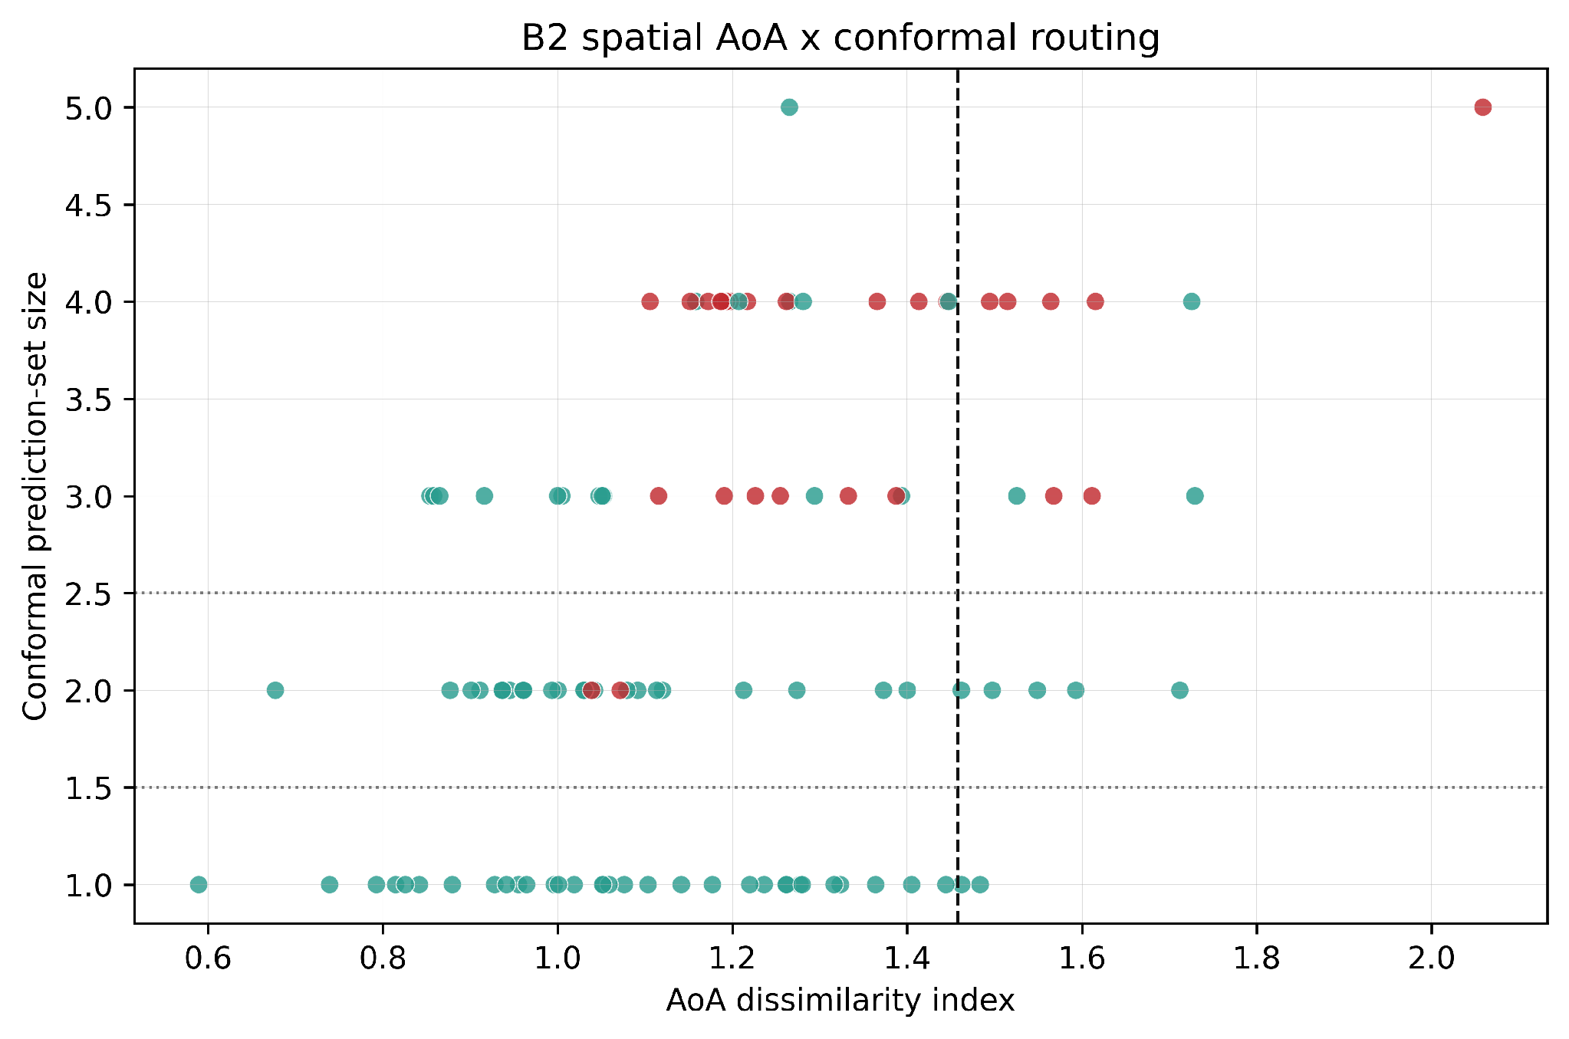
Table 14. B3 spatial cross-fitted router summary by action policy.
Action policy | Action | n | Accuracy (Wilson 95% CI) | Coverage | Mean set size | Errors | Error capture
Set-size-only diagnostic before AoA | Singleton auto-map diagnostic | 131 | 0.641 [0.556, 0.718] | 0.634 | 0.756 | 47 | 0.746
Set-size-only diagnostic before AoA | Expert review for two-class ambiguity | 39 | 0.590 [0.434, 0.729] | 0.949 | 2.000 | 16 | 0.254
Set-size-only diagnostic before AoA | Field verification or refusal | 4 | 1.000 [0.510, 1.000] | 1.000 | 3.000 | 0 | 0.000
Set size plus AoA diagnostic | Singleton auto-map diagnostic | 57 | 0.789 [0.667, 0.875] | 0.789 | 0.895 | 12 | 0.190
Set size plus AoA diagnostic | Expert review for two-class ambiguity | 36 | 0.611 [0.449, 0.752] | 0.944 | 2.000 | 14 | 0.222
Set size plus AoA diagnostic | Field verification or refusal | 81 | 0.543 [0.435, 0.647] | 0.556 | 0.815 | 37 | 0.587
Set size plus AoA plus calibration risk gate | Risk-controlled auto-map | 32 | 0.938 [0.799, 0.983] | 0.938 | 0.969 | 2 | 0.032
Set size plus AoA plus calibration risk gate | Field verification or refusal | 142 | 0.570 [0.488, 0.649] | 0.662 | 1.113 | 61 | 0.968

3.6 Leave-region SKIPPED results become a deployment-readiness gate
The strict leave-region audit did not produce a transferable accuracy number, and this is intentional. At the variogram-derived block distance of approximately 151 km, the available verified samples were not sufficient to support a zero-leakage agricultural leave-region claim. The workflow therefore records SKIPPED rows instead of fabricating or relaxing the conclusion. Table 15 and Fig. 5 document this deployment-readiness gate.
Table 15. Leave-region feasibility audit under zero-leakage constraints.
Target region | Status | Reason | Target n | Zero-leakage source n | Target agri retained
Johor-Pahang rubber belt | SKIPPED | Configured source calibration split retains no target agricultural class with calibration count >= min_class_count=30. | 75 | 110 | 0
Kedah-Perlis paddy belt | SKIPPED | Configured source calibration split retains no target agricultural class with calibration count >= min_class_count=30. | 131 | 387 | 0
Core study area | SKIPPED | Configured source calibration split retains no target agricultural class with calibration count >= min_class_count=30. | 318 | 4 | 0
Figure 5. Leave-region feasibility audit under zero-leakage constraints.
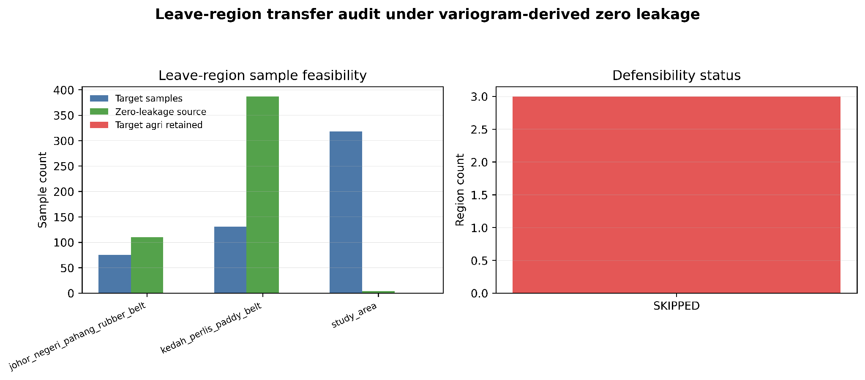
This table does not solve the external-validation problem; it narrows the claim. The manuscript does not say that external-region transfer works. It says the current evidence is insufficient for that claim under the declared rules, and it provides a reproducible gate that would become OK only after enough verified, spatially separated samples exist.

3.7 Spatial-block sensitivity confirms sparse independent support
The selected indicator-variogram block distance is approximately 151 km. The spatial-block accuracy rows are not monotonic because the four-fold composition changes as the block distance changes; with only four folds, shifts in which spatial blocks enter each test partition can dominate any smooth distance trend. The support-density diagnostic adds the missing class-support view: under the locked six-class legend, the approximately 83.0 km diagnostic block retained only 77/524 samples, and the 0.25x diagnostic retained 217/524. Coarse legends can recover support, with the three-class agriculture/forest/built-up diagnostic retaining 445/524 at 151 km, but this changes the map product. Table 16 reports forced-label accuracy sensitivity; Table 17 reports the support-density frontier. Figure 6 visualizes the same block-sensitivity result and effective folds.
Table 16. Spatial-block sensitivity for B3 Random Forest; rows are diagnostic and non-monotonic because fold composition changes.
Range multiplier | Block distance | OK folds | B3 RF mean OA | B3 RF macro-F1 | Interpretation
0.25x | approximately 38 km | 4 | 0.486 | 0.462 | diagnostic; fold composition changes with block size
0.35x | approximately 53 km | 4 | 0.509 | 0.468 | diagnostic; fold composition changes with block size
0.50x | approximately 75 km | 4 | 0.482 | 0.430 | diagnostic; fold composition changes with block size
0.75x | approximately 113 km | 4 | 0.270 | 0.254 | diagnostic; fold composition changes with block size
1.00x | approximately 151 km | 4 | 0.460 | 0.331 | diagnostic; fold composition changes with block size
Table 17. Support-density frontier for block scale and legend-resolution diagnostics.
Diagnostic setting | Block scale | Router-evaluable n/524 | Interpretation
Locked 6-class | 0.25x (37.7 km) | 217/524 (41.4%) | Partial only: oil-palm 11/86; rubber 28/75
Locked 6-class | 0.55x (83.0 km) | 77/524 (14.7%) | Does not rescue oil-palm/rubber support
Locked 6-class | 1.00x (150.9 km) | 174/524 (33.2%) | Declared spatial-honesty setting; strict but sparse
Perennial merge (5-class) | 1.00x | 182/524 (34.7%) | Oil-palm+rubber merge alone remains insufficient
Coarse 4-class | 1.00x | 288/524 (55.0%) | Improves support but sacrifices other-agriculture detail
Coarse 3-class | 1.00x | 445/524 (84.9%) | Supportable broad triage; not crop-specific inventory
Figure 6. Spatial-block sensitivity and effective spatial folds.
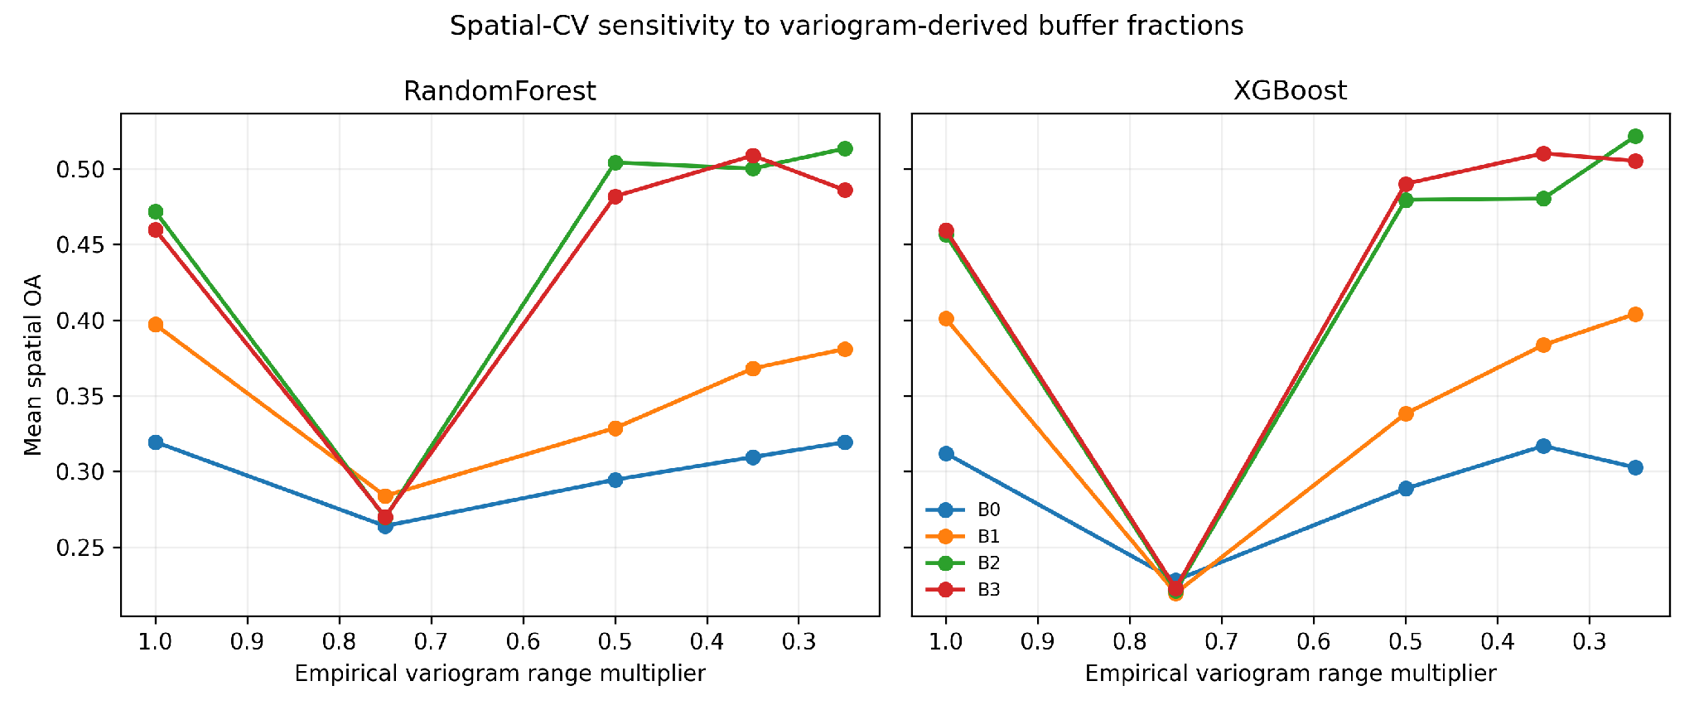

4. Discussion

4.1 Why this is an agricultural computing contribution
The revised framing is deliberately different from a conventional remote-sensing accuracy paper. The system is a computer-based decision layer for agricultural mapping teams. It takes classifier probabilities and returns work queues: labels that can be accepted, locations that need expert review, and locations that deserve field verification. This is directly aligned with agricultural computing because it changes how limited human and survey resources are allocated.
The field-audit, AoA, open-evidence, and second-reader experiments provide concrete operational measures, but the manuscript separates what is demonstrated from what remains pending. The budget experiment shows that uncertainty-ranked queues can reduce checks per detected verified-key error within the router-evaluable held-out sample table. AoA adds a safety gate for deployment. The completed R2 audit gives readable-pair inter-reader agreement for remote visual labels, while the open-evidence audit shows that public ground-view evidence is unavailable in the current run. None of these outputs replaces geotagged field validation.

4.2 Implications for rubber, paddy, and smallholder inventory
The weak-reference results show why local verification is not optional in smallholder landscapes. Rubber-to-forest confusion can remove an agriculturally important perennial crop from inventory. Paddy-to-other-agriculture collapse can obscure irrigation-relevant seasonal cropland. These errors have different consequences from generic land-cover mistakes because they affect commodity monitoring, water planning, and field-survey allocation. Reporting this disagreement explicitly is more useful than relying only on aggregate accuracy indices that can hide class-specific and allocation-specific errors (Pontius and Millones, 2011; Shao et al., 2019).
The support-density and second-reader audits are the most important corrections to the oil-palm and rubber story. A raw forced-label spatial confusion matrix makes oil palm look like a classifier failure with zero predicted cases, but the support-aware accounting shows that the router had no defensible oil-palm release denominator under the declared zero-leakage support rule. Block-distance sensitivity does not provide a clean rescue: the approximately 83 km diagnostic still leaves oil palm and rubber unsupported, and 0.25x only partially recovers them. The blind second-reader audit adds a second warning: rubber agreement was only 5/70 in the primary audit and 8/70 after a targeted rescreen sensitivity. Two valid repair paths remain. If the six-class crop inventory is the target product, the next experiment must add spatially separated verified support in the shortfall folds and obtain stronger class-specific evidence for rubber. If a coarser product is acceptable, the broad agriculture/forest/built-up legend is supportable but no longer answers the oil-palm-versus-rubber inventory question. Lowering the support threshold would make the table look better while weakening the calibration claim, so it is not used.
A practical deployment would use weak references to propose candidates and prioritize review, but the final reporting layer should rely on verified samples and trust actions. The workflow therefore protects agricultural users from a common shortcut: using a global land-cover product as if it were local ground truth.

4.3 What the AlphaEarth results do and do not prove
AlphaEarth features are useful in the current workflow because B2 and B3 support the strongest spatial-CV macro-F1 and the most useful risk-controlled routing behavior among the tested stacks. However, the results do not justify a universal statement that AlphaEarth plus Sentinel is always better. The correct conclusion is that foundation embeddings can make trust-aware workflows more useful, but they still need spatial calibration, abstention, AoA checks, and local reference evidence before operational release.
Model-family robustness remains secondary in this manuscript. The primary action-layer pipeline is implemented for Random Forest, while XGBoost appears only in diagnostic sensitivity outputs. The manuscript therefore does not frame XGBoost as a complete alternative conformal-action deployment pipeline.
This is consistent with the broader uncertainty literature on land-cover mapping under domain shift: representation gains do not remove the need to report where a model is reliable, under-supported, or outside the evidence envelope (Ji and Tang, 2025).

4.4 Turning SKIPPED into a scientifically useful result
The leave-region audit, AoA singleton-enrichment gate, and second-reader tables are key changes. Instead of treating SKIPPED, MISSING, or unreadable states as weaknesses to hide, the revised CEA framing treats them as deployment-readiness tests. A decision-support system should be allowed to say that the available evidence is insufficient for external-region release, singleton-enrichment inference, all-row visual agreement, or class-specific rubber release.
This point should be emphasized in submission because it reduces reviewer risk. Reviewers may still request more external validation, but the manuscript no longer overclaims transfer. The audit table tells them exactly why the claim is not made and what data would be needed. That makes the limitation actionable rather than vague.

4.5 Recommended deployment workflow
A practical deployment would proceed in stages. First, weak products and existing local knowledge would be used to propose candidate labels and sampling strata. Second, a verified reference sample would be collected or reviewed by analysts. Third, the feature stack and classifier would generate probabilities for candidate map units. Fourth, conformal calibration would convert probabilities into prediction sets. Fifth, the trust-action layer would split outputs into auto-map, expert-review, and field-verify/refuse queues. Finally, the field team would inspect locations in descending conformal-risk order until the verification budget is exhausted.
This workflow gives managers several control points. They can raise or lower the minimum class count, change the conformal alpha value, require more stringent action thresholds, or allocate separate budgets to high-value agricultural classes. Because every run writes status and provenance, the consequences of those choices can be audited rather than treated as informal judgment.

4.6 Why CEA is the appropriate outlet
The paper belongs in Computers and Electronics in Agriculture only if framed around the decision layer rather than the sensor comparison, and only with the present evidence limits made explicit. The developed element is a software workflow that turns machine-learning output into agricultural work queues and verification priorities. The agricultural problem is limited survey capacity under class ambiguity, not remote-sensing image classification alone.
The framing follows the journal's stated emphasis on investigator-developed computer-based approaches for solving agricultural problems, rather than first-time application of off-the-shelf technology to a crop or region (Computers and Electronics in Agriculture, 2026).
If the manuscript were framed only as AlphaEarth versus Sentinel land-cover accuracy, it would be weaker for CEA and would compete with many remote-sensing classification papers. The revised framing instead treats the classifier as an input to a verification management system. That is the strongest path to CEA external review because the article's computer-based contribution changes how agricultural mapping evidence is triaged, audited, and converted into field-survey actions (Computers and Electronics in Agriculture, 2026).

5. Limitations and future work
- The present study evaluates sample-level trust-routing decisions rather than a complete full-coverage operational mapping product.
- The verified sample set is sufficient for the reported sample-level trust-action, AoA, and audit-budget experiments, but not for successful zero-leakage leave-region agricultural transfer or six-class oil-palm/rubber release without targeted support expansion.
- No monetary field-survey cost data were available; cost implications are therefore expressed as field checks per detected error, queue error enrichment, and residual unchecked error rather than currency.
- No geotagged in-situ field survey or DOI-bearing public archive for the exact CEA R12 package was supplied. A stable public GitHub tag archive is provided for this final package at https://github.com/wenzhedai57-coder/spatial-validation-geoai-smallholder-mapping/tree/cea-r12-final-evidence-aligned-qa-20260623. The completed R2 table addresses the previous second-annotator MISSING gate for readable-pair remote visual agreement, but it does not convert the reference labels into field truth. The remaining field-truth and DOI-bearing archive gates are therefore unresolved rather than inferred.
- The current primary classifier is Random Forest with fixed hyperparameters. XGBoost appears only in diagnostic sensitivity outputs and is not treated as a full conformal trust-action deployment pipeline.

6. Reproducibility and evidence integrity
All reported numeric results are read from CSV/JSON artifacts generated by repository scripts. The current build adds class-conditional outer spatial cross-fitted router tables, risk-threshold tables, denominator accounting, rerun open-evidence outputs, fold-design audits, optimized-fold sensitivity outputs, and second-reader agreement artifacts while preserving the variogram and weak-reference audit artifacts. Missing, unreadable, or unsupported results are reported as SKIPPED, MISSING, or ERROR rather than replaced with plausible values. Table 18 indexes the evidence files for these manuscript claims.
Table 18. Evidence index for the full main manuscript.
Evidence role | Artifact path
Indicator variogram and leakage audit | results_revision9_variogram_20260614/variogram_choice.json; spatial_fold_leakage_audit.csv
Class-conditional spatial cross-fitted risk router | results_revision10_mondrian_router_standard_20260614/table_r10_*
Denominator, budget, blind-audit, and second-reader agreement | results_revision10_crossfit_supporting_audits_*/table_r10_*; second_reader_evidence_20260620/*
Open public-evidence audit | results_revision10_open_public_evidence_audit_20260614/table_*
Optimized-fold sensitivity | results_revision10_spatial_crossfit_router_optimized_20260614/table_r10_*
Marginal conformal undercoverage diagnostic | results_revision10_spatial_crossfit_router_standard_20260614/table_r10_*
AoA single-split diagnostic retained only for feature-space comparison | results_revision9_aoa_conformal_20260614/table28-33
Weak-reference audit | results_weak_reference_contamination_20260606/table24-25
Spatial sensitivity | results_revision9_spatial_sensitivity_20260614/table13_spatial_cv_sensitivity_summary.csv
Class-support repair audit | results_revision11_class_support_repair_20260614/table_r11_*; figures_revision11_class_support_repair_20260614/figure_r11_b3_supported_vs_unsupported_by_class.png
Support-density sensitivity and sampling shortfall | results_revision12_support_density_sensitivity_20260614/table_r12_*; figures_revision12_support_density_sensitivity_20260614/figure_r12_support_density_frontier.png

Declarations
Funding: The authors declare that no specific funding was received for this work.
Competing interests: The authors declare that they have no known competing financial interests or personal relationships that could have appeared to influence the work reported in this paper.
CRediT authorship contribution statement: W.D. conceptualized the study, designed the spatial-validation and trust-routing framework, assembled the reproducibility workflow, prepared the analyses, and drafted the manuscript. W.C. contributed to reference-label checking and methodological checking, and assisted with interpretation and manuscript revision. X.H. supervised the study, reviewed the evidence interpretation, and revised the manuscript. All authors read and approved the final manuscript.
Declaration of generative AI and AI-assisted technologies: During the preparation of this work, the authors used OpenAI Codex/ChatGPT to assist with code drafting, manuscript drafting, language editing, consistency checks, and formatting-quality control. All data-bearing result figures and tables were generated from repository code and numerical artifacts. After using these tools, the authors reviewed and edited the content as needed and take full responsibility for the content of the submitted article.
Data and code availability: The generated artifacts supporting this manuscript are included in the accompanying reproducibility package CEA_R12_FINAL_EVIDENCE_ALIGNED_QA_PACKAGE_20260623.zip, which contains the manuscript, manuscript figures, result CSV/JSON evidence, second-reader evidence, final QA logs, PACKAGE_MANIFEST.csv, PACKAGE_SUMMARY.json, PACKAGE_VERIFY.json, and SHA256 checksums. The same package and repository materials are available at the stable GitHub tag URL https://github.com/wenzhedai57-coder/spatial-validation-geoai-smallholder-mapping/tree/cea-r12-final-evidence-aligned-qa-20260623 and tag archive URL https://github.com/wenzhedai57-coder/spatial-validation-geoai-smallholder-mapping/archive/refs/tags/cea-r12-final-evidence-aligned-qa-20260623.zip. The tag provides a stable public archive link; no DOI has been minted for this package.

References
Angelopoulos, A. N., and Bates, S., 2021. A gentle introduction to conformal prediction and distribution-free uncertainty quantification. arXiv preprint. https://doi.org/10.48550/arXiv.2107.07511
Belgiu, M., and Dragut, L., 2016. Random forest in remote sensing: A review of applications and future directions. ISPRS Journal of Photogrammetry and Remote Sensing 114, 24-31. https://doi.org/10.1016/j.isprsjprs.2016.01.011
Boryan, C., Yang, Z., Mueller, R., and Craig, M., 2011. Monitoring US agriculture: The US Department of Agriculture, National Agricultural Statistics Service, Cropland Data Layer Program. Geocarto International 26, 341-358. https://doi.org/10.1080/10106049.2011.562309
Breiman, L., 2001. Random forests. Machine Learning 45, 5-32. https://doi.org/10.1023/A:1010933404324
Brown, C. F., Brumby, S. P., Guzder-Williams, B., Birch, T., Hyde, S. B., Mazzariello, J., Czerwinski, W., Pasquarella, V. J., Haertel, R., Ilyushchenko, S., Schwehr, K., Weisse, M., Stolle, F., Hanson, C., Guinan, O., Moore, R., and Tait, A. M., 2022. Dynamic World, near real-time global 10 m land use land cover mapping. Scientific Data 9, 251. https://doi.org/10.1038/s41597-022-01307-4
Brown, C. F., Kazmierski, M. R., Pasquarella, V. J., Rucklidge, W. J., Samsikova, M., Zhang, C., Shelhamer, E., Lahera, E., Wiles, O., Ilyushchenko, S., Gorelick, N., Zhang, L. L., Alj, S., Schechter, E., Askay, S., Guinan, O., Moore, R., Boukouvalas, A., and Kohli, P., 2025. AlphaEarth Foundations: An embedding field model for accurate and efficient global mapping from sparse label data. arXiv preprint. https://doi.org/10.48550/arXiv.2507.22291
Chen, T., and Guestrin, C., 2016. XGBoost: A scalable tree boosting system. Proceedings of the 22nd ACM SIGKDD International Conference on Knowledge Discovery and Data Mining, 785-794. https://doi.org/10.1145/2939672.2939785
Computers and Electronics in Agriculture, 2026. Guide for Authors and Aims and Scope. Elsevier. https://www.sciencedirect.com/journal/computers-and-electronics-in-agriculture/publish/guide-for-authors (accessed 6 June 2026).
Congalton, R. G., 1991. A review of assessing the accuracy of classifications of remotely sensed data. Remote Sensing of Environment 37, 35-46. https://doi.org/10.1016/0034-4257(91)90048-B
Descals, A., Wich, S., Meijaard, E., Gaveau, D. L. A., Peedell, S., and Szantoi, Z., 2021. High-resolution global map of smallholder and industrial closed-canopy oil palm plantations. Earth System Science Data 13, 1211-1231. https://doi.org/10.5194/essd-13-1211-2021
[dataset] ESA WorldCover Consortium, 2021. ESA WorldCover 10 m 2020 v100. Zenodo. https://doi.org/10.5281/zenodo.5571936
Foody, G. M., 2002. Status of land cover classification accuracy assessment. Remote Sensing of Environment 80, 185-201. https://doi.org/10.1016/S0034-4257(01)00295-4
[dataset] Google Earth Engine, 2025. Satellite Embedding V1 Annual. Google Earth Engine Data Catalog. https://developers.google.com/earth-engine/datasets/catalog/GOOGLE_SATELLITE_EMBEDDING_V1_ANNUAL (accessed 6 June 2026).
Gorelick, N., Hancher, M., Dixon, M., Ilyushchenko, S., Thau, D., and Moore, R., 2017. Google Earth Engine: Planetary-scale geospatial analysis for everyone. Remote Sensing of Environment 202, 18-27. https://doi.org/10.1016/j.rse.2017.06.031
Inglada, J., Vincent, A., Arias, M., Tardy, B., Morin, D., Rodes, I., and Hagolle, O., 2017. Operational high resolution land cover map production at the country scale using satellite image time series. Remote Sensing 9, 95. https://doi.org/10.3390/rs9010095
Ji, C., and Tang, H., 2025. Towards reliable land cover mapping under domain shift: An overview and comprehensive comparative study on uncertainty estimation. Earth-Science Reviews 263, 105070. https://doi.org/10.1016/j.earscirev.2025.105070
Meyer, H., and Pebesma, E., 2021. Predicting into unknown space? Estimating the area of applicability of spatial prediction models. Methods in Ecology and Evolution 12, 1620-1633. https://doi.org/10.1111/2041-210X.13650
Olofsson, P., Foody, G. M., Herold, M., Stehman, S. V., Woodcock, C. E., and Wulder, M. A., 2014. Good practices for estimating area and assessing accuracy of land change. Remote Sensing of Environment 148, 42-57. https://doi.org/10.1016/j.rse.2014.02.015
Pelletier, C., Valero, S., Inglada, J., Champion, N., and Dedieu, G., 2016. Assessing the robustness of random forests to map land cover with high resolution satellite image time series over large areas. Remote Sensing of Environment 187, 156-168. https://doi.org/10.1016/j.rse.2016.10.010
Ploton, P., Mortier, F., Rejou-Mechain, M., et al., 2020. Spatial validation reveals poor predictive performance of large-scale ecological mapping models. Nature Communications 11, 4540. https://doi.org/10.1038/s41467-020-18321-y
Pontius, R. G., Jr., and Millones, M., 2011. Death to Kappa: Birth of quantity disagreement and allocation disagreement for accuracy assessment. International Journal of Remote Sensing 32, 4407-4429. https://doi.org/10.1080/01431161.2011.552923
Rao, P., Zhou, W., Bhattarai, N., et al., 2021. Using Sentinel-1, Sentinel-2, and Planet imagery to map crop type of smallholder farms. Remote Sensing 13, 1870. https://doi.org/10.3390/rs13101870
Roberts, D. R., Bahn, V., Ciuti, S., Boyce, M. S., Elith, J., Guillera-Arroita, G., Hauenstein, S., Lahoz-Monfort, J. J., Schroeder, B., Thuiller, W., Warton, D. I., Wintle, B. A., Hartig, F., and Dormann, C. F., 2017. Cross-validation strategies for data with temporal, spatial, hierarchical, or phylogenetic structure. Ecography 40, 913-929. https://doi.org/10.1111/ecog.02881
Sadinle, M., Lei, J., and Wasserman, L., 2019. Least ambiguous set-valued classifiers with bounded error levels. Journal of the American Statistical Association 114, 223-234. https://doi.org/10.1080/01621459.2017.1395341
Shao, G., Tang, L., and Liao, J., 2019. Overselling overall map accuracy misinforms about research reliability. Landscape Ecology 34, 2487-2492. https://doi.org/10.1007/s10980-019-00916-6
Singh, G., Moncrieff, G., Venter, Z., Cawse-Nicholson, K., Slingsby, J., and Robinson, T. B., 2024. Uncertainty quantification for probabilistic machine learning in earth observation using conformal prediction. arXiv preprint. https://doi.org/10.48550/arXiv.2401.06421
Stehman, S. V., 1997. Selecting and interpreting measures of thematic classification accuracy. Remote Sensing of Environment 62, 77-89. https://doi.org/10.1016/S0034-4257(97)00083-7
Trivedi, P., Marshall, M., Estes, L., et al., 2023. Cropland mapping in tropical smallholder systems with seasonally stratified Sentinel-1 and Sentinel-2 spectral and textural features. Remote Sensing 15, 3014. https://doi.org/10.3390/rs15123014
Valavi, R., Elith, J., Lahoz-Monfort, J. J., and Guillera-Arroita, G., 2019. blockCV: An R package for generating spatially or environmentally separated folds for k-fold cross-validation of species distribution models. Methods in Ecology and Evolution 10, 225-232. https://doi.org/10.1111/2041-210X.13107
Vovk, V., Gammerman, A., and Shafer, G., 2005. Algorithmic Learning in a Random World. Springer. https://doi.org/10.1007/b106715
Wadoux, A. M. J.-C., Heuvelink, G. B. M., and de Bruin, S., 2021. Spatial cross-validation is not the right way to evaluate map accuracy. Ecological Modelling 457, 109692. https://doi.org/10.1016/j.ecolmodel.2021.109692
Wilson, E. B., 1927. Probable inference, the law of succession, and statistical inference. Journal of the American Statistical Association 22, 209-212. https://doi.org/10.1080/01621459.1927.10502953
Xu, Y., Zhou, J., and Zhang, Z., 2024. A new Bayesian semi-supervised active learning framework for large-scale crop mapping using Sentinel-2 imagery. ISPRS Journal of Photogrammetry and Remote Sensing 209, 17-34. https://doi.org/10.1016/j.isprsjprs.2024.01.023

