**Capstone_Stage1**

Description Intended User Features

User Interface Mocks Screens

Key Considerations

How will your app handle data persistence? Describe any corner cases in the UX.

Describe any libraries you’ll be using and share your reasoning for them.

Next Steps: Required Tasks

Task 1: Project Setup

Task 2: Implement UI for Each Activity and Fragment Task 3: Your Next Task

**GitHub Username​**:​wenzhuang0514

Quiz

Description

It is a Quiz app for a open TDB (<https://opentdb.com>). The app allows people to improve

general knowledge and enjoy along. People can choose topic which they interested from a wide range of subjects and pick a quiz.

Intended User

All age user group can use this app. It is a fun learning app.

Features

List the main features of your app. For example:

* It is easy to go through
* Login feature
* Wide range of subjects

User Interface Mocks

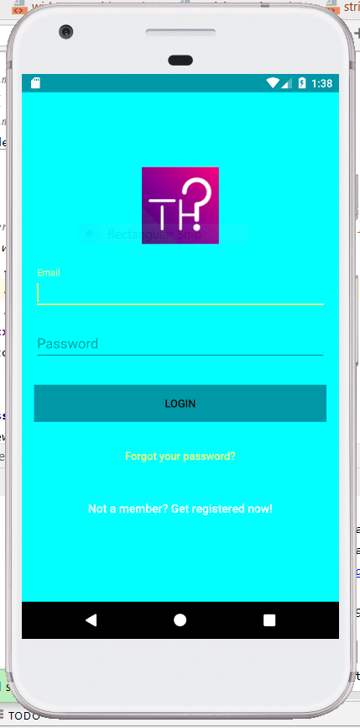

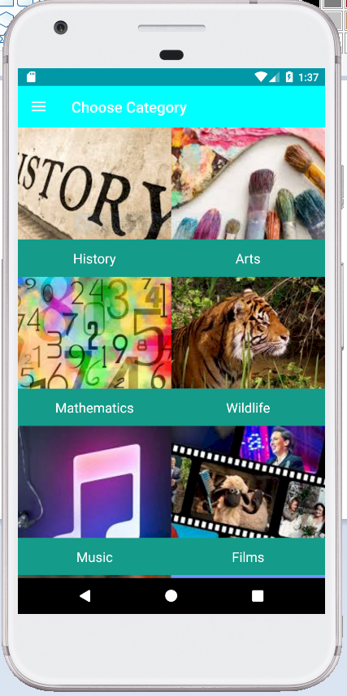

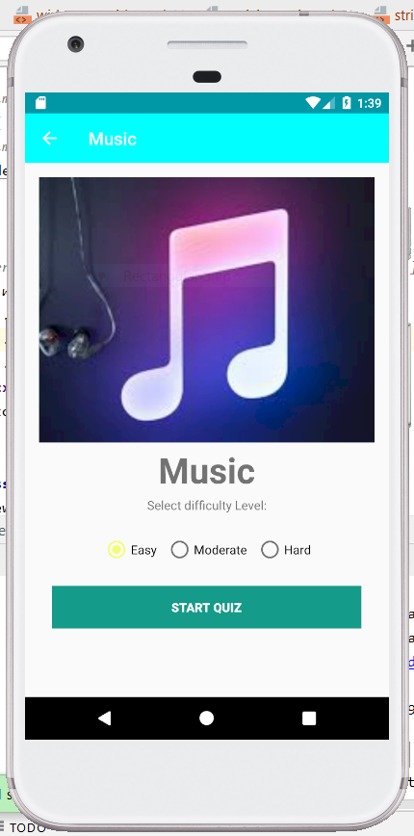

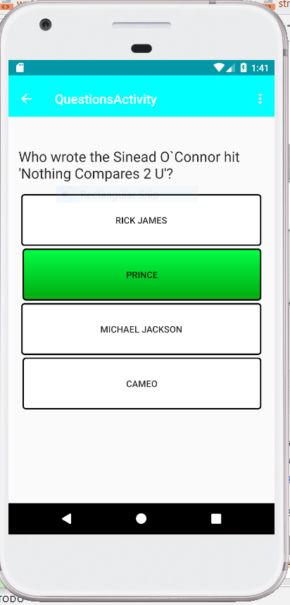

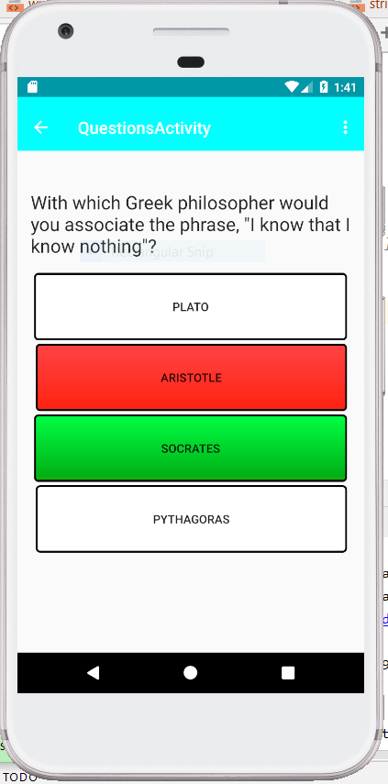

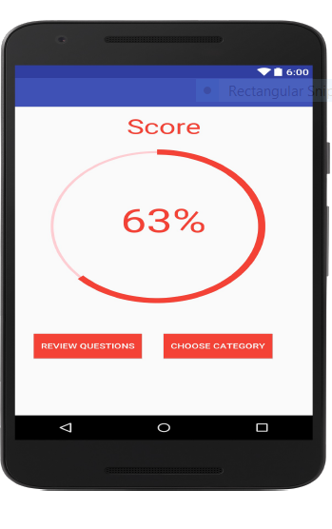

Key Considerations

**How will your app handle data persistence?**

The app will use firebase real time data base to store scores of the user, also contains provider will be used to store the data received from API.

**Describe any corner cases in the UX.**

**Describe any libraries you’ll be using and share your reasoning for including them.**

I am using Picasso to handle the loading images and HTTP requests for Network communication

**Describe how you will implement Google Play Services.**

Firebase Auth – This will be used to login user and provide necessary authentication.

Firebase Real Time Database - Real time database will be used to store the scores of the user.

Next Steps: Required Tasks

This is the section where you ca take the main feature of your app (declared above) and decompose them into tangible technical tasks that you can complete incrementally until you have a finished app.

Task 1: Project Setup

1. Setup dependencies in gradle
2. Create a new Android project with an empty activity
3. Organize code in respective folder.

Task 2: Implement UI for each Activity and Fragment

1. Build UI for all activities.
2. Build adapter for grid view.
3. Implement Listener and call back for Detail View.
4. Click on the Intent to ensure flow between activities are working properly.

Task 3: Implement Navigation Drawer, Question Fragment and Result

1. Create Drawer layout.
2. Add it to Main Activity.
3. Create Question Fragment and use it to show questions with correct answer with user clicking.
4. Implement the logic.

Task 4: Implement Firebase database and Content Provider

1. Create Database Contract and SQLite Helper.
2. Table will have three columns “Category”, “Score” and “User”.
3. Firebase Database will have three entries.
4. Design Content URI.
5. Implement Content Provider.

Task 5: Implement Firebase Auth and Google play services

1. Implement Login, Register and Reset Password.
2. Implement sign out feature
3. Store user score into database.