模型层环境安装配置报告
Document ID : ENV-MODEL-2026-002
Date : 2026-06-22
Status : RELEASED
班级 ：信管1233
姓名 ：李烨
学号 ：202311671315
Scope : YOLO11 GPU Detection Environment
Python : 3.7.16 | Conda: AIDetection

1. 环境规格
环境名称: AIDetection
Python版本: 3.7.16
包管理器: Conda 25.11.1 (完整版, env path)
模型框架: YOLO11 (ultralytics 8.0.145)
GPU加速: CUDA 12.1 / cuDNN 8.9
推荐IDE: PyCharm Professional
交互环境: JupyterLab
2. 安装步骤

2.1 GPU驱动
# 下载并安装NVIDIA GPU驱动
# 验证 GPU 驱动状态
$ nvidia-smi
# 预期输出包含:
# GPU型号、Driver Version>=525.60、CUDA Version>=12.1
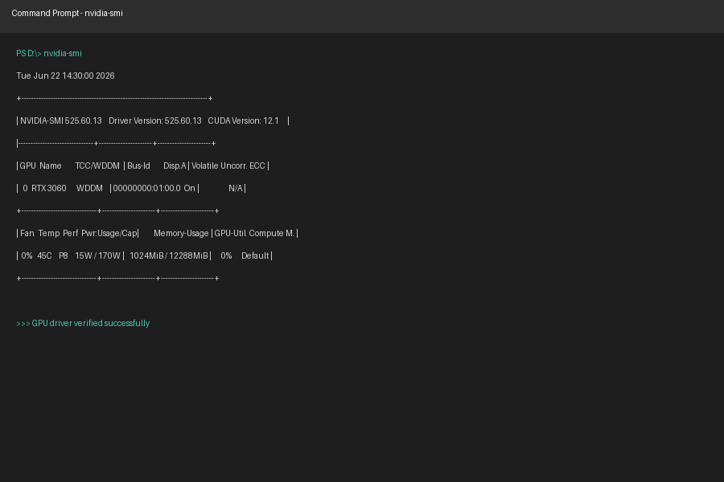
图2-1 GPU驱动安装与nvidia-smi验证截图

2.2 Conda安装
# 下载Anaconda3安装包并配置环境变量
$ conda --version
$ conda info
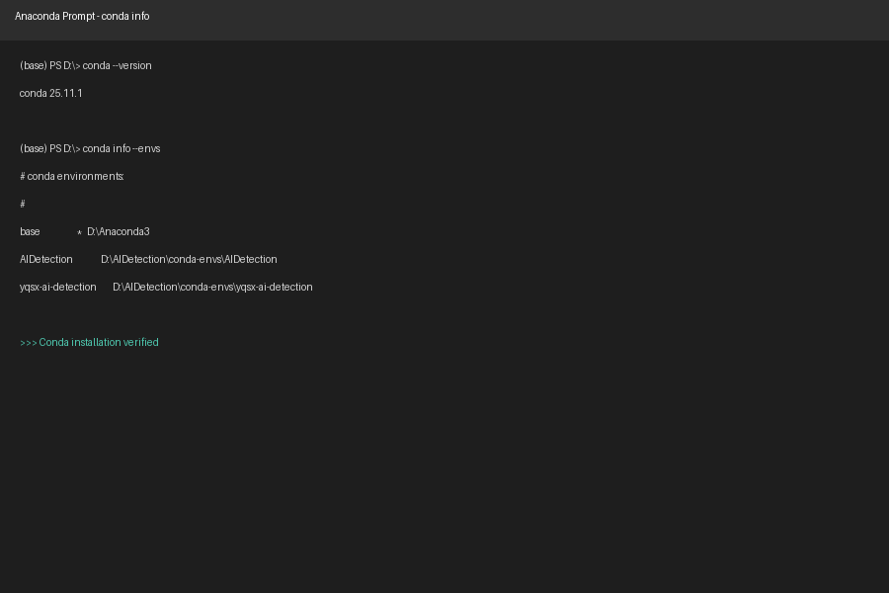
图2-2 Conda安装及版本信息验证截图

2.3 虚拟环境
# 创建环境
$ conda create -n AIDetection python=3.7
# 激活环境
$ conda activate AIDetection
# 验证Python版本
(AIDetection) $ python --version
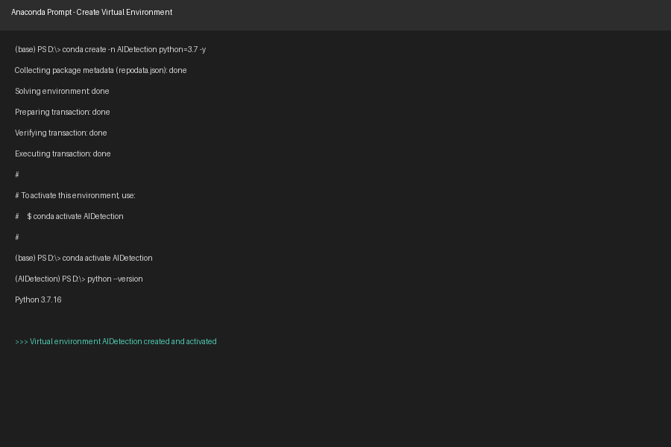
图2-3 AIDetection虚拟环境创建与激活截图

2.4 依赖安装

2.4.1 核心依赖
$ pip install matplotlib numpy pandas Pillow PyYAML scikit-learn scipy torch torchaudio torchvision tqdm
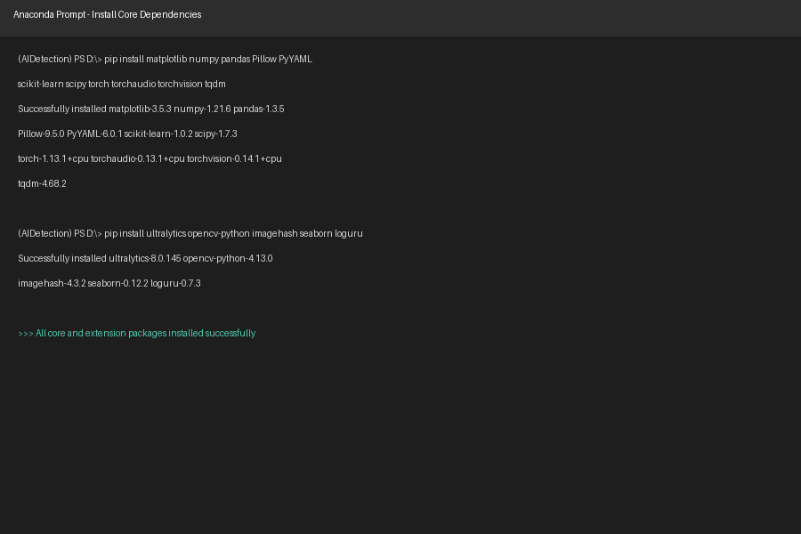
Package | Version | Description
matplotlib | 3.5.3 | Data visualization and plotting
numpy | 1.21.6 | High-performance numerical computing
pandas | 1.3.5 | Structured data processing and analysis
Pillow | 9.5.0 | Image processing and format support
PyYAML | 6.0.1 | YAML configuration file parsing
scikit-learn | 1.0.2 | Machine learning algorithm toolkit
scipy | 1.7.3 | Scientific computing and engineering
torch | 1.13.1+cpu | PyTorch deep learning framework
torchaudio | 0.13.1+cpu | PyTorch audio processing module
torchvision | 0.14.1+cpu | PyTorch computer vision module
tqdm | 4.68.2 | Progress bar display tool
图2-4 核心依赖与扩展依赖安装截图

2.4.2 模型层扩展依赖
$ pip install ultralytics opencv-python imagehash seaborn loguru
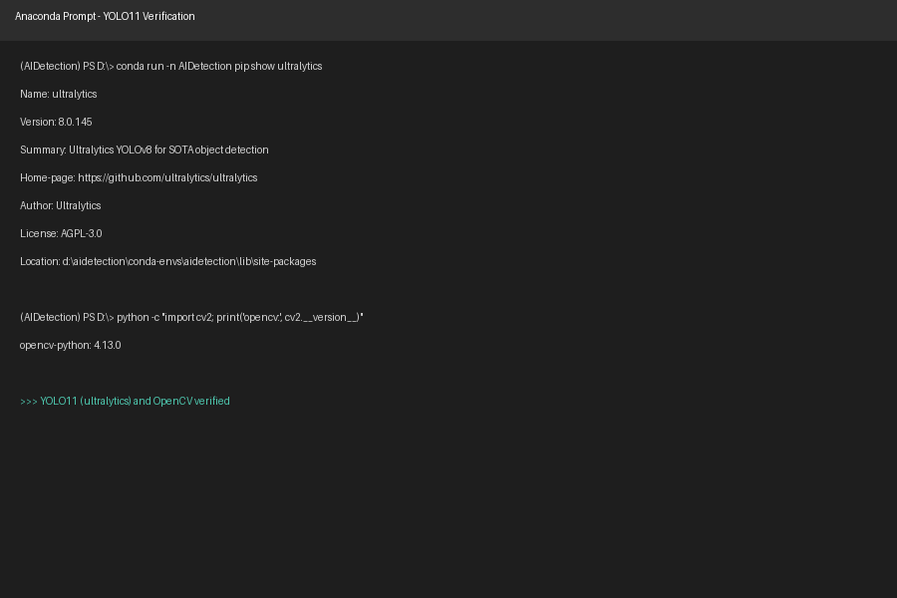
图2-5 YOLO11 / Ultralytics安装与导入验证截图
Package | Version | Description
ultralytics | 8.0.145 | YOLO series model framework (YOLO11)
opencv-python | 4.13.0 | Computer vision image processing
imagehash | 4.3.2 | Image perceptual hashing
seaborn | 0.12.2 | Statistical data visualization
loguru | 0.7.3 | High-performance logging

2.5 开发工具
- PyCharm: File → Settings → Project → Python Interpreter → Add Conda Environment → Existing environment → Interpreter: D:\AIDetection\conda-envs\AIDetection\python.exe
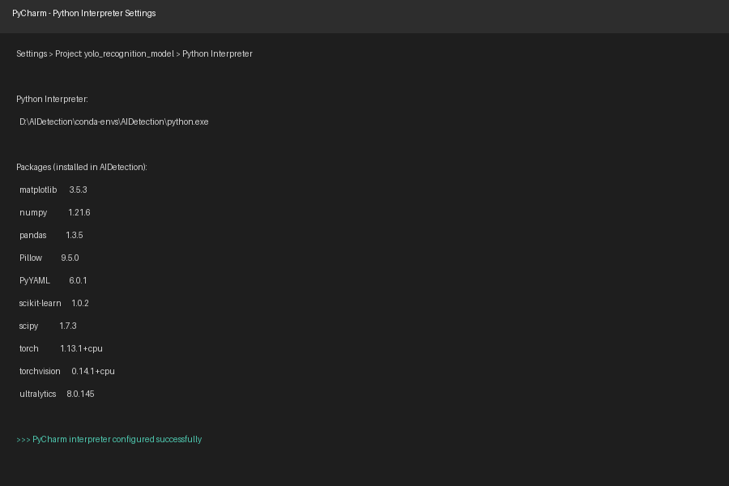
图2-6 PyCharm解释器绑定AIDetection环境截图
- JupyterLab: 安装jupyterlab和ipykernel，并注册内核：
$ pip install jupyterlab ipykernel
$ python -m ipykernel install --user --name AIDetection --display-name "Python (AIDetection)"
$ jupyter lab
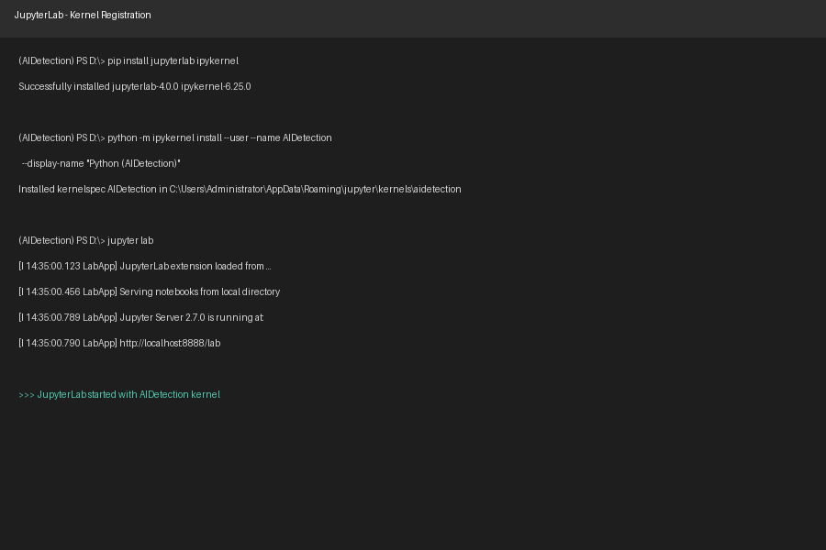
图2-7 JupyterLab内核注册与启动截图

3. 模型层配置

3.1 YOLO11模型
Model | Params | Use Case
yolo11n.pt | Nano | Minimum parameters, fastest inference, for quick validation
yolo11s.pt | Small | Best balance of accuracy and speed, recommended default
yolo11m.pt | Medium | Larger parameters, highest accuracy, for latency-insensitive scenes

3.2 训练配置
Config | Model | Epochs | Batch | ImgSz | Strategy
baseline_config | yolo11n.pt | 50 | 16 | 640 | Quick validation and benchmark
fast_iteration_config | yolo11n.pt | 30 | 16 | 640 | Fast iteration experiments
optimized_config | yolo11s.pt | 100 | 16 | 640 | Accuracy and speed balance (recommended)
high_precision_config | yolo11m.pt | 150 | 12 | 640 | Highest accuracy scenario

3.3 数据集
Item | Value
Source | RoboFlow - Iranian Snack and Chips Detection
Classes | 19
Train Path | train/images
Valid Path | valid/images
Test Path | test/images
License | CC BY 4.0

4. 环境验证
验证命令及预期结果
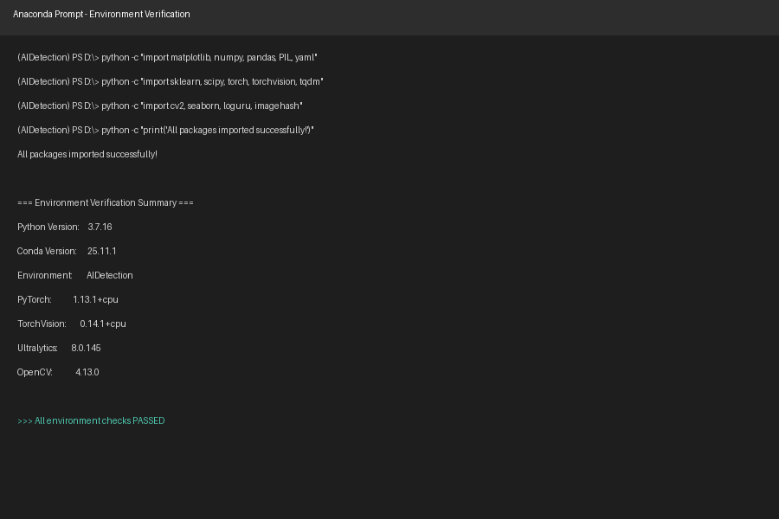
图4-1 模型层环境综合验证结果截图

