Group: SE-2404

Team Members:
Abdunur Amangeldiev
Kasymov Abilmansur
Ayazhan Ayetova
github repo: https://github.com/weolyse/blockchain-final-project.git

DeFi Super App Architecture and Testing Documentation
Project scenario: Option A - DeFi Super-App. The system implements a composable decentralized protocol deployed to Arbitrum Sepolia. It combines a custom constant-product AMM, a UUPS-upgradeable lending pool, an ERC-4626 yield vault, Chainlink-style price feeds, OpenZeppelin Governor and Timelock governance, The Graph indexing, and a React/Wagmi frontend.
Repository reviewed: blockchain-final-project. Main implementation folders: contracts, frontend, subgraph, deployments, docs, and GitHub Actions CI.

1. Executive Summary
The protocol is designed as a small full-stack DeFi application. Users can hold and delegate the governance token, swap between protocol tokens, provide and remove liquidity, deposit assets into a yield vault, supply collateral to the lending pool, borrow against that collateral, repay debt, and participate in DAO voting. The contracts are the source of truth for protocol state. The frontend reads live contract state with Wagmi and reads indexed proposal data from The Graph. Deployment data and post-deployment checks are committed under deployments/.
The architecture intentionally demonstrates several production-grade blockchain patterns: factory deployment, deterministic CREATE2 pair creation, UUPS proxy upgradeability, ERC20Votes governance, Timelock-controlled ownership, oracle adapter abstraction, Checks-Effects-Interactions, SafeERC20 transfers, ReentrancyGuard for user-facing asset movement, and event indexing for frontend reads.

2. System Context
The application sits between wallet users, Arbitrum Sepolia, Chainlink-compatible price feeds, and The Graph. Users connect via MetaMask or WalletConnect through RainbowKit. Write operations are sent directly to smart contracts on Arbitrum Sepolia. Indexed data is loaded from the hosted subgraph endpoint.
External actors: wallet users, liquidity providers, borrowers, liquidators, voters, and the deployer/team during setup.
External systems: Arbitrum Sepolia RPC, Arbiscan, Chainlink-compatible price feeds or mock feed on Arbitrum Sepolia, The Graph Studio, MetaMask, WalletConnect, GitHub Actions.
Core protocol boundary: contracts/src contains all on-chain state transitions; frontend and subgraph are clients and do not hold authority over protocol rules.

3. High-Level Component Diagram
User Wallet
|
v
React dApp / RainbowKit / Wagmi
|-- direct contract reads and writes --> Arbitrum Sepolia contracts
|-- GraphQL proposal/history reads --> The Graph subgraph
Arbitrum Sepolia contracts
|-- GovToken (ERC20Votes + ERC20Permit)
|-- Utility Token / LPToken
|-- AMMFactory -> ConstantProductAMM -> LPToken
|-- LendingPool proxy -> LendingPoolV1/V2 implementation -> PositionNFT
|-- YieldVault (ERC4626) -> LendingPool strategy
|-- PriceFeedAdapter -> Chainlink AggregatorV3Interface
|-- DeFiGovernor -> DeFiTimelock -> Treasury / protocol ownership

4. Smart Contract Architecture

4.1 Token Layer
GovToken is the main governance asset. It extends ERC20Votes and ERC20Permit, which gives it snapshot-based voting power and EIP-2612-style permit support. Minting is protected by AccessControl through MINTER_ROLE, and total supply is capped by MAX_SUPPLY. Delegation creates voting checkpoints used by the Governor.
LPToken is an ERC-20 token minted and burned only by the AMM contract through AMM_ROLE. Each ConstantProductAMM deploys its own LP token in the constructor. This prevents users from minting liquidity shares outside the pair accounting logic.
PositionNFT is an ERC-721 receipt for lending positions. LendingPool receives MINTER_ROLE and mints a position NFT the first time a borrower opens debt. tokenURI returns on-chain Base64 JSON with an embedded SVG image.

4.2 AMM Layer
ConstantProductAMM is a custom x*y=k pair contract for two ERC-20 assets. It stores token0, token1, reserve0, reserve1, blockTimestampLast, LP token address, cumulative prices, and total fees. Liquidity providers deposit both assets and receive LP shares. The first liquidity provider permanently locks MINIMUM_LIQUIDITY to avoid division and inflation edge cases.
Swaps charge a 0.3% fee by using 997/1000 input amount in the output formula. The user supplies minAmountOut, so slippage protection is enforced at the contract level. The swap function validates the input token, recipient, liquidity, minimum output, transfers input with SafeERC20, updates reserves, transfers output, and emits Swap.
The AMM includes an inline Yul implementation of getAmountOutAssembly and a pure Solidity equivalent getAmountOutSolidity. The tests compare both formulas to prove behavioral equivalence. This satisfies the advanced Solidity requirement for assembly benchmarkability.
AMMFactory creates pairs using both CREATE and CREATE2. It sorts token addresses so pair identity is canonical, rejects duplicate pairs, rejects identical tokens and zero addresses, and stores both getPair[token0][token1] and getPair[token1][token0]. createPair2 hashes sorted tokens with the supplied salt to make deterministic deployment safer.

4.3 Lending Layer
LendingPoolV1 is the upgradeable lending protocol. It uses Initializable, UUPSUpgradeable, OwnableUpgradeable, ReentrancyGuard, and SafeERC20. The deployed lending pool is an ERC1967Proxy pointing to the implementation. Ownership is transferred to the Timelock after deployment, so upgrades and privileged configuration must go through governance.
The lending state is organized around Position and AssetConfig structs. Position tracks collateral, debt, and lastAccrued. AssetConfig tracks the price feed, LTV in basis points, and whether the asset is enabled. The pool also tracks totalDeposits, totalBorrows, primaryDebtAsset, user position NFT IDs, and each user asset list.
Supported flows are deposit, borrow, withdrawCollateral, repay, liquidate, healthFactor, accountLiquidity, positionOf, and currentInterestRateBps. Interest accrues linearly using baseRateBps + utilization*slopeRateBps. Borrowing requires healthFactor >= 1e18 after the debt is added. Liquidation is allowed only when healthFactor is below 1e18 and seizes collateral with liquidationBonusBps.
LendingPoolV2 demonstrates the documented V1 to V2 upgrade path. It adds flashLoanFeeBps, initializeV2, version, and setFlashLoanFeeBps while preserving V1 storage layout by appending new storage after inherited variables.

4.4 Vault Layer
YieldVault is an ERC-4626 tokenized vault over the governance token. Deposited assets are forwarded to the lending pool strategy by overriding _deposit. Withdrawals pull idle assets first and then withdraw collateral from the lending strategy if needed. totalAssets combines idle vault balance and strategy collateral returned by positionOf.
The vault has a performance fee flow through reportYield. The owner sends reported yield to the vault, the vault takes PERFORMANCE_FEE_BPS, transfers the fee to Treasury, deposits net yield into the lending pool, and emits YieldReported. Treasury can be updated only by owner, which becomes the Timelock after deployment.
A decimals offset of 6 is used to reduce ERC-4626 inflation attack impact. Tests cover preview rounding behavior and fuzz deposit/withdraw flows.

4.5 Oracle Layer
PriceFeedAdapter isolates Chainlink feed reads behind IOracleAdapter. It calls AggregatorV3Interface.latestRoundData, rejects zero feed addresses, rejects stale prices older than STALENESS_THRESHOLD, rejects non-positive answers, and returns price plus feed decimals. LendingPoolV1 also reads configured feeds directly for collateral and debt valuation.

4.6 Governance and Treasury Layer
DeFiGovernor uses the OpenZeppelin Governor stack: Governor, GovernorSettings, GovernorCountingSimple, GovernorVotes, GovernorVotesQuorumFraction, and GovernorTimelockControl. The parameters match the project requirement: voting delay 1 day, voting period 1 week, proposal threshold 1 token, and quorum numerator 4%.
DeFiTimelock extends TimelockController with MIN_DELAY = 2 days. During deployment, the Governor is granted proposer and executor roles, the deployer admin role is revoked, and ownership of the lending pool, vault, and treasury is transferred to the Timelock. Treasury release is Ownable-protected and uses SafeERC20.

5. Deployment Architecture
Deploy.s.sol is idempotent: it checks deployments/<chainId>.json and skips redeployment if the file already exists. It deploys GovToken, Utility LP-style token, PositionNFT, price feed or mock feed, PriceFeedAdapter, AMMFactory, deterministic AMM pair, LendingPoolV1 implementation, ERC1967Proxy, Treasury, YieldVault, DeFiTimelock, and DeFiGovernor. It then configures roles and ownership.
Verify.s.sol reads the deployment JSON and validates post-deployment invariants: lending pool owner is Timelock, vault owner is Timelock, treasury owner is Timelock, Timelock delay is 2 days, Governor voting delay is 1 day, voting period is 1 week, and quorum numerator is 4. Output is written to deployments/verification-output.txt.
Committed deployment network: Arbitrum Sepolia, chainId 421614. The README contains Arbiscan links for GovToken, Utility Token, AMM Factory, AMM Pair, Lending Pool Proxy, Lending implementation, Yield Vault, Position NFT, Price Feed, Price Feed Adapter, Governor, Timelock, and Treasury.

6. Frontend Architecture
The frontend is a React + TypeScript dApp. App.tsx provides a tabbed interface with Swap, Liquidity, Vault, Borrow, Governance, and Portfolio pages. RainbowKit supplies the wallet connection UI. Wagmi provides contract reads, writes, account state, and chain switching. NetworkGuard detects wrong chain and prompts the user to switch to Arbitrum Sepolia.
Swap page: reads AMM quote and submits approve/swap transactions.
Liquidity page: reads reserves and submits approve/add/remove liquidity transactions.
Vault page: reads vault shares, total assets, previewDeposit, and submits approve/deposit/withdraw transactions.
Borrow page: reads user health factor and submits approve/supply/borrow/repay transactions.
Governance page: reads active proposal data from The Graph and submits Governor castVote transactions.
Portfolio page: reads balances, voting power, delegate address, vault shares, and submits delegate transactions.
ErrorBoundary and StatusLine components provide user-facing error and transaction status surfaces. The frontend does not make authorization decisions; all critical checks live in contracts.

7. Subgraph Architecture
The subgraph indexes AMM, Governor, and Vault events on Arbitrum Sepolia. subgraph.yaml defines three data sources: ConstantProductAMM, DeFiGovernor, and YieldVault. The schema has seven entities: Swap, LiquidityPosition, LiquidityEvent, Proposal, Vote, VaultDeposit, and VaultWithdraw.
AMM mappings persist swap history, liquidity events, and mutable user LP balances. Governor mappings persist proposals, vote counts, individual votes, and executed/canceled states. Vault mappings persist ERC-4626 deposit and withdrawal history. docs/subgraph-queries.md documents five GraphQL queries for swaps, active proposals, liquidity positions, vault history, and swap volume.

8. Storage and Data Model
ConstantProductAMM: token addresses, packed reserves, last reserve timestamp, LP token, total fees, and cumulative prices.
AMMFactory: two-direction getPair mapping and allPairs array.
GovToken: OpenZeppelin ERC20Votes checkpoint storage, permit nonces, roles, and capped supply.
LPToken: ERC20 balances and AccessControl role storage for AMM mint/burn authority.
PositionNFT: ERC721 ownership storage, role storage, and private next token ID counter.
LendingPoolV1: UUPS/Ownable storage, PositionNFT reference, rate parameters, asset configs, totals, primary debt asset, user NFT IDs, positions by user and asset, and user asset tracking arrays.
LendingPoolV2: appends flashLoanFeeBps after V1 storage, preserving proxy storage compatibility.
YieldVault: ERC4626/ERC20 share storage, immutable lending pool reference, treasury address, and totalPerformanceFees.
Treasury: Ownable storage only; token balances are held by ERC-20 contracts.

9. Critical User Flows

9.1 Swap Flow
The user selects tokenIn and amountIn in the frontend. The dApp reads getAmountOut from the AMM pair. The user approves the AMM pair to spend tokenIn, then calls swap(tokenIn, amountIn, minAmountOut, to). The AMM validates reserves, computes output with the 0.3% fee formula, enforces minAmountOut, transfers input, updates reserves, transfers output, and emits Swap. The subgraph indexes the Swap event for history and volume queries.

9.2 Deposit to Vault Flow
The user approves the YieldVault to spend DGV, then calls deposit. ERC4626 mints vault shares based on preview logic. The overridden _deposit forwards underlying DGV to the lending pool, increasing the vault strategy collateral. totalAssets later reads both idle vault balance and lending-pool collateral.

9.3 Borrow Flow
The user deposits collateral into the lending pool, then calls borrow. The pool accrues existing debt, adds requested debt, checks healthFactor, mints a PositionNFT if this is the first borrow position, transfers borrowed tokens to the user, and emits Borrowed. Repay accrues debt, caps repayment at outstanding debt, transfers tokens in, reduces debt, and emits Repaid.

9.4 Governance Flow
A token holder delegates DGV voting power. A proposer with at least the proposal threshold submits a proposal. After the 1 day voting delay, voters cast Against, For, or Abstain votes during the 1 week voting period. If quorum and vote outcome succeed, the proposal is queued in the Timelock. After the 2 day delay, it is executed by GovernorTimelockControl. Treasury and protocol ownership actions are therefore delayed and vote-controlled.

10. Security and Design Patterns
Factory pattern: AMMFactory deploys pairs and maintains canonical pair registry.
CREATE2 pattern: createPair2 supports deterministic pair deployment using sorted token addresses and salt.
UUPS proxy pattern: LendingPoolV1 is upgradeable through UUPS with _authorizeUpgrade restricted to owner; Timelock becomes owner.
Access control: GovToken, LPToken, and PositionNFT use AccessControl; LendingPool, YieldVault, Treasury, and ProtocolSettings use Ownable-style authorization.
Reentrancy protection: AMM swaps and liquidity changes, lending asset movement, and vault operations are protected with ReentrancyGuard.
SafeERC20: token transfers and approvals use OpenZeppelin SafeERC20 helpers where external ERC-20 calls are made.
Oracle adapter: PriceFeedAdapter isolates feed access and stale/invalid price validation.
Timelock governance: protocol ownership is transferred to DeFiTimelock, and Governor controls execution after voting and delay.
Checks-Effects-Interactions: state updates generally occur before external output transfers in user-facing asset flows.

11. Testing Strategy
The current Solidity test inventory contains 92 discovered test/invariant functions: 80 unit or scenario tests, 10 fuzz tests, 1 fork test, and 1 invariant test. The suite covers contracts, upgrade behavior, governance lifecycle, security case studies, AMM math, ERC-4626 vault behavior, oracle validation, and frontend smoke testing.
The canonical contract test command is:
forge test --root contracts -vvv
Coverage commands:
forge coverage --root contracts --report summary
forge coverage --root contracts --report lcov
Security/static analysis command:
slither contracts/src --config-file contracts/slither.config.json
Frontend verification commands:
cd frontend
npm ci
npx tsc --noEmit
npm run build
Subgraph verification commands:
cd subgraph
npm ci
npx graph codegen
npx graph build

12. Test Suite Inventory by Module

contracts/test/amm/AMM.t.sol
testAddLiquidity
testRemoveLiquidity
testSwap_zeroForOne
testSwap_oneForZero
testSwap_RevertSlippage
testFeeAccrual
testMinLiquidityLock
testAmountOutAssemblyMatchesSolidity
testFuzz_Swap
testFuzz_AddRemoveLiquidity
testFuzz_LPMint
invariant_kNeverDecreases

contracts/test/amm/AMMFactory.t.sol
testCreatePair
testCreatePairSortsTokens
testCreatePair2
testCreatePairRevertsDuplicate
testCreatePair2RevertsDuplicateReverseOrder
testCreatePairRevertsIdenticalTokens
testCreatePairRevertsZeroToken

contracts/test/governance/Governor.t.sol
testGovernanceLifecycle_FullE2E
testProposalThreshold_Reverts
testQuorum_Defeated
testTimelockDelay_Enforced
testTreasuryReleaseThroughGovernance
testGovernorConfiguration
testFuzz_VotingPower

contracts/test/lending/LendingPool.t.sol
testInitializeSetsOwnerAndRates
testOnlyOwnerCanSetAssetConfig
testDepositUpdatesCollateralAndTotals
testDepositTransfersTokensToPool
testDepositRevertsForDisabledAsset
testBorrowMintsPositionNft
testWithdrawCollateral
testBorrowTransfersAssetToBorrower
testBorrowRevertsWhenHealthFactorTooLow
testHealthFactorMath
testHealthFactorWithoutDebtIsMax
testRepayReducesDebt
testRepayCapsAtOutstandingDebt
testFuzz_RepayInterest
testInterestAccruesLinearly
testCurrentInterestRateUsesUtilization
testLiquidateRevertsWhenHealthy
testLiquidateUnhealthyPosition
testFuzz_HealthFactor
testUpgradeToV2PreservesStorage

contracts/test/oracles/PriceFeedAdapter.t.sol
testGetPrice
testZeroFeedReverts
testStalePriceReverts
testNegativePriceReverts
testZeroPriceReverts
testFuzz_PriceFeed
testFork_ChainlinkETHUSD

contracts/test/security/AccessControlAttack.t.sol
testUnguardedMintSucceedsForAttacker
testGovTokenMintRevertsForAttacker

contracts/test/security/ReentrancyAttack.t.sol
testReentrantSwapFailsWithGuard

contracts/test/tokens/GovToken.t.sol
testConstructorGrantsAdminAndMinterRoles
testAdminCanGrantMinterRole
testMinterCanMint
testNonMinterCannotMint
testMintRevertsAboveMaxSupply
testTransferMovesBalance
testDelegateCreatesVotingPowerCheckpoint
testTransferUpdatesDelegatedVotes
testPermitApprovesSpender
testExpiredPermitReverts
testFuzz_GovTokenDelegate

contracts/test/tokens/LPToken.t.sol
testMetadata
testAmmCanMint
testNonAmmCannotMint
testAmmCanBurn
testNonAmmCannotBurn
testTransfer

contracts/test/tokens/PositionNFT.t.sol
testConstructorGrantsRoles
testMinterCanMint
testMintIncrementsTokenId
testNonMinterCannotMint
testTokenUriIsDataUri
testTokenUriRevertsForMissingToken
testTransfer

contracts/test/vault/YieldVault.t.sol
testMetadataAndConstructorState
testDepositMintsSharesAndForwardsAssets
testMintMintsExactShares
testWithdrawPullsAssetsFromLendingPool
testRedeemPullsAssetsFromLendingPool
testReportYieldTakesPerformanceFee
testReportYieldOnlyOwner
testSetTreasury
testSetTreasuryOnlyOwner
testRoundingPreviewInvariants
testFuzz_VaultDepositWithdraw
testFuzz_VaultInflationAttack

13. Test Coverage Explanation

13.1 AMM and Factory Tests
AMM tests validate liquidity minting, minimum liquidity lock, liquidity removal, both swap directions, slippage reverts, fee accrual, formula equivalence between assembly and Solidity implementations, fuzz swap behavior, fuzz add/remove liquidity behavior, fuzz LP mint constraints, and the constant-product invariant. Factory tests validate regular CREATE deployment, deterministic CREATE2 deployment, token sorting, duplicate rejection, reverse-order duplicate rejection, identical token rejection, and zero token rejection.

13.2 Lending Tests
Lending tests validate initialization, owner-only asset configuration, collateral accounting, token transfers into the pool, disabled asset reverts, position NFT minting on borrow, collateral withdrawal, borrow transfers, low health factor reverts, health factor math, max health factor with no debt, repayment accounting, repayment capping, linear interest accrual, utilization-based rates, healthy liquidation reverts, unhealthy liquidation, fuzz interest repayment, fuzz health factor ranges, and UUPS upgrade to V2 with storage preservation.

13.3 Governance Tests
Governance tests validate the full propose-vote-queue-execute lifecycle, proposal threshold enforcement, defeated proposal behavior when quorum is not met, Timelock delay enforcement, Treasury release through governance, Governor parameter configuration, and fuzz voting power delegation/checkpoint behavior.

13.4 Token Tests
GovToken tests cover role setup, minter role assignment, minting, non-minter rejection, maximum supply cap, transfers, delegated vote checkpoint creation, vote updates on transfer, permit approval, expired permit rejection, and fuzz delegation. LPToken tests cover metadata, AMM-only minting and burning, non-AMM reverts, and transfers. PositionNFT tests cover role setup, minter-only minting, token ID incrementing, data URI metadata, missing-token URI revert, and transfers.

13.5 Vault Tests
Vault tests cover constructor metadata, deposit share minting and strategy forwarding, exact-share minting, withdrawal from lending strategy, redeem flow, performance fee accounting, owner-only yield reporting, treasury update, owner-only treasury update, ERC-4626 preview rounding invariants, fuzz deposit/withdraw, and fuzz inflation attack resistance.

13.6 Oracle and Security Tests
Oracle tests cover normal price reads, zero feed rejection, stale price rejection, negative price rejection, zero price rejection, fuzz price and staleness combinations, and a fork test against a real Chainlink ETH/USD feed. Security tests reproduce and fix access-control and reentrancy scenarios: an intentionally unguarded mint succeeds for an attacker, GovToken protected mint rejects the attacker, and reentrant AMM swap attempts fail with the guard.

14. CI and Verification
The GitHub Actions workflow runs on push and pull_request. The contracts job checks out submodules, installs Foundry, builds contracts, runs forge tests, runs forge coverage with lcov output, installs Slither, and runs Slither against contracts/src. The frontend job installs Node.js 20, runs npm ci, builds the frontend, and checks Prettier formatting for TypeScript/TSX source files.
For a clean local verification, initialize submodules before running Foundry commands:
git submodule update --init --recursive
Then run the contract, frontend, and subgraph commands listed above. Any final submission should include generated coverage and security reports in docs/ if required by the course rubric.

15. Deployment Addresses
Network: Arbitrum Sepolia, chainId 421614.
GovToken: 0x399fb298082AF707711adA0b545a4F4532891556
Utility Token: 0xfAf9d03CEe672341cE3E8a95cE11ace7f8624c8A
AMM Factory: 0xE5164AbBf35cFa87d87232B06C638EAd76411509
AMM Pair: 0xa1Da546c5e942DcEB2554C47b8f1FFbF68EB349E
Lending Pool Proxy: 0xB98BA3d9bFc30b13A2aa7F751e06e9e2E054ccA0
Lending V1 Implementation: 0x0F1CA7237C9276BaE9Bf5AC34C956F248088AC89
Yield Vault: 0xE97d8038bA22e96Ca37cCcBf70a52598f6776F6F
Position NFT: 0x6aFDF82771dCAbd933C07Beb6B9A293aD96A1cE3
Price Feed: 0xf01329274321Ab337545Fa181edD39897badDC48
Price Feed Adapter: 0x282f689d828A15386F5fA2c80556858A18e90FeC
Governor: 0x6838ce5AAb674eDfcFD4b74E8afaF5744dF5768F
Timelock: 0xa274d612706fC4B5363Db7F9949C8Dd77e5Fa5Fc
Treasury: 0x3aecc5263c9853DF849FCCcA2d7C6d97E26A6e76

16. Final Notes for Reviewers
This document describes the implementation as present in the repository. It should be read together with README.md, deployments/421614.json, deployments/verification-output.txt, docs/subgraph-queries.md, and the Solidity/TypeScript source files. The most important review path is to initialize submodules, run the full Foundry suite, run coverage, run Slither, build the frontend, and build the subgraph.
Architecture Diagrams
The following diagrams summarize the main architecture and verification flows of the DeFi Super App implementation.
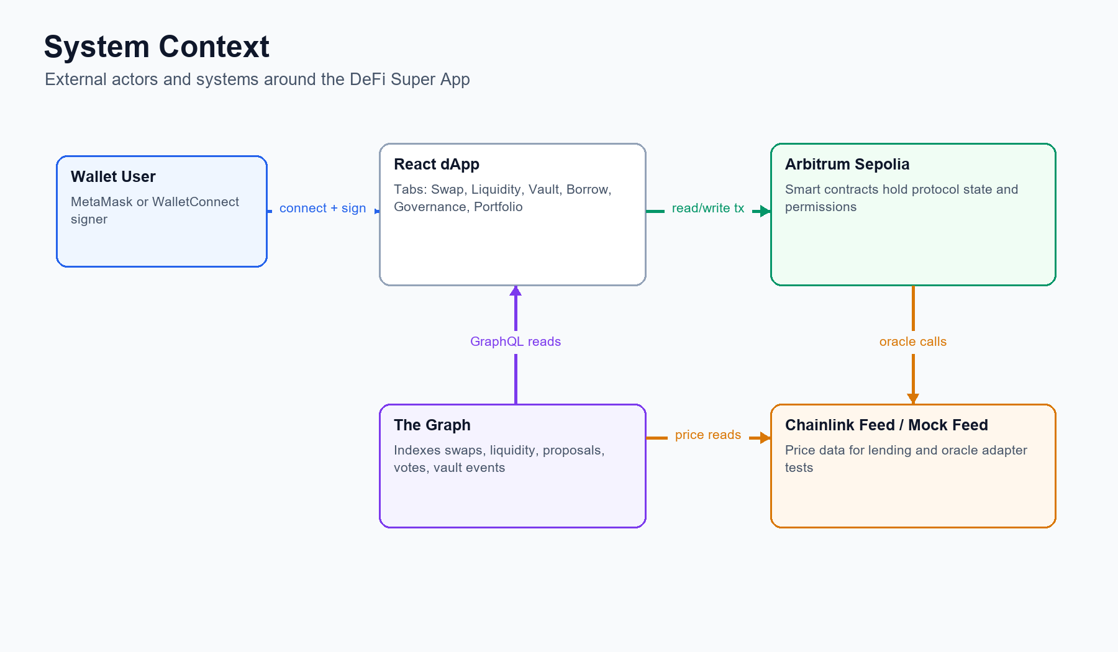
Figure 1. System context diagram.
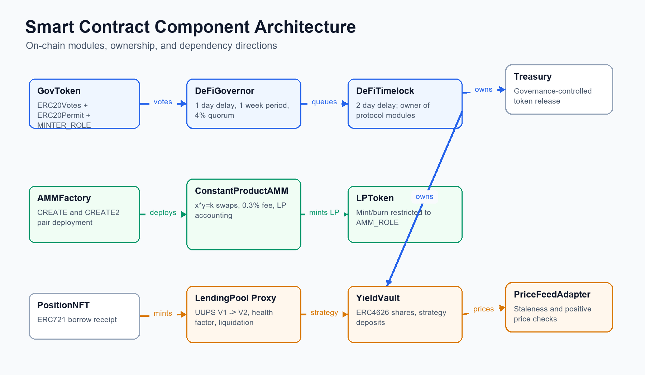
Figure 2. Smart contract component architecture.
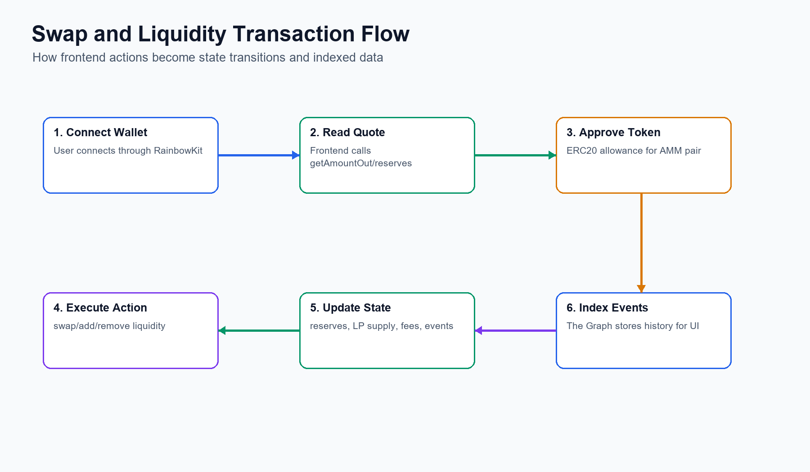
Figure 3. Swap and liquidity transaction flow.
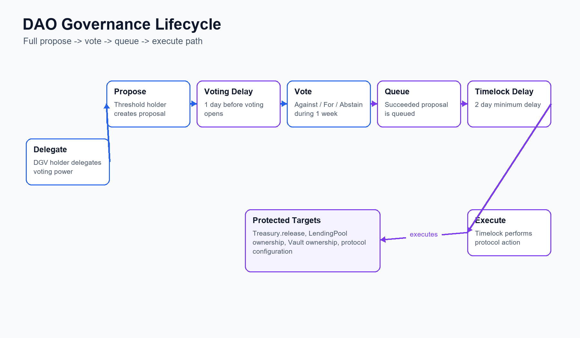
Figure 4. DAO governance lifecycle.
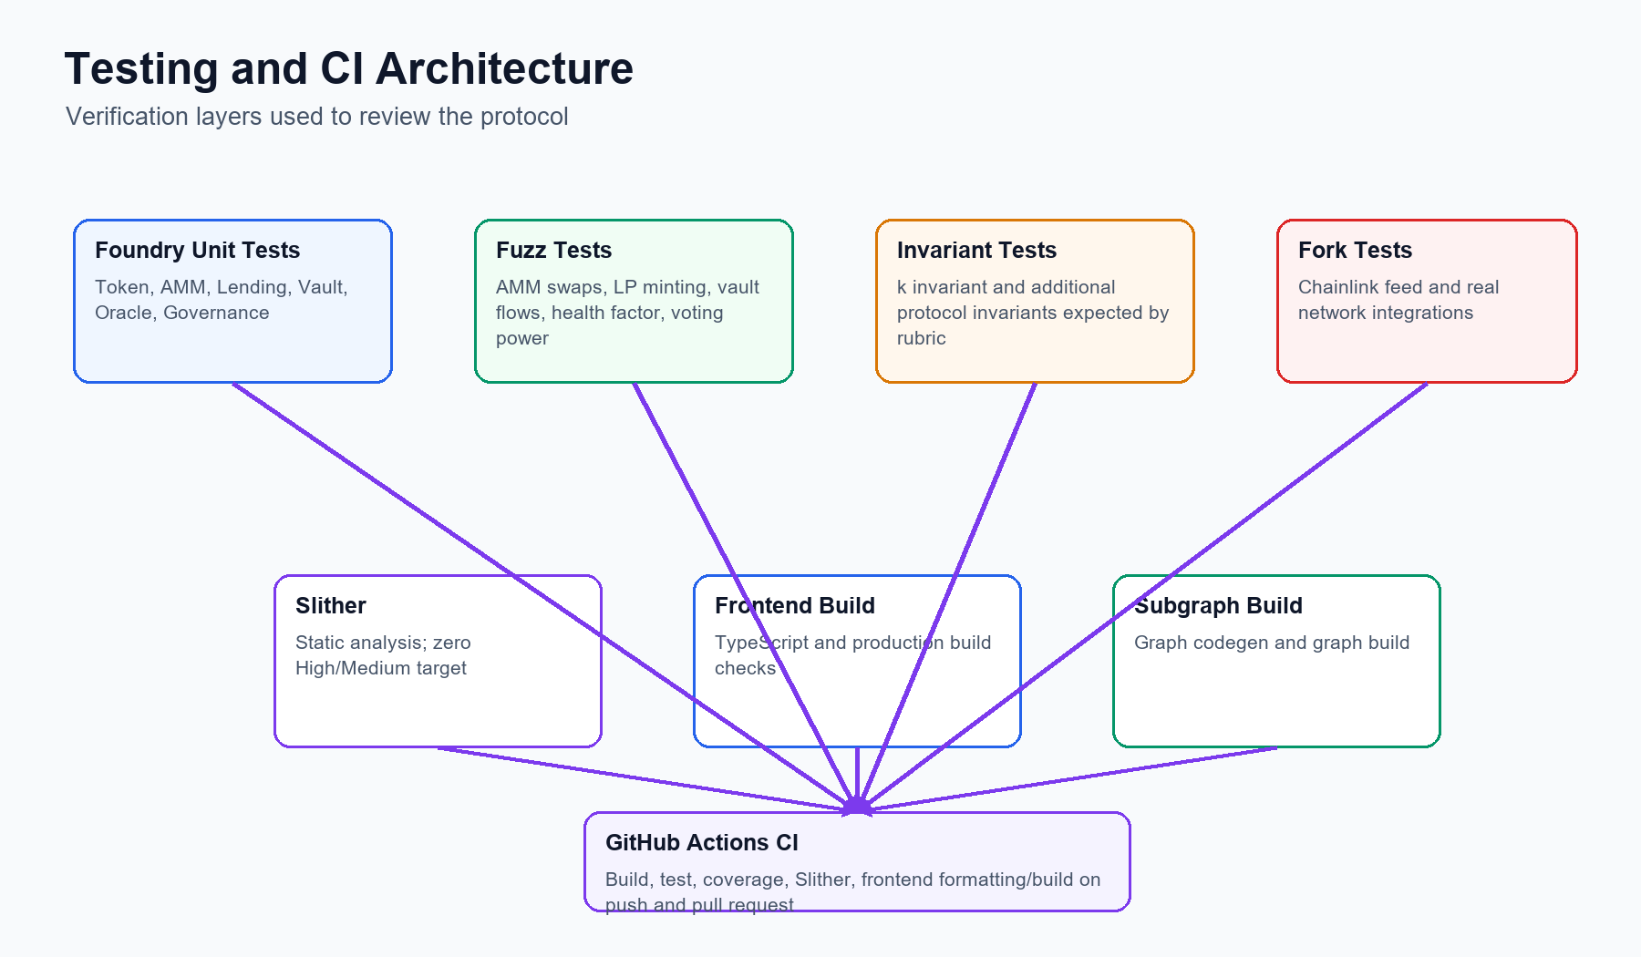
Figure 5. Testing and CI architecture.

