STRIPE DASHBOARD EVIDENCE
Weppa Group LLC - Source of Funds Support
Purpose. The screenshots below show the Stripe dashboard payout pages for the three Stripe flows summarized in this package. Each screenshot shows paid payouts to COLUMN NA MERCURY ending 3905, matching the Stripe payout CSV exports included in the support package.
Verification note. These screenshots are provided as visual evidence that the payout records summarized in the PDF were exported from Stripe dashboard payout activity. The CSV exports remain the source records for transaction-level detail.
Stripe Flow | Dashboard Area | Visible Destination | CSV Support
Bukeer | Transactions > Payouts | COLUMN NA MERCURY •••• 3905 | Bukeer payout CSV
ColombiaTours | Transactions > Payouts | COLUMN NA MERCURY •••• 3905 | ColombiaTours payout CSV
weppa.cloud / Weppa Tech Services | Transactions > Payouts | COLUMN NA MERCURY •••• 3905 | Weppa Tech payout CSV

1. Stripe Payouts - Bukeer
Stripe dashboard payout page showing paid payouts to COLUMN NA MERCURY ending 3905.
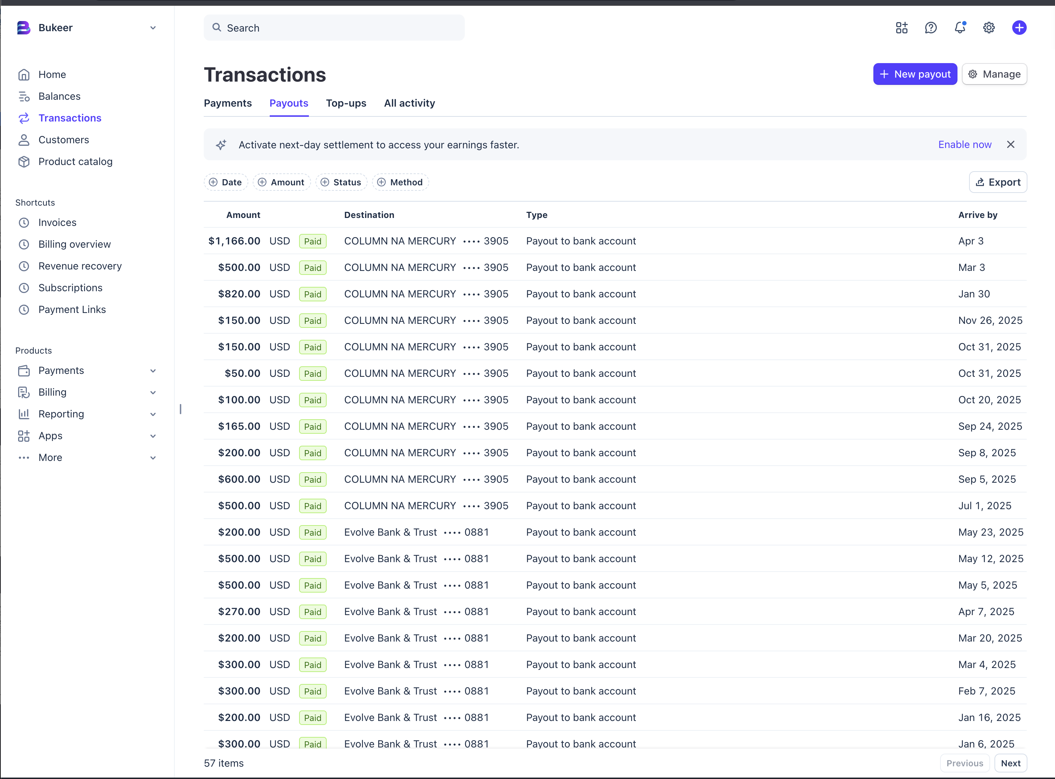

2. Stripe Payouts - ColombiaTours
Stripe dashboard payout page showing paid payouts to COLUMN NA MERCURY ending 3905.
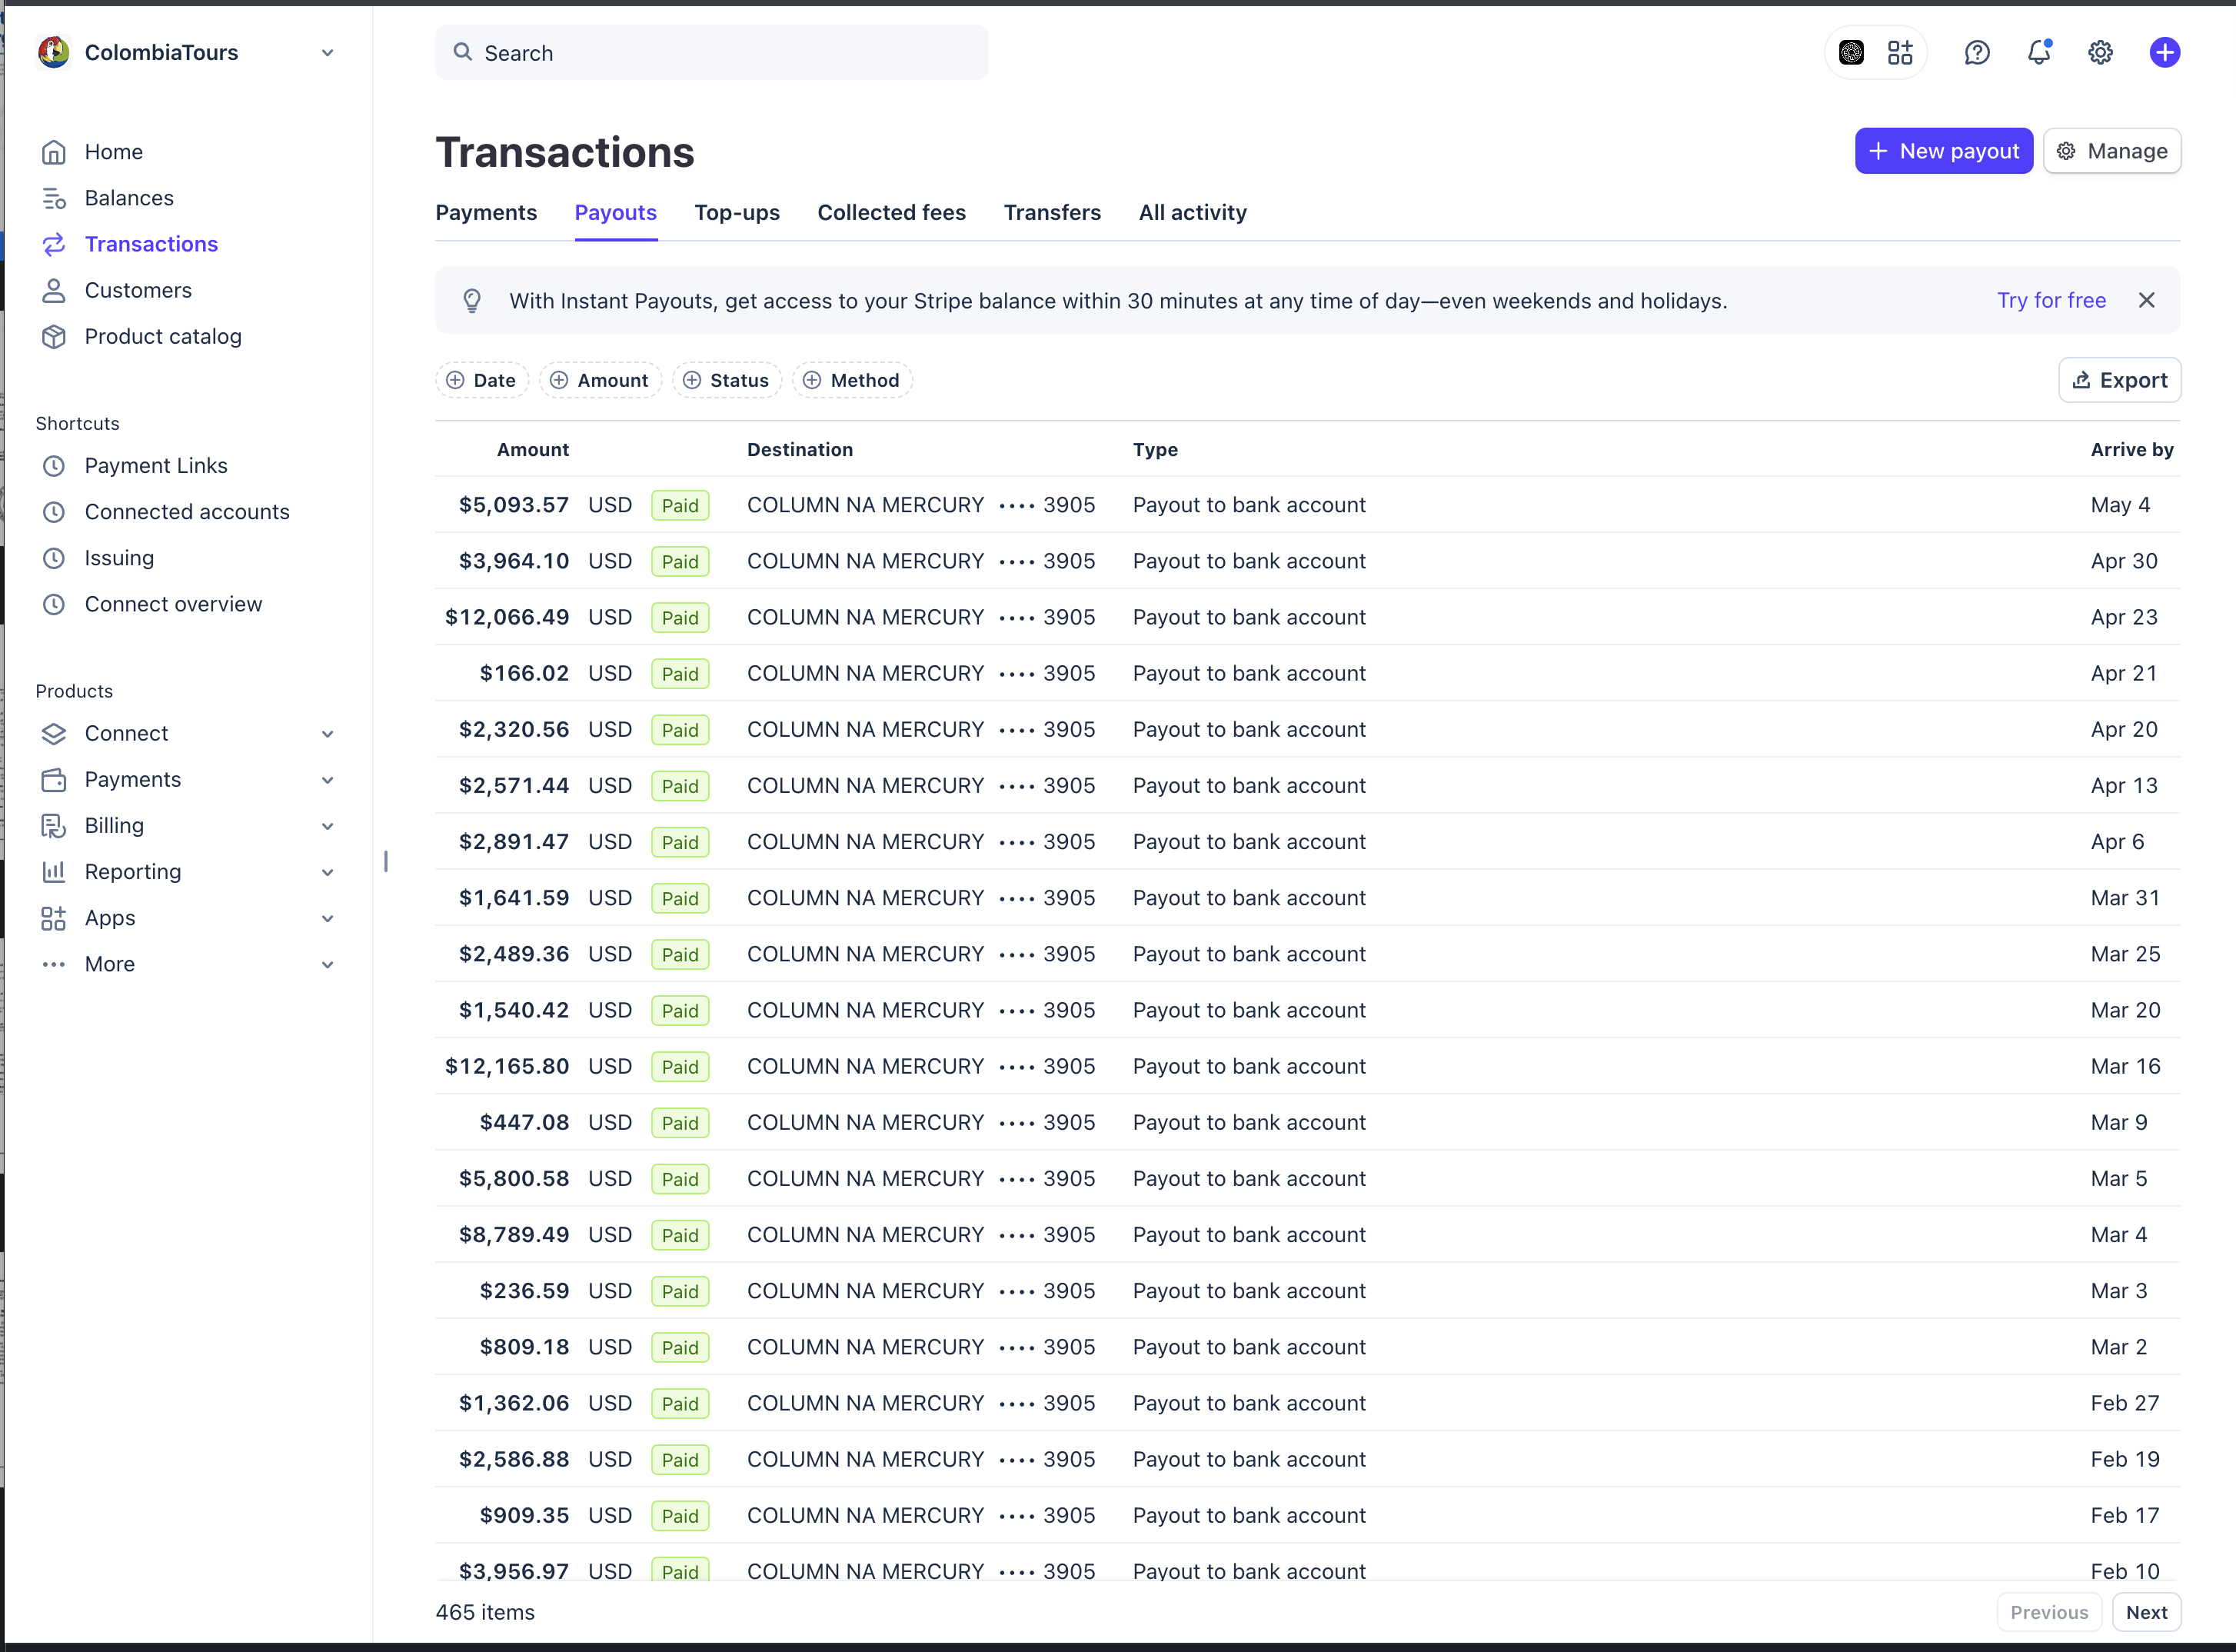

3. Stripe Payouts - weppa.cloud / Weppa Tech Services
Stripe dashboard payout page showing paid payouts to COLUMN NA MERCURY ending 3905.
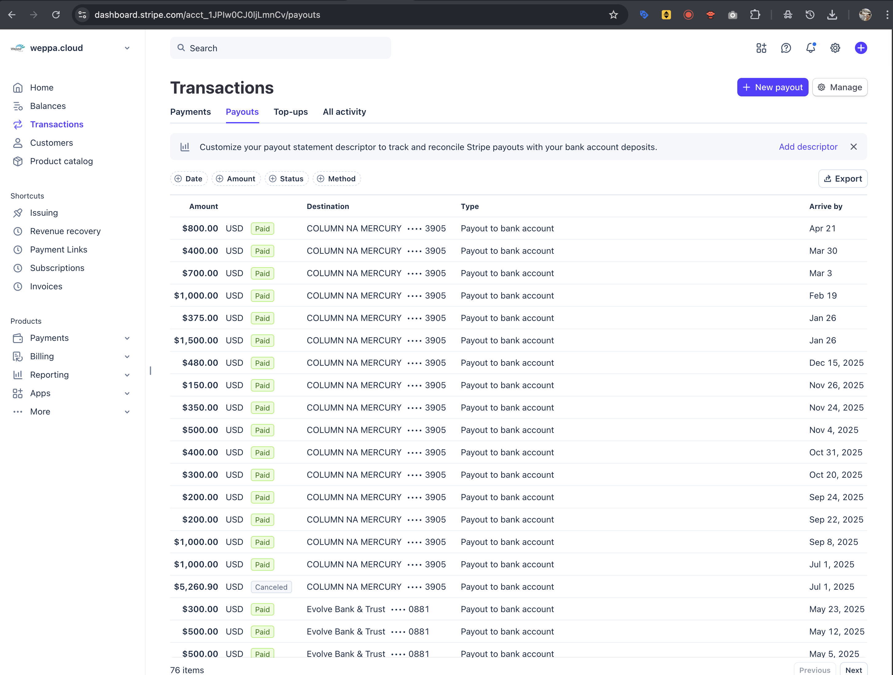
Prepared for Mercury account review on May 6, 2026.

