Google Ads API Standard Access Design Documentation
ColombiaTours Travel internal campaign operations tool

Company Name: ColombiaTours Travel
Primary Website: https://colombiatours.travel/
Tool Availability: Internal users only. The tool is not publicly accessible and external users or clients will not have direct access.

Business Model
ColombiaTours Travel is a travel agency that sells customized travel packages and tours in Colombia to international travelers. The company generates leads through its website and sales team, then helps travelers plan and purchase destination-specific travel packages. We advertise only our own travel services and websites, and we do not manage Google Ads accounts for third-party clients.

Tool Access and Use
The Google Ads API tool will be used only by internal employees and managers of ColombiaTours Travel. The tool will help the internal marketing team create, validate, pause, update, and review Google Ads Search campaigns. Campaigns will be created from approved internal campaign templates and CSV bundles. All new campaigns, ad groups, keywords, and ads will be created in paused status first, reviewed internally, and then manually enabled by an authorized account user.

Tool Design
The tool will use the Google Ads API to manage Search campaign structures for ColombiaTours Travel. Internal users will prepare approved campaign data such as campaign names, budgets, ad groups, keywords, negative keywords, responsive search ads, sitelinks, callouts, and structured snippets.
Before applying changes, the tool will validate the campaign data, check required fields, verify naming conventions, and prevent duplicate campaign creation. The tool will support dry-run or validation mode before creating or updating account entities.
The tool will also retrieve campaign performance metrics for internal reporting, including impressions, clicks, cost, conversions, CTR, CPC, and conversion rate. Reports will be used by the internal marketing team to review performance and optimize ColombiaTours campaigns.

Security and Access Control
Only authorized internal users will be able to run the tool. API credentials and OAuth tokens will be stored securely and will not be exposed to end users. The developer token will not be shared with external users. The tool will only access Google Ads accounts owned or managed by ColombiaTours Travel.

API Services Called
- GoogleAdsService: retrieve account, campaign, ad group, keyword, ad, and performance reporting data.
- CustomerService: access basic customer account information.
- CampaignBudgetService: create and update campaign budgets.
- CampaignService: create, pause, and update Search campaigns.
- AdGroupService: create, pause, and update ad groups.
- AdGroupCriterionService: create and update keywords and negative keywords.
- AdGroupAdService: create and update responsive search ads.
- AssetService: create ad assets such as sitelinks, callouts, and structured snippets.
- CampaignAssetService: attach campaign-level assets.
- CustomerNegativeCriterionService: manage account-level negative keywords when needed.

Supported Campaign Types
Search campaigns.

Primary Capabilities
- Campaign creation
- Campaign management
- Keyword management
- Negative keyword management
- Responsive search ad creation
- Ad asset management
- Reporting

Change Review Process
All bulk changes are reviewed before being applied. New campaigns are created in paused status by default. An authorized ColombiaTours user reviews the changes in Google Ads before enabling campaigns for delivery. The tool is intended to reduce manual upload errors and standardize campaign creation, not to automatically launch campaigns without human review.

Tool Mockups

Mockup 1: Internal performance dashboard
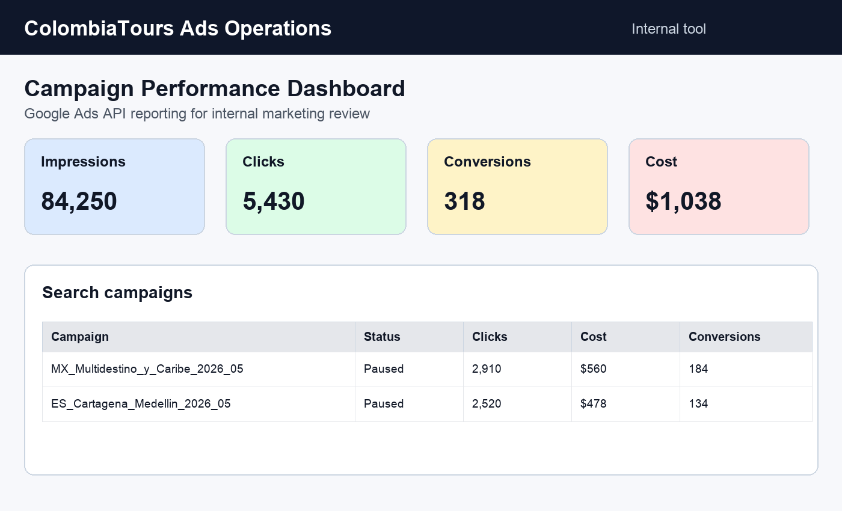

Mockup 2: Campaign upload dry-run validator
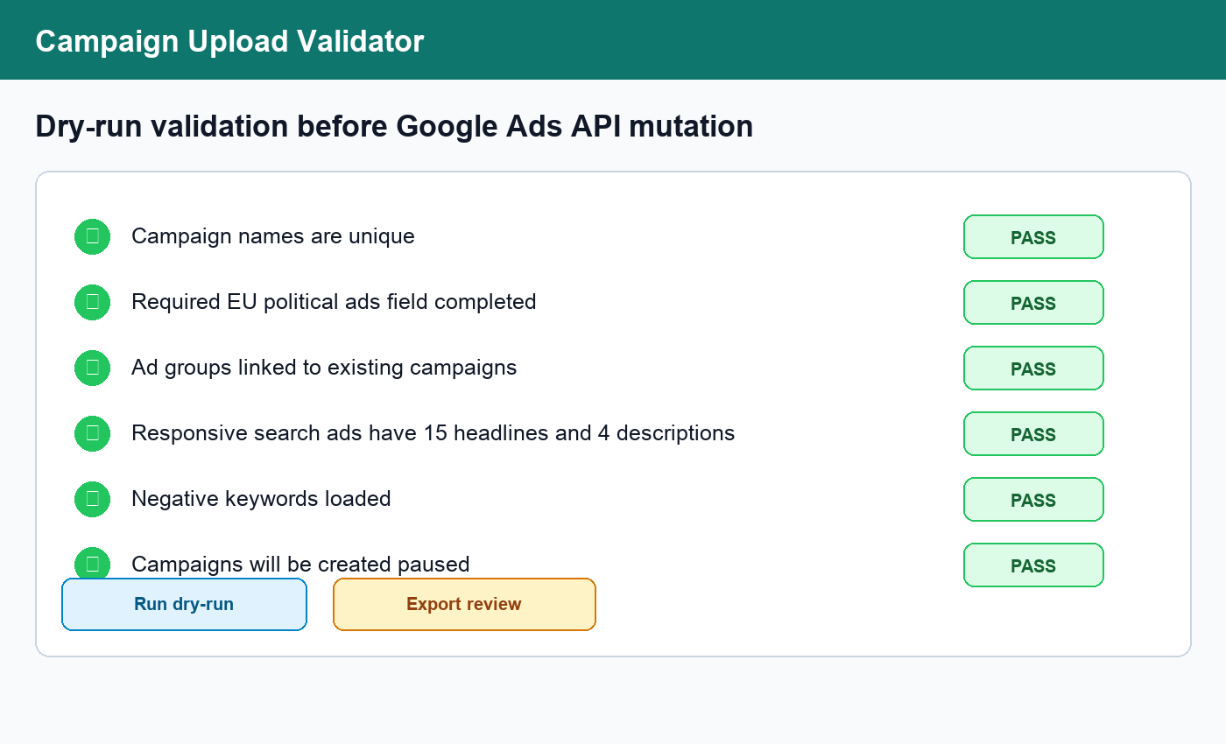

Mockup 3: Human review queue before launch
