**DATABASE COMPULSORY TASK**

Make sure you’ve met **“Useful preconditions”** provided thereto.

Please use **“deliveries” database** to perform the following task.

**Database diagram:**

*The results of your work should be SQL-queries inserted in this document.*

Use the Database diagram and screenshots of the expected results to each SQL-query to adjust them. **Ensure that Columns in your resulting table correspond to the expected results provided.**

**Tasks and expected results:**

**1.** Select all the information about Suppliers from Germany

**SQL Query:** select * from Suppliers where Country = 'Germany'

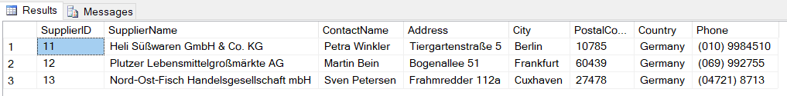

**2.** Select all the information about Products with CategoriesID “1” and “6” and sort the results by Price

**SQL Query:** select * from Products where CategoryID = 1 or CategoryID = 6 order by Price

**3.** Select all Seafood products with the Price up to 20 inclusive

*Use ‘Product’ table, but do not hesitate to take a look into other tables for any additional info.*

**SQL Query:** select Products.ProductName, Products.CategoryID, Products.Price FROM Products inner join Categories on Categories.CategoryID = Products.CategoryID where Categories.CategoryName = 'Seafood' and Products.Price <= 20

**4.** Select all the Employees who has the First Name with the 3rd  letter “N” and whose ID number is between 2 and 10

**SQL Query:** select EmployeeID, FirstName, LastName, BirthDate from Employees where substring(FirstName, 3, 1) = 'N' and EmployeeID between 2 and 10

**5.** Select the product with the maximum price and name the resulting column “MAXPrice”

**SQL Query:** select top 1 ProductName, Price as MAXPrice from Products order by Price DESC

**\*6.** Show the average price of the products delivered in jars, round to 2 decimal places and name the resulting column “AVGPrice”

**SQL Query:** select round(AVG(Price),2) as AVGPrice from Products where Unit like '%jars'

**7.** Show the number of customers who do not live in the USA and Spain. Name the resulting column “FinalResult”

**SQL Query:** select count(*) AS FinalResult from Customers where Country != 'USA' and Country != 'Spain'

**8.** Show a list of the customers whose name ends with “s”, from the country which name does not contain “U” letter and starts with “B”. Sort the list by the customers’ name from Z to A

**SQL Query:** select CustomerName, Address, Country from Customers where right(CustomerName,1) = 's' and Country not like '%U%' and substring(Country, 1,1) = 'B' order by CustomerName DESC

**9.** Count the number of customers in each country and name the resulting column “ClientNumber”

**SQL Query:** select Country, count(*) as ClientNumber from Customers group by Country

**10.** Show the list of employees who was born in winter till 1963. Sort the list by EmployeeID in descending order.

**SQL Query:** select FirstName, LastName, BirthDate from Employees where year(BirthDate) < 1963 and month(BirthDate) in (12,1,2) order by EmployeeID DESC

**11.** Select the first 15 customers and show their full address in 1 column.

**SQL Query:** select top 15 CustomerName, concat(Country, ',', City, ',', Address) as FullAddress from Customers

