Types Of SSD

* 5 Types Of Form-Factors (Is How The SSD looks like physicaly And by which разъём they plugged)

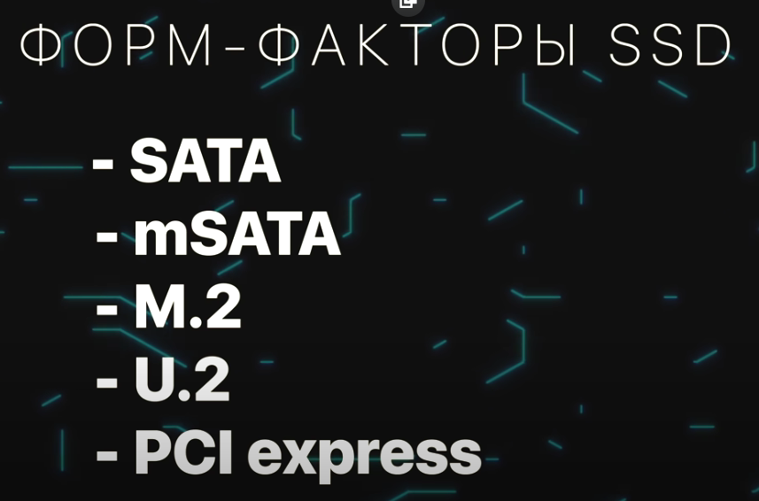

2 Connection Interfaces (2 интерфейса подключения) (How the disks are logically connected to the processor & How data move in a computer)

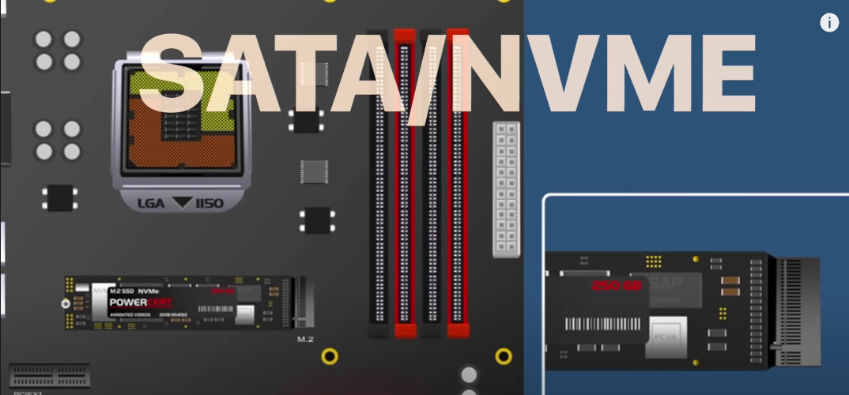SATA – old interface

NVME – new – witch wirked via bus PCI express

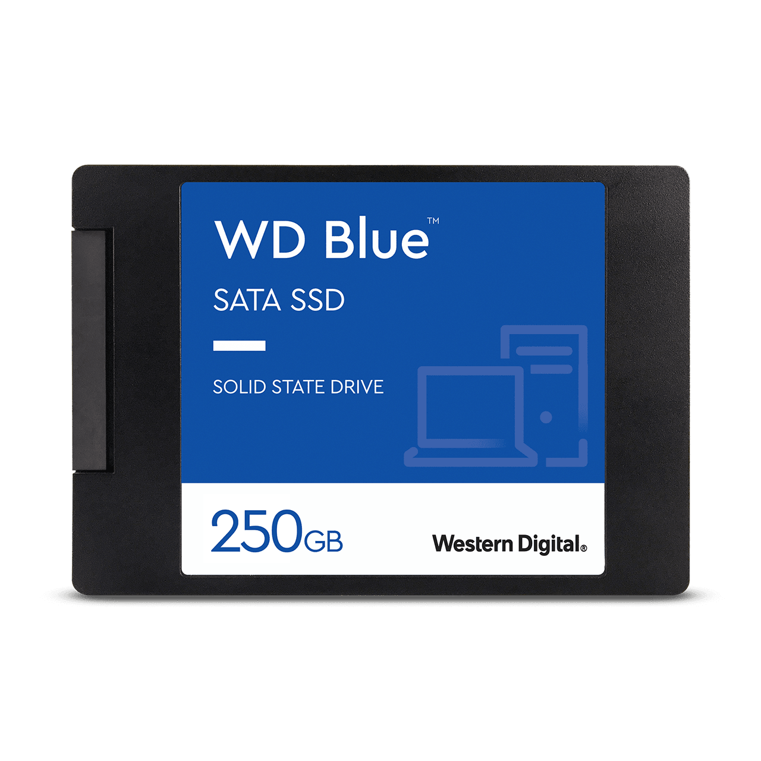

2, 5 дюймовый диск