# **Assignment 4. Coloring Algorithm**

|  |  |  |  |
| --- | --- | --- | --- |
|  | 알고리즘 | 이름 | 김민기 (20150217) |
|  | 화요일, 목요일 | 학급 | 소프트웨어학부 나반 |
|  | 13:30-14:45 | 학기 | 2학기 |
|  | 신정훈 교수님 | 날짜 | 2016.11.24  (목) |

**OUTPUT by C++**

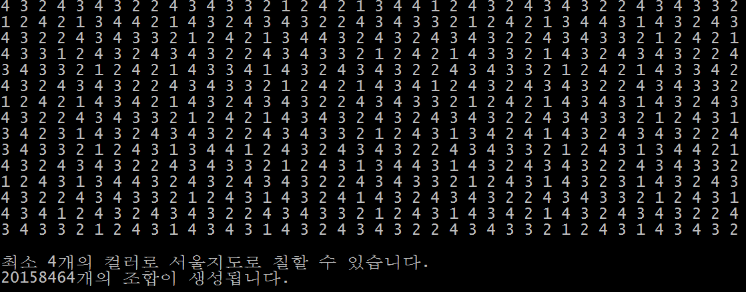

[CODE]

#include <iostream>

using namespace std;

int W[26][26] =

{0 ,1 ,2 ,3 ,4 ,5 ,6 ,7 ,8 ,9 ,10 ,11 ,12 ,13 ,14 ,15 ,16 ,17 ,18 ,19 ,20 ,21 ,22 ,23 ,24 ,25 }

{1 ,0 ,1 ,1 ,0 ,0 ,0 ,0 ,0 ,0 ,0 ,0 ,0 ,0 ,0 ,0 ,0 ,0 ,0 ,0 ,0 ,0 ,0 ,0 ,0 ,0 }

{2 ,1 ,0 ,1 ,0 ,0 ,1 ,0 ,0 ,0 ,0 ,0 ,0 ,0 ,0 ,0 ,0 ,0 ,0 ,0 ,0 ,0 ,0 ,0 ,0 ,0 }

{3 ,1 ,1 ,0 ,1 ,0 ,1 ,0 ,0 ,0 ,0 ,0 ,0 ,0 ,0 ,0 ,0 ,0 ,0 ,0 ,0 ,0 ,0 ,0 ,0 ,0 }

{4 ,0 ,0 ,1 ,0 ,1 ,1 ,0 ,0 ,0 ,0 ,0 ,1 ,0 ,0 ,0 ,0 ,0 ,0 ,0 ,0 ,0 ,0 ,0 ,0 ,0 }

{5 ,0 ,0 ,0 ,1 ,0 ,1 ,1 ,0 ,0 ,0 ,1 ,1 ,0 ,0 ,0 ,0 ,0 ,0 ,0 ,0 ,0 ,0 ,0 ,0 ,0 }

{6 ,0 ,1 ,1 ,1 ,1 ,0 ,1 ,0 ,0 ,0 ,0 ,0 ,0 ,0 ,0 ,0 ,0 ,0 ,0 ,0 ,0 ,0 ,0 ,0 ,0 }

{7 ,0 ,0 ,0 ,0 ,1 ,1 ,0 ,1 ,1 ,1 ,0 ,0 ,0 ,0 ,0 ,0 ,0 ,0 ,0 ,0 ,0 ,0 ,0 ,0 ,0 }

{8 ,0 ,0 ,0 ,0 ,0 ,0 ,1 ,0 ,1 ,0 ,0 ,0 ,0 ,0 ,0 ,0 ,0 ,1 ,0 ,0 ,0 ,0 ,0 ,0 ,0 }

{9 ,0 ,0 ,0 ,0 ,0 ,0 ,1 ,1 ,0 ,1 ,0 ,0 ,0 ,0 ,0 ,0 ,0 ,1 ,0 ,0 ,0 ,0 ,0 ,0 ,0 }

{10 ,0 ,0 ,0 ,0 ,0 ,0 ,1 ,0 ,1 ,0 ,1 ,0 ,0 ,0 ,0 ,0 ,1 ,1 ,0 ,0 ,0 ,0 ,0 ,0 ,0 }

{11 ,0 ,0 ,0 ,0 ,1 ,0 ,0 ,0 ,0 ,1 ,0 ,1 ,0 ,0 ,1 ,0 ,1 ,0 ,0 ,0 ,0 ,0 ,0 ,0 ,0 }

{12 ,0 ,0 ,0 ,1 ,1 ,0 ,0 ,0 ,0 ,0 ,1 ,0 ,1 ,1 ,1 ,0 ,0 ,0 ,0 ,0 ,0 ,0 ,0 ,0 ,0 }

{13 ,0 ,0 ,0 ,0 ,0 ,0 ,0 ,0 ,0 ,0 ,0 ,1 ,0 ,1 ,0 ,0 ,0 ,0 ,0 ,0 ,0 ,0 ,0 ,0 ,0 }

{14 ,0 ,0 ,0 ,0 ,0 ,0 ,0 ,0 ,0 ,0 ,0 ,1 ,1 ,0 ,1 ,0 ,0 ,0 ,0 ,0 ,0 ,0 ,0 ,0 ,0 }

{15 ,0 ,0 ,0 ,0 ,0 ,0 ,0 ,0 ,0 ,0 ,1 ,1 ,0 ,1 ,0 ,1 ,1 ,0 ,0 ,0 ,0 ,0 ,0 ,0 ,0 }

{16 ,0 ,0 ,0 ,0 ,0 ,0 ,0 ,0 ,0 ,0 ,0 ,0 ,0 ,0 ,1 ,0 ,1 ,0 ,0 ,0 ,0 ,1 ,1 ,0 ,0 }

{17 ,0 ,0 ,0 ,0 ,0 ,0 ,0 ,0 ,0 ,1 ,1 ,0 ,0 ,0 ,1 ,1 ,0 ,1 ,0 ,0 ,1 ,1 ,0 ,0 ,0 }

{18 ,0 ,0 ,0 ,0 ,0 ,0 ,0 ,1 ,1 ,1 ,0 ,0 ,0 ,0 ,0 ,0 ,1 ,0 ,1 ,0 ,1 ,0 ,0 ,0 ,0 }

{19 ,0 ,0 ,0 ,0 ,0 ,0 ,0 ,0 ,0 ,0 ,0 ,0 ,0 ,0 ,0 ,0 ,0 ,1 ,0 ,1 ,1 ,0 ,0 ,0 ,0 }

{20 ,0 ,0 ,0 ,0 ,0 ,0 ,0 ,0 ,0 ,0 ,0 ,0 ,0 ,0 ,0 ,0 ,0 ,0 ,1 ,0 ,1 ,0 ,0 ,1 ,0 }

{21 ,0 ,0 ,0 ,0 ,0 ,0 ,0 ,0 ,0 ,0 ,0 ,0 ,0 ,0 ,0 ,0 ,1 ,1 ,1 ,1 ,0 ,1 ,0 ,1 ,0 }

{22 ,0 ,0 ,0 ,0 ,0 ,0 ,0 ,0 ,0 ,0 ,0 ,0 ,0 ,0 ,0 ,1 ,1 ,0 ,0 ,0 ,1 ,0 ,1 ,0 ,0 }

{23 ,0 ,0 ,0 ,0 ,0 ,0 ,0 ,0 ,0 ,0 ,0 ,0 ,0 ,0 ,0 ,1 ,0 ,0 ,0 ,0 ,0 ,1 ,0 ,1 ,1 }

{24 ,0 ,0 ,0 ,0 ,0 ,0 ,0 ,0 ,0 ,0 ,0 ,0 ,0 ,0 ,0 ,0 ,0 ,0 ,0 ,1 ,1 ,0 ,1 ,0 ,1 }

{25 ,0 ,0 ,0 ,0 ,0 ,0 ,0 ,0 ,0 ,0 ,0 ,0 ,0 ,0 ,0 ,0 ,0 ,0 ,0 ,0 ,0 ,0 ,1 ,1 ,0 }

int vcolor[26];

int n=25, m=4, count=0;

bool promising(int i)

{

int j = 1;

bool _switch = true;

while(j<i && _switch)

{

if(W[i][j] && vcolor[i]==vcolor[j])

_switch = false;

j++;

}

return _switch;

}

void m_coloring (int i)

{

int color;

if(promising(i))

if(i==n)

{

for(int j=1; j<=n;j++)

cout<<vcolor[j]<<" ";

count++;

}

else

for(color = 1; color<=m; color++)

{

vcolor[i+1] = color;

m_coloring(i+1);

}

}

int main()

{

void m_coloring(int i);

m_coloring(0);

cout<<"\n\n 최소 4개의 컬러로 서울지도로 칠할 수 있습니다.”<<endl;

cout<<count<<"20158464개의 조합이 생성됩니다."<<endl;

}

