# **User`s Manual for PIEROGIS**

Created by: Lingbin Kong, Robin Oe, Jiani She, Weronika Tuszynska

Date: 23/12/2023

Course: AG2411 – GIS Architecture and Algorithms

Division: Geoinformatics, KTH

## Introduction

This is the user‘s manual for Pierogis Software. This software can display map images, by which users can observe them interactively. And it also can implement some map algebra algorithms, including local statistics, focal statistics and zonal statistics. Users can operate this software easily by following this manual.

## Formats of data

Pierogis only supports text (txt) files. The data type supported is ASCII.txt files. This is the case for both reading and saving the files

## Software interface

When starting the application, Pierogis looks like this(figure 1). It mainly consists of four parts: the menu bar, the file content, the map content, and the status bar.

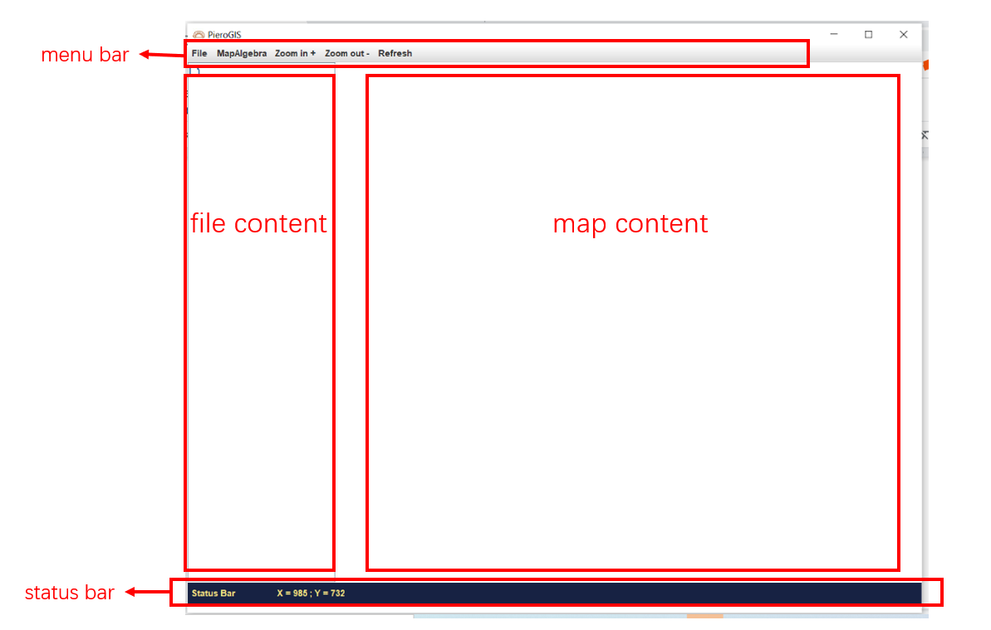

Figure 1 software interface

## Available tools

1. **File**

This button in the menu-bar opens the possibilities to get files from your computer. Also the option for exit is found here. Underneath file: the following functions can be found.

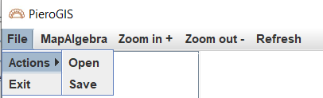

Figure 2 Available tools - File

* Open: File > Actions > Open: this option allows you to open .txt files from your storage, and visualizes them into the map content area. The ‘open’ button directs first to the user/home pathway, and on further tries within the session stays stationary at the last full path that was opened.
* Save: File > Actions > Save: This option allows you to save the file that you created on your computer. The default setting for the staring computer pathway for this button is users/home documents.
* Exit: File > Exit: This button allows you to exit the PieroGIS software. The program shuts down.

1. **MapAlgebra**

When you click this item, you can there are three map algebra options.

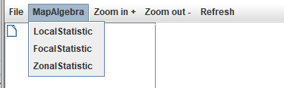

Figure 3 Available tools - MaoAlgebra

* LocalStatistic: when you click this option, you can see a new window called LocalStatistic, where you can try some local statistical operations. This option is to calculate a per-cell statistic from multiple files. Now it supports at most two files for calculating and five statistic types(sum, maximum, minimum, mean, variety)

SUM: adding each value of the same cell from every file; VARIETY:

What you need to do is to select the file you want to calculate from the “input file” select box and then click the “add” button to add it to the file list. And you can use the default output file path or change it by clicking the “choose” button to select and create the file path. And the last thing, you need to choose the statistic type you want to implement.

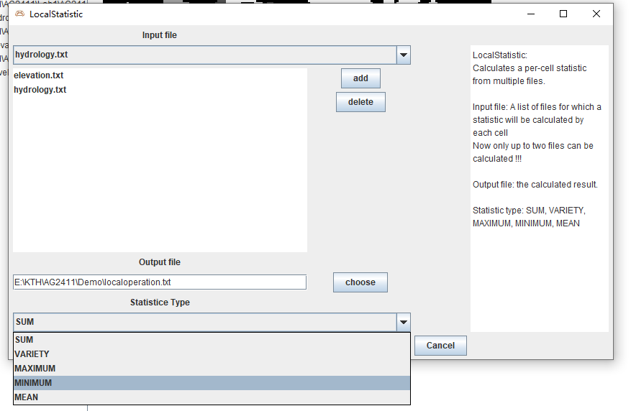

Figure 4 Available tools – MapAlgebra – LocalStatistic

* FocalStatistic: when you click this option, you can see a new window called FocalStatistic, where you can try some focal statistical operations. This option is to calculate for each input cell location a statistic of the values within a specific area around it. Now it supports two shapes of neighborhood(square and circle) and five statistic types(sum, maximum, minimum, mean, variety) .

What you need to do is to select the file you want to calculate from the “input file” select box. And you can use the default output file path or change it by clicking the “choose” button to select and create the file path. You also need to choose the neighborhood shape and enter a radius value that cannot be negative. And the last thing, you need to choose the statistic type you want to implement.

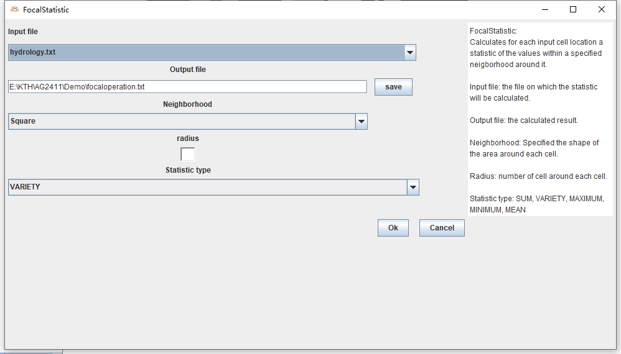

Figure 5 Available tools – MapAlgebra – FocalStatistic

* ZonalStatistic: when you click this option, you can see a new window called ZonalStatistic, where you can try some zonal statistical operations. This option is to calculate statistics on the values of a file within the zones of another file. Now it supports five statistic types(sum, maximum, minimum, mean, variety).

What you need to do is to select the file that defines the zone from the “input file (zonal data)” select box and the value file that you want it to be calculated from “input value file” select box. And you can use the default output file path or change it by clicking the “choose” button to select and create the file path. The last thing, you need to choose the statistic type you want to implement.

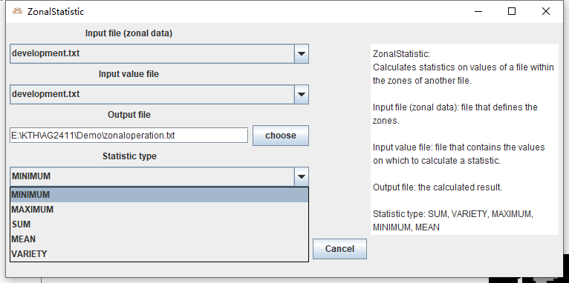

Figure 6 Available tools – MapAlgebra – ZonalStatistic

1. **Zoom in & Zoom out**

There are two ways you can zoom in and zoom out on the map. One is by scrolling your mouse wheel, and the other one is by clicking the “Zoom in +” and “Zoom out –” items.

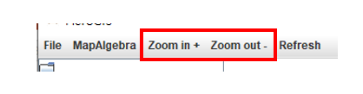

Figure 7 Available tools – “Zoom in +” and “Zoom out –” items

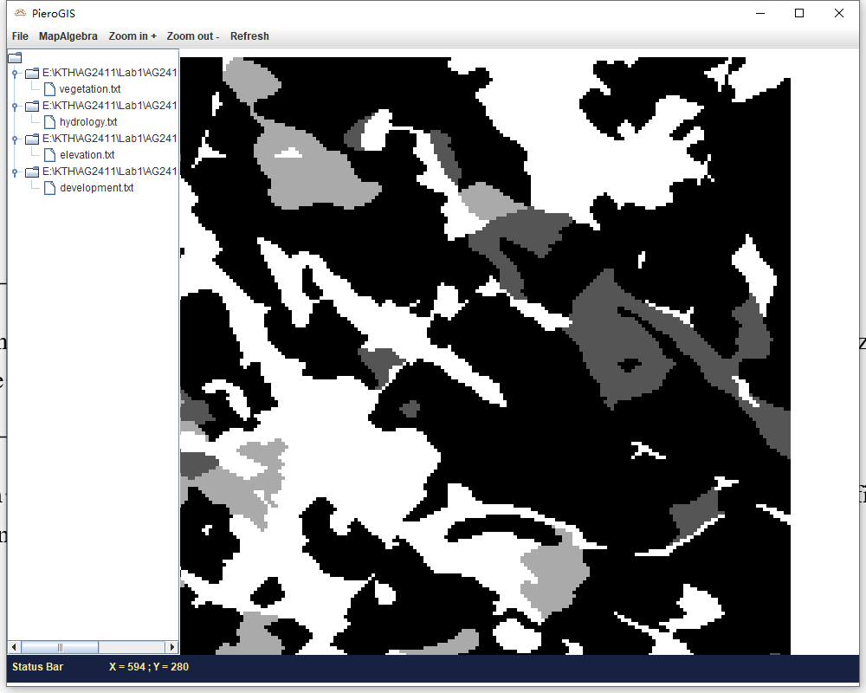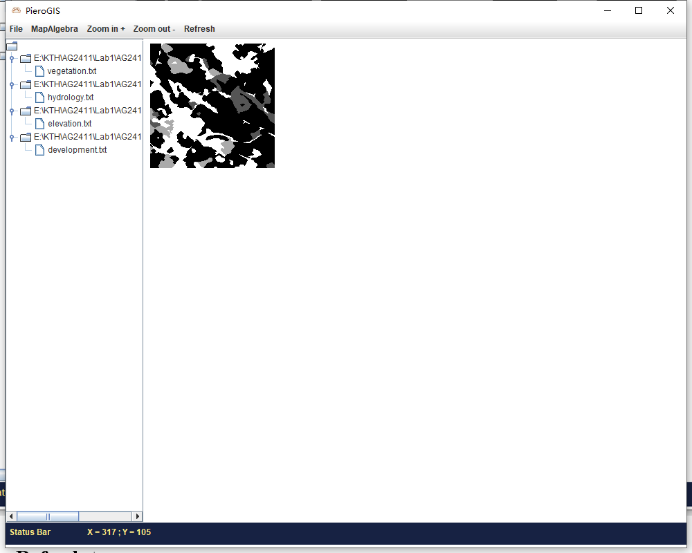

Figure 8 Available tools – Zoom in & Zoom out

1. **Refresh**

When you click the “Refresh” button, the map will be set to the original scale, which size you see when you start the application.

1. **File content**

On the file content, you can select which map you want to observe by left-clicking the file item.

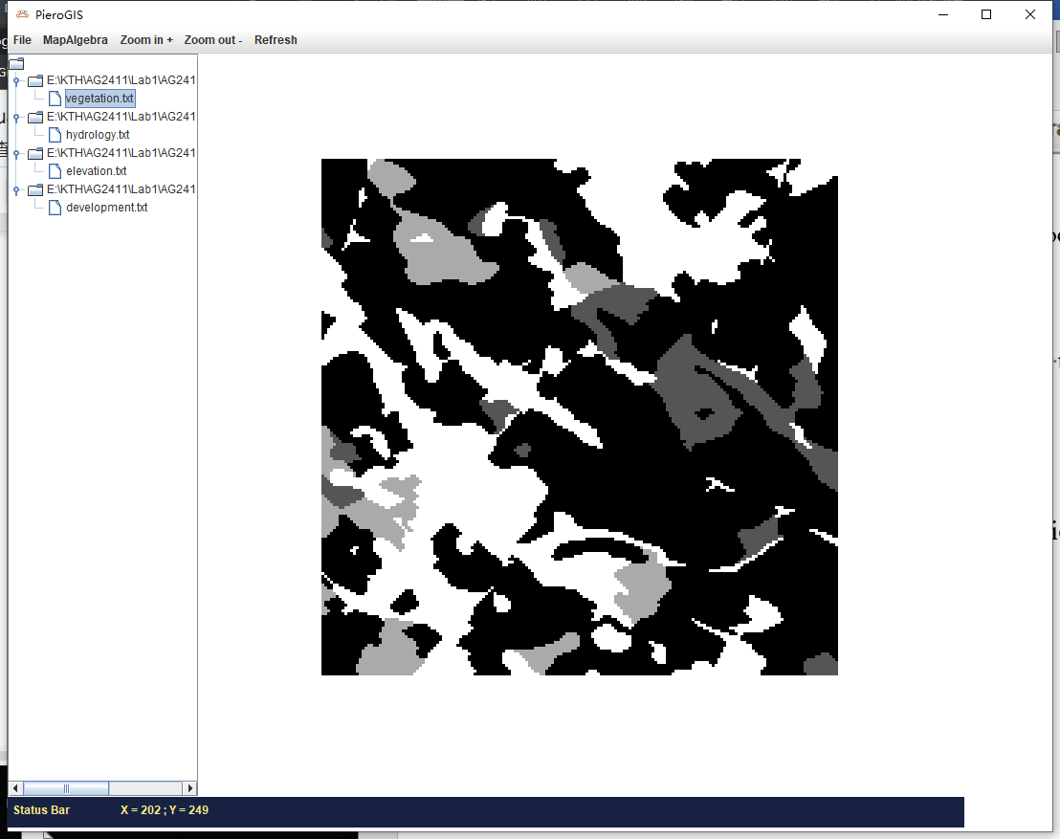 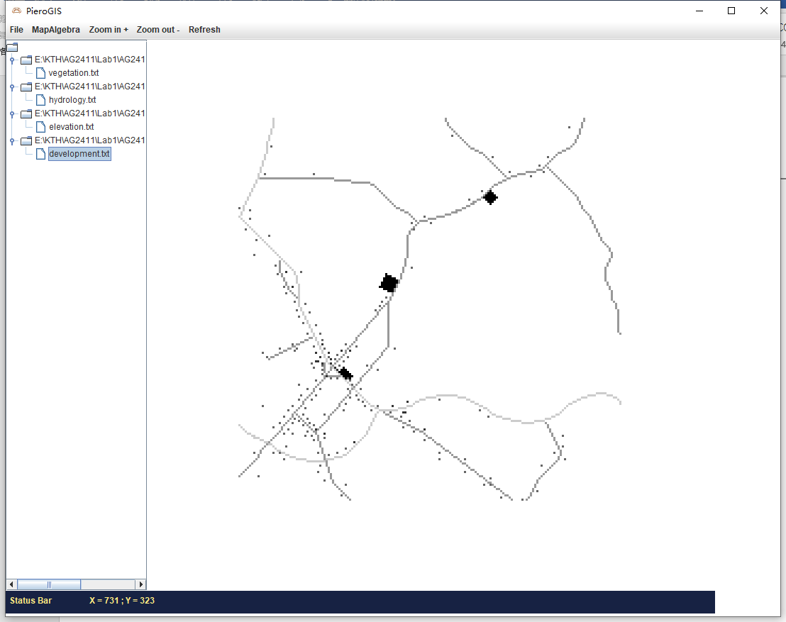

Figure 9 Available tools – File content – select file

And you also can remove the file/map from the file content/map content if you don’t need it. Just right-clicking the file item, then you can see a “Delete” option and then click it.

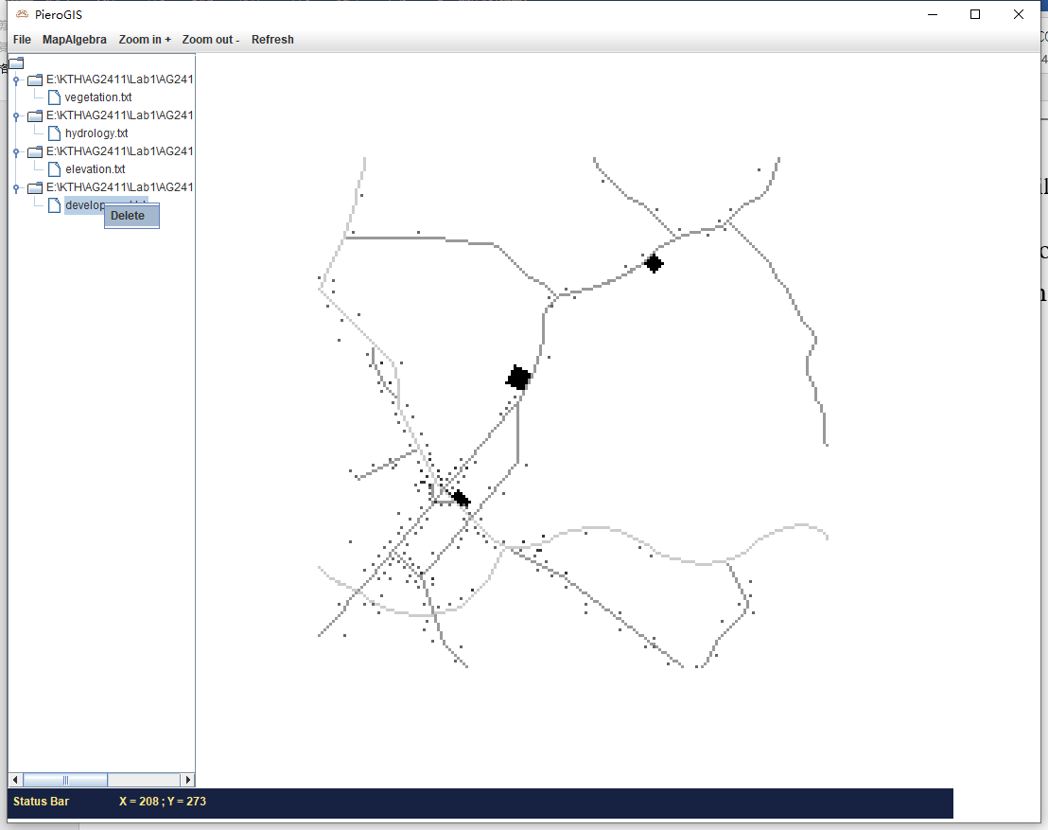

Figure 10 Available tools – File content – delete file

1. **Map content**

On the map content, you can zoom in and zoom out the map(see “Zoom in & Zoom out” above) and drag the map by left-clicking the map and keep pressing your mouse and move it at the same time. Then you can see the map is moving.

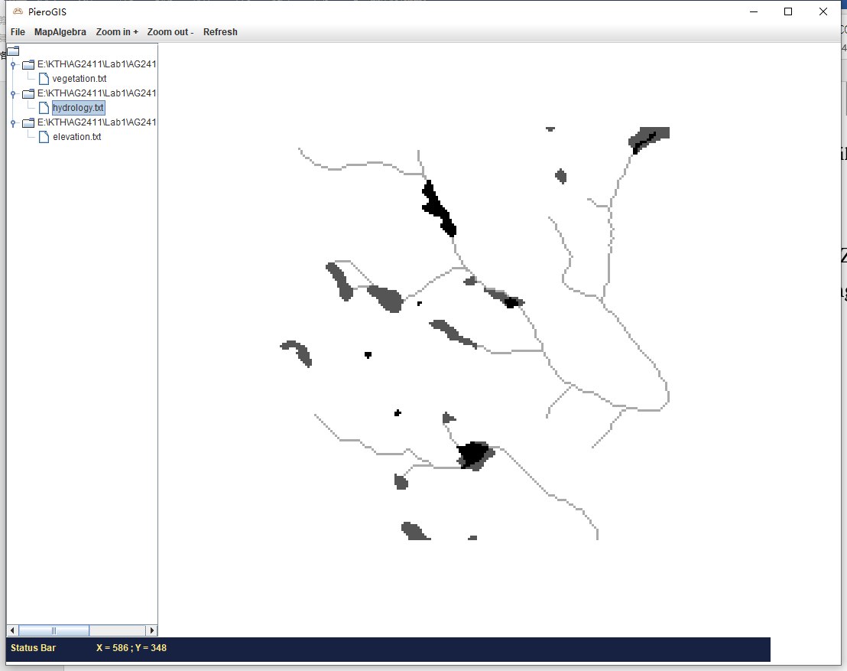 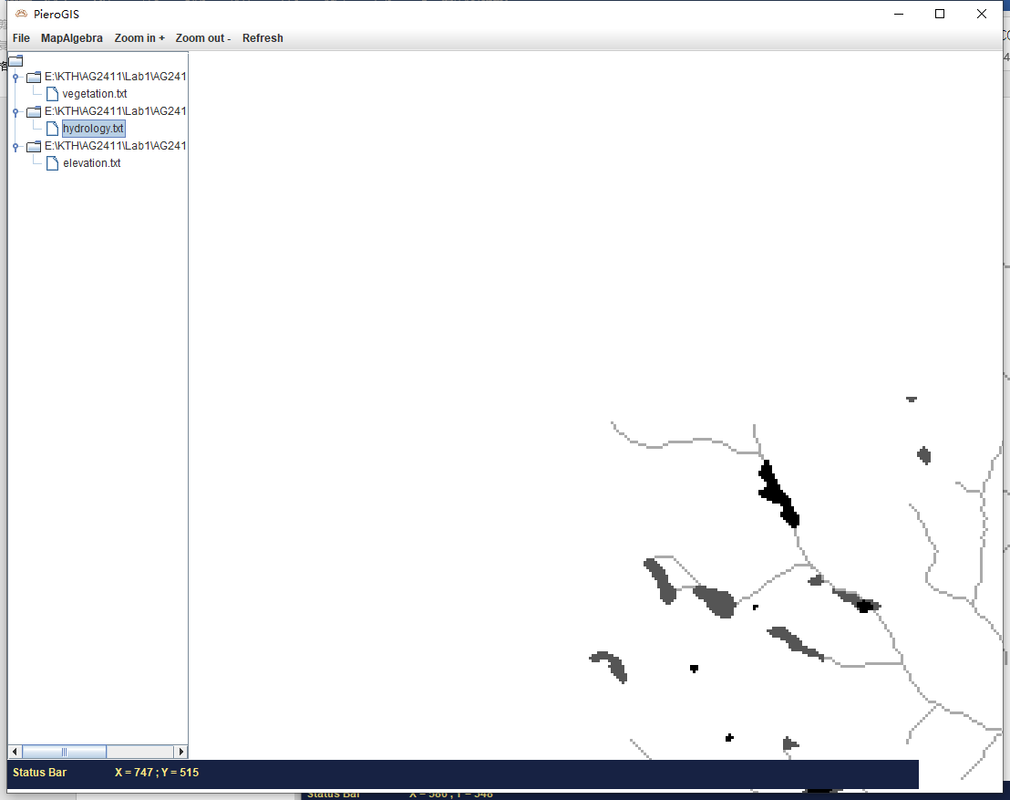

Figure 11 Available tools – Map content – drag the map

1. **Status bar**

On the status bar, you can see the coordinate value. When you move the cursor, the value will change at the same time. It is supposed to display the map coordinate of the location of the point where the cursor is put within the map. But it is now displaying the screen pixel coordinate. Our team is still working on it.

## How the tools have been implemented

## - how the tools are organized, invoked, and controlled. Illustrate there usage with pictures of their associated graphical user interface elements