Front-end UI Developer

Participates in the technical design of application systems. Develops and implements application systems by participating through the software development lifecycle from inception to delivery and beyond. The role is high touch position with a notable amount of collaboration across product teams and stakeholders to define requirements and understand how they fit into the end objective.

Front-end web development, also known as client-side development is the practice of producing HTML, CSS and JavaScript for a website or Web Application so that a user can see and interact with them directly.

This position will be responsible for the analysis, design, testing, development and maintenance of best in class software experiences. The candidate is a self-motivated individual who can collaborate with a team and across the organization. The candidate takes responsibility of the software artifacts produced adhering to U.S. Bank standards in order to ensure minimal impact to the customer experience. The candidate will be adept with the agile software development lifecycle and DevOps principles.

Responsibilities include:
- Designs and write complex code in several languages relevant to our existing product stack, with a focus on automation
- Configures, tunes, maintains and installs applications systems and validates system functionality
- Installs new software releases and application system upgrades. Evaluates and installs software patches
- Monitors and fine tunes applications system to achieve optimum performance levels and works with hardware teams to resolve issues with hardware and software
- Assists with application system problem resolution by working with application developers, vendors, and internal infrastructure team’s member to troubleshoot
- Addresses product backlog and provide continuous delivery of high-quality features
- Maintains a comprehensive operating system hardware and software configuration database/library of all supporting documentation to ensure data integrity
- Acts to improve the overall reliability of systems and to increase efficiency
- Works collaboratively with cross functional teams, using Agile / DevOps principles to bring products to life, achieve business objectives and serve customer needs
- Development of websites and applications through all phases of the development life cycle (including planning, building, testing, deploying, and maintaining)
- Working with project managers using traditional and Agile methodologies to plan and execute development · A solid grasp of fundamental algorithms and applications Strong design and coding skills in Typescript/JavaScript, and/or React
- Firm understanding of software development principles, capabilities and limitations of platforms, including first-time user experience, battery life, connectivity issues, and perceived performance
- Experience influencing software engineering best practices within your team
- Hands on experience with JavaScript frameworks · Knowledge of Accessibility and Web Standards · Experience with both Responsive and Adaptive Web Design
- Experience with common front-end development tools such as Babel, Webpack, NPM, yarn, etc.

Technical Skills Qualifications:

Non-negotiable/Required
- Javascript
- Typescript
- ReactJS
- NodeJS

Nice-to-have/Advantage
- AngularJS
- Agile Development
- UML
- Design Patterns

Work Environment
- Location: Office in Makati City, Philippines
- Schedule: Willingness to work a night shift
- Client: US Bank & Financial Tech (Banking & Financial Services)
- US Onshore Opportunity
- Setup: Flexible Hybrid Work-set Up (2x a week-NCR, NCR+/NCR++ Temporary WFH)

Note:

NCR and NCR Plus - are required to do onsite twice a week.

Outside NCR (NCR++) (as stated in the table) - and other locations not listed in the table they can do temporary work from home, with a commitment letter that they are amenable to do onsite once required.

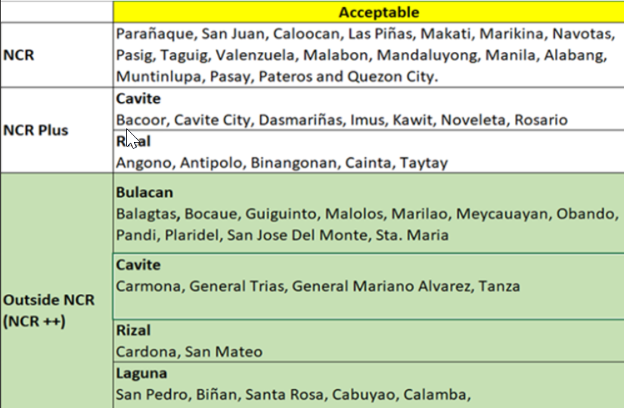

Candidate Experience

We value every job applicant and prioritize our candidate experience. Here is an overview of our standard recruitment process: After application, please expect feedback within 5 working days.

Three interview rounds:

First round: Interview with SMEs and potentially a colleague. Feedback within 1 week.
Second Round: Interview with Hiring Manager. Feedback within 1 week.
Potential Third Round: Interview with Global Manager or Client. Feedback within 1 week.

Successful candidates will receive feedback and job offers directly from Human Resources.

