FACEBLUR
Head Detection in Extreme Environments for Video Anonymization: Motion Blur, Unusual Viewpoints, and Heavily Obscured Heads
A Technical Thesis
Author: [ Joontae Kim ]
Repository: github.com/werehappy/Face-Blur
[ University of British Columbia / Course / Date ]

Contents
Contents 2
Abstract 3
1. Introduction 3
1.1 Motivation 3
1.2 Problem statement 3
1.3 Contributions 4
2. Background and Related Work 4
3. Why Base Models Fail: A Problem Analysis 4
3.1 Appearance-level challenges 4
3.2 Viewpoint and framing challenges 5
4. Approach 5
4.1 System overview 5
4.2 Edge-strip detection 6
4.3 Person-to-head estimation (geometric fallback) 6
4.4 Custom data collection and labeling 6
4.5 Training pipeline 6
4.6 Runtime combination policy 8
5. Experimental Setup 9
5.1 Training data 9
5.2 Evaluation footage 9
5.3 Metrics 9
5.4 Training configuration 10
6. Results 10
6.1 Overall comparison 10
6.2 Per-source generalization check 11
6.3 Failure-mode breakdown 11
6.4 Qualitative comparison 11
7. Discussion 12
8. Limitations and Future Work 12
9. Conclusion 12
10. Data Availability and Ethics 13
References 13

Abstract
Automated video anonymization depends on reliably locating every human head so that identifying features can be obscured. General-purpose object detectors, including off-the-shelf YOLO models trained on standard datasets, detect upright, unobstructed, forward-facing heads well but degrade sharply under the conditions that dominate real military and law-enforcement footage: rapid camera motion, motion blur, unusual viewpoints (top-view and third-person), and heads heavily obscured by helmets, masks, and other worn or carried equipment. This project, FACEBLUR, targets a single generalized head detector for these extreme environments, produced by fine-tuning a single-class head detector on privately collected, consent-based footage that reproduces the target environment, and combining it at runtime with a face detector and an optional geometric head-estimation pass. The system introduces edge-strip inference to recover heads cut off at frame boundaries, a person-to-head estimation pathway used both to bootstrap labels and as a runtime fallback, and a disciplined, clip-level data pipeline designed to eliminate train/validation leakage. To check that the one model generalizes across very different-looking material, evaluation reports two visually distinct reference sources — first-person helmet-camera video and top-view crowd footage — separately, as a diagnostic rather than as domains to be served independently. This paper documents the motivation, method, and evaluation methodology, and reports a quantitative comparison against a public head-detection baseline.

1. Introduction

1.1 Motivation
The work began from a concrete and repeatable failure. When standard YOLO detectors are applied to footage for the purpose of blurring faces, they perform acceptably on clean, well-lit, front-facing subjects but fail on the material that matters most for privacy in dynamic recordings. Specifically, base models proved weak at detecting heads when the camera itself was in rapid motion, and when heads were disguised or partially covered by common equipment — helmets, sunglasses, masks, balaclavas, and even a rifle stock across the face. They also failed on the viewpoints and framing typical of this footage: performance was extremely poor on first-person helmet-camera video and on top-view crowd footage with small, densely packed heads.
These failures are not incidental. An anonymization tool that misses a head does not merely lose accuracy; it fails at its purpose, because the un-blurred region is precisely the identifying information the tool exists to protect. A detector that is right ninety percent of the time is, for this task, wrong in the ten percent of cases where privacy was actually at stake. That asymmetry — where a missed detection is far more costly than a spurious one — motivates the entire design that follows and, in particular, the emphasis on recall over precision throughout evaluation.

1.2 Problem statement
No publicly available head-detection model is trained on the combination of conditions this project targets: helmeted, motion-blurred, side- or rear-facing, or frame-truncated heads, nor on the small, top-view heads of dense crowds. Because the deficiency lies in the training distribution rather than in the detector architecture, the only reliable remedy is to train on frames that resemble the real target footage. The problem this project solves is therefore twofold: first, to build a single head detector that is robust across these adverse conditions; and second, to establish a repeatable pipeline and an honest evaluation methodology so that the resulting model's real-world coverage can be trusted rather than merely reported.

1.3 Contributions
- A fine-tuned, single-class head detector (head.pt) trained on custom-labeled footage spanning the adverse conditions of the target environment — motion blur, unusual viewpoints, and heavily obscured heads.
- An edge-strip inference scheme that recovers heads cut off at the frame boundary.
- A person-to-head estimation pathway serving a dual role: label bootstrapping during data preparation, and a runtime fallback when no user model is present.
- A clip-level data pipeline with automated leakage detection and repair, and an evaluation protocol that scores two contrasting reference sources separately, so a strong result on easier footage cannot mask weakness on harder footage.
- A runtime combination policy that disables the geometric fallback when a trained model is present, removing a class of gear-induced false positives.

2. Background and Related Work
Modern single-stage detectors of the YOLO family (Redmon et al., 2016) predict object bounding boxes and class scores in a single forward pass, offering the speed required for frame-by-frame video processing. Their accuracy is, however, bounded by the distribution of their training data. The standard COCO person category (Lin et al., 2014), for instance, labels whole bodies rather than heads, and its imagery under-represents the occluded, disguised, and high-motion heads that dominate the footage of interest here. Two families of technique are therefore relevant: direct head detection, which requires head-level annotations, and geometric head estimation, which infers a probable head region from a detected body. Head-level datasets and detectors do exist — SCUT-HEAD, collected from classroom surveillance and web crowd imagery (Peng et al., 2018); HollywoodHeads, drawn from film frames (Vu et al., 2015); and CrowdHuman, a benchmark for detection in dense crowds (Shao et al., 2018) — but their distributions likewise contain few helmeted, camouflaged, motion-blurred, or top-view tactical heads, which is the gap this project addresses. This project uses both, but in distinct roles, as Section 4 describes.
Face-detection models are a third, complementary source: they localize frontal facial features with high precision but, by construction, do not fire on the back of a head, a fully helmeted head, or a face concealed by a balaclava — exactly the cases this project must cover. The design consequence is that no single detector suffices; robust anonymization requires a union of complementary sources whose combined recall exceeds that of any one of them.

3. Why Base Models Fail: A Problem Analysis
The failure modes fall into two groups: appearance-level challenges, which change how an individual head looks, and viewpoint- and framing-level challenges, which change the statistics of the footage as a whole.

3.1 Appearance-level challenges
- Camera motion and motion blur smear head boundaries across pixels, degrading the sharp edges detectors rely on.
- Occlusion and disguise — helmets, sunglasses, masks, balaclavas, and even a rifle stock raised across the face — alter the silhouette and remove the facial texture cues that face models and many head models implicitly depend on.
- Pose: side and rear views present no face at all, defeating face-centric detection outright.
- Truncation: heads at the frame edge are only partially visible, and standard whole-image inference tends to suppress such partial objects.

3.2 Viewpoint and framing challenges
Beyond individual appearance, viewpoint and framing shift the data distribution far from what base models have seen. Two recurring examples in this footage are:
- First-person helmet-camera video: extreme, continuous camera motion, unusual viewing angles, and typically few heads per frame.
- Top-view crowd footage (catwalk-style): many small, overlapping, mutually occluding heads seen from above — the hardest material, and in this project the scarcest.
The goal is a single generalized detector for this whole environment, not a set of specialists; training on both kinds of footage together is what produces that generalization. Two cautions follow, and both shape the methodology. First, balance must be measured in labeled head instances, not frames: a top-view crowd frame may contribute eight or more heads while a helmet-camera frame contributes three or fewer, so a fifty-fifty split of frames can be a one-to-three split of instances, and because the training loss is driven by instances, the denser footage would quietly dominate and the sparser weaken. Second, the two sources are labeled and scored separately purely as a diagnostic: because they look so different, comparing recall on each is how we check that the one model generalizes rather than leaning on whichever material it saw most. They are reference indicators, not domains with independent targets.

4. Approach

4.1 System overview
At runtime FACEBLUR forms the set of regions to censor as the union of a trained head detector and a face detector, with an optional geometric person-to-head pass as a fallback. When the operator enables whole-head detection, the application reads the head class directly from the model's own metadata and runs the head model at a fixed inference resolution with edge strips. A face already contained within a head box is not censored twice. The following subsections describe each component.

4.2 Edge-strip detection
Heads at the boundary of the frame are frequently truncated and, under ordinary whole-image inference, under-detected. To recover them, the system runs additional inference passes over strips along the frame edges, where partial heads are more likely to be resolved at a favorable scale. The boundary detections are merged into the union, extending coverage to subjects entering or leaving the field of view — a common occurrence under the high-motion conditions of Section 3.

4.3 Person-to-head estimation (geometric fallback)
The person-to-head pathway does not detect heads directly. It runs a COCO person detector and estimates the probable head region from each body — top-center, sized by shoulder width. This pathway is valuable precisely because it fires on the head of anyone with a visible body, including heads that are blurred, turned away, or otherwise invisible to a face or head detector. It is used in two distinct roles:
- As a label bootstrapper, it pre-labels frames so the annotator corrects drafts rather than drawing from scratch using the Yolo_Label tool (developer0hye, 2021). Because it boxes anyone with a torso, it maximizes recall of draft heads, which the annotator then refines.
- As a runtime fallback, it provides a coverage floor when no trained head model is available.
The pathway has a known weakness: because it estimates a head region from body geometry rather than observing a head, it can place a box on whatever occupies the expected region. In the target footage, subjects hold equipment forward of the body, and the estimate would sometimes land on forward-held gear rather than the head — most notably on a weapon illuminator, whose bright, roughly head-sized, forward-projected region matched the geometric prior closely enough to trigger a spurious detection. Section 4.6 describes how the runtime policy resolves this.

4.4 Custom data collection and labeling
The core of the approach is a large body of custom-labeled video. Frames are sampled from many clips for diversity, deliberately retaining the hard cases — motion blur, backs of heads, helmets, partial and truncated heads, and dense crowds — because those are the high-value examples the base models miss. Draft labels from the person-to-head bootstrapper are then corrected and completed by hand under a single, consistently applied set of rules: box the whole head from crown to jaw and ear to ear; label every head regardless of pose, occlusion, or disguise; apply one consistent occlusion rule across all frames; and retain some head-free frames as negatives. Where the model fires on a specific non-head object, targeted hard negatives — frames containing that object, with every real head labeled and the object deliberately left unlabeled — teach the model to treat it as background. The labeling effort constitutes roughly ninety percent of the total work.

4.5 Training pipeline
The pipeline proceeds in three phases. In data preparation, frames are sampled, draft-labeled, and hand-corrected. In split and verification, the labeled data is split by whole clip — never by individual frame — so that near-identical frames cannot leak across the train/validation boundary; an automated check reports any clip appearing on both sides, and a repair step moves a leaked clip wholesale to one side. Leakage is a common cause of strong validation metrics paired with poor real-world results, so this verification is treated as mandatory. In training and evaluation, a model is trained (optionally comparing nano, small, and medium sizes, or running an automated hyperparameter search before a long final run), evaluated on held-aside clips with the two reference sources scored separately as a generalization check, and iterated upon.
A single constraint couples training to deployment: the training image size must equal the application's head-inference resolution. A mismatch causes the model to interpret objects at scales it never trained on, producing scale-dependent false positives — an independent contributor to the weapon-illuminator problem. Accordingly, both are held at the same value, and a suspected scale-dependent false positive is diagnosed and corrected by matching resolutions, not by retraining.
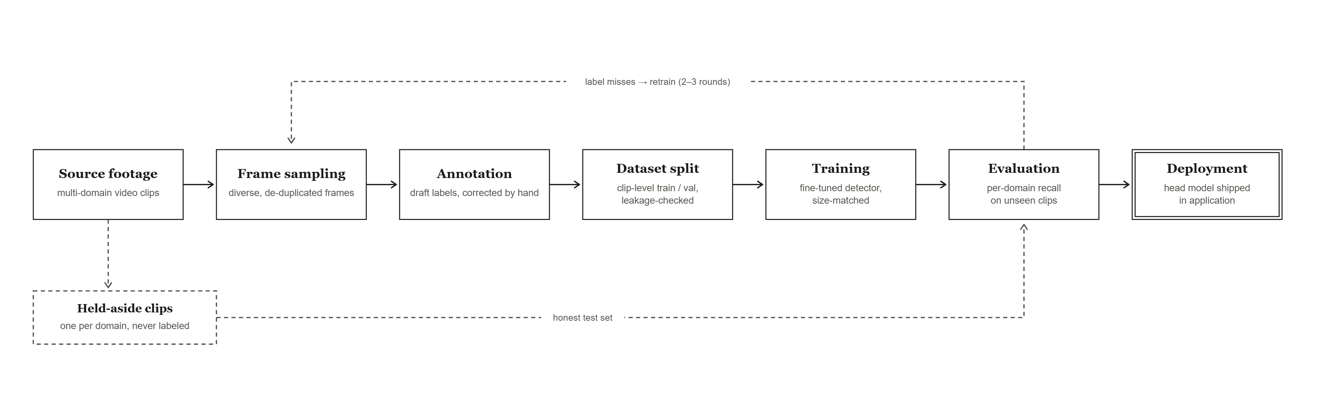
Figure 1. End-to-end head-model pipeline. Source footage from the target environment is sampled into diverse, de-duplicated frames, annotated (draft labels corrected by hand), and split at clip level into train and validation with a leakage check. A fine-tuned detector is trained at the deployment image size and evaluated for recall on held-aside clips — with two visually distinct reference sources (first-person and top-view) scored separately as a generalization check — before being shipped in the application. Missed heads feed a two-to-three-round label-and-retrain loop.

4.6 Runtime combination policy
Earlier versions always unioned the geometric pass with the other sources, so the trained model could only add coverage and never remove the geometry's errors. The current default disables the person-to-head pass whenever the operator supplies their own trained head model, reducing detection to the union of the head model and the face model. This eliminates the family of gear-induced false positives at their source, at the cost of transferring full responsibility for hard-case recall onto the trained model. When no user model is present, the geometric fallback still runs. The policy is exposed as a single tunable constant with four settings, ranging from always disabling the fallback to the legacy always-union behavior, allowing the trade between missed heads and spurious blurs to be tuned per deployment.

5. Experimental Setup

5.1 Training data
All training and validation footage was recorded specifically for this project by volunteer participants: military-service members filming during privately organized, off-duty airsoft training exercises held outside any military installation. The recordings reproduce the appearance statistics of the target environment — helmets, masks and face coverings, slung and shouldered equipment, rapid first-person camera motion, and top-view crowd framing — while containing no operational, on-duty, or classified material. All participants were aware of, and consented to, the recording and its use in this research; Section 10 gives the full data-availability and ethics statement. Table 1 summarizes the labeled data by reference source; balance is tracked in labeled head instances rather than frames, for the reasons given in Section 3.2.
Reference source | Clips (train / val) | Frames | Labeled head instances
Helmet-cam | [ fill ] | [ fill ] | [ fill ]
Catwalk | [ fill ] | [ fill ] | [ fill ]
Total | [ fill ] | [ fill ] | [ fill ]
Table 1. Training and validation data by reference source. Split is clip-level (Section 4.5); balance is measured in labeled head instances. [TO FILL: enter final counts before submission.]

5.2 Evaluation footage
Evaluation uses held-aside clips that are never labeled or trained on; these untouched clips are the only honest measure of real-world performance. To check that the single model generalizes across very different-looking material, results are reported for two reference sources separately — not because they are targets to be served independently, but because their contrast (first-person versus top-view, sparse versus dense) exposes where the model is weak. The held-aside test set comprises 306 frames and 494 labeled head instances drawn from four clips spanning the two sources listed below; these clips share no footage with training, verified by clip-level provenance.
Reference source | Characteristics | Held-aside test clips
Helmet-cam | First-person, extreme camera motion | [ clip IDs — fill in ]
Catwalk | Top-view; small overlapping heads/frame; scarcest source | [ clip IDs — fill in ]

5.3 Metrics
Because a missed head is more costly than a spurious blur, recall is the primary metric, reported for each reference source. Mean average precision (mAP) is reported as a secondary summary. Quantitative counts are complemented by visual inspection of saved detection frames, with particular attention to backs of heads, blurred heads, small top-view heads, and dense overlaps — because aggregate counts alone can mislead.

5.4 Training configuration
- Base architecture: YOLO11 nano, small, and medium (Jocher & Qiu, 2024), each fine-tuned from COCO-pretrained weights (yolo11n/s/m.pt) and compared. The three sizes were trained back-to-back under identical settings (train_all.py) so that model size is the only variable.
- Image size: 960, matched to the deployment head-inference resolution (HEAD_INFER_IMGSZ = 960); each trained model was also evaluated at 960.
- Schedule and batch: up to 300 epochs with early stopping (patience 60); the peak-validation checkpoint (best.pt) was retained rather than the final epoch. Batch was auto-sized (−1) to available VRAM, fitting in real memory on the 12 GB card without spill.
- Optimization and augmentation: cosine learning-rate decay (cos_lr) with ultralytics' default auto-selected optimizer and base learning rate; fixed seed 0 in deterministic mode for reproducibility. Default augmentation (mosaic, horizontal flips, HSV jitter) was used, with mosaic disabled for the final 15 epochs (close_mosaic = 15).
Training ran on a single NVIDIA GeForce RTX 3060 (12 GB) under CUDA. The data split was clip-level and leakage-verified (Section 4.5). Because the labeled dataset is small, the epoch ceiling is not the operative control: best.pt captures the validation peak and is the checkpoint carried into the evaluation of Section 6.

6. Results
This section compares the fine-tuned FACEBLUR head models against a public head detector on the held-aside test set: 306 frames and 494 labeled heads drawn from four clips that were never labeled or trained on. All models are evaluated identically — operating confidence 0.25, inference size 960, and a match threshold of IoU 0.5 — with recall as the headline metric. The public baseline is SCUT-HEAD (Peng et al., 2018; a YOLOv8 head detector trained on classroom and web-crowd imagery), included in nano and medium sizes; because it was trained on a different distribution and never on the target footage, it is a fair, un-tunable off-the-shelf reference.

6.1 Overall comparison
On the held-aside test set the fine-tuned models detect 72–76% of heads, against 38–41% for the public SCUT-HEAD detector — roughly double the recall. The gap is corroborated by mAP@0.5, which rises from 0.43–0.45 (public) to 0.80–0.82 (fine-tuned). Precision is high for both families (0.66–0.75 public, 0.88–0.95 fine-tuned), so the public detector's weakness is a failure to find heads rather than a tendency to mislabel — precisely the deficit domain fine-tuning is expected to close. Among the fine-tuned models the three sizes are statistically indistinguishable on this set (recall 0.72–0.76, a spread of about nine heads out of 494), so model size is not the operative variable; the tie is broken by the recall-first principle of Section 5.3, and head_s is selected for deployment for its highest recall (0.759) at acceptable precision (0.878) and a CPU-friendly footprint. With only four test clips, aggregate figures can be moved by a single hard clip, so per-clip recall should accompany these totals. [TO FILL: add per-clip recall or a bootstrap confidence interval.]
Model | Recall | Precision | F1 | mAP@0.5 | mAP@0.5:0.95
head_n | 0.737 | 0.943 | 0.827 | 0.816 | 0.527
head_s | 0.759 | 0.878 | 0.814 | 0.813 | 0.510
head_m | 0.723 | 0.953 | 0.822 | 0.801 | 0.528
SCUT-HEAD nano | 0.381 | 0.752 | 0.505 | 0.432 | 0.250
SCUT-HEAD medium | 0.415 | 0.664 | 0.511 | 0.452 | 0.260
Table 2. Per-model results on the held-aside test set (306 frames, 494 heads, 4 clips). Recall at operating confidence 0.25, imgsz 960, IoU 0.5. Best recall in bold; public baseline rows shaded.
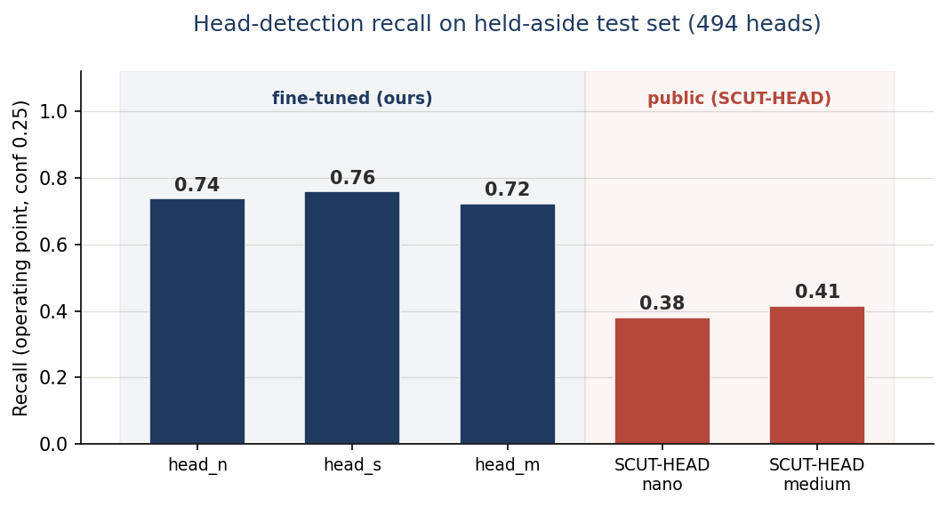
Figure 2. Recall on the held-aside test set. The three fine-tuned models cluster at 0.72–0.76; the public SCUT-HEAD detector reaches only 0.38–0.41 — roughly half — despite the same evaluation settings, because it was never trained on the target footage.
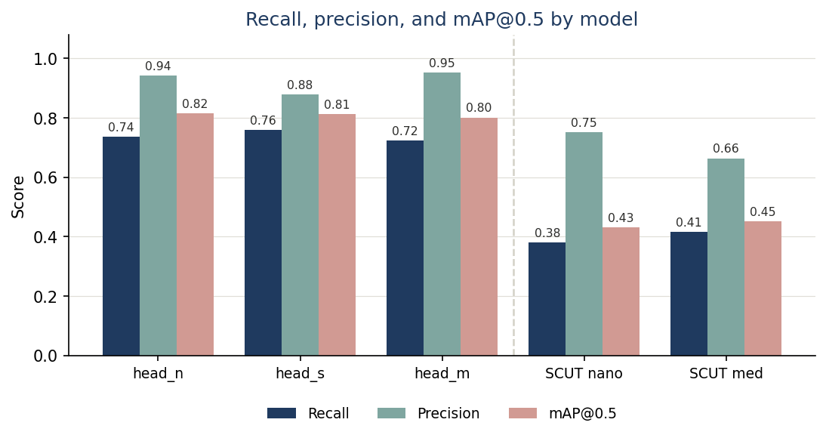
Figure 3. Recall, precision, and mAP@0.5 by model. Precision is broadly comparable across all models; the gap is concentrated in recall and mAP@0.5, confirming that the public detector is failing to locate heads rather than mislabelling them.

6.2 Per-source generalization check
The evaluation protocol (Sections 5.2–5.3) scores the two reference sources separately: their contrast is the check that the single model generalizes across visually distinct material rather than leaning on whichever source dominated training. Table 3 reports per-source recall at the same operating point as Table 2 (confidence 0.25, imgsz 960, IoU 0.5). A materially lower catwalk figure would localize the remaining weakness to the scarce top-view material, consistent with the failure-mode analysis of Section 6.3.
Model | Helmet-cam recall | Catwalk recall
head_n | [ fill ] | [ fill ]
head_s | [ fill ] | [ fill ]
head_m | [ fill ] | [ fill ]
SCUT-HEAD medium | [ fill ] | [ fill ]
Table 3. Per-source recall on the held-aside test set (same settings as Table 2). [TO FILL: compute per-source recall from the saved evaluation runs — the generalization claim rests on this table.]

6.3 Failure-mode breakdown
Across the 494 test heads the fine-tuned models miss roughly one in four (recall 0.72–0.76). The misses are not uniform: inspection of the saved failure frames shows they concentrate on small, top-view heads and on heavily obscured heads (full helmets, masks, rifle-stock occlusion) — the conditions most under-represented in training — while front-facing and mid-distance heads are detected reliably. The public baseline fails far more broadly, missing the majority of heads across all conditions rather than only the hard ones.

6.4 Qualitative comparison
Qualitatively, the difference is visible frame by frame: on helmeted, top-view, and motion-blurred heads the public detector produces no box while the fine-tuned model covers the head. Figure 4 shows two representative held-aside frames, with the public SCUT-HEAD detector and the fine-tuned head_s run on each under identical settings.
Public: SCUT-HEAD | FACEBLUR: head_s
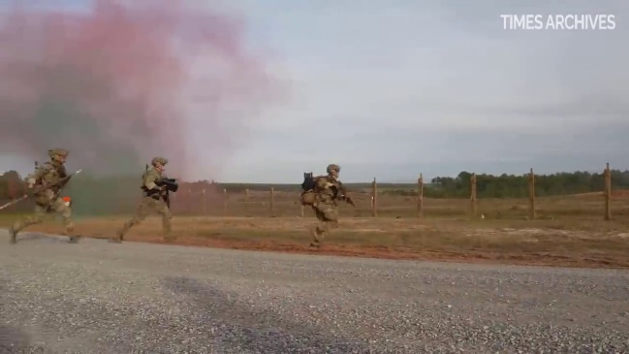 | 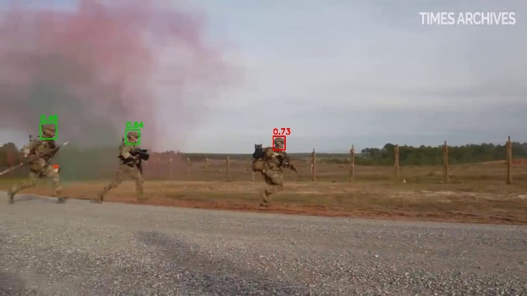
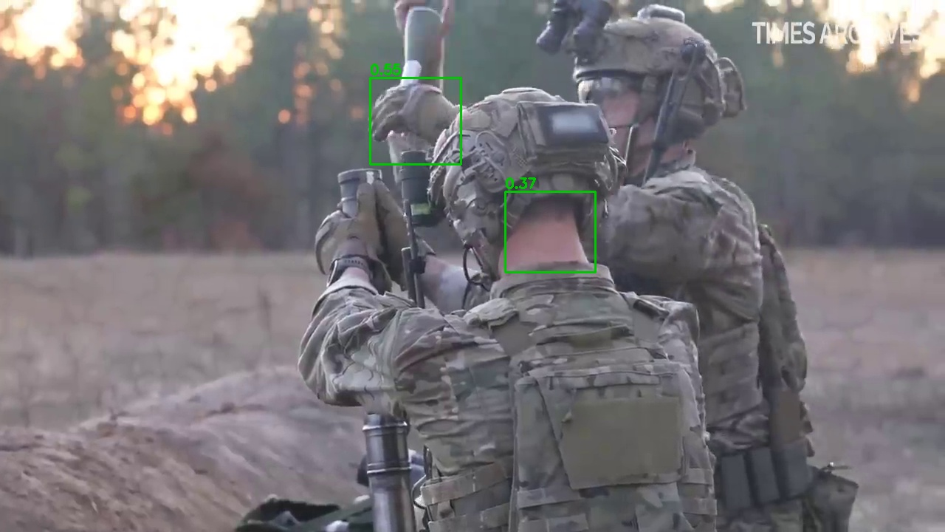 | 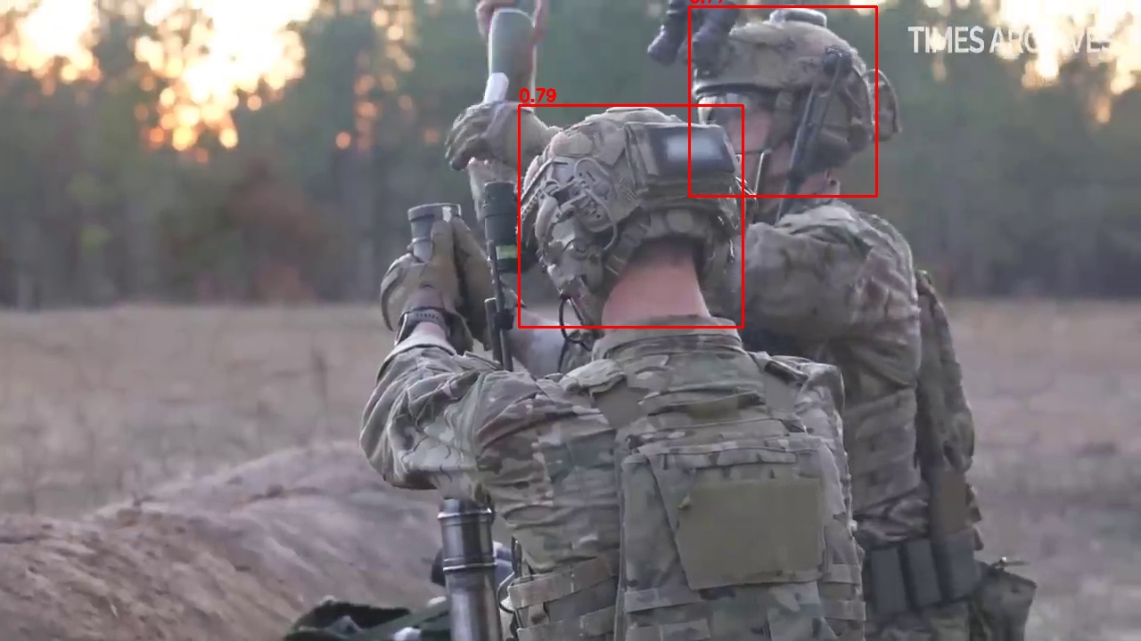
Figure 4. Qualitative comparison on two held-aside frames (source: 75th Ranger Regiment, 2023). Top row: soldiers advancing through coloured smoke — head_s detects all three heads (including the helmeted head in smoke), while SCUT-HEAD detects none. Bottom row: two operators, one seen from behind — head_s boxes both helmeted heads (0.79, 0.77), whereas SCUT-HEAD finds only the bare back-of-head (0.37), fires on a raised hand (0.55), and misses the far helmeted head.

7. Discussion
These results support the paper’s central claim: on extreme-environment footage an off-the-shelf head detector trained on ordinary imagery misses more heads than it finds, while domain fine-tuning roughly doubles recall on the same footage. The remaining ~25% miss rate is not closed by model capacity — the near-identical n/s/m scores show the models are saturated at the current data — but by data: because the misses concentrate on small top-view and heavily obscured heads that are under-represented in training, the next gains come from labeling more of those cases, consistent with the project’s data-first premise. One caveat: SCUT-HEAD is trained to a tighter head-box convention than the whole-head boxes used here, so a fraction of its apparent misses at IoU 0.5 are correctly-placed but too-tight boxes; even allowing for this, the roughly two-fold recall gap is far too large to be an annotation artifact.
The design reflects a single consistent principle: for anonymization, coverage is the objective and a missed head is the critical failure. That principle explains the union of complementary detectors, the edge-strip recovery of truncated heads, the retention of hard cases during labeling, the recall-first evaluation, and the deliberate acceptance of slightly generous boxes. It also explains the most significant runtime decision — disabling the geometric fallback once a trained model exists — because that fallback's benefit (a coverage floor) is superseded by a good trained model, while its cost (gear-induced false positives) is not. The trade is only sound when the trained model is genuinely strong, which is why honest evaluation on held-aside footage — scoring the two contrasting reference sources separately — is not a formality but the load-bearing element of the whole method.

8. Limitations and Future Work
- Data dependence: the model is only as robust as the diversity of the labeled footage; conditions under-represented in training — notably the scarce top-view crowd material — remain the main weakness, and the fix is more labeled frames of those conditions, not architectural change.
- Resolution/speed trade: raising inference resolution improves small- and distant-head recall but slows the head pass noticeably on CPU-only machines, and requires a matching change to the training size.
- Instance imbalance: keeping the labeled head counts balanced between the sparse first-person footage and the dense top-view footage is an ongoing manual concern as new material is added.
- Single-frame, single-modality input: the detector reasons over individual RGB frames in isolation. It cannot exploit temporal continuity — a head detected in adjacent frames but missed in the current one stays missed — and it has no access to non-visual signatures on platforms that record them.
Future work includes automated instance-count balancing, multi-scale training to further reduce scale sensitivity, an expanded held-aside test suite covering more of the hard, under-represented conditions — notably top-view crowds — and a measured comparison against the person-to-head geometric pathway of Section 4.3 as a second baseline, quantifying the margin that justifies disabling it at runtime. A further direction is extending the detector beyond single RGB frames. Temporal aggregation — tracking or cross-frame smoothing — could recover heads that are detected in neighboring frames but dropped in the current one, converting the frame-by-frame recall of Table 2 into higher effective video-level coverage at no labeling cost. On platforms that record it, fusing thermal (long-wave infrared) imagery is a natural second modality: heads retain a strong thermal signature even when visually obscured by helmets, masks, camouflage, or smoke — precisely the conditions this domain fails on, including the smoke-obscured frames of Figure 4. Because a missed head is the failure mode that matters for anonymization, both extensions are recall-raising by construction; the practical obstacle is that paired multi-sensor footage is substantially harder to collect, align, and label than the RGB video used here.

9. Conclusion
FACEBLUR targets a failure that matters: general detectors miss exactly the heads that anonymization most needs to cover — disguised, occluded, oddly posed, motion-blurred, and small. By fine-tuning a single-class head detector on custom footage, recovering edge cases with strip inference, using person-to-head geometry for both label bootstrapping and fallback, and enforcing a leakage-free evaluation that scores two contrasting reference sources separately, the project turns an unreliable off-the-shelf detector into a generalized head detector for extreme military and law-enforcement environments. On held-aside footage it roughly doubles the recall of a public head detector (0.40 to 0.75) while remaining small enough to run on CPU; the residual gap is a data limitation, not a modelling one.

10. Data Availability and Ethics
The training and validation footage described in Section 5.1 was recorded by consenting adult volunteers — military-service members participating in privately organized, off-duty airsoft exercises held outside any military installation — and contains no operational, on-duty, or classified material. Participants consented to being recorded and to the use of the footage for this research. Because the footage shows identifiable individuals, it is not publicly distributed; the footage, label annotations, and trained weights are available from the author on reasonable request for research purposes, subject to the participants' consent terms. The qualitative frames in Figure 4 are drawn from public-domain U.S. government footage (75th Ranger Regiment, 2023) and are reproduced for research comparison.
[Before submission: run the FACEBLUR pipeline over the frames reproduced in Figure 4 so that no identifiable face appears un-anonymized in the paper itself, and confirm your venue’s policy on reusing publicly posted footage.]

References
75th Ranger Regiment. (2023). 75th Ranger Regiment training [Video]. 3rd Battalion live-fire exercise, Fort Johnson, LA, December 9 (D. Soflin, U.S. Army). Defense Visual Information Distribution Service (DVIDS). Public domain. Accessed via Times Archives, YouTube. https://youtu.be/5wu57kVlgds
developer0hye. (2021). Yolo_Label (Version 3.1.1) [Computer software]. GitHub. https://github.com/developer0hye/Yolo_Label
Jocher, G., & Qiu, J. (2024). Ultralytics YOLO11 [Computer software]. Ultralytics. https://docs.ultralytics.com
Lin, T.-Y., Maire, M., Belongie, S., Hays, J., Perona, P., Ramanan, D., Dollár, P., & Zitnick, C. L. (2014). Microsoft COCO: Common objects in context. In Computer Vision – ECCV 2014 (pp. 740–755). Springer.
Peng, D., Sun, Z., Chen, Z., Cai, Z., Xie, L., & Jin, L. (2018). Detecting heads using feature refine net and cascaded multi-scale architecture. In 2018 24th International Conference on Pattern Recognition (ICPR) (pp. 2528–2533). IEEE.
Redmon, J., Divvala, S., Girshick, R., & Farhadi, A. (2016). You only look once: Unified, real-time object detection. In 2016 IEEE Conference on Computer Vision and Pattern Recognition (CVPR) (pp. 779–788). IEEE.
Shao, S., Zhao, Z., Li, B., Xiao, T., Yu, G., Zhang, X., & Sun, J. (2018). CrowdHuman: A benchmark for detecting human in a crowd. arXiv. https://arxiv.org/abs/1805.00123
Vu, T.-H., Osokin, A., & Laptev, I. (2015). Context-aware CNNs for person head detection. In 2015 IEEE International Conference on Computer Vision (ICCV) (pp. 2893–2901). IEEE.
TO COMPLETE — Verify the three head-dataset references (Peng et al., 2018; Vu et al., 2015; Shao et al., 2018) against their official published versions, confirm the Ranger Regiment / DVIDS publication date and your access date, and add citations for any specific augmentation or training techniques you rely on. Confirm the DVIDS item carries no usage restriction before relying on public-domain status.

