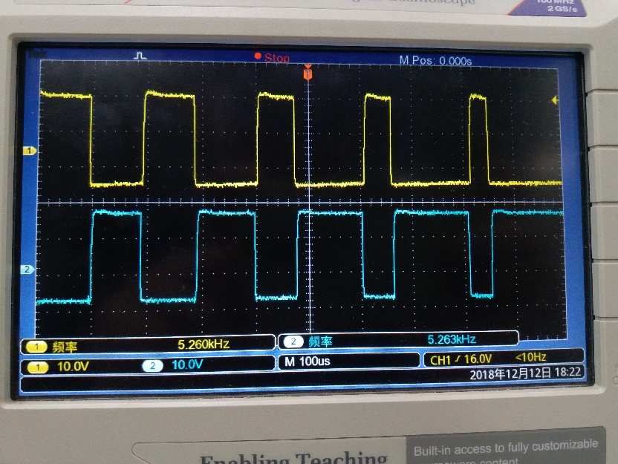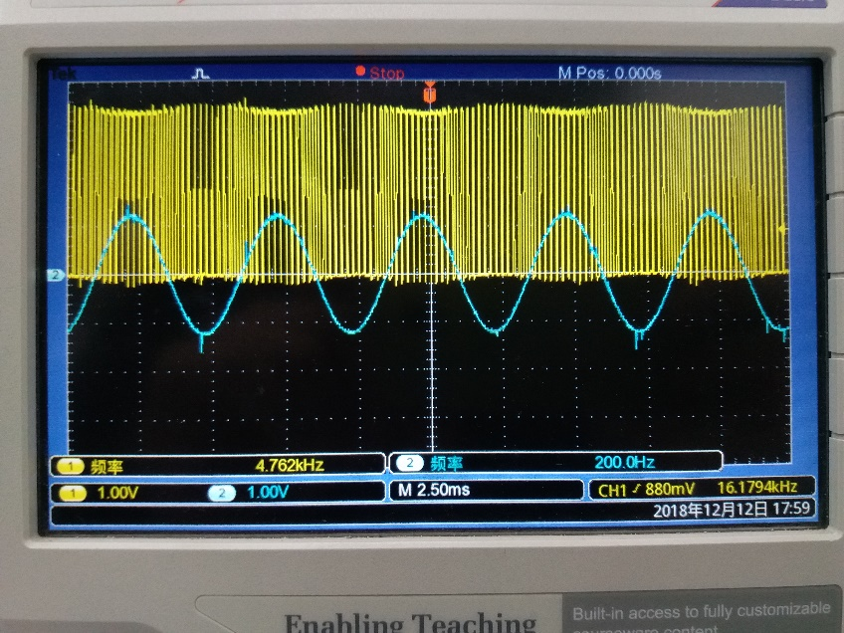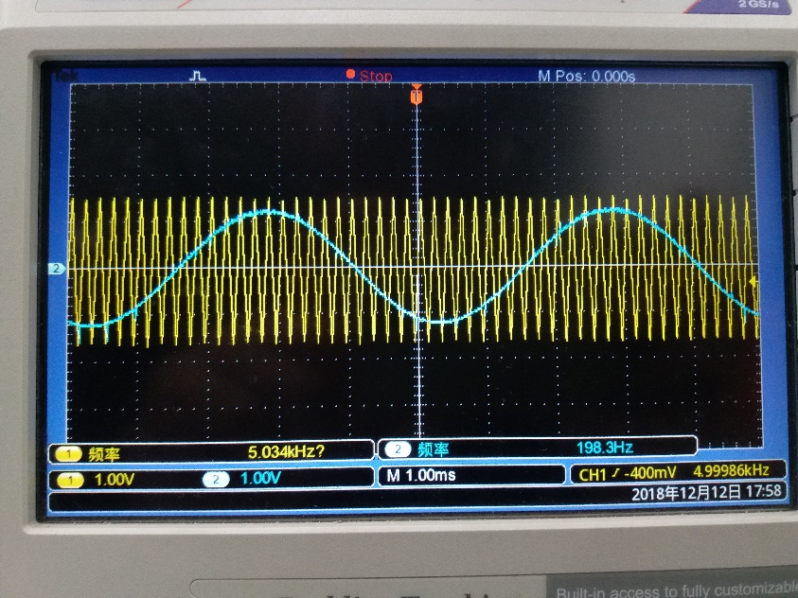

fc=5kHz, fr=200Hz时PWM1，Ur

V2和V4栅射电压Uge2, Uge4

fc=5kHz, fr=200Hz时Uc，Ur

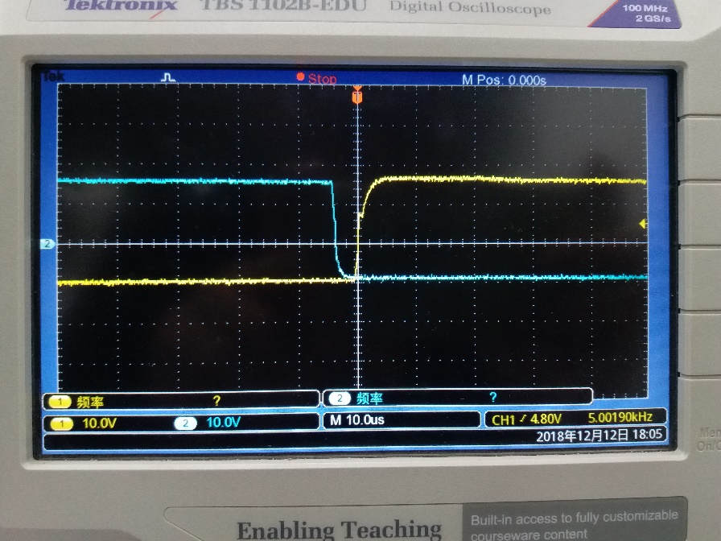

R=100, fc=5kHz, fr=200Hz时Uo，UL

R=100, fc=5kHz, fr=100Hz时Uo，UL

死区时间测量

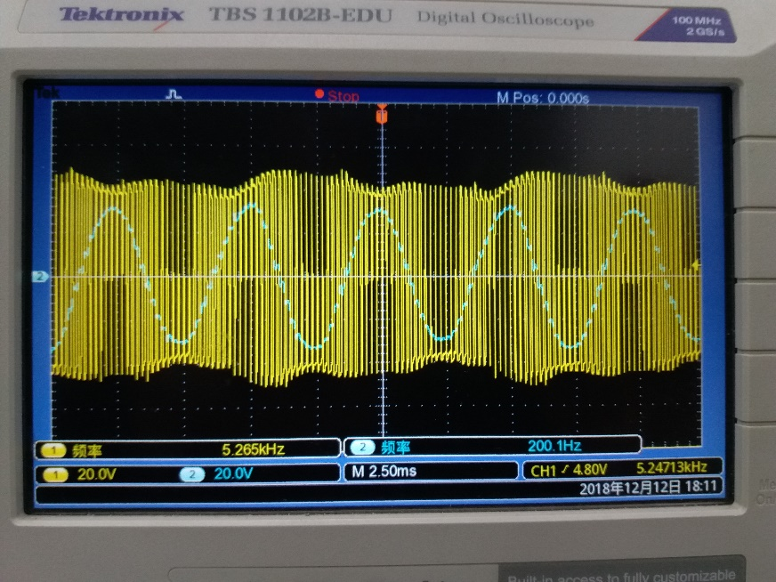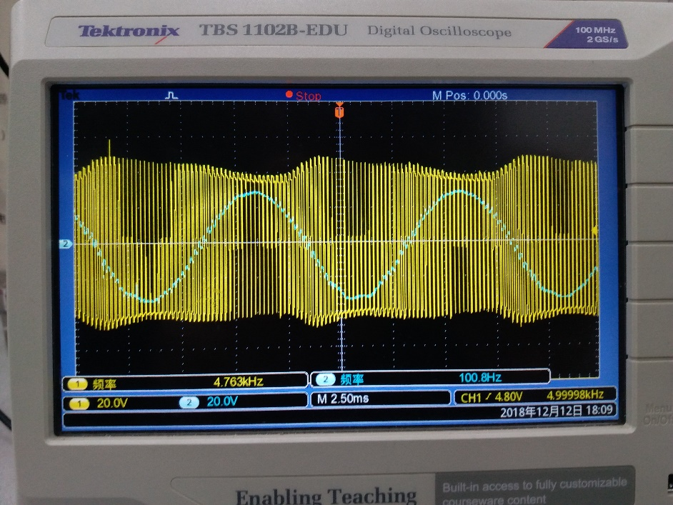

R=100, fc=10kHz, fr=50Hz时Uo，UL

R=100, fc=5kHz, fr=50Hz时Uo，UL

