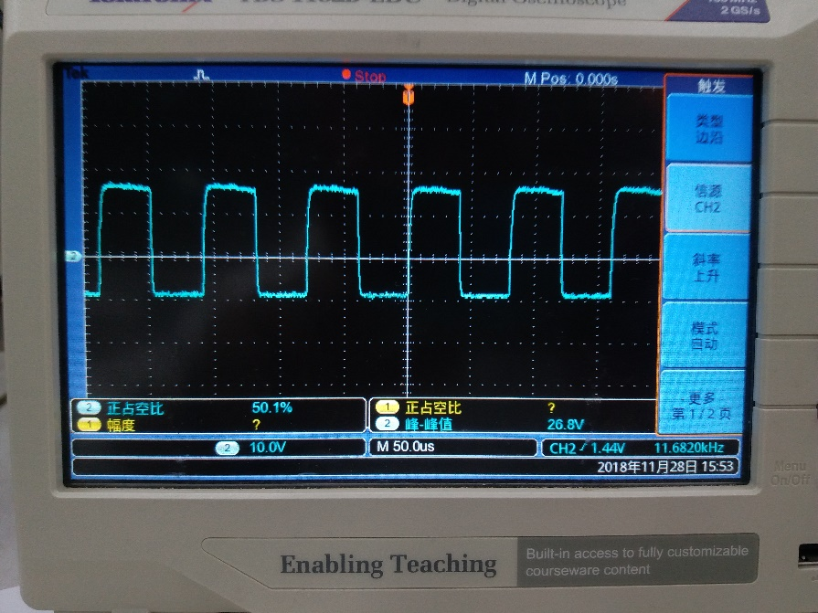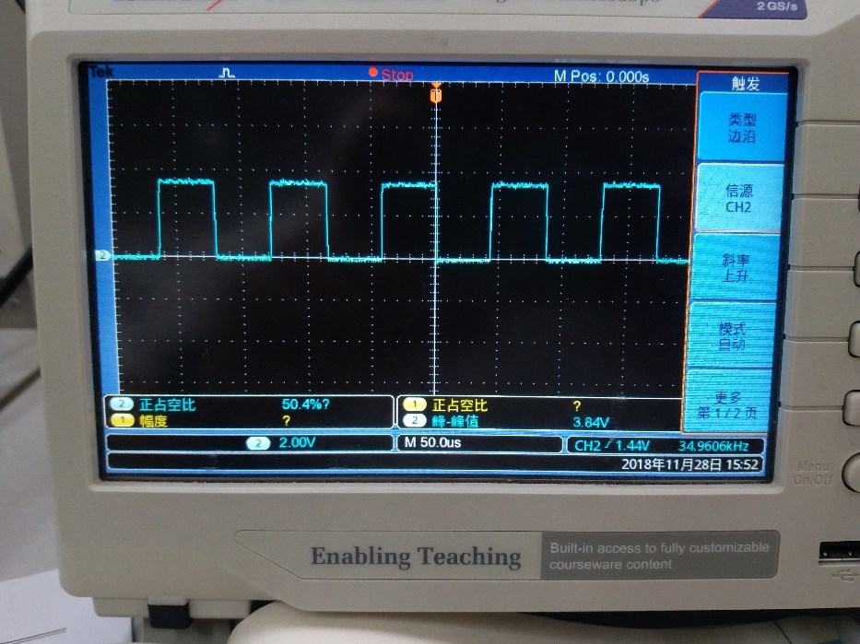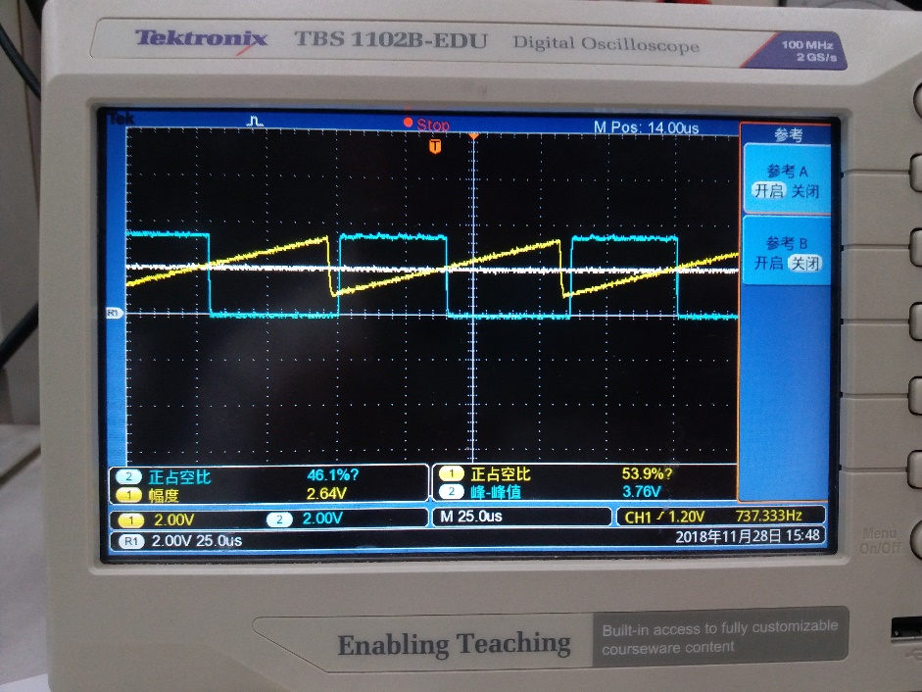

α=50% 时IGBT栅射电压Uge

α=50% 时PWM波

开环、10k、模式1时锯齿波、调制波和PWM波

α=30% 时Uce和Uo

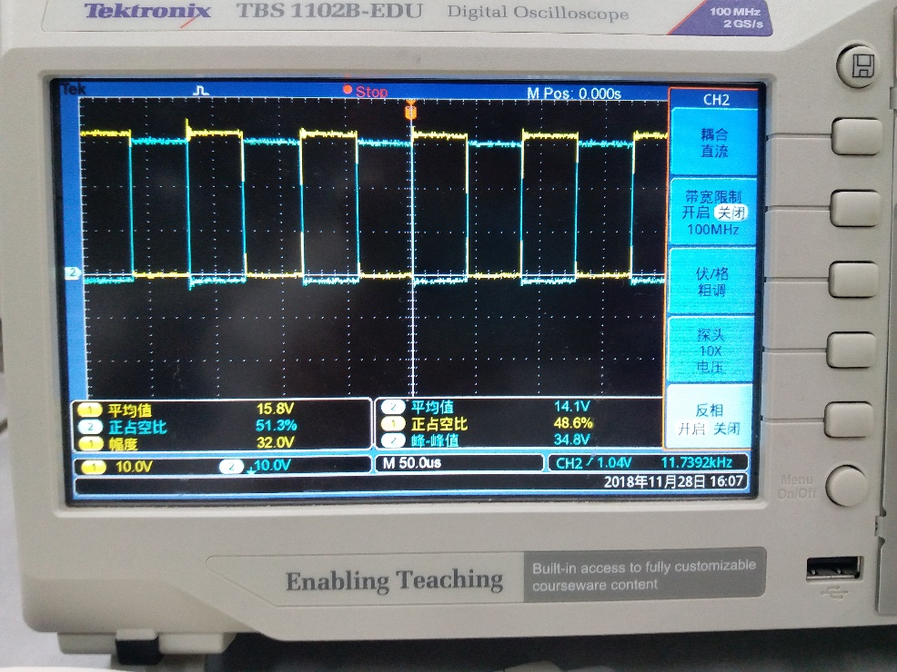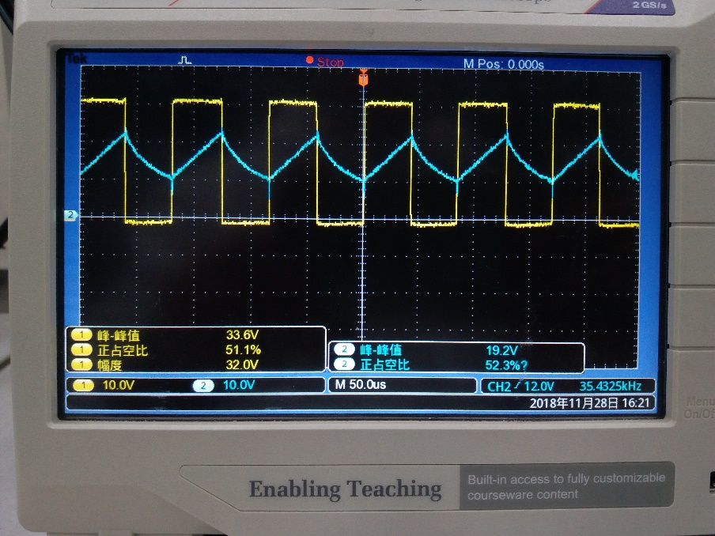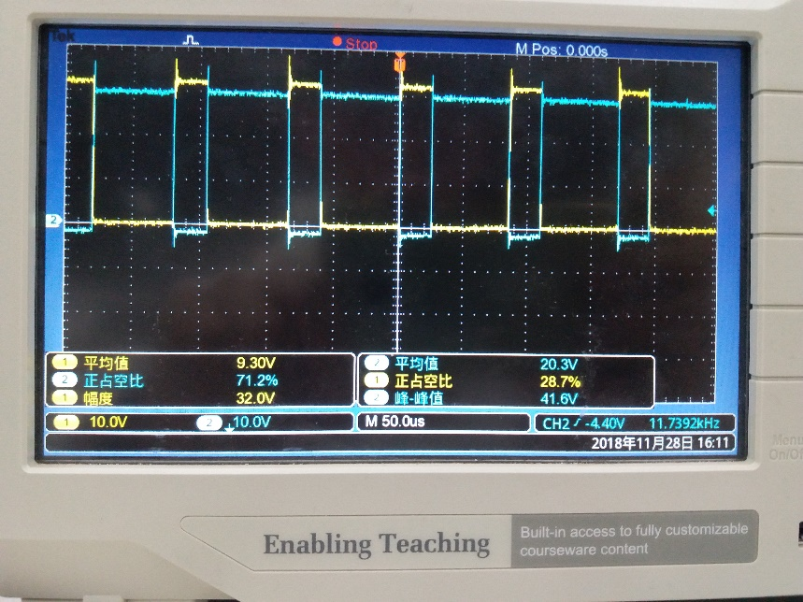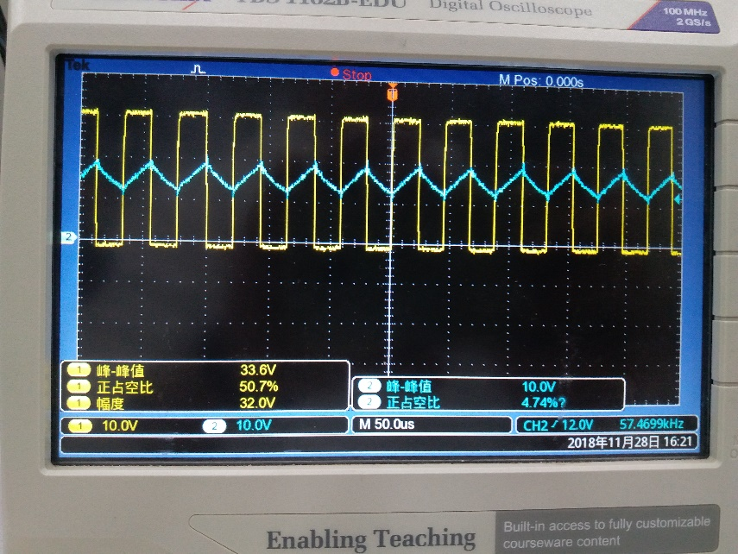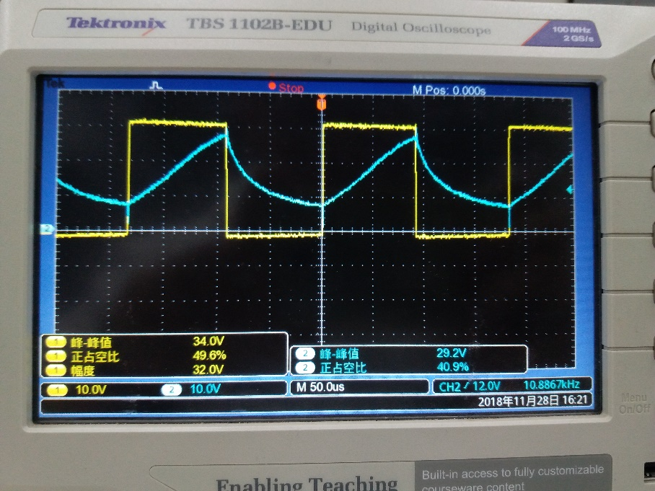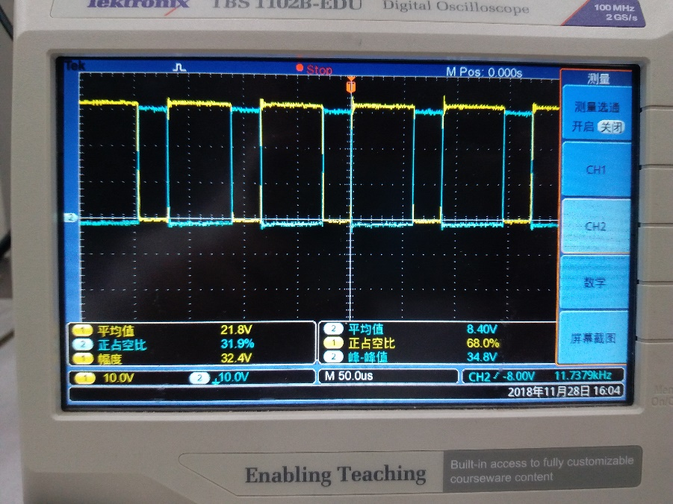

α=50%、fs=20kHz 时uo和io

α=50%、fs=10kHz 时uo和io

α=50%、fs=5kHz 时uo和io

α=70% 时Uce和Uo

α=50% 时Uce和Uo