**Seminar 2**

Wang Xingyi 2226215258

# Topic

For topic1, we are going to analyze the Rectification Mode and Active Inversion Mode of the Three-phase Full Bridge Rectifier (thyristors) with a set of given parameters (L,R,E,α). Correspondingly, simulations, theoretical calculations of several critical values and comparison between theoretical results and simulation results are required.

For topic 2, we will carry out a simulation based on the Three-phase Full Bridge Rectifier with power diode and RC load. We need to explore how variations of load resistor RL would influence Output Voltage (Vo), Power Factor (PF) and Total Harmonic Distortion (THD). After that, we are supposed to give plots between these three values and load resistor RL.

# Simulation Model

There are 3 characteristics to be specified and 3 models are established correspondingly.

## *2.1* Rectification Mode of Three-phase Full Bridge Rectifier (thyristors)



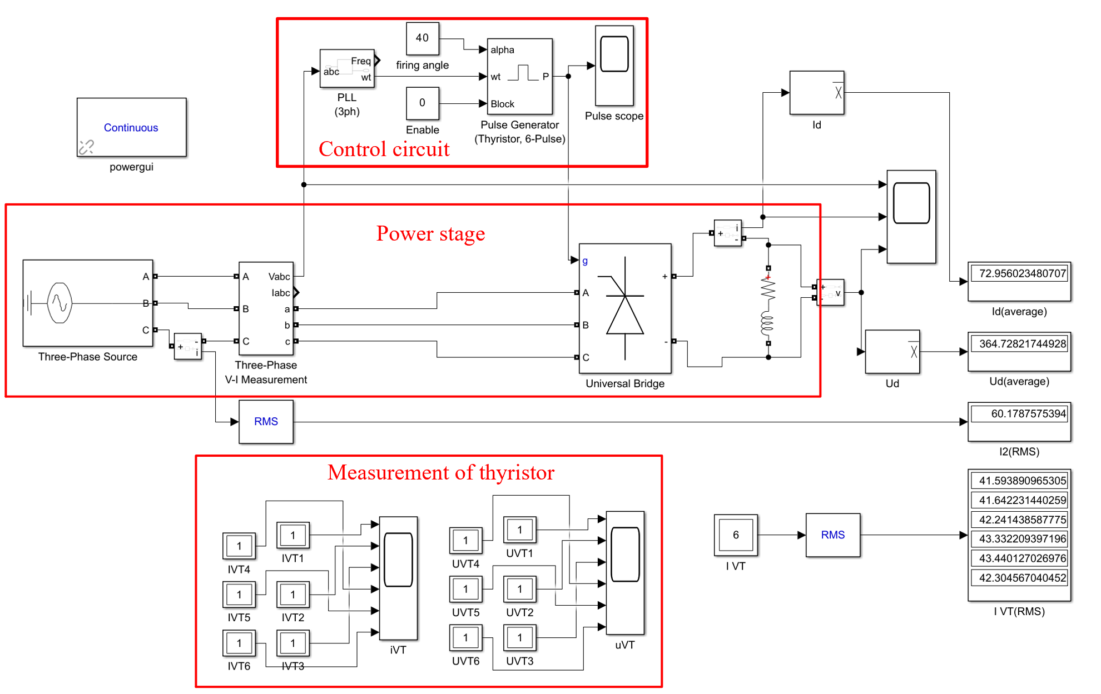

Fig 1: Simulation Model of Rectification Mode

Through this model, we can have a clear view of Average value of DC-link voltage , Average value of DC-link current , RMS value of AC side current  and RMS value  of the current flowing through a thyristor. Meanwhile, the waveform of  and the sequence of driving signal of each thyristor can also be presented through scopes.

This model includes 3 important components, which will be thoroughly illustrated in the following part.

## *2.1.1* Power stage

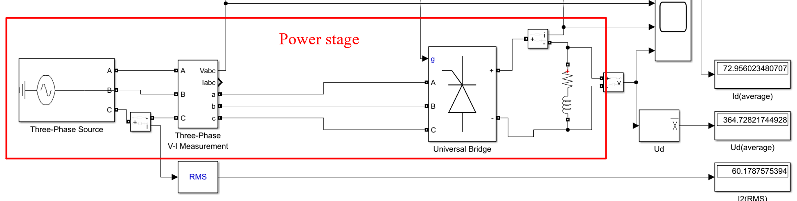

Fig 2: Power stage

This is the main circuit of the model, which contains a Three-Phase Source and a Three-Phase V-I Measurement, a Three-Arm Thyristor Bridge, a RL Series Load.

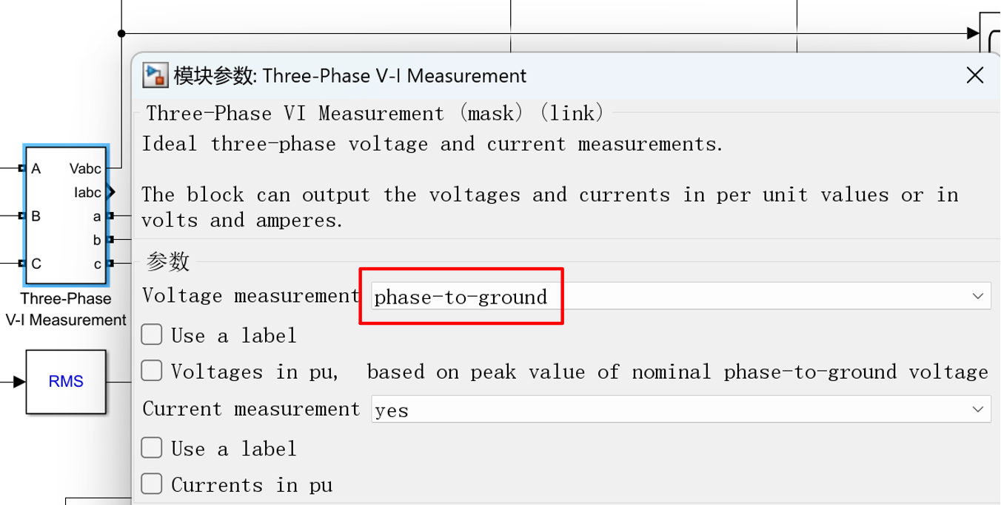

Fig 3: Three-Phase V-I Measurement block

The Three-Phase V-I Measurement block here can measure and then output the **phase-to-ground** voltage  ( Three phase voltages of the AC side in one channel) to the Phase-Locked-Loop in the control circuit.

## *2.1.2* Control circuit

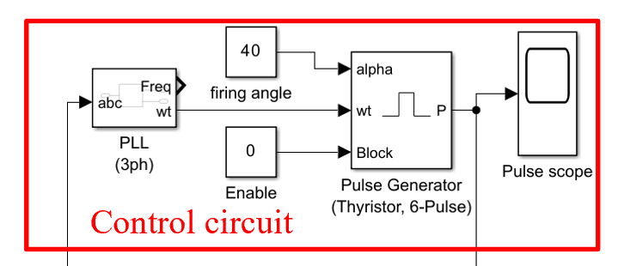

Fig 4: Control circuit

The control circuit of the rectifier is shown above. This section can generate the desired pulse triggering signals to the gate of the thyristors. Usually, it is composed of a Phase-Locked Loop and a Pulse Generator.

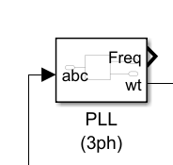

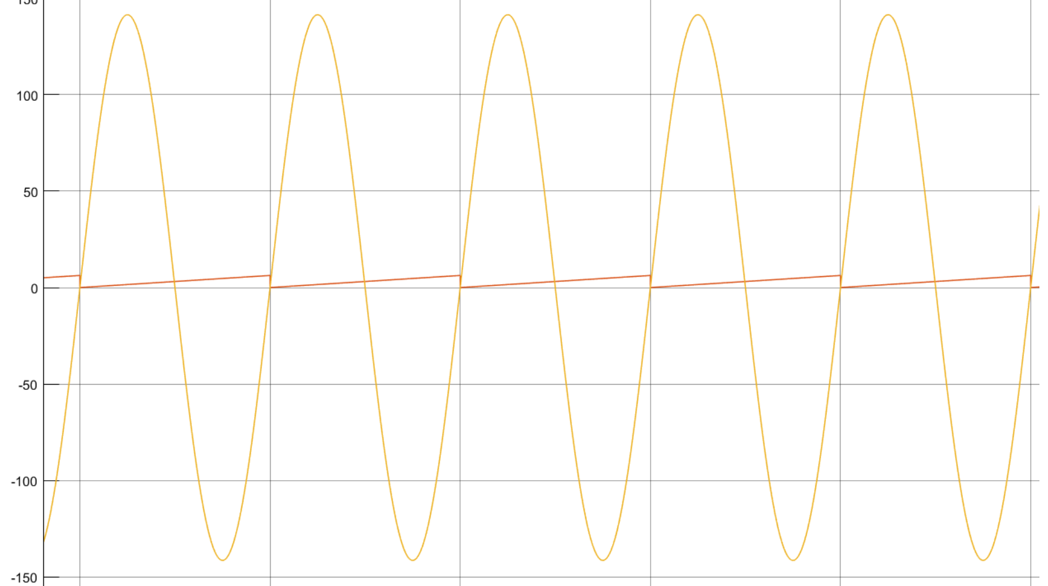

Fig 5: wt (red line) fundamental wave of phase A (yellow line)

This Three-Phase Locked Loop (PLL) system can be used to synchronize on a set of variable frequency, three-phase sinusoidal signals. To be more specific, when we input a vector  containing the normalized three-phase signals, we can acquire the measured frequency and a ramping signal varying between 0 and . This ramping signal wt is synchronized on zero crossings of the fundamental of phase A. In a word, we can know the frequency and phase degree of the phase A voltage under anytime through this block.

Actually, unlike simulation in which we can freely adjust the initial phase of signal, we can not always determine the exact initial phase of the input signals in the reality. Sometimes we even can not know when the input signal begins. Because the firing angle is based on the natural commutation point, we may lose this reference point which is always set to be a known constant in the simulation, and this can cause us some troubles into deciding when to add pulsing signals to electronic devices. However, this issue can be perfectly addressed through PLL.

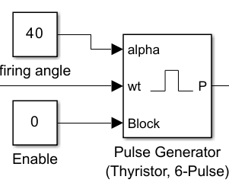

Fig 6: Pulse Generator

This is a 6-pulse generator for thyristor bridge. Input ‘alpha’ means the firing angle . Input ‘wt’ means the **angle (in rad) of the phase A** of the primary transformer voltage, which can be sent from the previously mentioned PLL block. We choose double pulsing method to generate triggering signals. Two pulses are sent to each thyristor: the 1st pulse when the alpha angle is reached, then a 2nd pulse 60 degrees later, when the next thyristor is fired.

## *2.1.3* Measurement of thyristor

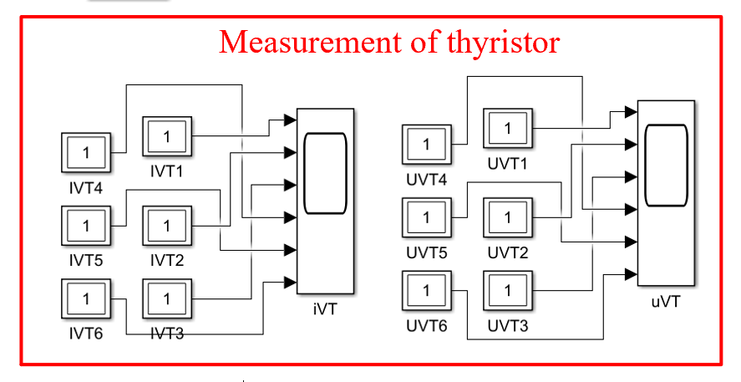

In this part, we separately use twelve multimeters to present the voltage and current waveforms of 6 thyristors. This can clearly show the On and Off state of each thyristor.

## *2.2* Active Inversion Mode of Three-phase Full Bridge Rectifier (thyristors)

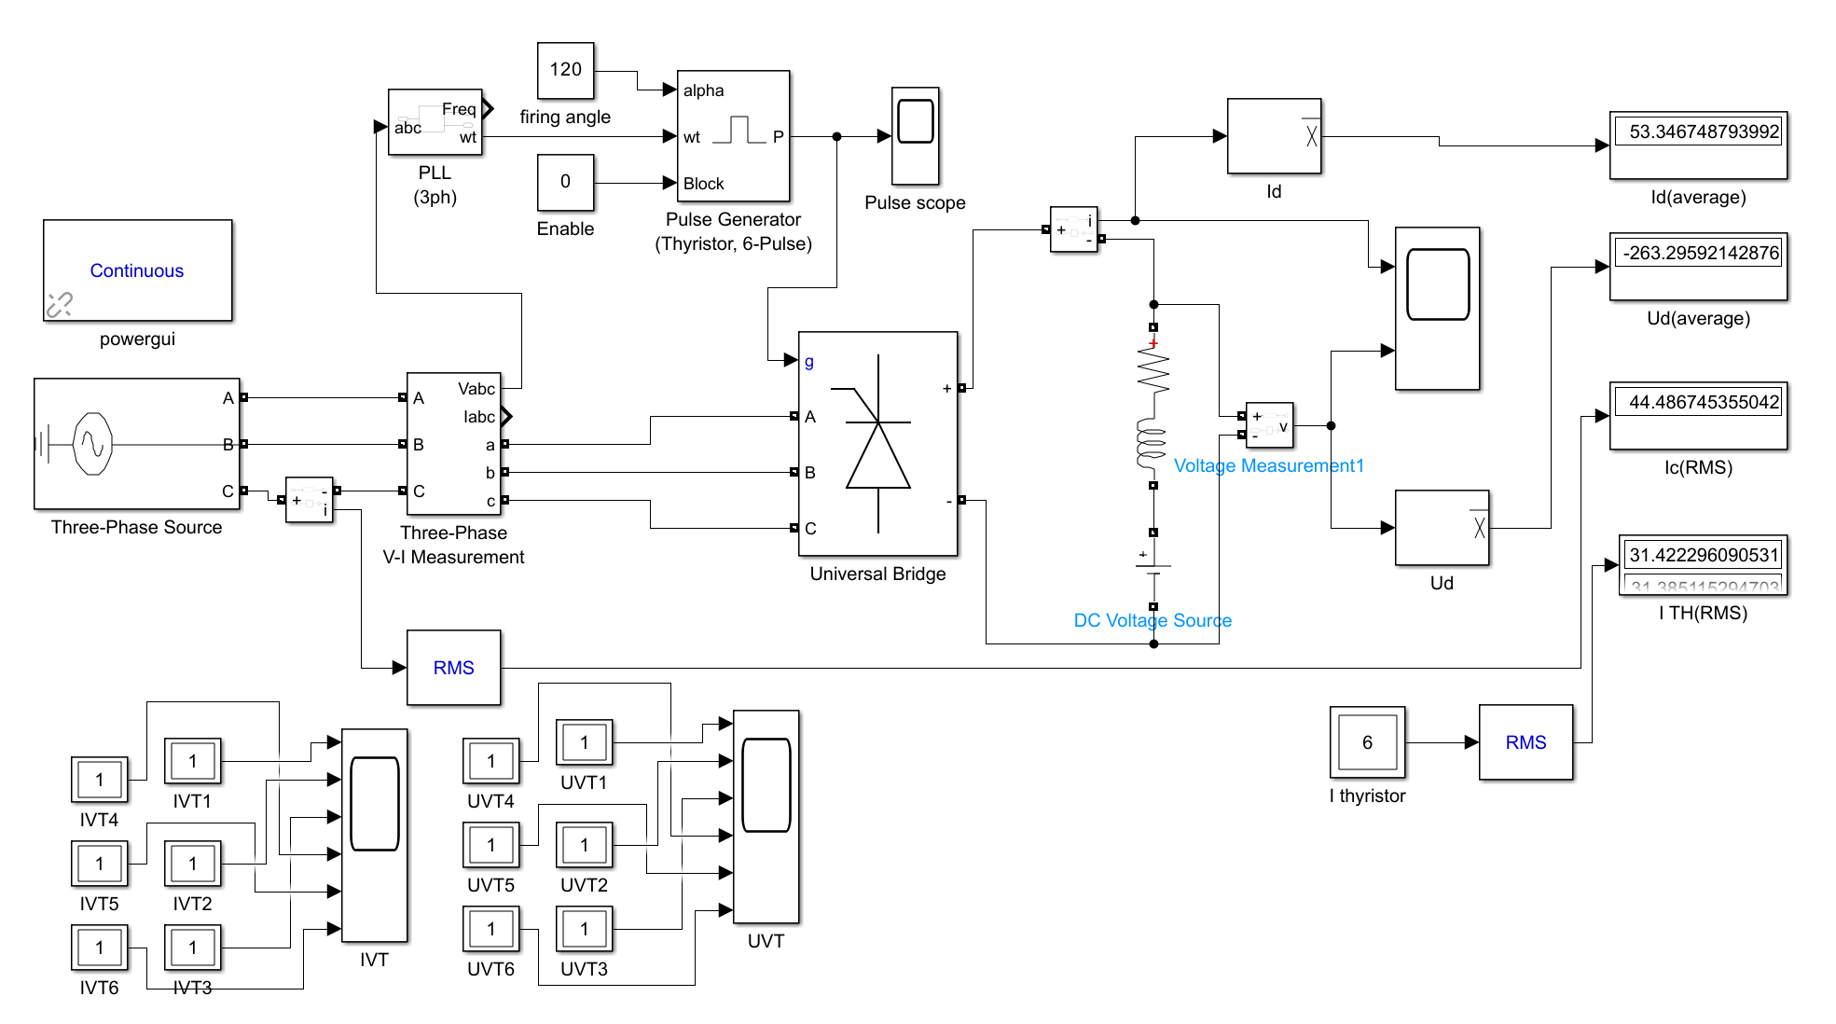

Fig 7: Simulation Model of Active Inversion Mode

This model is quite similar to Model 1, except from a negative EMF in series with the RL load. The detailed structure has been illustrated in the previous part.

## *2.3 Three-Phase Full bridge Rectifier with Power Diode and RC Load*

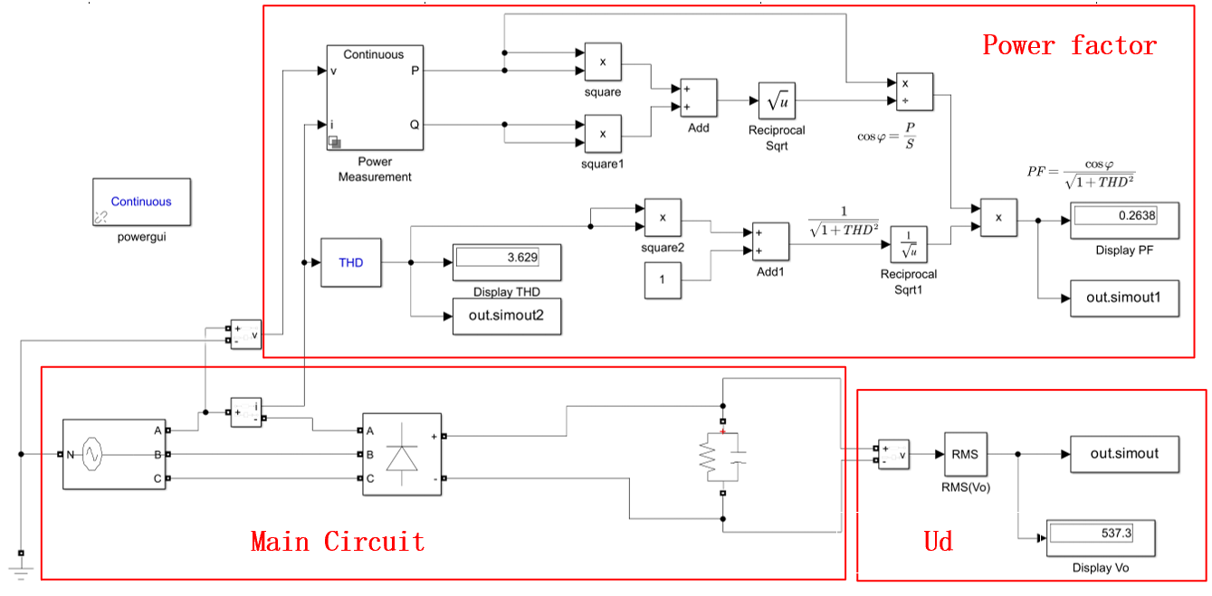

Fig 8: Three-Phase Full bridge Rectifier with Power Diode and RC Load

In this part, power diode replaces the thyristor, which means we do not need control circuit anymore. The whole main circuit can be composed of power source, universal bridge and RC load. However, we need to calculate the power factor, load voltage and THD under different values of .

*2.3.1 Calculation of Power Factor*

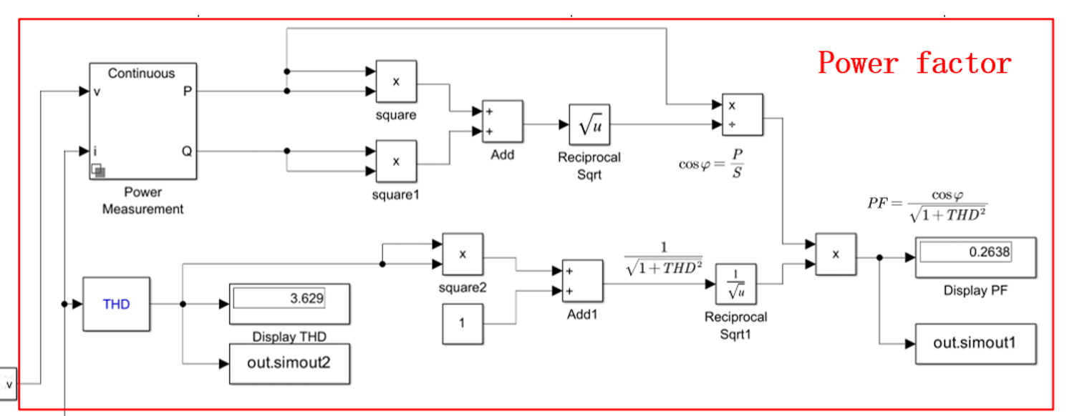

Fig 9: Calculation of Power factor

For the distortion current I, the relationship between fundamental component and harmonic components could be :



Thus, the power factor could be calculated as:



THD could be directed got from the THD block in Simulink.

Through power measurement block, we can know the active power P and reactive power Q(fundamental component) of the AC side. Thus, the displacement factor  could be calculated from:



It is noticed that distortion power D (reactive power generated by harmonic current) is ignored, we use the simplified definition, which is currently widely accepted.

# Parameter Setup

Considering the frequency being 50Hz, the total duration time of all the parts is set to be 0.1s.

*3.1 Part 1:**Three-Phase Full Bridge Rectifier (Thyristor)*

*3.1.1 Power Source*

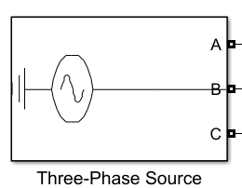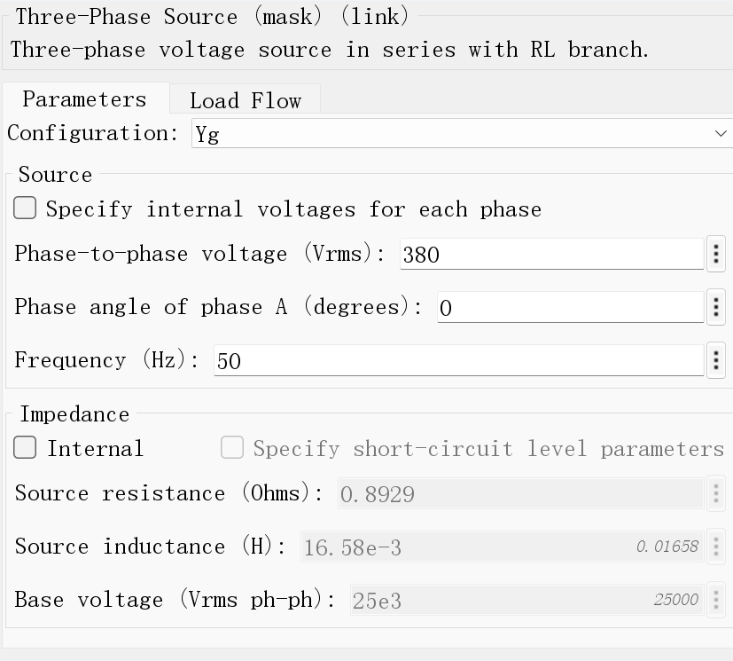

RMS Value of Phase-To-AC-Neutral-Point Voltage is 220V, thus the phase-to-phase voltage (Vrms) is 380V. The line frequency is 50 Hz.

*3.1.2 Pulse Generator*

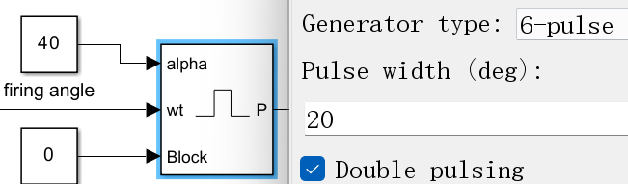

Typically, double pulsing with pulse width being 20 deg would be recommended, and the firing angle  is set to 40°. In the Active Inversion Mode, the firing angle is 120°.

*3.1.3 Thyristor Bridge*

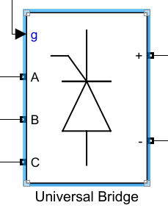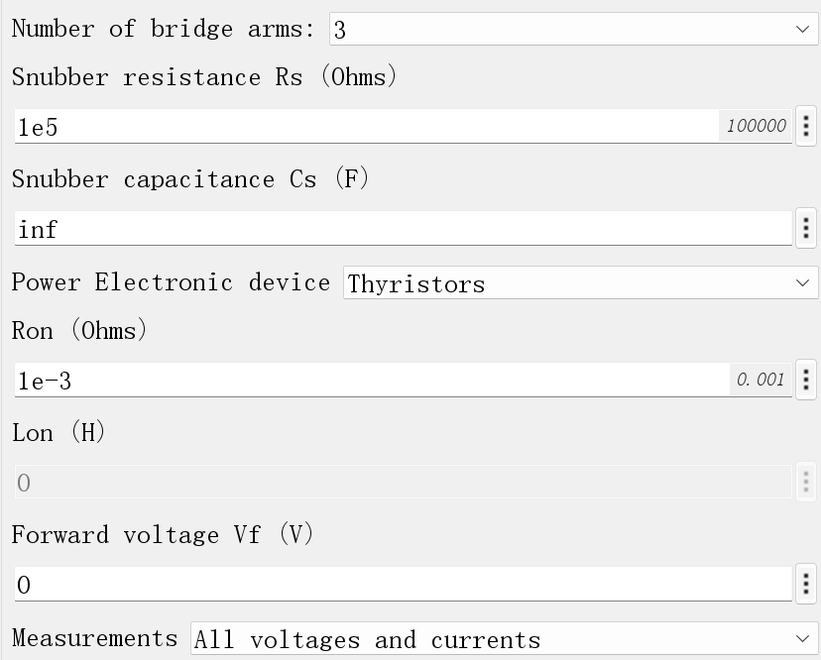

*3.1.4 RL Load and EMF*

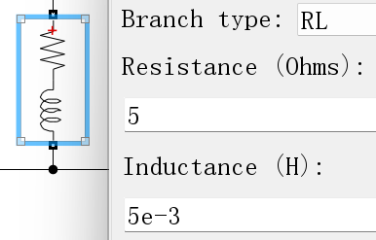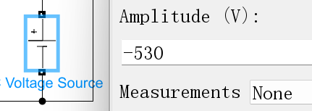

*3.2 Part 2: Three-Phase Full Bridge Rectifier (Power Diode)*

*3.2.1 Power Source*

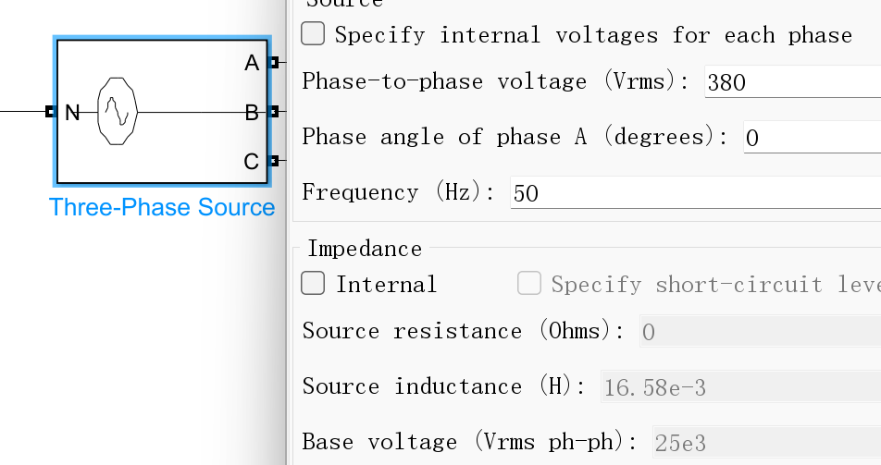

The parameter of power source in the Three-Phase Full Bridge Rectifier does not have any changes. The Phase-to-phase voltage (RMS) is set to be 380V and initial angle of phase A is 0. The internal impedance is ignored.

*3.2.2 RC Load*

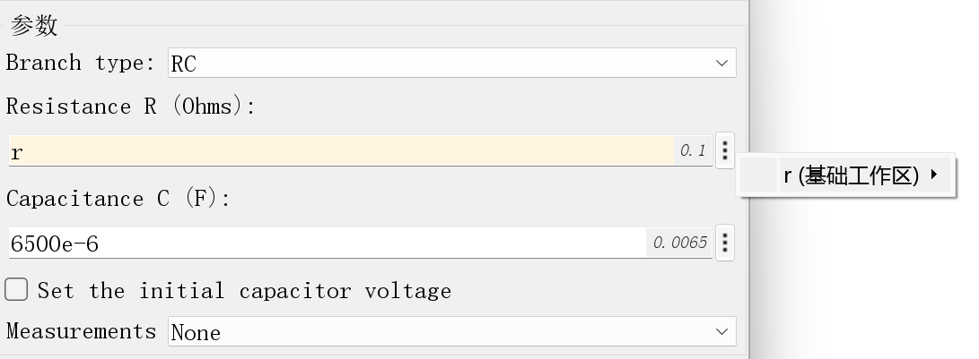

In this part, load resistor  is set to be the variable **r** in the workspace of MATLAB, which means we can make the simulation model run automatically under numerous different resistance values to obtain smoother curves. Capacitance is set to be 6.5mF according to the requirement.

*3.2.3 Power Diode Bridge*

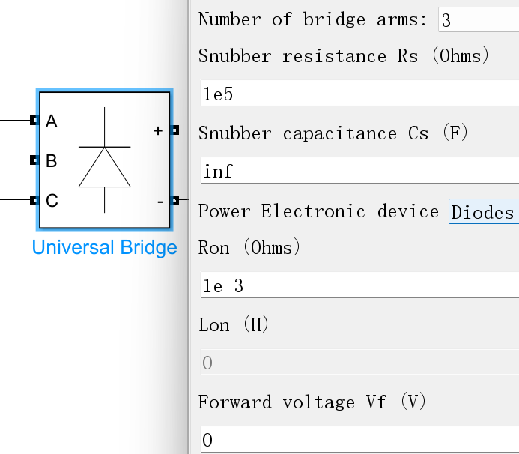

# Simulation Results

*4.1 Rectification Mode of Three-Phase Full Bridge Rectifier (Thyristor)*

*4.1.1 Waveform of* and 

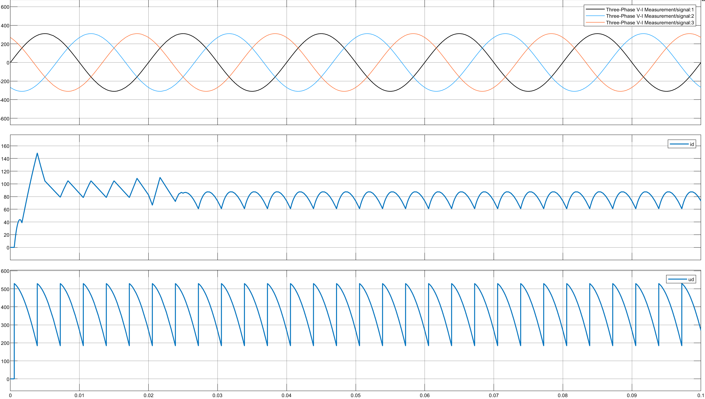

Fig 10: waveform of ,and 

The waveform of and  has been shown above. From the wave of , we can see that the circuit works under the rectification mode.

*4.1.2 The sequence of driving signal to each thyristor*

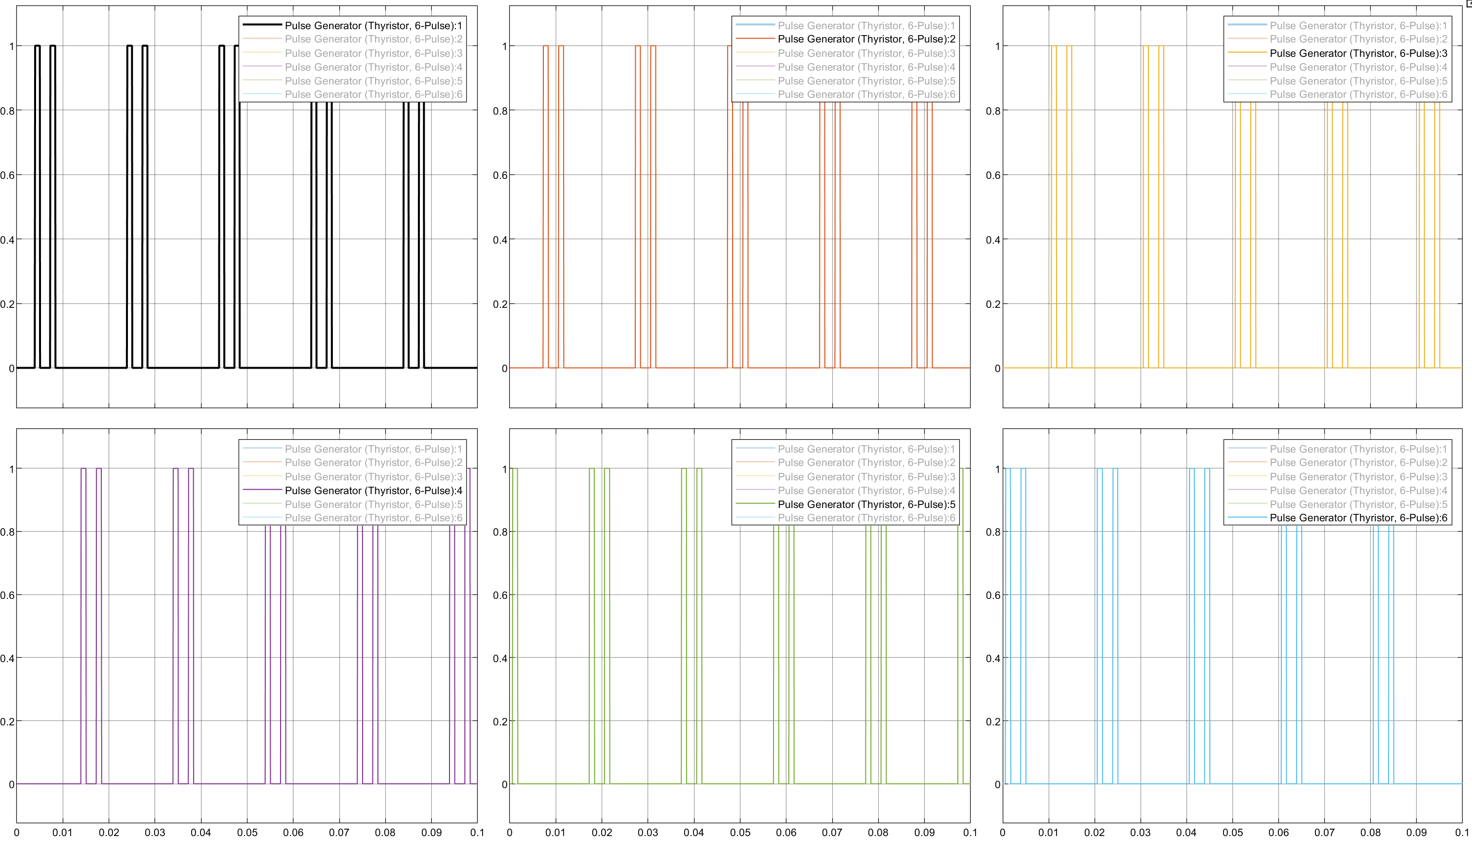

Fig 11: Triggering pulse of the thyristor

The exact conduction period of each thyristor with firing angle being 40° is listed below:

|  |  |  |  |  |  |  |
| --- | --- | --- | --- | --- | --- | --- |
| Phase angle | VT1 | VT2 | VT3 | VT4 | VT5 | VT6 |
| 310°~° |  |  |  | on | on |  |
| 10°~° |  |  |  |  | on | on |
| °~° | on |  |  |  |  | on |
| °~° | on | on |  |  |  |  |
| 190°~° |  | on | on |  |  |  |
| °~° |  |  | on | on |  |  |

*4.1.3 The on and off state of each thyristor*

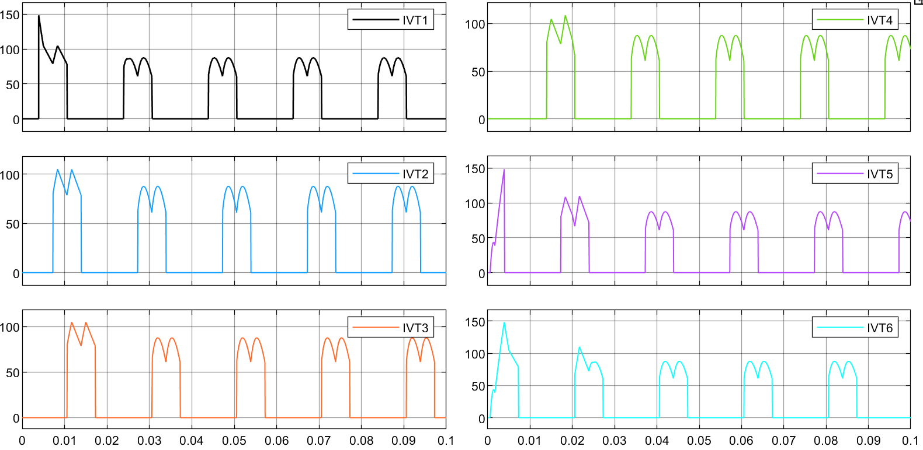

Fig 12: waveform of the current through the thyristor

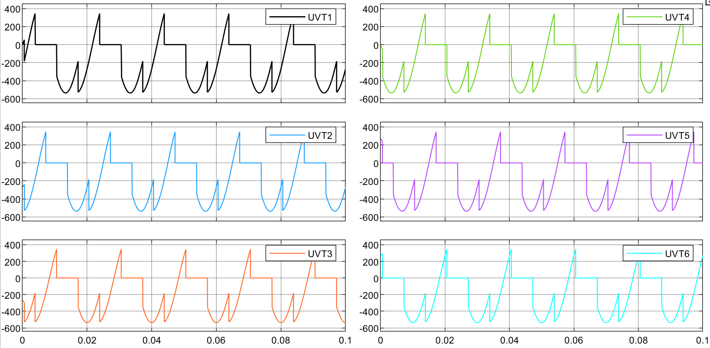

Fig 13: waveform of the voltage of the thyristor

*4.1.4 Theoretical Results*



*4.1.5 Simulation Results*

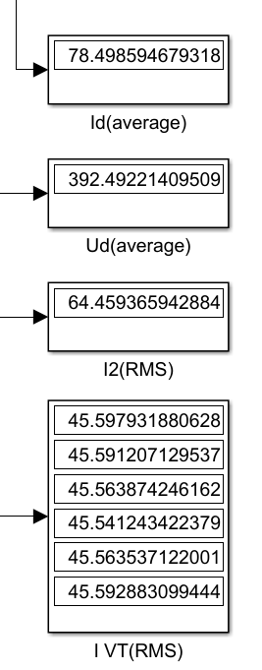

The average value of  would be: 45.57 A.

*4.1.6 Comparison between Simulation Results and Theoretical Results*

|  |  |  |  |
| --- | --- | --- | --- |
|  | Theoretical results | Simulation Results | Relative Error(%) |
| (V) | 394.36 | 392.49 | 0.4742 |
| (A) | 78.87 | 78.50 | 0.4691 |
| (A) | 45.54 | 45.57 | 0.0659 |
| (A) | 64.36 | 64.46 | 0.1554 |

We can see that the simulation results is almost the same as theoretical result.

*4.2 Active Inversion Mode of Three-Phase Full Bridge Rectifier (Thyristor)*

*4.2.1 Waveform of* and 

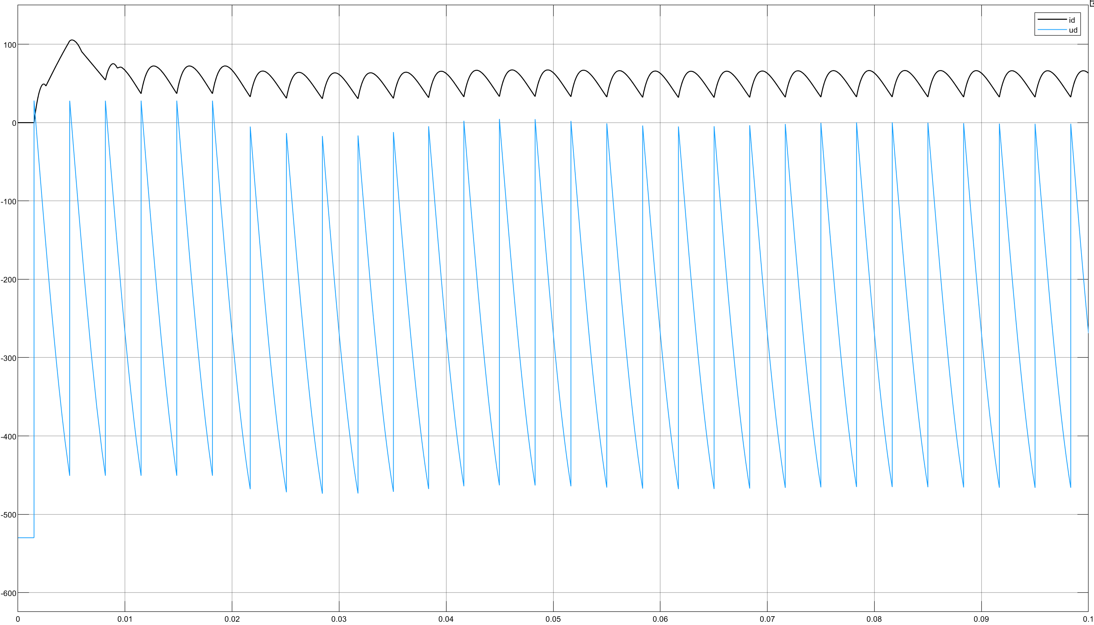

Fig 14: waveform of and 

*It is clear that this circuit works under active inversion mode.*

*4.2.2 The sequence of driving signal to each thyristor*

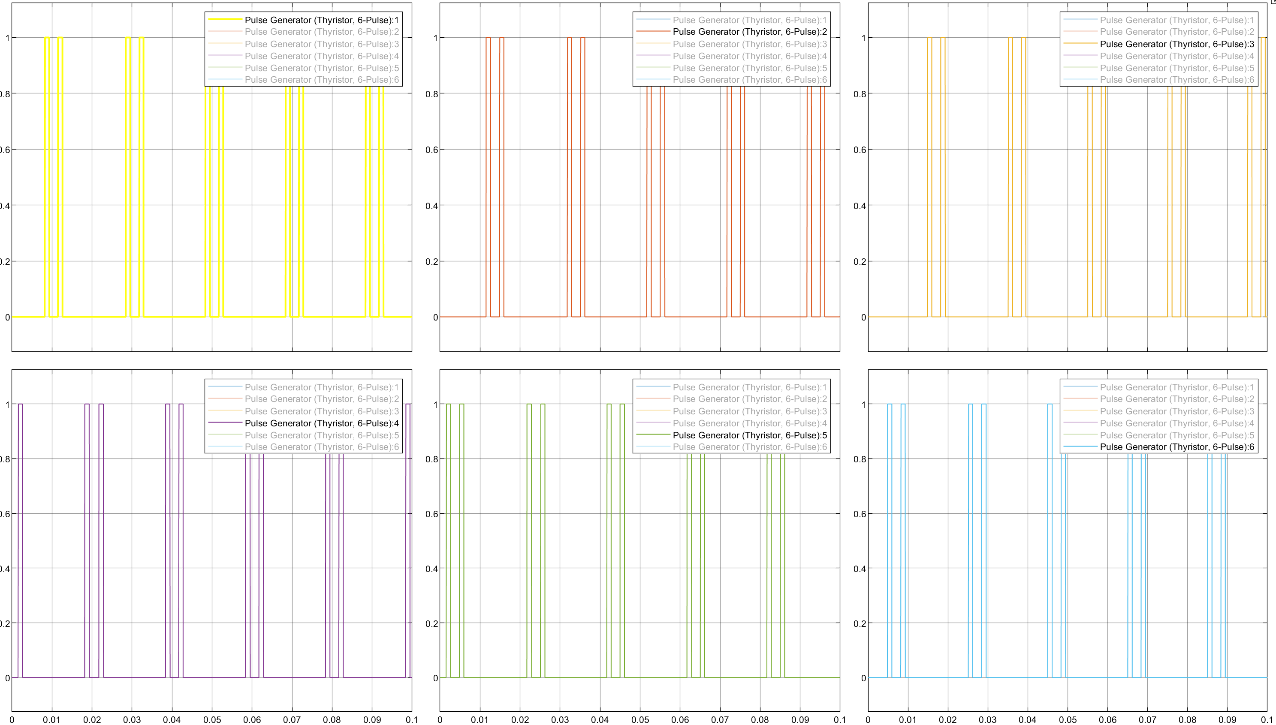

Fig 15: *sequence of driving signal to each thyristor*

|  |  |  |  |  |  |  |
| --- | --- | --- | --- | --- | --- | --- |
| Phase angle | VT1 | VT2 | VT3 | VT4 | VT5 | VT6 |
| 150°~° | on |  |  |  |  | on |
| 210°~° | on | on |  |  |  |  |
| °~° |  | on | on |  |  |  |
| °~° |  |  | on | on |  |  |
| 30°~° |  |  |  | on | on |  |
| °~° |  |  |  |  | on | on |

*4.2.3 The on and off state of each thyristor*

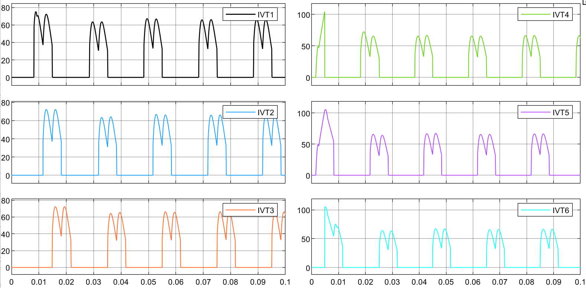

Fig 16: *current of the thyristor*

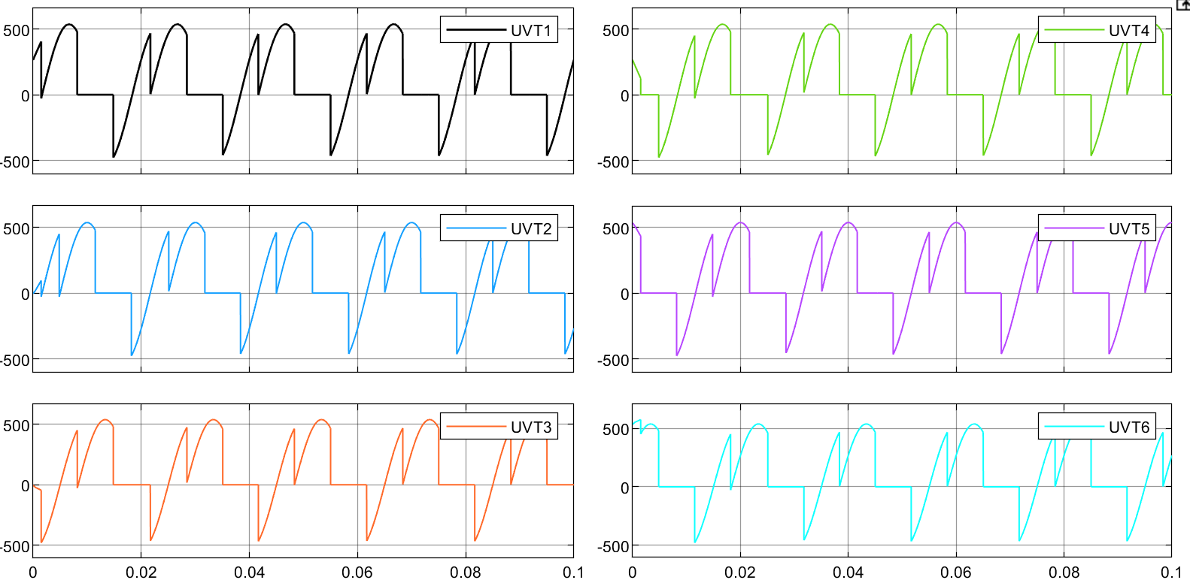

Fig 17: *waveform of the voltage of the thyristor*

*4.2.4 Theoretical Result*



*4.2.5 Simulation Results*

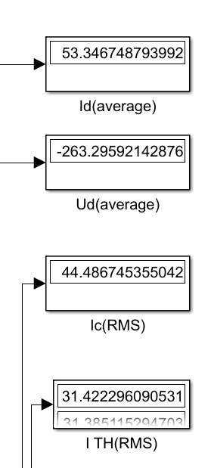

*4.2.6 Comparison between Simulation Results and Theoretical Results*

|  |  |  |  |
| --- | --- | --- | --- |
|  | Theoretical results | Simulation Results | Relative Error (%) |
| (V) | -257.4 | -263.30 | 2.2921 |
| (A) | 54.52 | 53.35 | 2.1460 |
| (A) | 31.46 | 31.42 | 0.1271 |
| (A) | 44.49 | 44.487 | 0.0067 |

We can see that the simulation results is almost the same as theoretical result.

*4.3 Part 2: Three-Phase Full Bridge Rectifier (Power Diode)*

*4.3.1 Output Voltage*

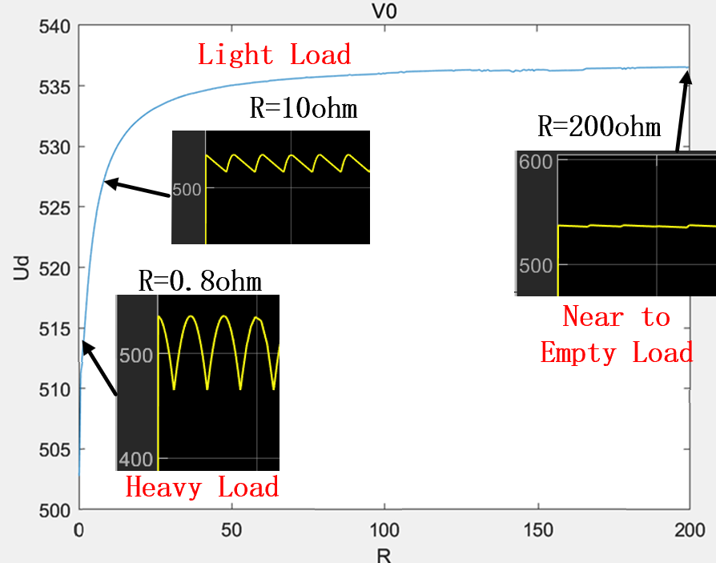

Fig 17: Vo = f(RL)

From the plot, we can see the Output voltage varies from 515V to 540V when load resistor is increasing. When  is over 30 ohm, the curve gradually tends to be flat.

As we know, the critical condition for the current  being intermittent or continuous is:



Where:



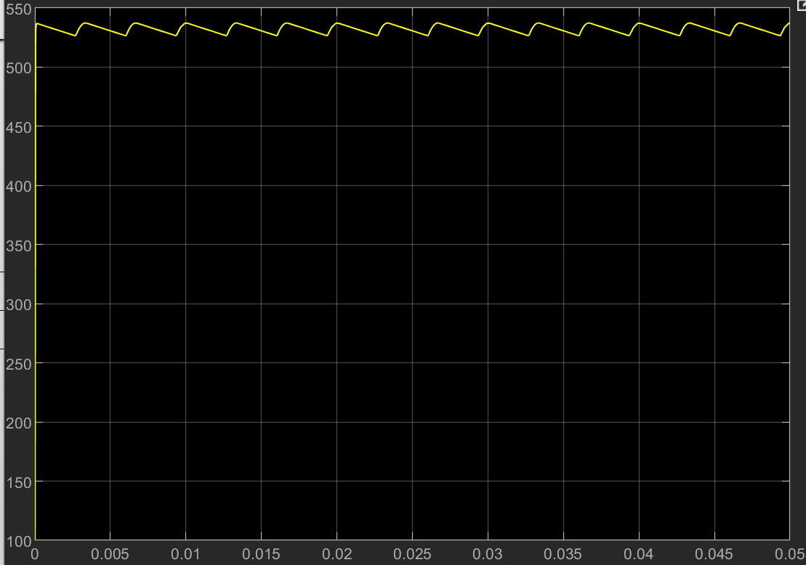

Fig 18: The waveform of ud (R=20hom)

*When the load is light (load here refers to the DC current* *), which means* , the charging current is intermittent. The non-sinusoidal wave of Fig 18 refers to the section when capacitor is discharging towards the resistive load. When the thyristor is conducting,  is the contour of the line-to-line voltage, the AC side line voltage is supplying power to both the resistive load and the capacitor. But when the resistance is so large that it forms an open circuit (empty load), the capacitor cannot discharge anymore. Thus, the voltage of will almost remain stable at a certain level, which is the largest point of the line voltage.

The value of maximum voltage would be:



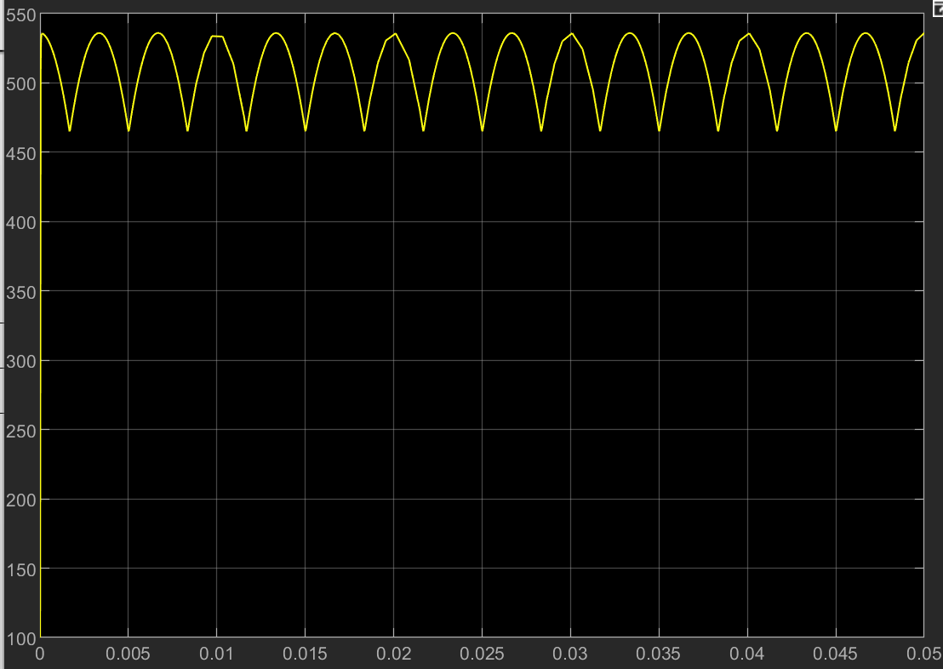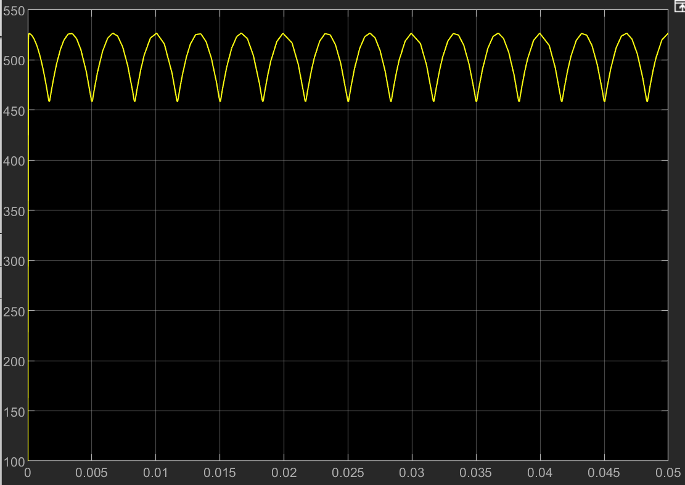

Fig 19: The waveform of ud Left:(R=0.5hom) Right:(R=0.8hom)

When the load is heavy (), the current  is continuous, which means the voltage  is similar to the contour of the line-to line voltage of AC side. Thus, this circumstance has nothing different from the Three-phase Fully-controlled Rectifier with firing angle being 0. The average value of  would be relatively stable at:



*4.3.2 Total Harmonic Distortion*

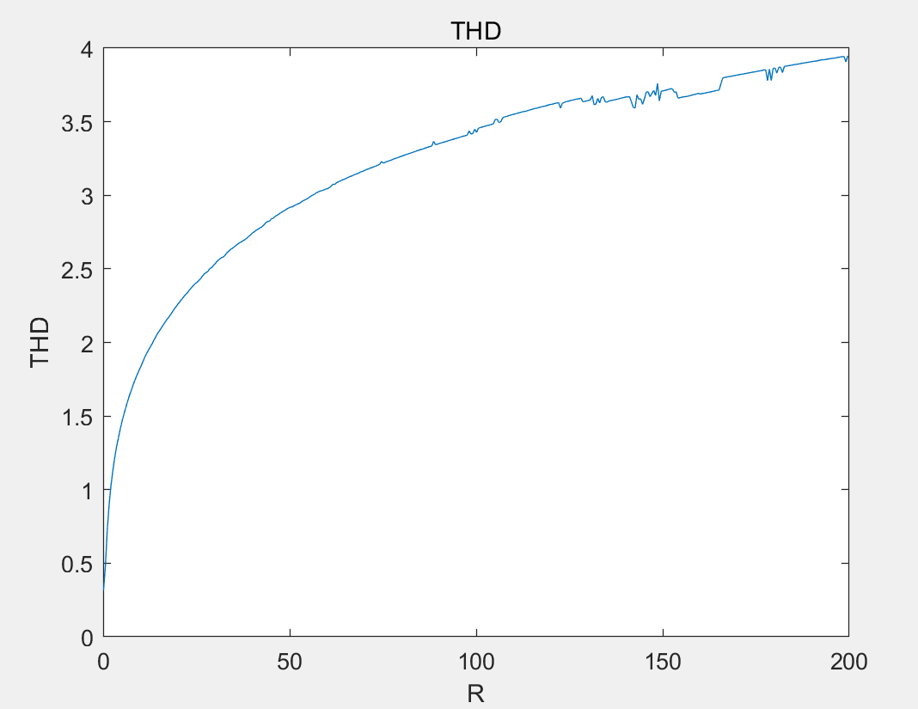

Fig 20: THD=f(RL)

From this plot, we can also combine the result with the theory. When the load is heavy, the voltage of load is just similar to the contour of the AC side line voltage, which means THD is small. But when the load is light, capacitor actually acts as a filter by discharging towards the load. This may cause the distortion of the waveform of load voltage. So it is easy to see the THD increases with the increment of resistive load R.

*4.3.3 Power factor*

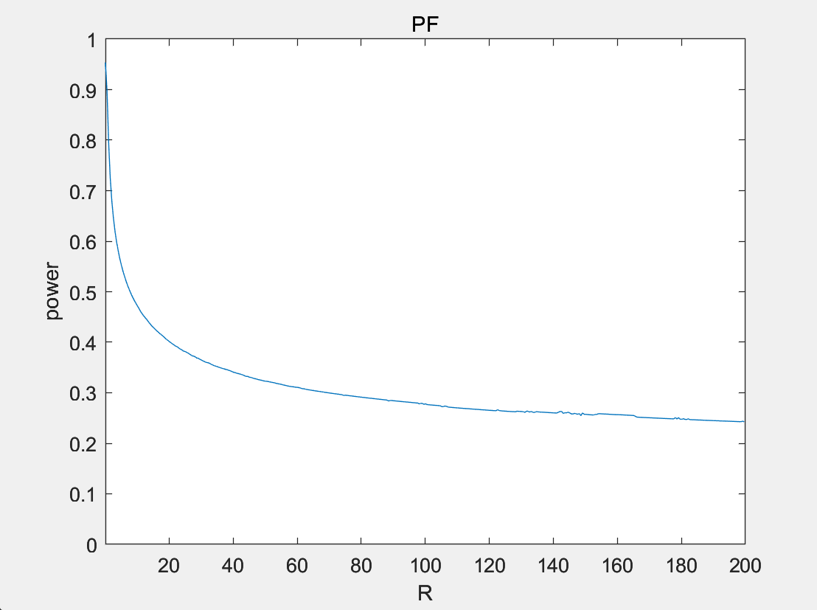

Fig 21: PF=f(RL)

From 4.3.2, we can know that the load ( only R is variable here) can influence the harmonic components. When the load is lighter (R is larger), the harmonic components increase while the fundamental component decreases. This can cause the distortion factor  decreasing and THD increasing. Thus the power factor would also decrease. ().