**Seminar 3**

Wang XingYi 2226215258

**Topic 1**

# Topic

This topic contains three major tasks on the series connection of 2 single-phase VSIs with single-phase full-bridge inverter. We can adjust the waveform of output voltage by changing the phase angle, so we build up the following model.

# Simulation Model

To be more specific, we are required to use 180° conducting mode () and change the external phase-shifting angle  between two invertors. Here are the tasks we need to tackle.

1. Observe the single invertor’s time sequence waveform and input/output voltage relationships with 180° conducting mode.
2. Study the basic operating principle of series connection of multiple single-phase VSIs.
3. With external phase-shifting angle  varying, we need to plot the curves characterizing the relationship between  and RMS value of the fundamental component in output voltage,3rd 5th 6th 7th and 9th harmonics components, THD of output voltage.

## *2.1 Circuit Schematic*



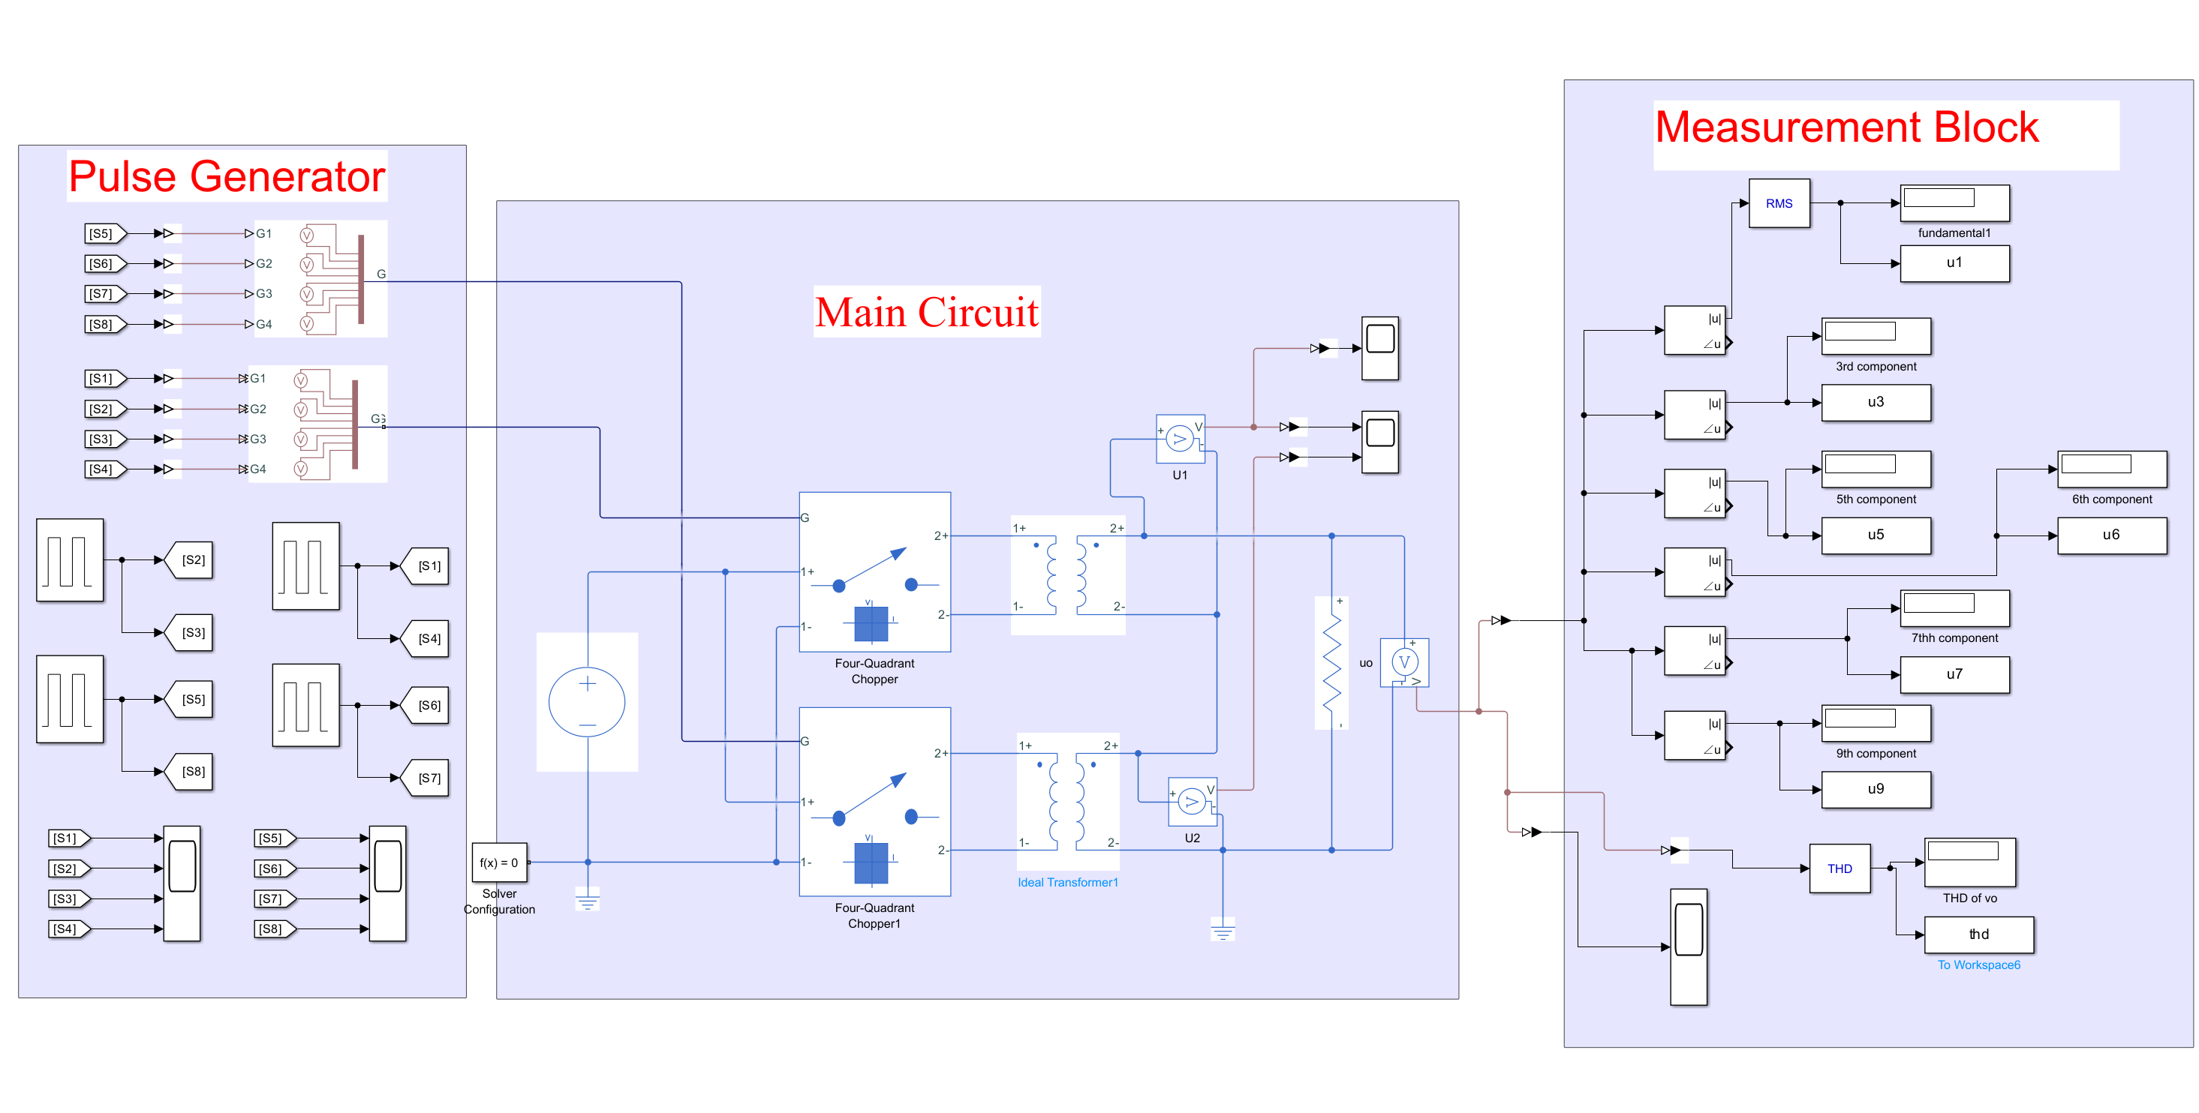

Figure 1: Simulation model 1

The model above is composed of three major parts: Main Circuit, Pulse Generator, Measurement Block.

## *2.2 Main Circuit*

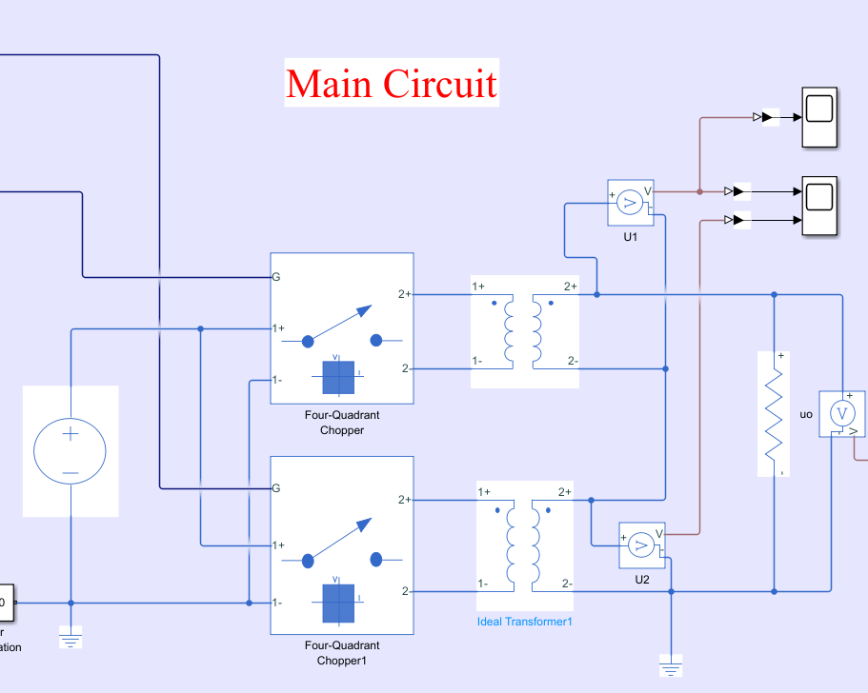

Figure 2: Main Circuit

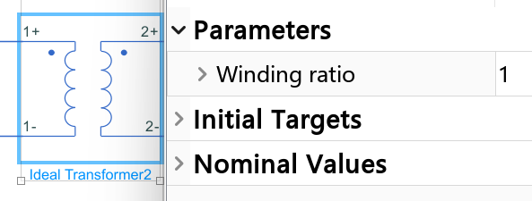

The winding ratio of the transformer is set to be 1.

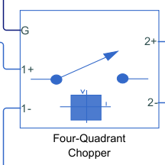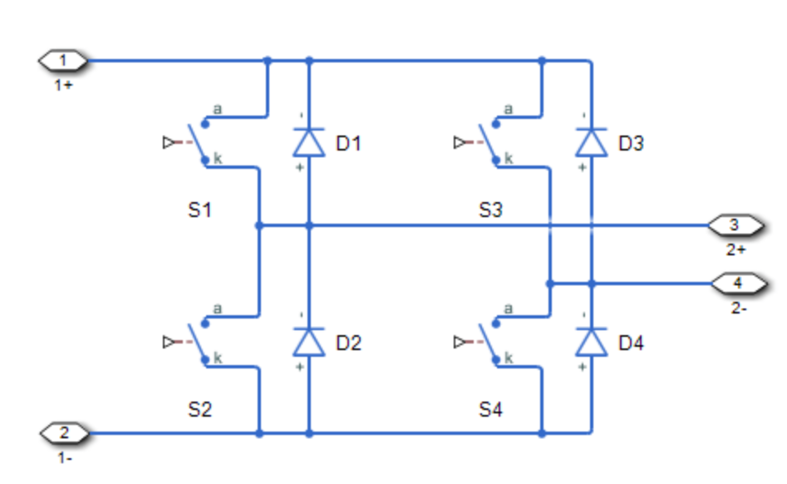

Figure 3: Four-Quadrant Chopper and its equivalent circuit

In the main circuit, we use the integrated Four-Quarter Chopper to substitute the H bridge of the single-phase full-bridge VSI. The Four-Quadrant Chopper block represents a four-quadrant controlled chopper for converting a fixed DC input to a variable DC output. The block contains two bridge arms. Each bridge arm each has two switching devices.

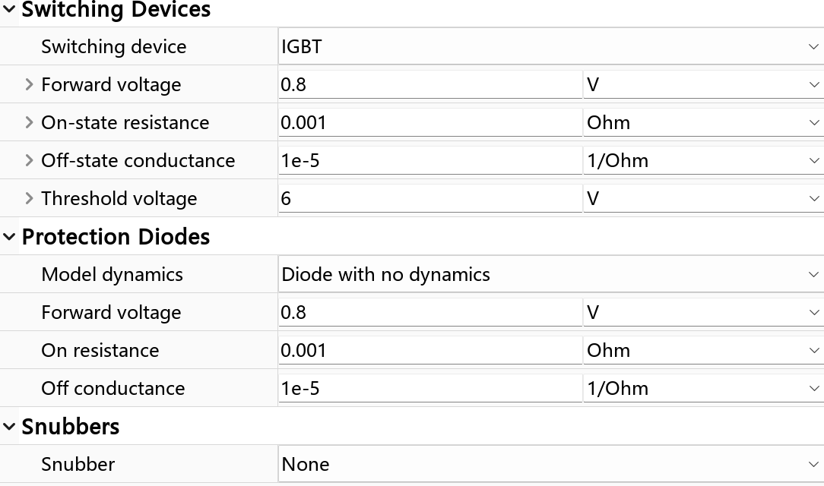

Figure 4: Parameters of Four-Quadrant Chopper

We use IGBT with anti-parallel diode as switching device here, detailed information can be found in Figure 4.

## *2.3 Pulse Generator*

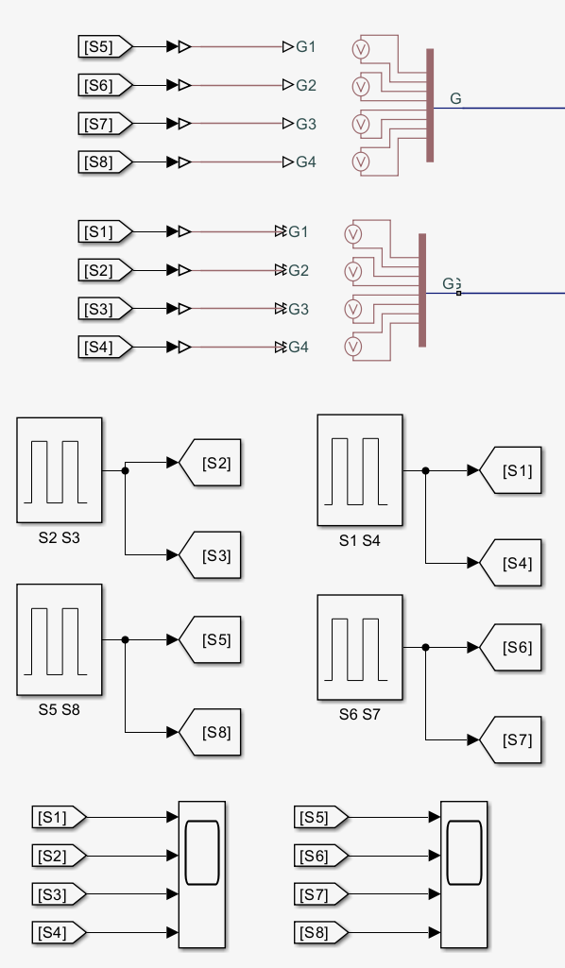

Figure 5: Gate Driver of IGBT

In this part we use four single pulse generators and two Four-Pulse Gate Multiplexers as IGBT gate driver. Taking account of 180° conducting mode, the pulse sequence of V1 and V4 is totally the same, which also applies to V2 and V3. Therefore, we only use four generators for two single VSIs in this topic.

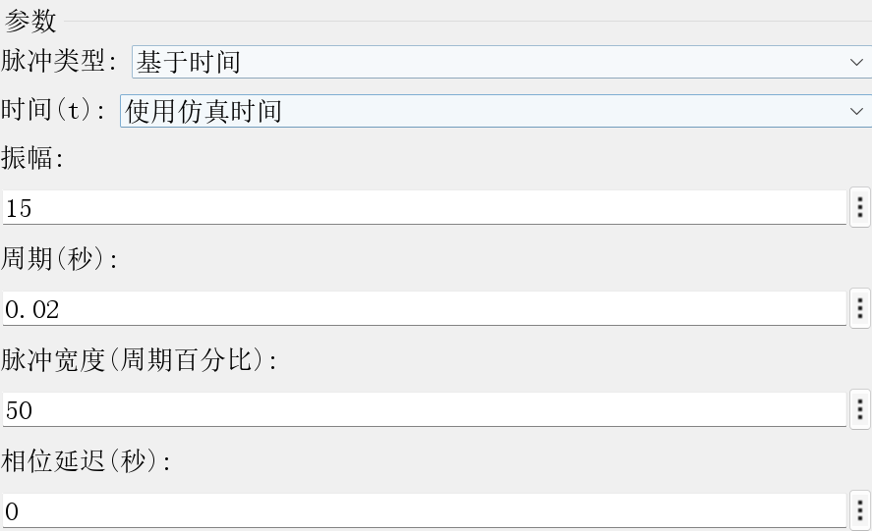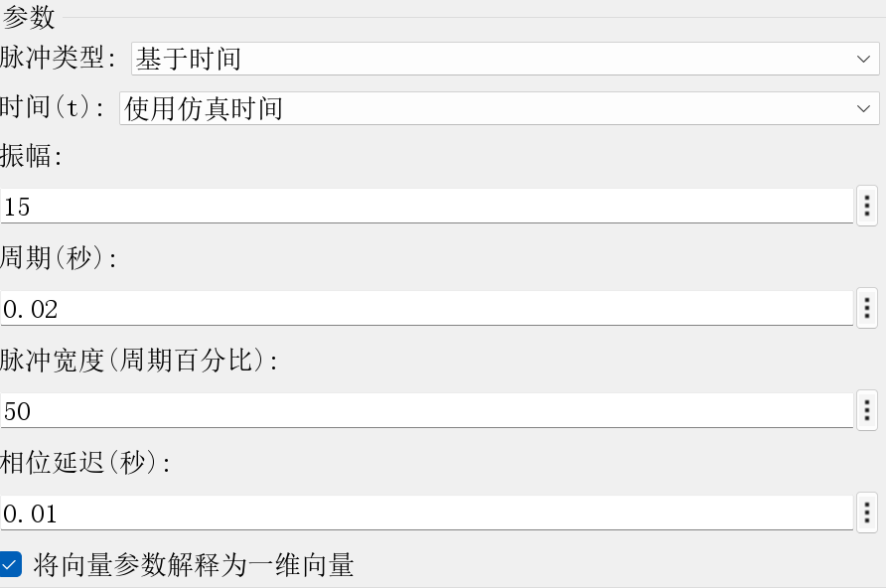

Figure 6: V1, V4 (L) V2, V3 (R)

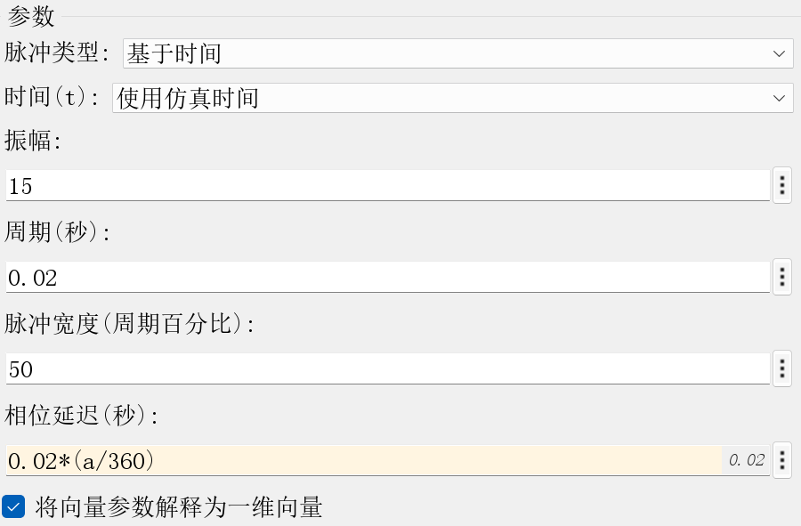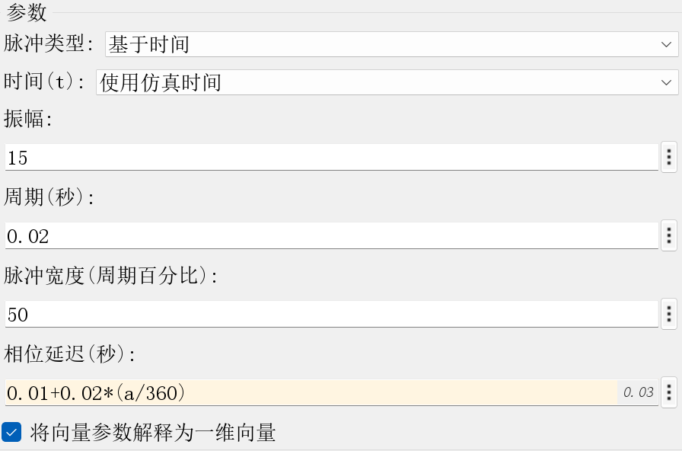

Figure 7: V5, V8 (L) V6, V7 (R)

With frequency being 50 Hz and 180° conducing mode,  is lagging  by 180 degrees, which means 0.01 sec. The value ‘a’ in Figure 7 refers to the external phase-shifting angle . By changing ‘a’ from 0° to 360° per degree, we will have smoother and more accurate curves of output voltage and other values.

# Parameter Setup

|  |  |  |  |
| --- | --- | --- | --- |
| R() | (V) | (°) | (°) |
| 8 | 400 | 180 | 1~360 per degree |

## *3.1 Matlab program*

# Simulation Results

## *4.1 Task one*

**In this task, we are required to observe the single invertor’s time sequence waveform and input/output voltage relationships.**

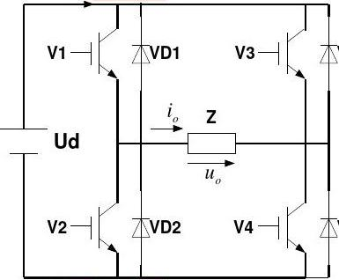

As the load in this part is purely resistive, we can only analyze the voltage waveform here.

When =180°:

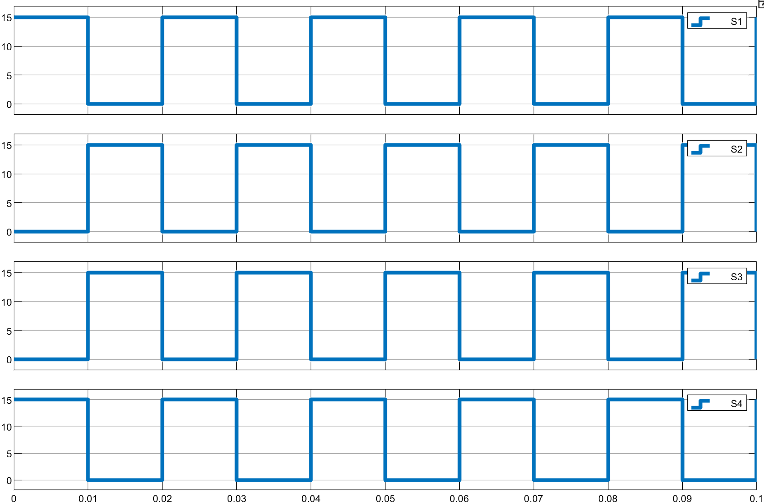

Figure 8: Gate Voltage Waveform from V1 to V4 ()

|  |  |  |  |  |
| --- | --- | --- | --- | --- |
|  | V1 | V2 | V3 | V4 |
|  | on | off | on | off |
|  | off | on | off | on |

From the figure above, we can see that the gate voltage of V1 and V2 is complimentary, so does VT3 and VT4.

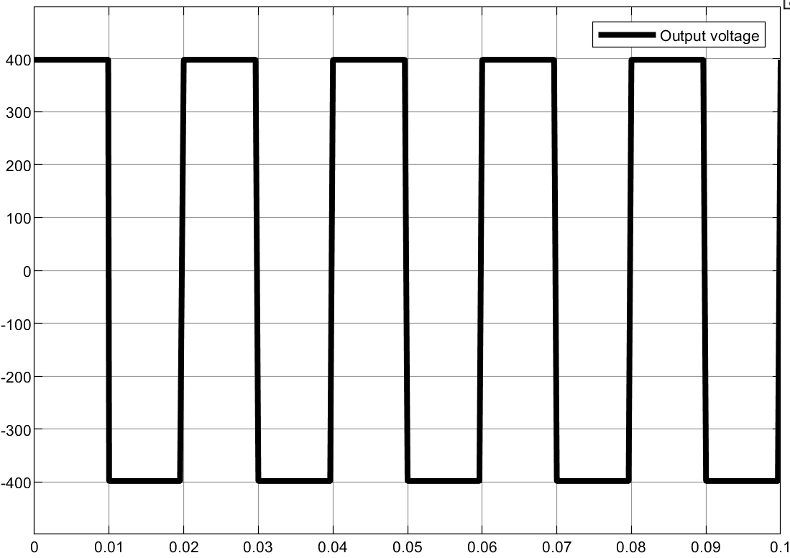

Figure 9: Waveform of output voltage ()

Therefore, the output voltage is a square wave, with its amplitude being the same as voltage source which is 400V.

When =60°:

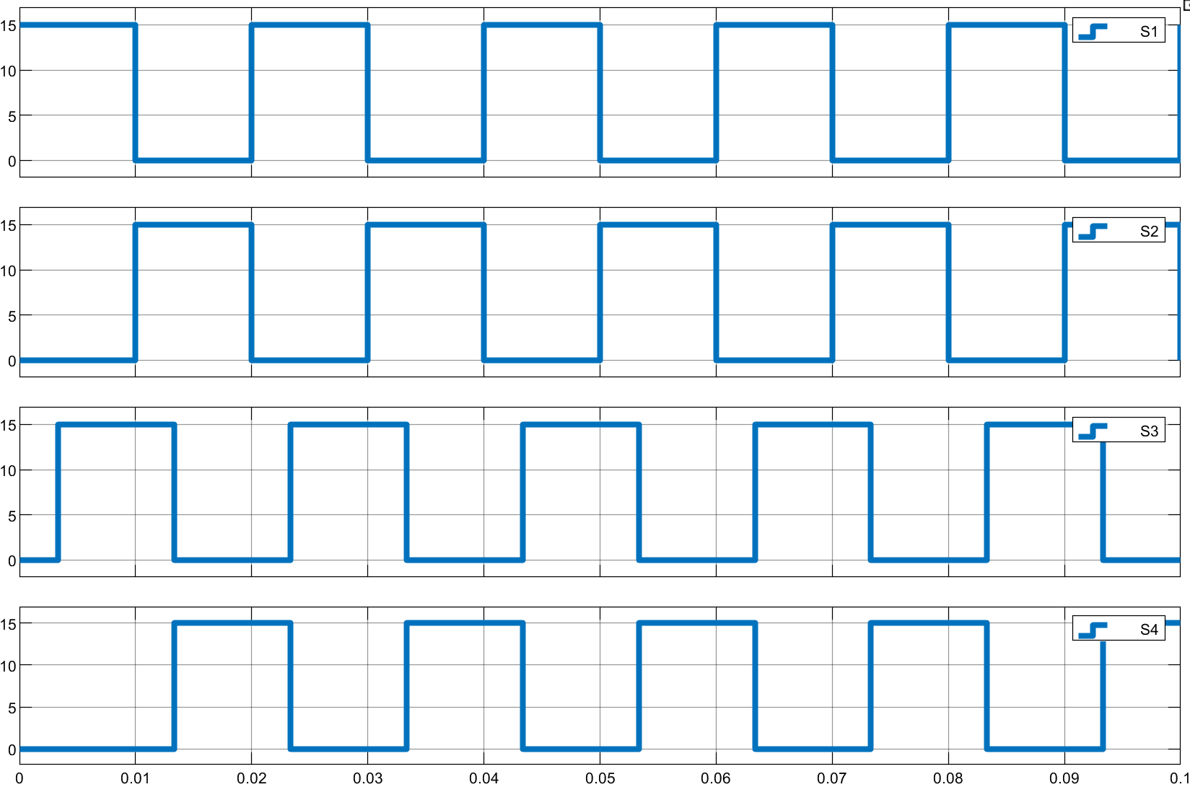

Figure 10: Waveform of output voltage ()

From Figure 10, we can see that the phase angle of V3 is lagging 60° to V1, and V4 is lagging 60° to V2.

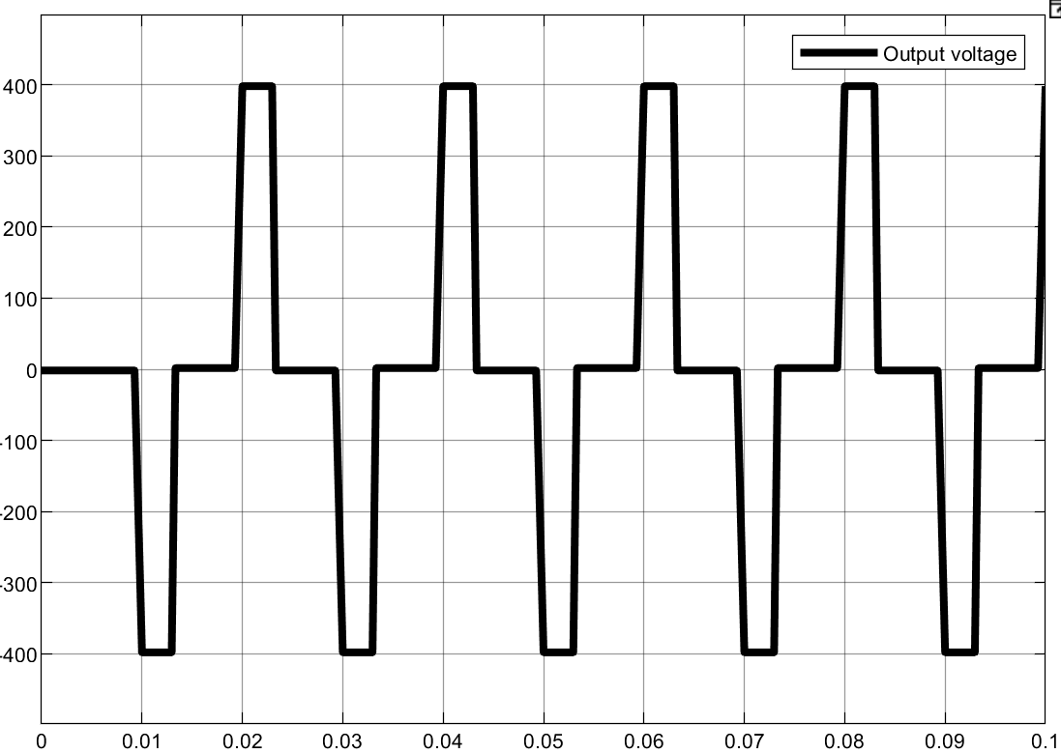

Figure 11: Gate Voltage Waveform from V1 to V4 ()

From Figure 11, we can see that the output voltage waveform is a series of alternative polarity pulses with the pulse width being 60°.

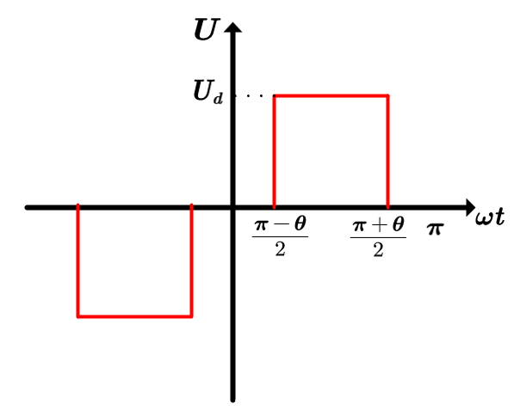

Figure 12: The relationship between output voltage and 

To sum up, we can alternate the pulse width of output voltage by changing .

The Fourier series of output voltage can be calculated as:



Through this equation, we can see that there are no even harmonic components in the output voltage. When , all odd harmonic components of output voltage avoid being eliminated.

## *Task two*

In this task, we are required to **study the basic operating principle of series connection of multiple single-phase VSIs.** Series connection here means putting output in series.

During this process, we will always use the 180° conducting mode as required, which means  contain all the odd harmonic components.

From previous section, we can know that the Fourier series of voltage  is:



Shift the conducting phase of two single-phase full-bridge invertors by , we can see:



Therefore, the output voltage  shall be:



Through this equation, we can clearly see the relationship between external phase-shifting angle and output voltage. With an assigned , we can know that when , the *k*(k=1,2,3…) harmonic component of output voltage will be eliminated. For instance, when , the  harmonic components will be eliminated in the output voltage, and the waveform of  is a rectangular wave with 120° pulse width.

## *Task three*

**Plot the curves characterizing the relationship between  and RMS value of the fundamental component in output voltage,3rd 5th 6th 7th and 9th harmonics components, THD of output voltage.**

## *4.3.1 RMS value of fundamental component of output voltage*

## 

Figure 13: Plot between  and fundamental component

Based on:



When =0° and , the RMS value of fundamental component of output voltage can be calculated as:



In general, when n=1, and , we can see:



This equation can perfectly explain the waveform shown in Figure 13.

## *4.3.2* 3rd 5th 6th 7th and 9th harmonics components

*

图表, 图示

# Analysis of the Results

Tips:

Here is the recommended format of the report: The font used in the report is “Times New Roman”. The title and first-rank title are of size 11, bolded; second-rank titles are of size 11, inclined; and text is of size 10. You can adjust the margin by yourself to make your report neat. When you want to plug in figures, please place it in the center, and the description of the figure should be of size 8.



Figure 1: Logo of XJTU

Your report should include these five parts above. Do these by yourself and discuss with your group member(s) when you have questions.