**Seminar 6**

Wang XingYi 2226215258

# Topic 1

# Topic

This task aims to carry out simulations on the three-phase bridge voltage-type PWM inverter circuit. To be more specific, there are two tasks to be completed:

1. Study how frequency spectrum of output voltage changes with respect to the variation of amplitude modulation ratio m
2. Analyze the operating sequence according to simulation waveforms

# Simulation Model

Based on the topology of three-phase VSI, we build up the following simulation model. We used the prevalent Modulation Method to generate the SPWM wave.

Figure 1-1: Three-phase PWM VSI Simulation Model

# Parameter Setup

The main difference between the three-phase PWM inverter circuit and the traditional three-phase inverter circuit is that the input switching signal is controlled by PWM, while the other structures are similar. There are three bridge arms, a total of 6 switches (composed of IGBT and diodes), and the specific module parameter settings are as follows:

## *3.1 Major Parameter*

|  |  |  |  |  |  |  |  |  |  |  |
| --- | --- | --- | --- | --- | --- | --- | --- | --- | --- | --- |
| Carrier Wave | L | | Vdc | | fline | | fs | | R | |
| Bipolar | | 4mH | | 900V | | 50Hz | | 20kHz | | 10ohm | |

## *3.2 Device Parameter*

Figure 1-2: Carrier Wave Parameter Setting

From Figure 1-2, we can see that the carrier wave of this model is bipolar.

Figure 1-3: Three Phase Modulation Wave Parameter Setting

It should be noted in particular that the amplitude of the modulated wave (sinusoidal wave) is the depth of modulation α, and the magnitude of the carrier wave should equal to 1V.

# Simulation Results

*4.1 Circuit Conducting Principle*

In order to facilitate analysis and observation, the carrier frequency was reduced to 400Hz, the depth of modulation was set to 1, and the simulation circuit was built to obtain the U-phase modulation, carrier and PWM waveforms, as shown in Figure 1-4 below.

Figure 1-4: Waveforms of the U-phase modulation wave, carrier wave and PWM wave

Taking U-phase values as an example. In Figure 1-4, the pink sine curve is the U-phase modulated signal. If , the upper bridge arm V1 is onl, and the lower bridge arm V4 is off, while , the upper bridge arm V1 turns off, and the lower bridge arm V4 is on. The conducting order of the other two phases is consistent with U, whose phases are staggered by 120 degrees. The grid emitter voltage waveform (PWM wave) of each switch is shown in the figure below.

图示

Figure 1-5: The grid emitter voltage waveform for each switch

Figure 1-6: The voltage waveform relative to the imaginary midpoint for each phase

Figure 1-6 shows the output voltage waveform of each phase relative to the imaginary midpoint N’ of the DC power supply. The operation of each phase IGBT and diode is the same as that of U, except that the three-phase waveform differs by 120°in turn. Then, based on the formula listed, we could get the uUN, the waveform of uUN is shown as follows.



Figure 1-7: Waveform of uUN

The PWM wave of phase voltage is composed of five levels, which are +600V, +300V, 0, -300V, -600V. The results are consistent with theoretical analysis.

*4.2 Harmonic analysis*

The harmonic content of output phase voltage under different modulation system is analyzed by FFT by changing depth of modulation a , taking 1, 0.8, 0.5, 0.3 and 0.1 respectively

Figure 1-8: Waveform of uUN (fs=20kHz)

Figure 1-9: Waveform of uUN (fs=20kHz, amplified)

Through theoretical analysis, it can be seen that the harmonics contained in the SPWM waveform are mainly the switching frequency and the harmonics near it. The switching frequency of our group is 20kHz and the fundamental frequency is 50Hz, so the number of main harmonics is 400, 800, 1200, etc. At the same time, the harmonic content decreases with the increase of the harmonic frequency.

Figure 1-10: Spectrum of uUN (α=1)

图表

Figure 1-11: Spectrum of uUN (α=0.8)

Figure 1-12: Spectrum of uUN (α=0.5)

Figure 1-13: Spectrum of uUN (α=0.3)

Figure 1-14: Spectrum of uUN (α=0.1)



Figure 1-15: Relationship between THD and modulation depth

When the modulation depth increases, the variation trend of each harmonic content is uncertain, and we used the THD module to obtain the curve as shown in the figure. It can be seen from the figure that the harmonic content of the output voltage decreases with the increase of the modulation system, so the modulation system should be as close to 1 as possible if conditions permit.

**Topic 2**

# Topic

For topic 2, we need to carry our simulation on the single-phase PWM full-bridge voltage-source converter. To be more specific, we are required to control the power stage so that the requirement of AC side current amplitude as well as the phase difference between AC side voltage and current could be satisfied.

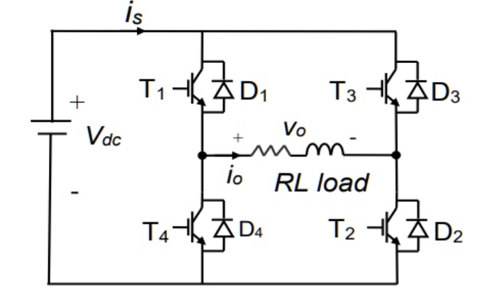

Figure 2-: Circuit Topology

# Simulation Model

In this topic, we majorly adopted two kinds of methods to generate the PWM wave. Therefore, we correspondingly build up two simulation models.

## *2.1 Triangular-Wave Natural Sampling——SPWM Wave*

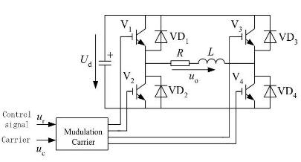

Figure 2-2: Circuit of Modulation Method

Figure 2-3: Simulation Model of Modulation Method

In this model, we adopted the Modulation Model, namely Triangular-Wave Natural Sampling, to generate the PWM wave. We set the modulating signal wave as sinusoidal wave so that we can correspondingly generate the SPWM wave on the AC side.

Figure 2-4: Directional Arm and Chopping Arm

From Figure 4, we can see V1 and V2 form the directional arm, and V3 together with V4 forms the chopping arm. For both arms, the signals from the upper arm and the lower arm are complimentary to each other. In the directional arm, the signal S12 comes from a sinusoidal wave, which has the same phase degree as the AC side voltage Uab. The polarity of the Uab determines the on and off state of V1 and V2. While in the chopping arm, the signal S34 comes from the modulation wave and the carrier wave.

Figure 2-5: Parameter of Carrier Wave

钟表的特写

Figure 2-6: Control Circuit for Chopping Arm

Typically, it is recommended to use isosceles triangle as the carrier wave. The frequency of carrier wave should be equal to that of switching frequency, and the magnitude should be 1V. From Figure 4, we can see that the unipolar carrier wave is adopted.

## *2.2 Current Hysteretic Control*

Figure 2-7: Single-Phase Half-Bridge VSI with Current Hysteretic Control

Figure 2-8: Simulation Model of Current Hysteretic Control

In this model, we utilized the Current Hysteretic Control method to generate the PWM wave. Instead of using modulating wave to modulate the carrier wave, we appointed the desired output signal as the commanding/reference signal, regarding the actual output wave as the feedback signal. Through hysteretic comparison of the transient values of these two signals, we can get the gate signals that change the switching state of the chopping arm. In this way, we can also adjust the pulse width of PWM wave.

Figure 2-9: Parameter of Relay

For the relay in the control circuit for chopping arm, we set the threshold current as 0.0001A, which means:



So the output current waveform value should bounce between  and .

Figure 2-10: Output waveform with hysteretic control

The threshold current in this model is set to be pretty small compared to the Modulation Method. Therefore, it is predictable that the output AC current will have smaller ripple components and harmonic components. Nevertheless, lower threshold current simultaneously increases the switching frequency for the chopping arm, generating larger switching loss. If not set properly, it may even be over the maximum switching frequency for the IGBT device, causing device damage consequently.

# Parameter Setup

## *3.1 Major Parameter*

|  |  |  |  |  |  |  |  |  |
| --- | --- | --- | --- | --- | --- | --- | --- | --- |
| Carrier Wave | Vac(rms) | | L | Vdc | fline | fs | Iac(rms) | φ(v,i) |
| Unipolar | | 220V | 4mH | 540V | 50Hz | 20kHz | 20A | -100° |

In our group, we are required to set the rms value of AC current to be 20A, and the phase of AC side current should lead current for 100 degrees.

# Simulation Results

## *4.1 Theoretical Calculation*

Ignoring the higher-order harmonics, the AC side current , input ac voltage  and inductor voltage  could be represented by the phasor:







It is noticed that we add a 0.1 ohm resistor in the AC side to avoid oscillation and decrease the transient duration of the circuit so that we can get desired AC current waveform.



Figure 2-11: Spectrum of Uab

From Figure 9, we can see that the harmonic orders of SPWM wave Uab are all based on line frequency and switching frequency.

The fundamental value (50Hz) of AC side SPWM voltage  should be:



From Figure 9, we can see one important phenomenon for single-phase SPWM VSI, which is that **the ratio of the magnitude of fundamental value Uabf over magnitude of Uab is the Modulation Depth “a”. Meanwhile, the modulation depth also equal to the magnitude of modulating signal in the control circuit of chopper arm. Since the magnitude of Uab is the DC side level. We can calculate the modulation depth “a” as:**



Therefore, we can see that when the AC side voltage is constant, the magnitude of  is solely determined by the magnitude of  and phase difference between  and .

For the Triangular-Wave Natural Sampling, the phase degree of the signal of the directional arm should be the same as that of Uabf, so does modulation wave for the chopping arm. The latter one is set to avoid the discontinuous current waveform.

## *4.2 Triangular-Wave Natural Sampling*

Figure 2-12: The waveform of AC current (green) and AC voltage (red)





The relative error should be:





## *4.3 Current Hysteretic Control*

Figure 2-13: The waveform of AC current (green) and AC voltage (red)









From what has been mentioned above, we can see that the simulation results are acceptable. The error of the magnitude of AC current majorly comes from the high-order harmonics and ripples. Theoretically, we consider the output current as the value with ideally fundamental component. Therefore, the maximum of the output current may not exactly lie in the point when the ideally sinusoidal wave reach the maximum, the same also applies to the phase difference.