**Seminar 7**

Wang XingYi 2226215258

**Topic 1**

# Topic

In this topic, we are required to compare the hard-switching with ZVS QRC (zero-voltage-switching quasi-resonant converter) on a typical buck converter.

To be more specific, for hard-switching Buck converter, we need:

1) Observe the switching waveform of power switch Q

2) Plot loss curve



Fig.1 Hard-Switching Buck Converter

For ZVS QRC Buck converter:

1. Observe the switching waveform of power switch Q
2. Plot loss curve and compare with previous case



Fig.2 ZVS QRC Buck Converter

# Simulation Model

## *2.1 Hard-Switching Buck Converter*

Fig.3 Hard-Switching Buck Converter Simulation Model

For hard-switching Buck converter, we built up the model above to carry out the simulations.

## *2.2 ZVS QRC Buck Converter*

Fig.4 ZVS QRC Buck Converter Simulation Model

For ZVS QRC Buck converter, we added an extra parallel resonant capacitance, an anti-parallel diode, and a series resonant inductor.

# Parameter Setup

## *3.1 Major Parameter*

|  |  |  |  |  |  |  |  |
| --- | --- | --- | --- | --- | --- | --- | --- |
|  |  |  |  |  |  |  |  |
|  |  |  |  |  |  |  |  |

## *3.2 Device Parameter*

|  |  |  |  |
| --- | --- | --- | --- |
| Switching Device | Switch Type | | Vgs |
| BSC060N10NS3 | | NMOS | 4.8V 5V |

For our group, we are required to use BSC060N10NS3 as our switching device. It is a NMOSFET, which means it can be conducted only when the gate-to-source voltage is larger than the threshold voltage.

Therefore, we need to assign an appropriate value for the magnitude of gate-source voltage. If the gate voltage is too large, it may cause extra power loss. If the gate voltage is too small, it may not reach the minimum threshold voltage for the switch to work properly.

Fig.5 Static Characteristics of BSC060N10NS3

Fig.6 Transfer Characteristic Plot of BSC060N10NS3

From Figure 5, we can see that the maximum gate threshold voltage for this device is 3.5V. Plus Fig 6, we finally assigned 4.8V for the hard-switching converter and 5V for ZVS QRC. We set the value of the resistor between gate and source terminal to be 5 ohm so that the charging and discharging period of the switch can be faster, and the Miller Plateau can be somewhat avoided.

# Simulation Results of Hard-Switching Buck Converter

## *4.1 Theoretical Analysis*

The Buck Converter is selected as the main circuit for this topic, which is commonly used for DC chopping by controlling the duty cycle D of the switching device to change the magnitude of output voltage . The theoretical relationship is pretty simple:

However, the formula above is acquired under the circumstance that power switching loss is totally neglected, and everything else is ideal. In practical, the performance of this circuit can be seriously impacted, especially by the switching loss, which can be shown in Fig 7.

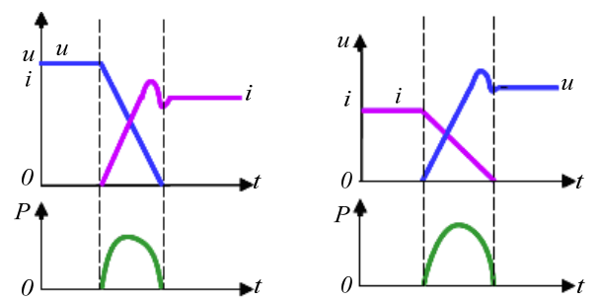

Fig.7 The Waveform of the Switching Process for Hard-Switching

## *4.2 Switching Waveform*

Before we start, we need to first assure an appropriate measurement range when the circuit has been on the steady state.

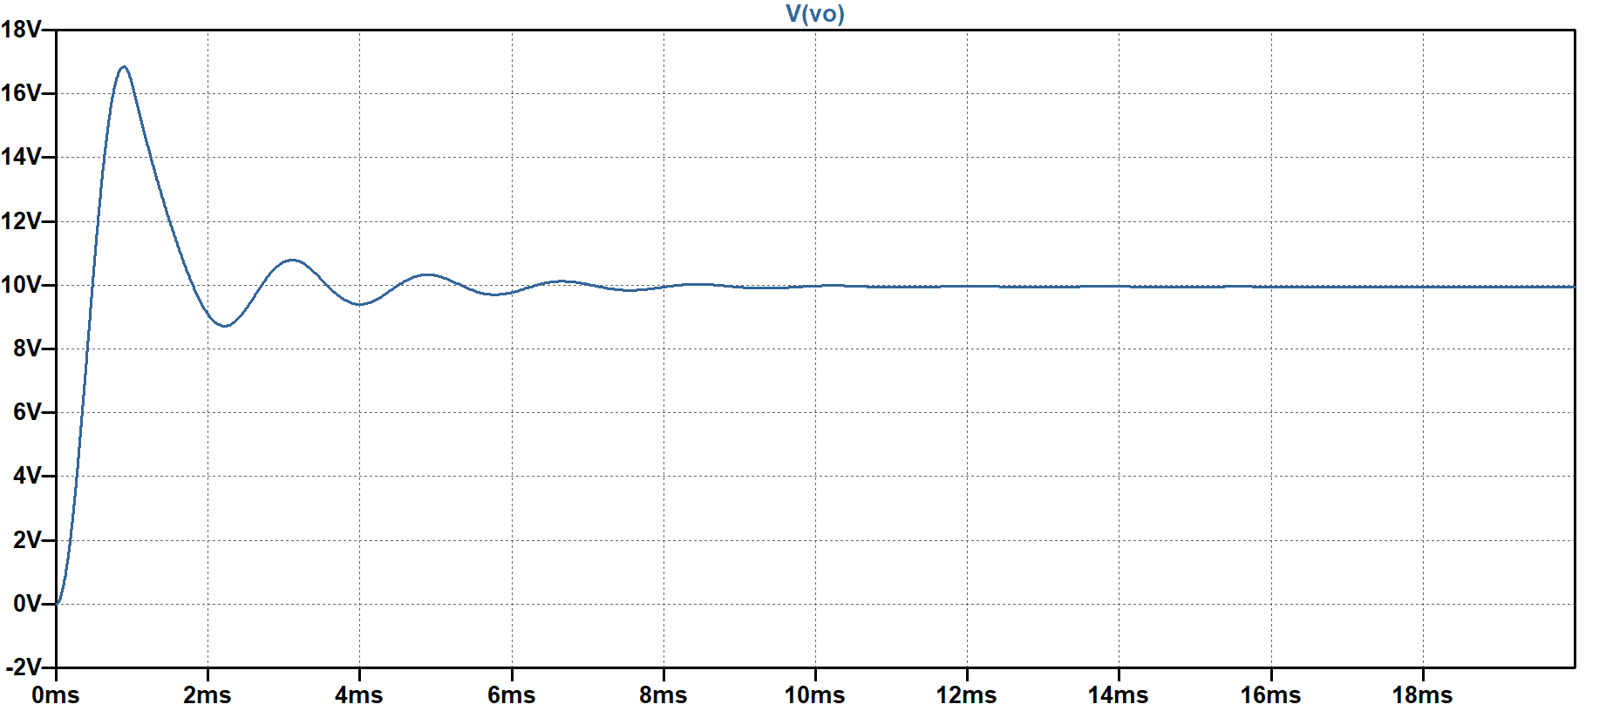

Fig.8 The Waveform of the Output Voltage

As shown in Fig 8, the output voltage has first experienced a transient oscillating period, then become steady around 10V after 18ms.

Fig.9 The Waveform of the Switch Current, Gate voltage and Switch Voltage

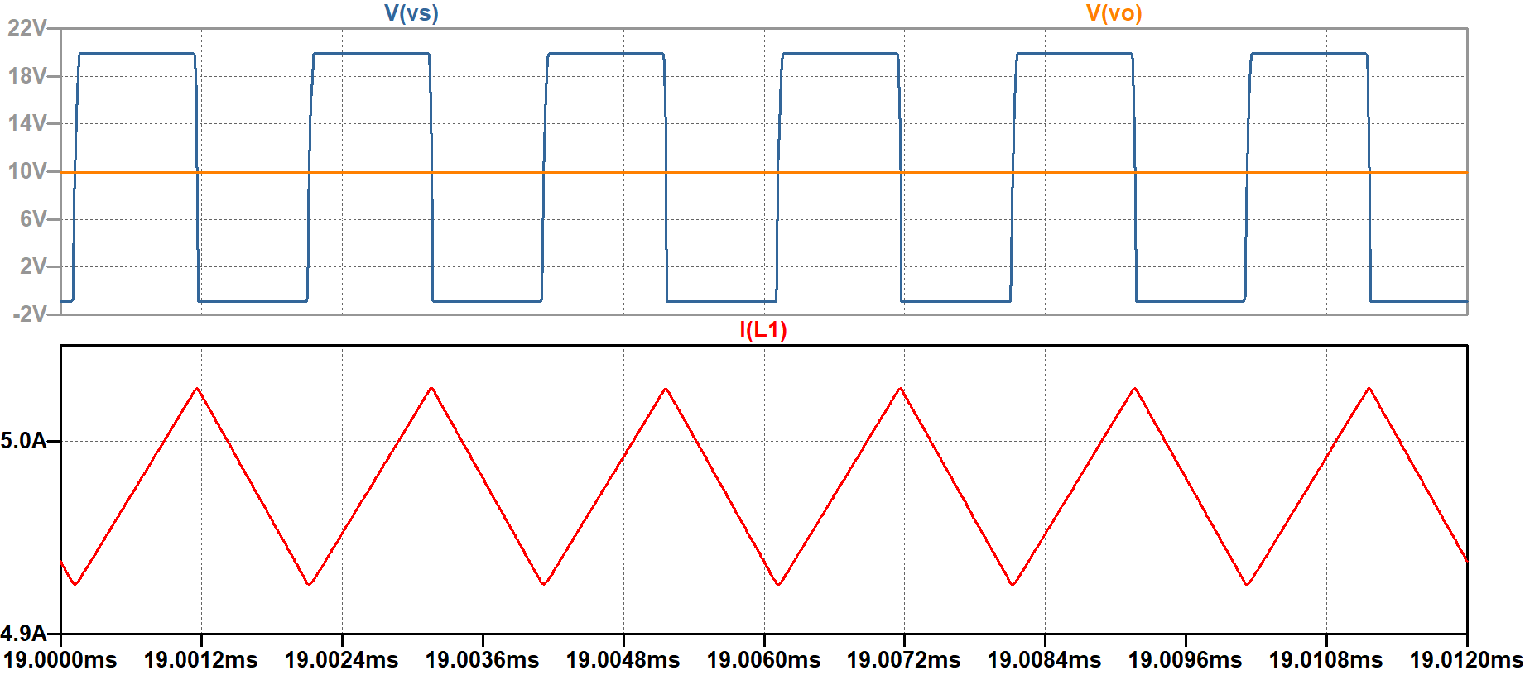

Fig.10 The Waveform of the Switch Voltage (blue), Output Voltage (orange) and the Inductor Current (red)

## *4.3 Loss Curve*

Fig.11 The Switching voltage, switching current and switching loss curve within one period

图形用户界面

Fig.12 Switching power loss

As what has been shown in Fig 11, we can see that there are overlaps areas for the switching voltage and current resulting in the switching power loss.

The followings are the waveforms of the switching voltage, current and the power loss for the turning-on, on-state, turning-off and off-state periods.

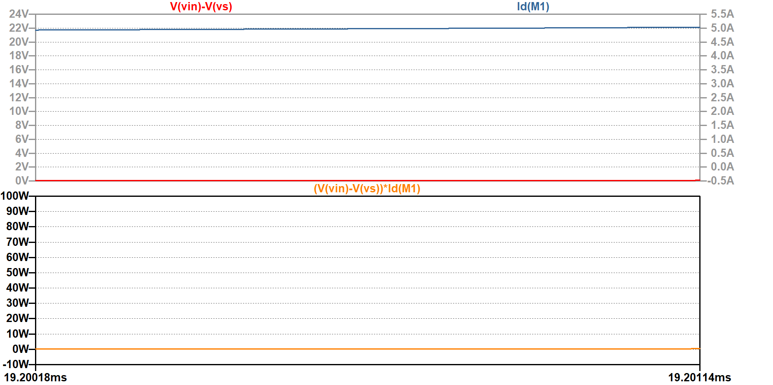

Fig.13 The Switching voltage, switching current and switching loss curve for on state

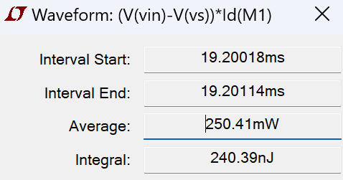

Fig.14 Switching Power Loss for On-State

Fig.15 The Switching voltage, switching current and switching loss curve for off state

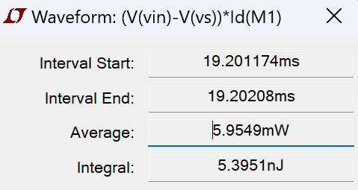

Fig.16 Switching Power Loss for Off-State

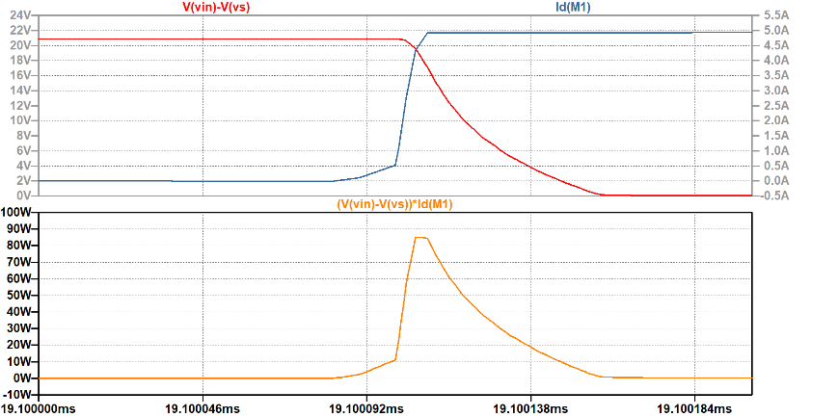

Fig.17 The Switching voltage, switching current and switching loss curve for Turning On

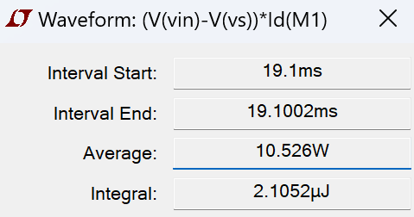

Fig.18 Switching Power Loss for Turning-On

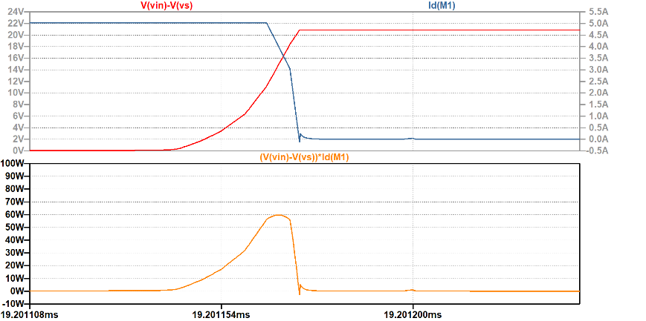

Fig.19 The Switching voltage, switching current and switching loss curve for Turning Off

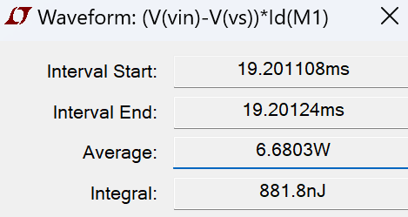

Fig.20 Switching Power Loss for Turning-Off

|  |  |  |  |  |  |
| --- | --- | --- | --- | --- | --- |
|  | On stage loss | Off stage loss | Turn on loss | Turn off loss | Total loss |
| Average | 250.41mW | 5.9549mW | 10.526W | 6.6803W | 1606.4mW |
| Integral | 240.39nJ | 5.3951nJ | 2105.2nJ | 881.8nJ | 3212.8nJ |

As shown in the table, we can see that most of the power loss is dissipated on the turning-on state and the turning-off state.

# Simulation Results of ZVS QRC Buck Converter

## *5.1 Theoretical Analysis*

It is known that the ZVS QRC, compared with the hard-switching circuit, has extra resonant inductance and resonant capacitance , whose values are much smaller. Another difference is an extra anti-parallel diode across the switch. When S is off, resonance occurs between and and the waveforms of voltage and current in the circuit are more like sinusoidal half-waves. This resonance decreases the slope of the switching voltage and current, and the overlap area during the turning-on and turning-off state can be avoided. Consequently, the switching power loss can be greatly reduced.

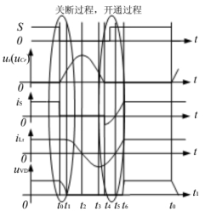

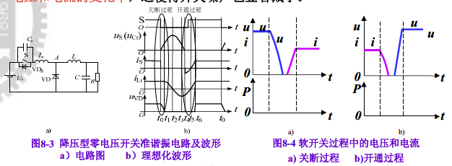

a) Turn-off process b) Turn-on process

Fig.21 Theoretical Switching Waveform for ZVS QRC

t0 ~ t1: Before t0, switch S is on, diode VD is off, ，. When S is turned off at t0, Cr slows down the increment of the voltage after S is turned off, so the turn-off loss of S is reduced. After S is turned off, VD is not on, and the circuit can be equivalent to Figure 22 a. The inductor Lr +L charges C. Since L is large, it can be equivalent to a current source. At the same time, the voltage at both ends of VD gradually decreases until t1, =0, VD is on. The growth rate of during this period can be expressed by the following formula.

t1 ~ t2: At t1, diode VD is on, inductor L continues to flow through VD, Cr, Lr, form a resonant loop. During the resonance process, Lr charges Cr, continues to rise, continues to fall, until the moment t2, drops to zero, reaches the resonance peak.

|  |  |
| --- | --- |
|  |  |
|  |  |
| Fig.22 ZVS QRC equivalent circuit | |

t2 ~ t3: After t2, Cr discharges to Lr, the polarity of the is changed, and continues to decline until t3, =, at which time, =0, reaching the reverse resonance peak.

t3 ~ t4: After t3, Lr reversely charges Cr, and continues to decline until =0 at t4.

The equation of the circuit resonance process from t1 to t4 is:

t4 ~ t5: is at zero, =, and decays linearly until time t5, =0. Since the voltage at both ends of the switch S during this period is 0, S must be turned on during this period to avoid opening loss.

t5 ~ t6: S is in the on-state and rises linearly until t6, when = and VD are turned off. The current change rate from t1 to t6 is

t6 ~ t0: S is on, and VD is off.

## *5.2 Switching Waveform*

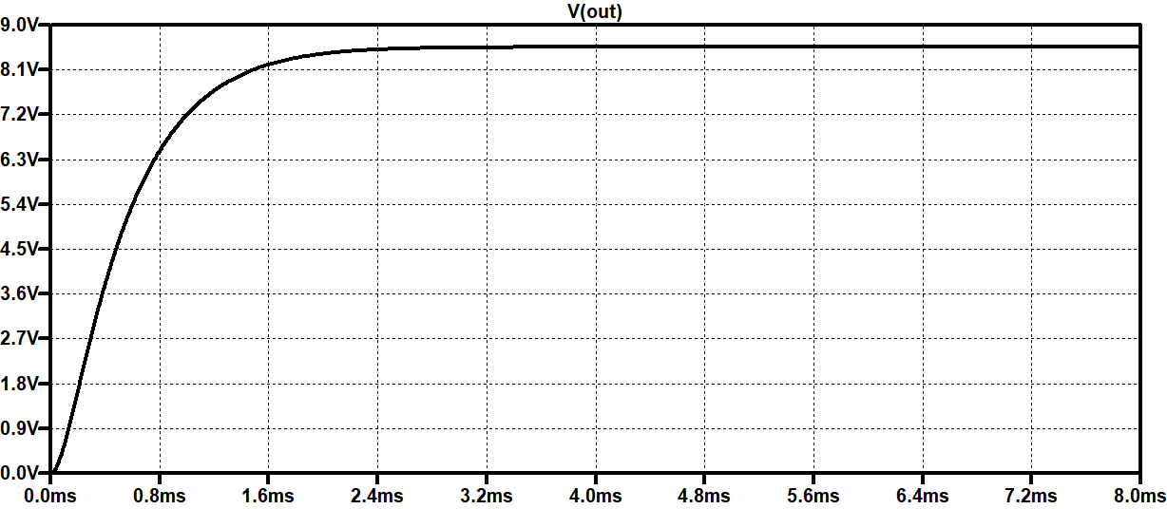

Fig.23 Output Voltage of ZVS QRC

Fig.24 Waveform of the Load Inductor Current

|  |  |
| --- | --- |
|  |  |
| Output voltage | Inductor current |

Fig.25 Average Value of the Output Voltage and Inductor Current

From Fig23, we can see that the oscillating process is greatly weaken for the ZVS QRC compared with the Hard-Switching Converter, and the transient period is also shortened correspondingly. In the following part, we choose one switching cycle from 3.9ms to analyze.

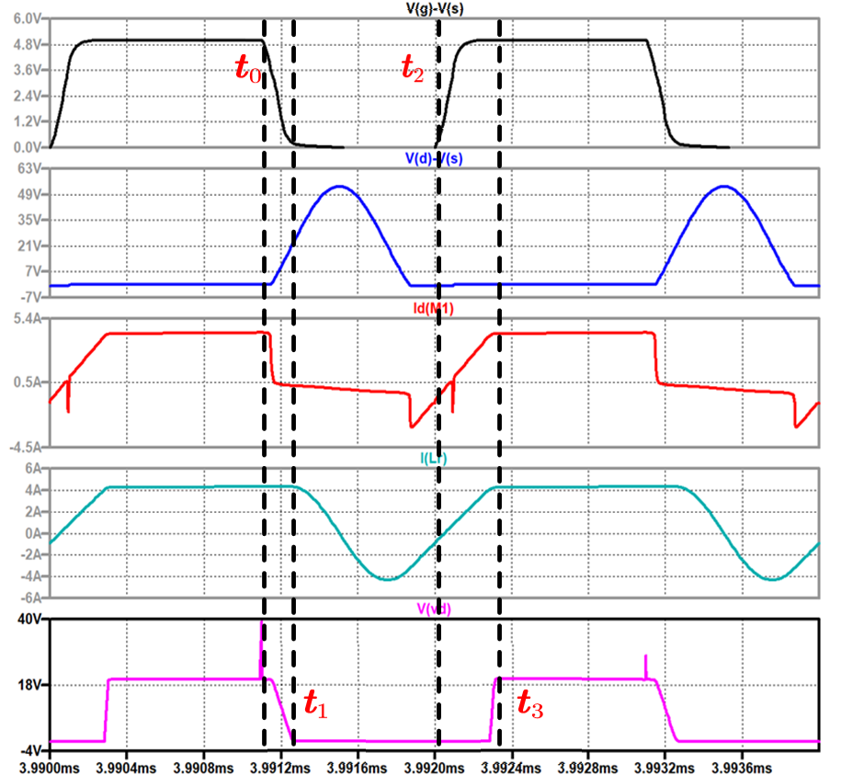

Fig.26 Switching Waveform of ZVS QRC

The plot above shows the waveform of gate voltage, switch voltage, switch current, load inductor current and the voltage between the diode in the Buck converter.

For the existence of the Miller Capacitance in the NMOSFET, the waveform of the gate voltage is not ideal compared to the theoretical waveform. Therefore, we defined the point when the gate voltage begins to drop from 5V as , the point when the diode voltage reaches zero as , the point when the gate voltage begins to rise as , the point when the diode voltage reaches maximum as .

: Turning-Off State; : Off State; : Turning-On State; : On State.

## *5.3 Loss Curve*

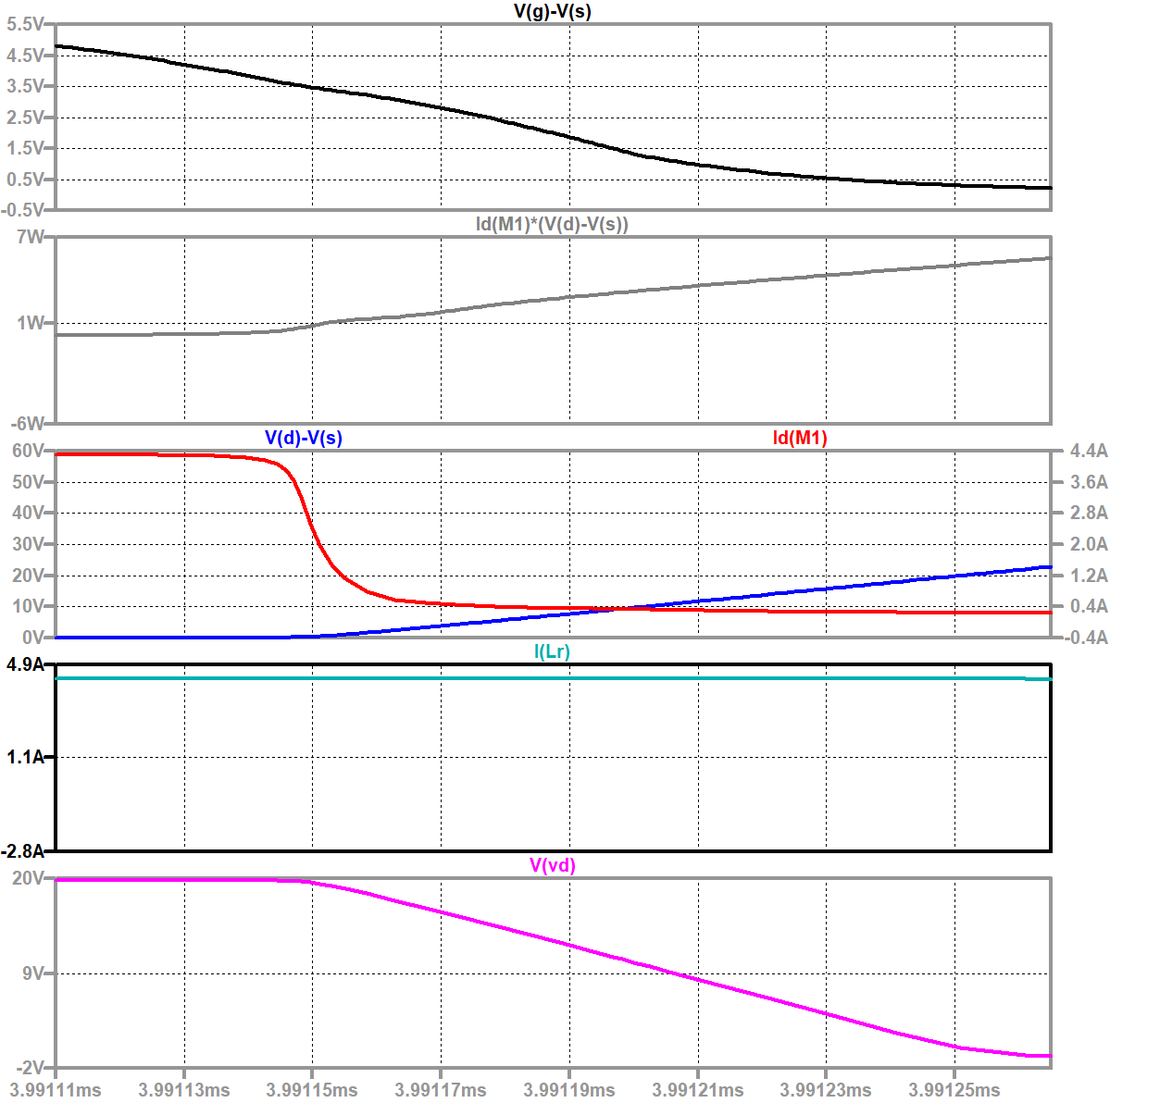

Fig.27 Turning-Off State Switching Waveform of ZVS QRC

Fig.28 Turning-Off State Switching Power Loss

Fig.29 Turning-On State Switching Waveform of ZVS QRC

Fig.30 Turning-On Switching Power Loss

图形用户界面, 表格

Fig.31 On-State (L) and Off-State (R) Switching Power Loss

Fig.30 Switching Power Loss within one period

Among them, the reason for the negative off-state loss is that when the resonance peak is reached, the current flowing through the MOSFET is just zero, and then is discharged to , and and are reversed. At this time, the MOSFET is under positive voltage, and the flow current is negative, resulting in the entire process of the off-state loss is negative.

Because the MOSFET is switched on before opening, the positive guide voltage drop is very small, so the opening loss is also very small, the average power is in the level, and the switching voltage rises from 0 to about 20V during the shutdown process, the range is large, and the current changes are large, so the shutdown loss is very large.

|  |  |  |  |  |  |
| --- | --- | --- | --- | --- | --- |
|  | On stage loss | Off stage loss | Turn on loss | Turn off loss | Total loss |
| Average | 165.2mW | -256.87mW | 82.94mW | 2.6033W | 186.29mW |
| Integral | 132.16nJ | -188.8nJ | 25.711nJ | 403.52nJ | 372.59nJ |

# Analysis of the Results

The four stages and total loss of the two circuits are compared in the following table. There is little difference between on-state loss and off-state loss of soft and hard switches. The on-off loss of the soft switch is greatly reduced compared with that of the hard switch, so the total loss is also reduced.

|  |  |  |  |  |  |
| --- | --- | --- | --- | --- | --- |
|  | On stage loss | Off stage loss | Turn on loss | Turn off loss | Total loss |
| Average for Hard-Switching | 250.41mW | 5.9549mW | 10.526W | 6.6803W | 1606.4mW |
| Integral for Hard -Switching | 240.39nJ | 5.3951nJ | 2105.2nJ | 881.8nJ | 3212.8nJ |
| Average for AVS QRC | 165.2mW | -256.87mW | 82.94mW | 2.6033W | 186.29mW |
| Integral for  ZVS QRC | 132.16nJ | -188.8nJ | 25.711nJ | 403.52nJ | 372.59nJ |