**Seminar8**

For this seminar, each group only need to complete one question. The specific groupings are shown in the appendix.

1. Build a Boost circuit and MOSFET driver circuit in LTSpice, as shown in the reference circuit diagram.  
   (1) Achieve an input voltage range of 150V to 300V, an output voltage of 400V, a power of 4kW, and a switching frequency of 50kHz.  
   (2) Analyze the effect of loop inductance Ln (1~30) on the voltage spike during device turn-off.  
   (3) Optimize the driver resistorsandto accelerate the driving speed and suppress the turn-off voltage spike, ensuring it does not exceed 10% of the rated value.  
   Reference parameters: Boost inductor L = 300, capacitor C = 100，R1=1~100。

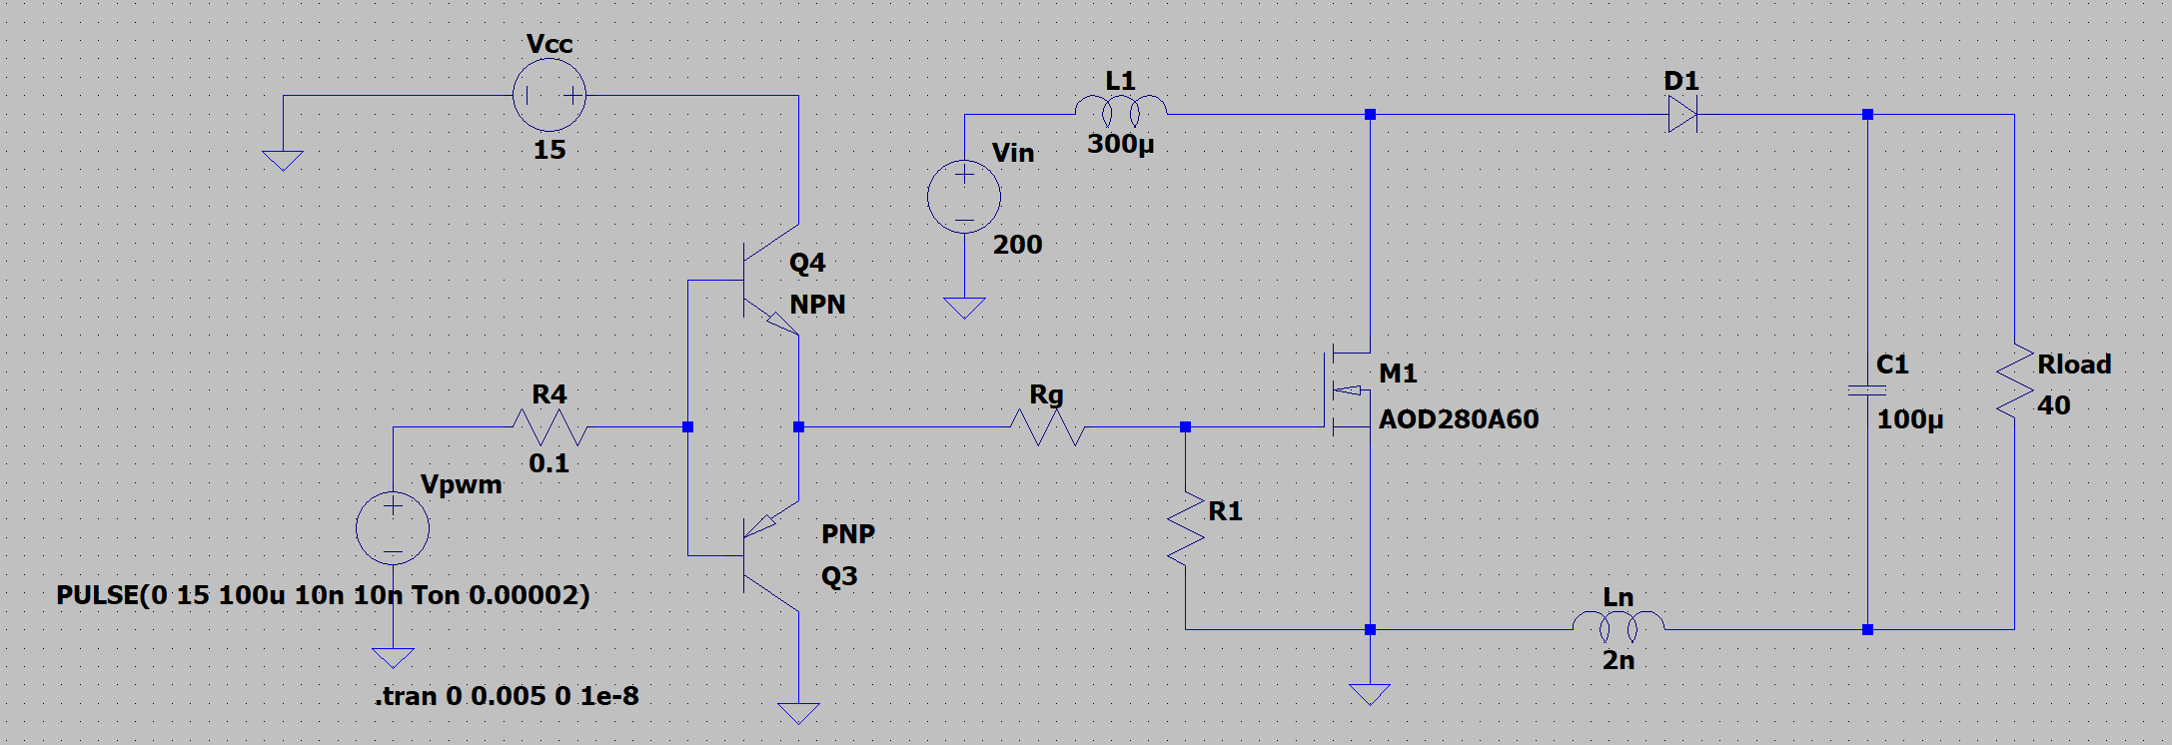

1. Build a Buck circuit and MOSFET driver circuit in LTSpice, as shown in the reference circuit diagram.  
   (1) Achieve an input voltage range of 300V to 400V, an output voltage of 200V, a power of 1kW, and a switching frequency of 50kHz.  
   (2) Analyze the effect of loop inductance Ln (1~30) on the voltage spike during device turn-off.  
   (3) Optimize the driver resistorsandto accelerate the driving speed and suppress the turn-off voltage spike, ensuring it does not exceed 10% of the rated value.  
   Reference parameters: Buck inductor L = 300, capacitor C = 100，=1~100。

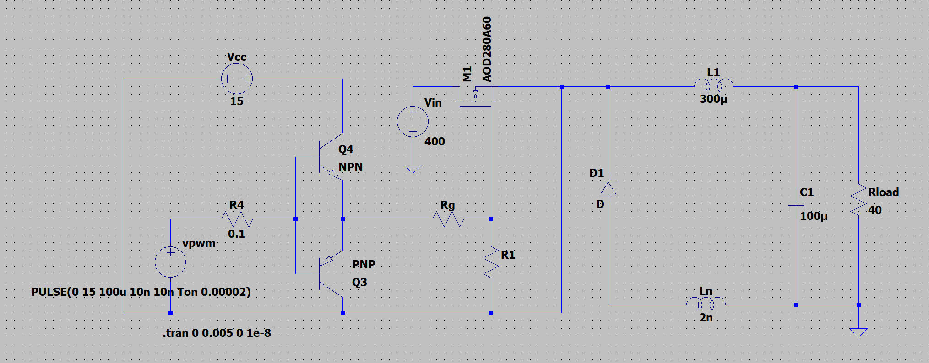

1. Build a Boost circuit and MOSFET driver circuit in LTSpice, as shown in the reference circuit diagram.



(1) Achieve an input voltage range of 150V to 300V, an output voltage of 400V, a power of 4kW, and a switching frequency of 50kHz.  
(2) Analyze the effect of loop inductance Ln (1 to 30) on the voltage spike during device turn-off.  
(3) Design RC and RCD snubber circuits to suppress the turn-off voltage spike, ensuring it does not exceed 20% of the rated value.  
Reference parameters: Boost inductor L = 300, capacitor C = 100, =1~100.

1. Build a Buck circuit and MOSFET driver circuit in LTSpice, as shown in the reference circuit diagram.



(1) Achieve an input voltage range of 300V to 400V, an output voltage of 200V, a power of 1kW, and a switching frequency of 50kHz.  
(2) Analyze the effect of loop inductance Ln (1 to 30) on the voltage spike during device turn-off.  
(3) Design RC and RCD snubber circuits to suppress the turn-off voltage spike, ensuring it does not exceed 20% of the rated value.  
Reference parameters: Buck inductor L = 300, capacitor C = 100, =1~100.

1. Build a Boost circuit and a parallel MOSFET driver circuit in LTSpice, as shown in the reference circuit diagram. LM1 and LM2 represent loop inductances (10–100nH), while RM1 and RM2 represent loop resistances (10–100).

(1) Without considering loop inductances and resistances, achieve an input voltage range of 150V to 300V, an output voltage of 400V, a power of 4kW, and a switching frequency of 50kHz.

(2) Simulate and analyze the effects of loop inductance and resistance characteristics on current-sharing performance.

(3) Further compare the switching loss differences between the two devices, considering loop inductances and resistances.

Reference parameters: Boost inductor L = 300, capacitor C = 100.

1. Build a Buck circuit and a parallel MOSFET driver circuit in LTSpice, as shown in the reference circuit diagram. LM1 and LM2 represent loop inductances (10–100), while RM1 and RM2 represent loop resistances (10–100).

(1) Without considering loop inductances and resistances, achieve an input voltage range of 300V to 400V, an output voltage of 200V, a power of 2kW, and a switching frequency of 50kHz.

(2) Simulate and analyze the effects of loop inductance and resistance characteristics on current-sharing performance.

(3) Further compare the switching loss differences between the two devices, considering loop inductances and resistances.

Reference parameters: Buck inductor L = 300, capacitor C = 100.

许多电脑萤幕画面

1. Design a control system for a single-phase full-bridge Boost-PFC circuit. The input voltage is 220V, 50Hz, and the output voltage is 380V, with a power of 3kW. Details are as follows:

(1) Analyze the operating principles of the single-phase full-bridge Boost-PFC circuit.

(2) Implement current loop control using a PI controller with voltage open-loop and triangular carrier modulation, which the switching frequency is =20kHz.

(3) Build on (2) by adding an outer voltage loop for control.

Reference parameters: The inductor L=700, and the capacitor C=470 .



1. Design a control system for a single-phase full-bridge Boost-PFC circuit. The input voltage is 220V, 50Hz, and the output voltage is 380V, with a power of 3kW. Details are as follows:

(1) Analyze the operating principles of the single-phase full-bridge Boost-PFC circuit.

(2) Implement current loop control using hysteresis comparator control with voltage open-loop, which the switching frequency is =20kHz.

(3) Build on (2) by adding an outer voltage loop for control.

Reference parameters: The inductor L=700, and the capacitor C=470.



1. Design a control system for a single-phase full-bridge Boost-PFC circuit. The input voltage is 220V, 50Hz, and the output voltage is 380V, with a power of 3kW. Details are as follows:

(1) Analyze the operating principles of the single-phase full-bridge Boost-PFC circuit.

(2) Implement current loop control using a PI controller with voltage open-loop and triangular carrier modulation, which the switching frequency is =20kHz.

(3) Implement current loop control using hysteresis comparator control with voltage open-loop, and compare and analyze the differences with the method in (2).

Reference parameters: The inductor L=700, and the capacitor C=470.



1. Design a control system for a single-phase full-bridge Boost-PFC circuit. The input voltage is 220V, 50Hz, and the output voltage is 380V, with a power of 3kW. Details are as follows:

(1) Analyze the operating principles of the single-phase full-bridge Boost-PFC circuit.

(2) Implement current loop control using a PI controller with voltage open-loop and triangular carrier modulation, which the switching frequency is=20kHz.

(3) When the initial voltage of the output capacitor is 0, analyze why inrush current occurs during startup without soft-start protection in the control strategy. Use a By-Pass diode for simple suppression of the inrush current.

Reference parameters: The inductor L=700, and the capacitor C=470.



**Appendix**

|  |  |
| --- | --- |
| Group No. | Question |
| **1** | 1 |
| **2** | 2 |
| **3** | 3 |
| **4** | 4 |
| **5** | 5 |
| **6** | 6 |
| **7** | 7 |
| **8** | 8 |
| **9** | 9 |
| **10** | 10 |