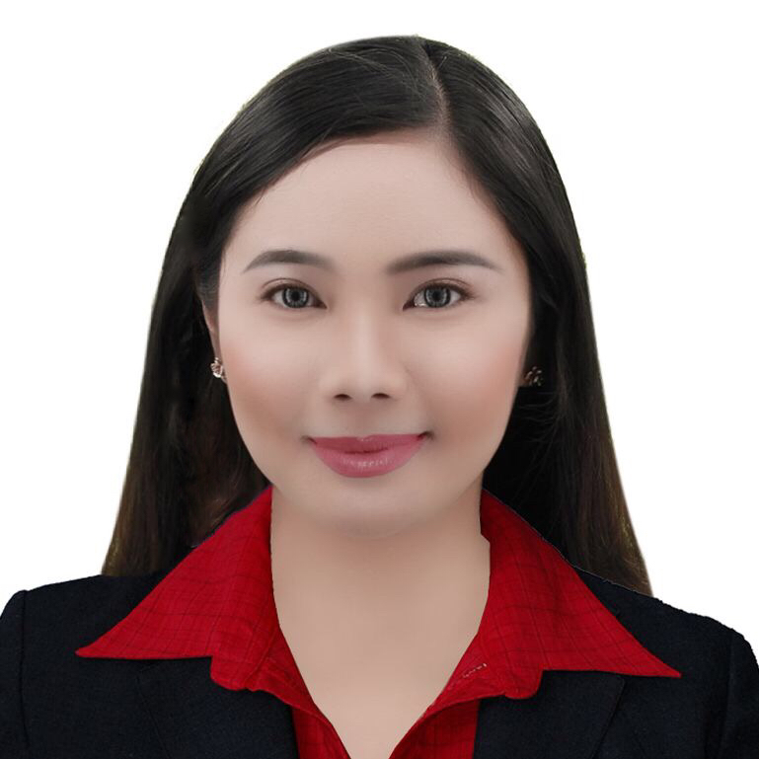

# Curriculum vitae

Personal Information

Full name

Address

Contact no.

Civil Status

email

Nationality

Date and place of birth

Height and weight

Gender

Educational Background

Primary school

Year

School

Secondary school

Year

School

Tertiary/college

Year

School/university

Course/program

Certifications

Location

Date

Certificate title

Reychelle Barretto Toralba

Block 20 Lot 34 Diamond Lane Street Medallion Homes Marilao Bulacan

0935 015 3840

Single

reychelletoralba@gmail.com

Filipino

July 4, 1995 / Meycauayan, Bulacan

5'3 / 58kg

Female

2002 - 2008

Discovery Child Development Center of Montessori

2011 - 2012

Barcelona Academy

2012 - 2016

New Era University

Bachelor of Arts in Foreign Service

University of the Philippines, Diliman, Quezon City

May 2015

Certificate of Participation at the Conference on Philippine Foreign Relations in the 21st Century

Page1-Curriculum vitae of **Reychelle Toralba**

May 2015

Conferences and Seminars

Date

Location

Conference

Date

Location

Conference

Date

Location

Conference

Trainings

Agency

Training span

Responsibilities

Certifications earneD

Job Experience

Company

Position

Job description

Job span

# Curriculum vitae

University of the Philippines, Diliman, Quezon City

Conference on Philippine Foreign Relations in the 21st Century: Challenges and Prospects

March 2015

University of the Philippines, Diliman, Quezon City

The Philippine Summit in European Studies: Collective Action for Peaceful Nations

February 2014

University of the Philippines, Diliman, Quezon City

Japan's Noh Theater and the Philippine Practice of Western Performance Traditions

Commission on Filipinos Overseas

February 10, 2016 - March 29, 2016

Provide and ensure the Emigrants the service they deserve and needed as we were to help them complete the final requirements needed for their emigration.

Certificate of Completion

Travellers International Hotel Group Inc. (Resorts World Manila)

Casino Cashier (Casino Treasury)

A Casino Cashier is responsible for financial transactions inside the casino, particularly the conversion of casino chips into cash. Other transactions includes cash advancements, credit process, cheque process, wire transfers, chip deliveries and receiving to/from table games, and daily in-house checking.

August, 8, 2016 - January 2017

Page2-Curriculum vitae of **Reychelle Toralba**

Skills and Competences

Language Spoken

Other Language(s)

Social Skills and Competences

Computer skills

ADDITIONAL INFORMATION

Character References

Name

Address

Contact no.

Relationship

Name

Address

Contact no.

Relationship

Name

Address

Contact no.

Relationship

Filipino

# Curriculum vitae

English, Spanish

Fluency in English language with the ability to speak it in various accents (e.g. British, American, Australian); Good English written skills; Ability to speak with confidence and deliver speech well.

Computer literacy. Microsoft Office. Adobe soft wares.

Aside from loving to read various novels, I am good at writing my own novels and stories, too. I also write my own songs for I am good at singing, which enhanced my skills to interact with a variety of people as I grew up joining singing contests, entertaining and sharing what I have throughout the society.

April Klinck

Villamor, Pasay City

0927 468 1468

Former Workmate

Ryan Christian Legaspi

Saluysoy, Meycauayan, Bul.

0975 177 7991

Friend

Hanny Lou M. Torres

Tandang Sora, Quezon City

09098041348

Colleague

Page3-Curriculum vitae of **Reychelle Toralba**