Name: VINZCEL S. CALAMONGAY

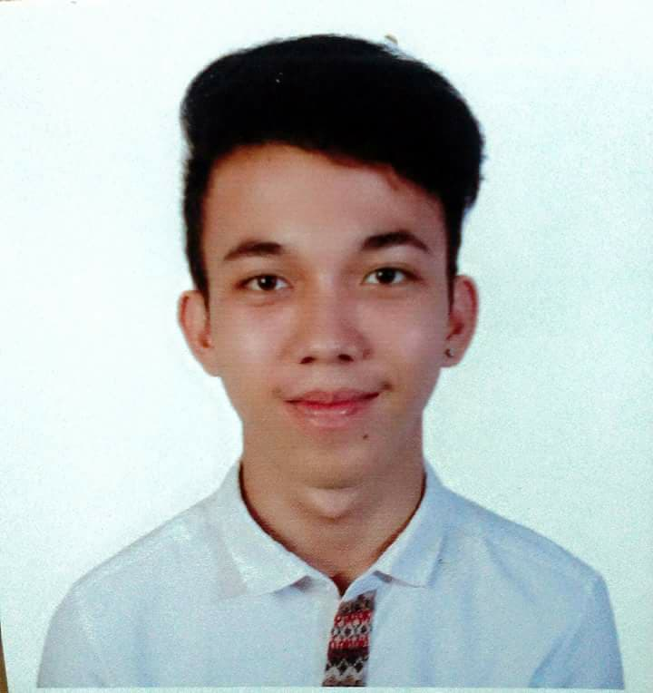

Address: SAN MIGUEL, APAS CEBU CITY

Contact no: 09494695223

Email: [vinzcala@gmail.com](mailto:vinzcala@gmail.com)

Website/Blog**:** www.supercrunchblog.wordpress.com

**CAREER OBJECTIVE**

- To work in a company where I can show my skills and growing along with the company. To obtain any kind of position that are available and to work with my fullest potential, so that I can help the progress in the company.

**CORE COMPETENCIES**

- Customer service

-Building collaborative relationships

- Providing motivational support

- Initiative

- Fostering teamwork

- hardworking

**EDUCATIONAL QUALIFICATIONS**

**TERTIARY**

- Mindanao State University - Main campus

Marawi City, Lanao del Sur

BSBA - Entrepreneurial Marketing

College level

**SECONDARY**

- Misamis Occidental National High School

Gov. A. Bernard St. Poblacion 1, Oroquieta City

2014-2015

**PRIMARY**

- Don Vicente Rama Memorial National High School

Macopa St. Cebu City, Cebu

2010-2011

**TECHNICAL SKILLS**

- Social Media experience

- Microsoft office

- WordPress

**WORK EXPERIENCE**

**POSITION**

**Content Writer** (Part time/ Home-based/ Paid via Paypal)

Tasks:

- Article should be Non-promotional, so write general info based on Keywords​

- Must be Good Flow & structured Content.

- 100% unique & Copyscape passed. And 4-5 articles per day (400-500 words).

- Once you’re done. Update them through Skype.

**Kitchen Crew** at Mang Inasal, Prince City Hall, Cebu City

October 02, 2017 - January 08, 2018

Tasks:

- Be responsible! Follow the standards.

- Food safety!

- 15 minutes before the time (Opening/Closing)

- Food availability/ Avoid pending orders

**Kitchen Helper** (On-call) at Hotel Pier Cuatro, Cebu City

May 2017

Tasks:

- Assist the Chef. Do what he says.

- Be on time. (4:00am - 2:00pm)

**Sales Clerk** (Shoes Department) at THE SM STORE, SM Seaside Cebu

September 02, 2016 - January 31, 2017

Tasks:

- Be nice at customers.

- Must hit the target quota sales every month.

- Report once a month together with the coordinator.

**SEMINARS/ORIENTATIONS ATTENDED**

**Philippine Contemporary Social Issues: A Sociological Perspectives**

Institute for Peace and Development in Mindanao State University, Marawi City

October 05-06, 2015

**Structured Learning Experience on Stress Management**

College of Social Sciences and Humanities, MSU, Marawi City

October 25, 2015

**JUAN BIG IDEA: A Voyage Towards Marketing Eminence**

Gymnasium, Mindanao State University - Iligan Institute of Technology

March 12, 2016

**Marketing Cup 2016: Building Communities through Innovative Ventures**

Saint Michael’s College Gymnasium, Tibanga, Iligan City

February 24, 2016

**PERSONAL INFORMATIONS**

Date of birth: 1998-07-31

Place of birth: Cebu City

Age: 19

Gender: Male

Status: Single

Nationality: Filipino

Height: 5’6

Weight: 55kg

Religion: Roman Catholic

Language known: English, Tagalog, Cebuano

**HOBBIES/INTERESTS:**

- Writing

- Reading books/ novels

- Exploring and surfing the net

- Blogging

- Watching movies

**DECLARATION**

I hereby declare that all statements made in this application are true, complete, and correct to the best of my knowledge and beliefs.