Taco Truck Order Management System
Team Members
Francisco Ruiz-Hernandez
Lisa Werth
Team Relational Taqueria

Webpage URL: http://classwork.engr.oregonstate.edu:60123/

Actions Based On Feedback:
- It was suggested that we introduce another entity into our draft. In our design draft, the many-to-many relationship between Orders and MenuItems is Modeled conceptually and implemented through the OrderItems intersection entity. This follows the guidelines/instructions for this step of the project stating that ER diagrams are logical models and many-to-many relationships may be shown without intersection tables. (left as is)
- It was also suggested that we rename our tables in MySQL Workbench to PascalCase. We will follow this advice and update to PascalCase as suggested, ie customers --> Customers, menuItems --> MenuItems etc.

Fixes based on Feedback from Step 1:
- It was suggested that we rename our tables in MySQL Workbench to PascalCase. We will followed this advice and updated to attributed as suggested, ie customers --> Customers, menuItems --> MenuItems etc.
Project Overview and Database Outline - Updated Version:
- We are introducing a primary key to the table OrderItems to align with the suggestion made in the lessons regarding Normalization.
- Based on the recent lesson in SQL Cascades and Normalization, we decided to make a change to the OrderItems table to account for the deletion of a menu item. If a menu item is deleted, the foreign key in OrderItems is set to NULL to preserve historical order records while maintaining data integrity.
- We include LineTotal in OrderItems to preserve the exact transaction value at the time of purchase. Since menu prices may change in the future, storing LineTotal ensures historical accuracy of financial records. This prevents discrepancies when querying past orders using current menu prices.

New Changes Based on Step 2 Feedback
- It was suggested we standardize our naming conventions, so we updated our table names to PascalCase (Customers, Orders, MenuItems, OrderItems) for consistency across our database outline, ER diagram, schema, and example data.
- It was suggested we correct the column names in example data to match the database outline, so we have updated those to match and be consistent.
- It was suggested we correct our decimal formatting in our example data, so we updated our currency values to include two decimal places. This properly reflects the decimal data type used in the schema (6,2).
- It was suggested we change OrderStatus from a tinyint to enum. The OrderStatus attribute will remain a tinyint, but wording was added to define the numeric meaning of each value. This ensures that the attribute’s purpose is clear and easy to understand for anyone viewing it.
- Column Headers were added to the OrderItems example data table
- Additional clarification was added to explain that LineTotal is stored to preserve the exact transaction value at time of purchase, keeping historical accuracy even if menu prices change in the future.
What Was Not Changed:
- We did not add ON UPDATE CASCADE to our foreign key relationships, because the Primary keys are auto incremented and not expected to change after creation. Because of this, ON UPDATE CASCADE was not necessary, and avoiding using it prevents unintended cascading updates.
- We did not remove the LineTotal attribute from OrderItems, because although LineTotal can be derived from Quantity and ItemPrice, it was intentionally retained in order to preserve historical transaction accuracy. Since menu prices can change over time, storing LineTotal ensures past order totals remain accurate.
- We did not add additional attributes as suggested, because these attributes were considered optional and outside the scope of project requirements. The existing attributes are sufficient to support the business needs described in the project overview while keeping the schema scope appropriate for this assignment.
- We did not modify the overall schema structure or add additional entities. The schema as it is currently satisfies normalization requirements and correctly implements the many-to-many relationship between Orders and MenuItems using the OrderItems intersection table. No additional entities were required at this time.

New Changes Based on Step 3 Feedback
- Based on feedback to improve query readability/maintainability, we replaced SELECT * statements with specific column selections. We added AS aliases to display clearer labels such as “Customer Name,” “Order ID,” and “Order Total.”
- To make the UI more user-friendly, we updated SELECT queries to use JOIN statements so that pages display readable values, such as customer names and menu item names, instead of only numeric foreign key IDs.
- In response to suggestions about dropdown usability, we updated the form dropdown queries to include descriptive labels such as concatenated customer names (“John Doe”) and menu item details (“Taco - $4.99”) instead of displaying just numeric IDs. We reformatted update fields to display values like “Order #1” instead of “1-1”, since it was a little difficult to read and understand before.
- We corrected inconsistencies in the UI, such as duplicate MenuItemID values in the “Order Item to Update” field. We also fixed labeling errors (example: renaming the “Orders!” header on the MenuItems page).
Overview
Our small taco truck processes approximately 50-100 orders a day, with possibly even up to 150 on weekends. As order volume increases, the taco truck will continue to experience increased sales volume. Retaining customer information, order history, and frequency of preferred menu items will provide clarity regarding future business decisions. As a result, this project proposes a database-driven website where customer data, orders, and menu items ordered can be collected. This will allow the taco truck to track which customers place orders, what items are included in each order, and provide real-time order status. For readability, our website displays customer names in a “human readable” format, and menu item names using relational joins and descriptive column aliases (instead of internal numeric identifiers).

Database Outline, in Words
- Customers: Records the details of Customers who order from us.
- CustomerID: int, auto_increment, unique, not NULL, Primary Key
- FirstName: varchar(50), not NULL
- LastName: varchar(50), not NULL
- Email: varchar(50), unique, not NULL
- Relationships: a 1:M relationship between Customers and Orders is implemented with customerID as a FK inside of Orders.

- Orders: records each order placed by a customer, including when it was placed and current status.
- OrderID: int, auto_increment, unique, not NULL, Primary Key
- CustomerID: int, not NULL, FK references Customers
- OrderDate: datetime, not NULL
- OrderStatus: tinyint(1), not NULL, default(0), stores current status of order (for reader clarity: 0 = placed, 1 = ready, 2 = completed)
- OrderTotal: decimal(6,2)
Relationships: a 1:M relationship between Orders and OrderItems is implemented with orderID as a FK inside of OrderItems.
A M:M relationship between MenuItems and Orders is implemented indirectly via a relationship with OrderItems.

- MenuItems: Stores information about items offered by the taco truck and prices for each item.
- MenuItemID: int, auto_increment, unique, not NULL, Primary Key
- Name: varchar(50), not NULL
- Price: decimal(6,2), not NULL
- Relationships: a 1:M relationship between MenuItems and OrderItems is implemented with menuItemID as a FK inside of OrderItems.
- A M:M relationship between MenuItems and Orders is implemented indirectly via a relationship with OrderItems.

- OrderItems: Links orders and menu items while recording the quantity of each item in an order.
- OrderItemID: int, auto_increment, unique, not NULL, Primary Key
- OrderID: int, not NULL, Foreign Key references Orders
- MenuItemID: int, not NULL, Foreign Key references MenuItems
- Quantity: int, not NULL
- ItemPrice: decimal(6,2), not NULL
- LineTotal: decimal(6,2), not NULL
- Relationships: a 1:M relationship between Orders and OrderItems is implemented with orderID as a FK inside of OrderItems.
- A 1:M relationship between MenuItems and OrderItems is implemented with menuItemID as a FK inside of OrderItems.
Entity Relationship-Diagram:
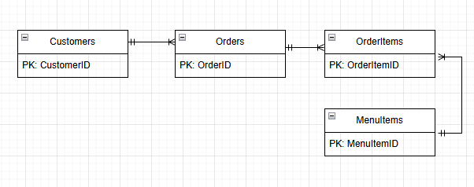

Schema Diagram:
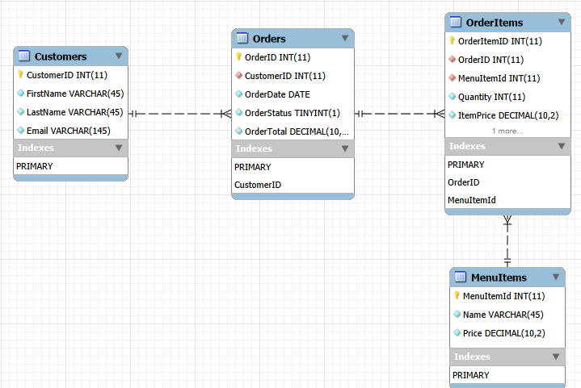

Assumptions:
- A customer may place many orders over time
- Each order may include multiple menu items
- Menu items may appear in multiple orders
- Quantity of each menu item in an order is tracked using OrderItems.quantity
- OrderItems is used to link Orders and MenuItems, allowing multiple items to be associated with each order

Example Data:
Customers
CustomerID | FirstName | LastName | Email
1 | Lisa | Werth | Lwerth@gmail.com
2 | Francisco | Ruiz-Hernandez | Fruiz@gmail.com
3 | Ted | Mosby | mr.johnwrench@yahoo.com

MenuItems
MenuItemID | ItemName | ItemPrice
1 | Taco | 6.00
2 | Burrito | 16.00
3 | Horchata | 5.00

Orders
OrderID | CustomerID | OrderDate | OrderStatus | OrderTotal
1 | 1 | 2026-01-09 | 1 | 12.00
2 | 2 | 2026-01-19 | 1 | 21.00
3 | 3 | 2026-01-29 | 0 | 22.00
4 | 3 | 2026-01-29 | 1 | 6.00

OrderItems
OrderItemID | OrderID | MenuItemID | Quantity | ItemPrice | LineTotal
1 | 1 | 1 | 2 | 6.00 | 12.00
2 | 2 | 2 | 1 | 16.00 | 16.00
3 | 2 | 3 | 1 | 5.00 | 5.00
4 | 3 | 1 | 1 | 6.00 | 6.00
5 | 3 | 2 | 1 | 16.00 | 16.00
6 | 4 | 3 | 1 | 5.00 | 5.00

