

SIMATS ENGINEERING

Saveetha Institute of Medical and Technical Sciences Chennai- 602105
Student Name: P. Swathika Reg. No.:192324197
Course Code: DSA0613 Slot: A
Course Name: Data Handling and Visualization for Data Analytics
Course Faculty: Dr. Kumaragurubaran T
Course Faculty: Dr. Senthilvadivu S

Project Title: Integrating Advanced Data Visualization and R Programming for Business Demand Forecasting
Module Photographs: (3 photographs –Module Photo, Individual student contribution module work in the project and presentation image)
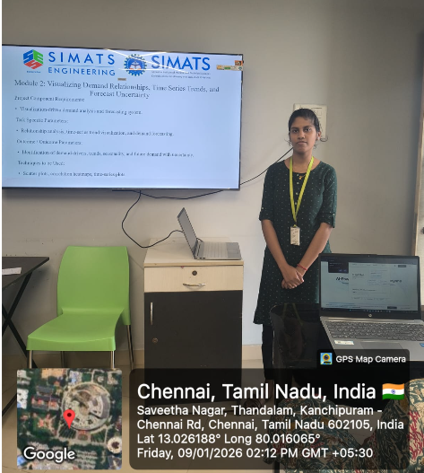 | 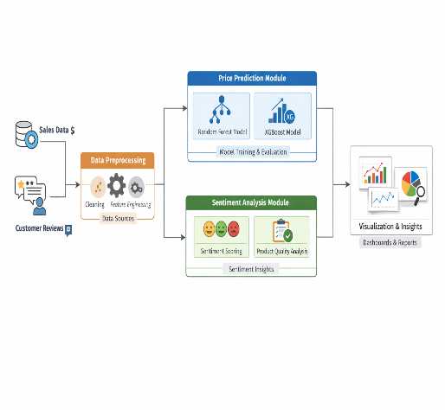 | 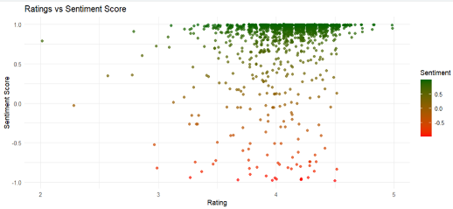  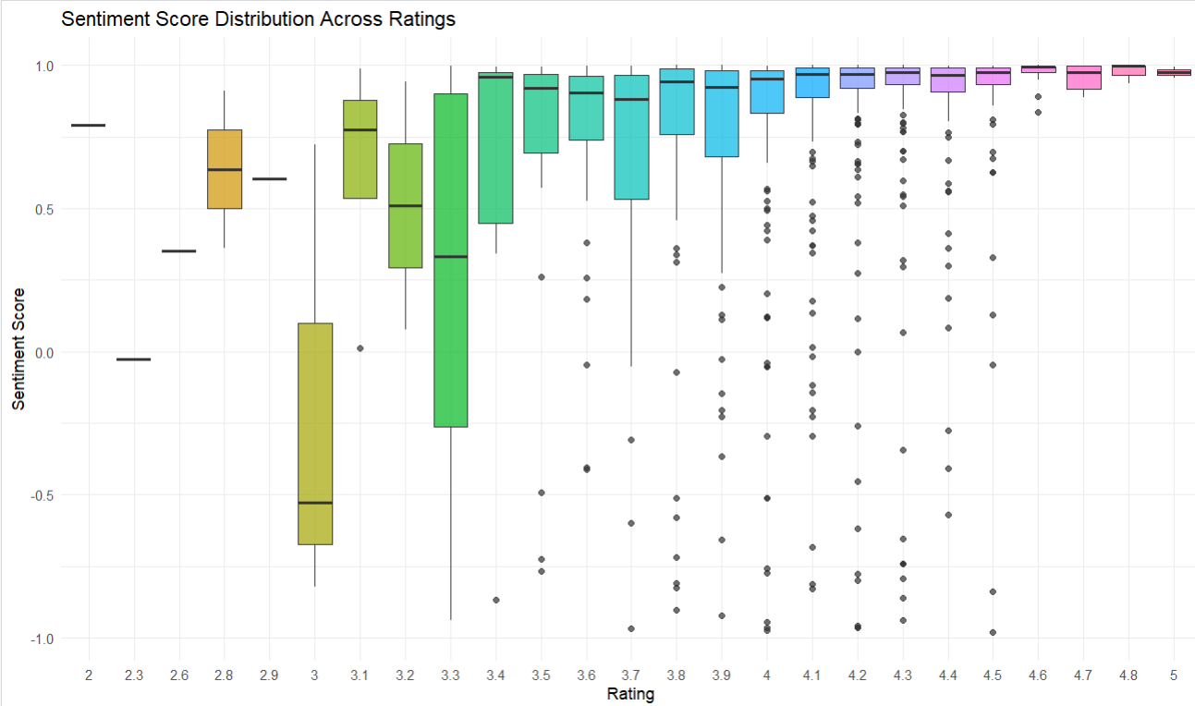

Project Description: (here you write what you did in this project (contribution) including Model Description
Integrating Advanced Data Visualization and R Programming for Business Demand Forecasting” is a project that combines data analytics and visualization techniques to support better business decision-making. My contribution focuses on Module 2, which analyzes customer review data to understand sentiment and product quality patterns that influence demand. In this module, publicly available e-commerce datasets containing product ratings, review text, sentiment scores, and review quality indicators were used. The data was cleaned and explored using R, and advanced visualizations such as scatter plots (ratings vs sentiment), bar plots (top-rated products), density plots (sentiment distribution), and boxplots (review quality comparison) were created. This module provides meaningful insights into customer perception and satisfaction, which indirectly supports demand forecasting by highlighting how customer sentiment and product quality impact purchasing behavior.

Student Signature Guide Signature

